SAN JOSÉ STATE UNIVERSITY

Charles W. Davidson College of Engineering

DEPARTMENT OF ELECTRICAL ENGINEERING

**EE 271 – Advanced Digital System Design and Synthesis**

Fall 2015 Final Project Report

**Implement and Analyze Different Types of 64-bit Adders**

|  |  |  |  |
| --- | --- | --- | --- |
| Name | Shantanu Vashishtha | SJSU ID | 010728900 |
| Email | Shantanu5092@gmail.com | Phone | +1-774-251-8094 |

**Executive Summary** (50 to 80 words)

This project is intended for the implementation of different types of 64-bit adders and performing the detailed analysis for timing and area for:

1. Ripple Carry Adder (RCA)
2. Carry Look-Ahead Adder (CLA-2L)
3. Carry Select Adder (CSA-EQG)
4. Carry select Adder (CSAU-EQG)

Each adder should take 1 clock cycle to complete the calculation.

Input and outputs are flopped.

## General Project Information

## Table I.1: List of EDA Tools Used

|  |  |  |  |  |
| --- | --- | --- | --- | --- |
| **Name** | **Company** | **Used for** | **Free? (Y/N)** | **Software Documents** |
| VCS | Synopsis | Simulation & test | No | VCS user_guide |
|  |  | Simulation & test |  |  |
| Design Vision | Synopsys | Synthesis | No | Design Vision user_guide |

## Table I.2: List of Libraries Used

|  |  |  |  |
| --- | --- | --- | --- |
| **Library file name** | **Company** | **Used with**  (EDA tool) | **The libraries are at**  (directories on eecad systems) |
| tc240c db_wccom25 | Synopsys | VCS | apps/toshiba/sjsu/synopsys/tc240c/tc240c db_wccom25 |
| tc240c db_bccom25 | Synopsys | VCS | /apps/toshiba/sjsu/synopsys/tc240c/tc240c db_bccom25 |
| tc240c.workview.sdb | Synopsys | VCS | /apps/toshiba/sjsu/synopsys/tc240c/tc240c.workview.sdb |

## Table I.3: List of Verilog Modules (both design and test modules)

|  |  |  |
| --- | --- | --- |
| **Module Name** | **Ports** | **Short Description** |
| rca_64bit | op1,op2,sum,crout,clock,reset | Two operands op1 & op2 are used as an inputs for the adder. Input cin is not used and outputs of the adder are sum and crout. Clock and reset are the controlling inputs of the flipflops. |
| cla64b | op1,op2,sum,crout,clock,reset | Two operands op1 & op2 are used as the inputs for the adder. Input cin is not used and outputs of the adder are sum and crout. Clock and reset are the controlling inputs of the flipflops. |
| csa1_64bit | op1,op2,sum,crout,clock,reset | Two operands op1 & op2 are used as the inputs for the adder. Input cin is not used and outputs of the adder are sum and crout. Clock and reset are the controlling inputs of the flipflops. |
| csa2_64bit | op1,op2,sum,crout,clock,reset | Two operands op1 & op2 are used as the inputs for the adder. Input cin is not used and outputs of the adder are sum and crout. Clock and reset are the controlling inputs of the flipflops. |
| rca_stimulus | - | Test Bench for Ripple Carry adder |
| cla64b_tb | - | Test Bench for Carry Look Ahead adder |
| csa1_stimulus | - | Test Bench for Carry Select adder with Equal bits |
| csa2_stimulus | - | Test Bench for Carry Select adder with unequal bits |

## II. The Implementation Overview

* Ripple Carry Adder is implemented by using 16 instances each of four bit adder which are made by instantiating 4- 1bit adders. Since cin is not to be used so the first bit is calculated using the half-adder.
* Carry Look-Ahead adder is implemented using 2 levels PG generator. There are blocks of 4 bits look ahead carry generator. 16 bit adder sum is calculated using ripple carry adder of 4 bit adder blocks. 2 levels of PG generator blocks are generated. And carry from 2nd level PG generator is rippled to the next 16 block adder.
* Carry select adder is implemented by instantiating 4-bit ripple carry adder blocks (16 times) followed by mux after each 4-bit group. Also, two four bit adders are made one cin-0 and another for cin-1. The role of multiplexer is to select which sum to use as an output depending upon the carry-in which becomes the select line for mux. Carry out from mux is rippled to the mux of next 4 bits adder block to decide sum and carry.
* Carry select adder with unequal bit groups is implemented by instantiating blocks of different bits. The different bit groups are of 4-4-5-6-7-8-9-10-11 for the best case.

**Figure II.1**: Overall Block Diagram of the 64-bit RCA

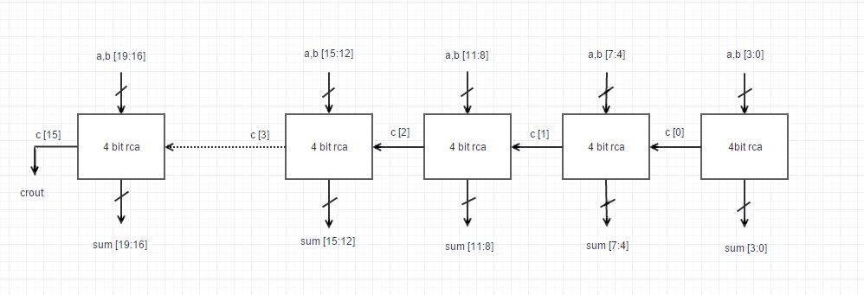

**Figure II.2**: Overall Block Diagram of the 64-bit CLA-2L

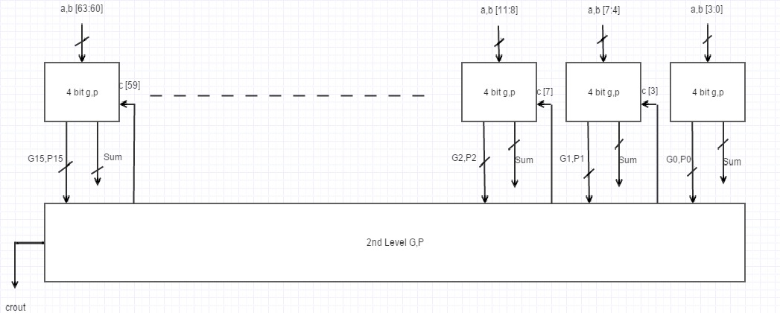

**Figure II.3**: Overall Block Diagram of the 64-bit CSA-EQG

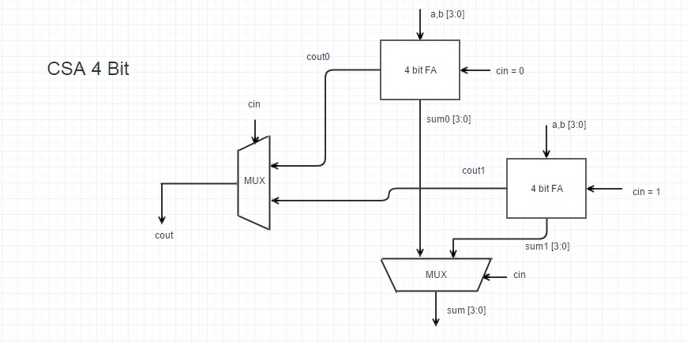

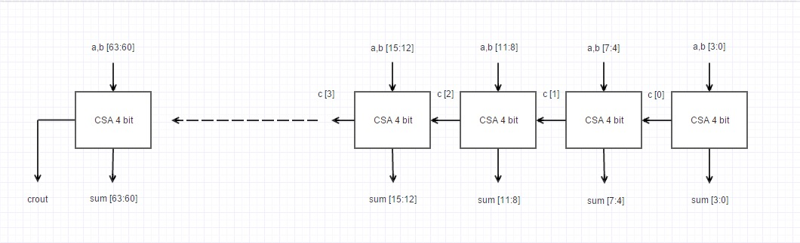

**Figure II.4**: Overall Block Diagram of the 64-bit CSA-UEQG

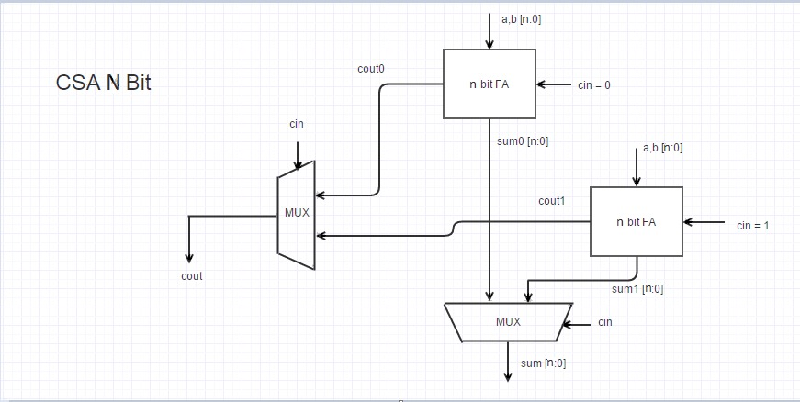

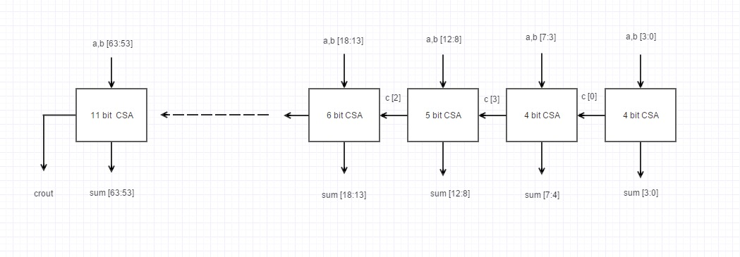

Approximated delay based on theory and measured delays:

**1. Ripple carry adder:**

For RCA, theoretical delay woud be equal to the sum of the ripples of all 63 carries and the delay of calculation of the last sum.

-Approximated delay

tadd = tsetup + (n-1) tcarry + tlast_sum

tadd = 0.31 + (64 -1) (0.08+0.09) + (0.08+0.64+0.15+0.33)

tadd = **12.22ns**

-Measured delay from synthesis

tadd = **12.6ns**

**2. Carry look ahead adder:**

For 64 bit 2 level carry look ahead adder, the delay would be equal to 8 times the single generate or propogate.

-Approximated delay

tadd = 8*Tg

tadd = 8 * (0.11+0.18+0.08+0.10)

tadd = **3.76ns**

-Measured delay from synthesis

tadd = **3.70ns**

**3. Carry Select EQG adder:**

For CSA equal, the delay would be equal to the sum of four bits of carry ripples, number of muxs used(16) and delay of calculation of the last sum.

-Approximated delay

tadd = tsetup + 4tcarry+(n/4)tmux + tectra_for_last_sum

tadd = 0.34 + 4(0.09+0.07) + 16(0.25) + 0.37

tadd = **5.35ns**

-Measured delay from synthesis

tadd = **5.90ns**

**4. Carry Select UNEQG adder:**

For CSA unequal, the delay would be equal to the sum of the first set of carry ripples, number of muxs used(8) and delay of calculation of the last sum.

-Approximated delay

tadd = tsetup + tcarry+10*tmux+tectra_for_last_sum

tadd = 0.34 + 0.17 + 8(0.27) + 0.31

**tadd = 2.98ns**

-Measured delay from synthesis

tadd = 4.1ns

**III. RTL-Level (Pre-synthesis) Simulations/Tests**

The different 6 test-benches are used with 6 different pair of inputs to verify the design. To verify the functionality of reset, the reset is also given in between the transitions of the inputs. 6 different inputs are selected such that major coverage of the design can be achieved. One of the inputs is all 0, this input is chosen to verify that none of the gate is misbehaving and giving all output as 0 without any glitches. Other pairs of inputs are such that ripple carry from one block to another can be verified.

**Table III.1** – Six Selected Test Data

|  |  |  |  |  |  |  |
| --- | --- | --- | --- | --- | --- | --- |
| **Test Case** | **op1** (hex) | **op2 (**hex) | **sum** (hex) | | | |
| **RCA** | **CLA-2L** | **CSA-EQG** | **CSA-UEQG** |
| **1** | **ffff_ffff_**  **ffff_ffff** | **0000_0000_**  **0000_0001** | **0000_0000_0000_0000** | **0000_0000_**  **0000_0000** | **0000_0000_**  **0000_0000** | **0000_0000_**  **0000_0000** |
| **2** | **14ab_78ef_**  **d853_5c7d** | **8dfd_eded_**  **cbed_8243** | **a2a9_66dd_**  **a440_dec0** | **a2a9_66dd_**  **a440_dec0** | **a2a9_66dd_**  **a440_dec0** | **a2a9_66dd_**  **a440_dec0** |
| **3** | **224f_9910_**  **23fa_39c6** | **28ad_bc24_**  **bd8f_18c0** | **4afd_5534_**  **e18a_18c0** | **4afd_5534_**  **e18a_18c0** | **4afd_5534_**  **e18a_18c0** | **4afd_5534_**  **e18a_18c0** |
| **4** | **bd82_a234_**  **b339_315c** | **66ff_abba_**  **239f_abcd** | **2482_4dee_**  **d6d8_dd29** | **2482_4dee_**  **d6d8_dd29** | **2482_4dee_**  **d6d8_dd29** | **2482_4dee_**  **d6d8_dd29** |
| **5** | **d2a9_b3c7_**  **72fa_7444** | **8822_2333_**  **5575_5892** | **5acb_d6fa_**  **c86f_ccd6** | **5acb_d6fa_**  **c86f_ccd6** | **5acb_d6fa_**  **c86f_ccd6** | **5acb_d6fa_**  **c86f_ccd6** |
| **6** | **58ab_68fa_**  **259a_3333** | **512c_438b_**  **4bba_2fab** | **a9d7_ac82_**  **7154_62de** | **a9d7_ac82_**  **7154_62de** | **a9d7_ac82_**  **7154_62de** | **a9d7_ac82_**  **7154_62de** |

*For each adder, you need to show simulation waveforms that can demonstrate major coverage in testing of your implementation and to support your expected results listed in Table III.1 above. Try to justify yourself if what parts of the tests and the changes from one value to other value that are important and should be included here in the report*

**Figure III.1a**: RTL simulation waveform that contains test case #1 for RCA

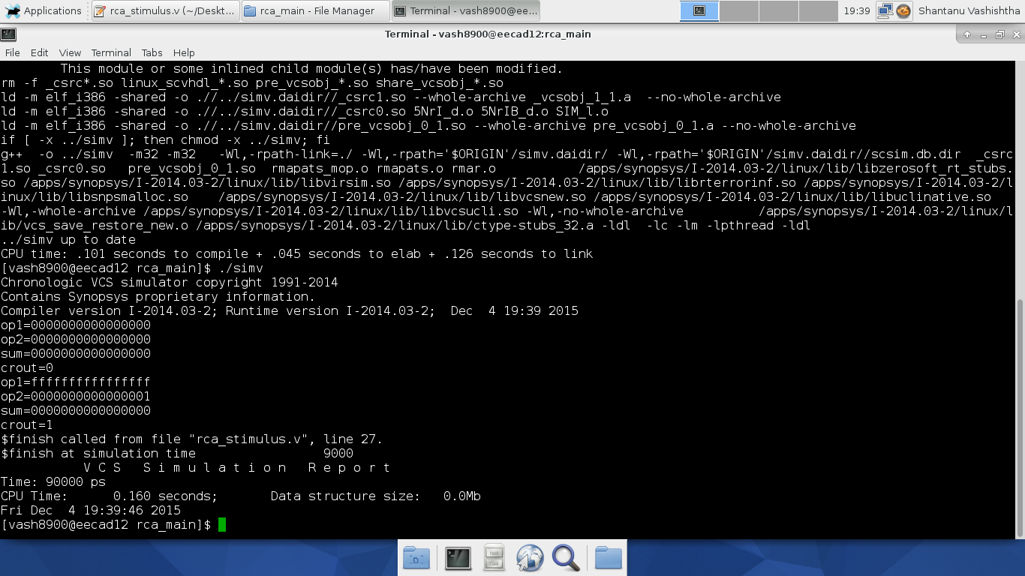

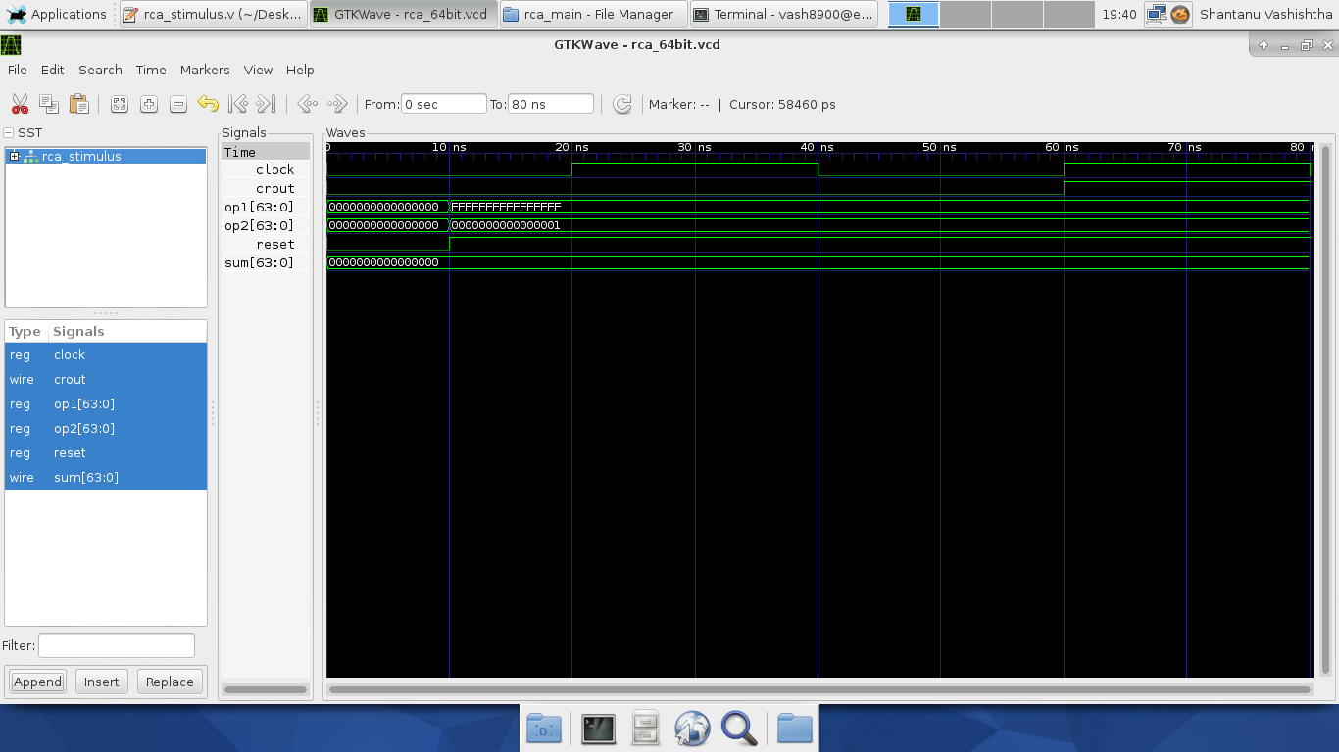

**Figure III.1b**: RTL simulation waveform that contains test case #1 for CLA-2L

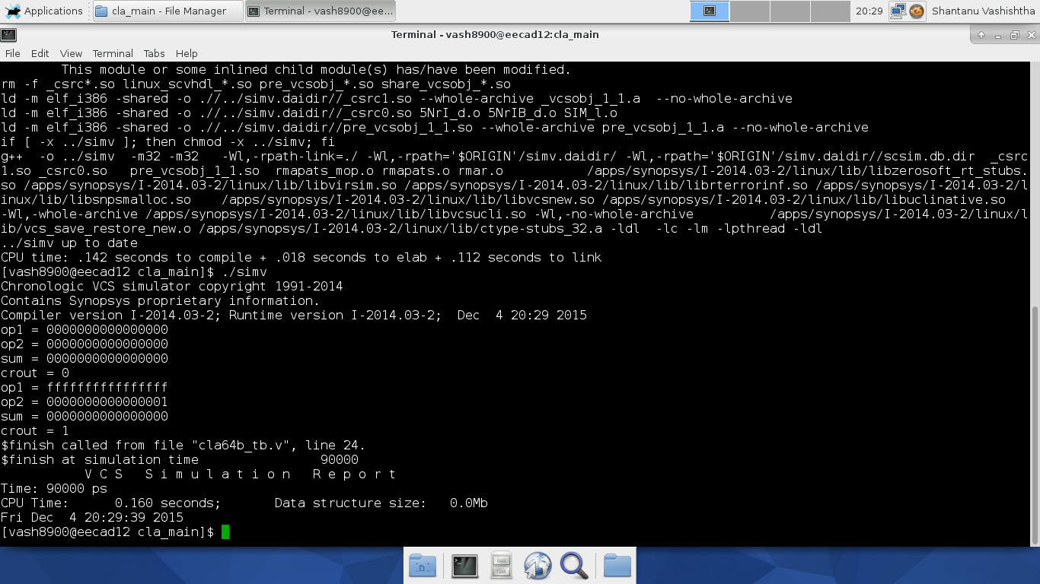

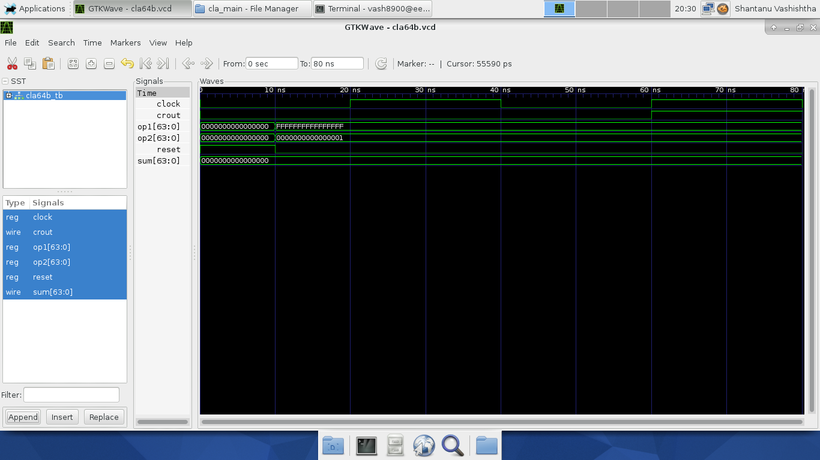

**Figure III.1c**: RTL simulation waveform that contains test case #1 for CSA-EQG

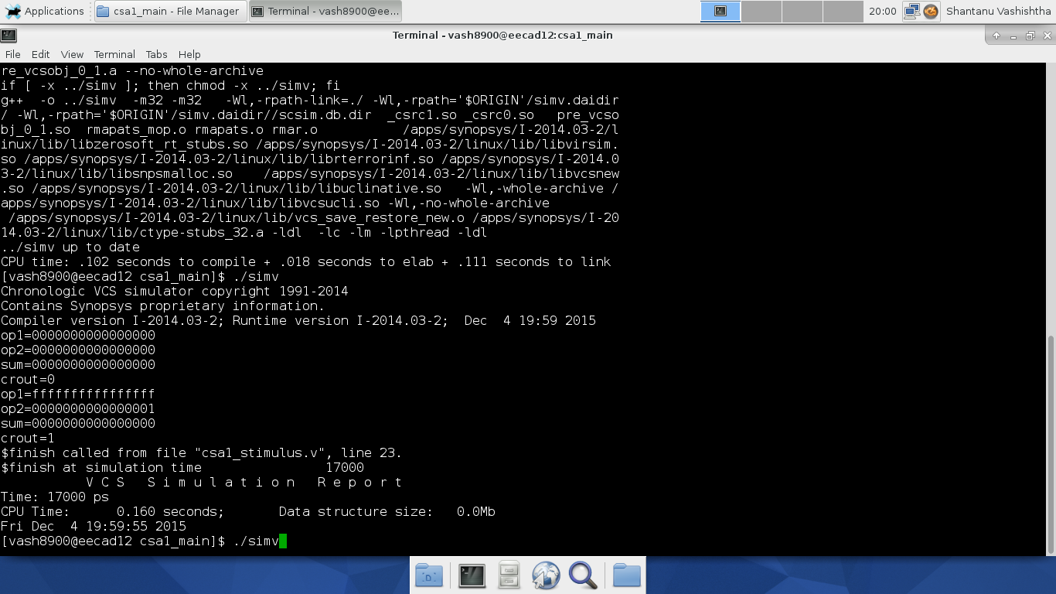

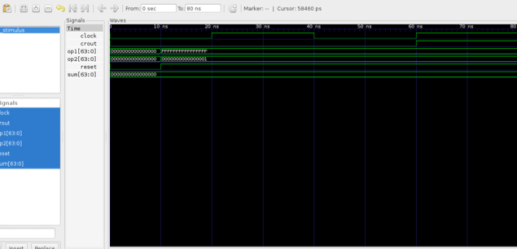

**Figure III.1d**: RTL simulation waveform that contains test case #1 for CSA-UEQG

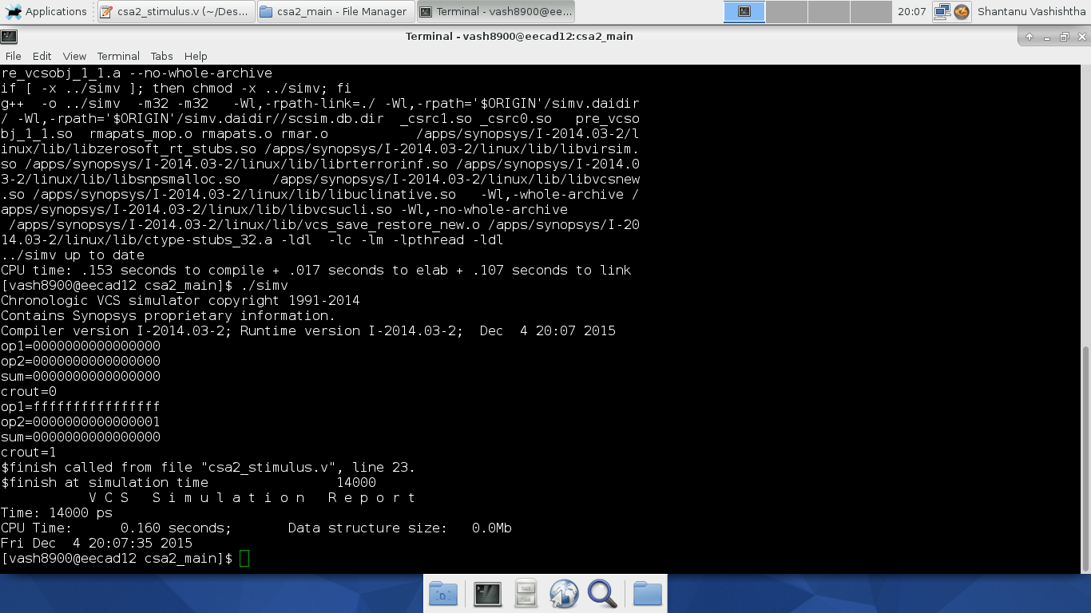

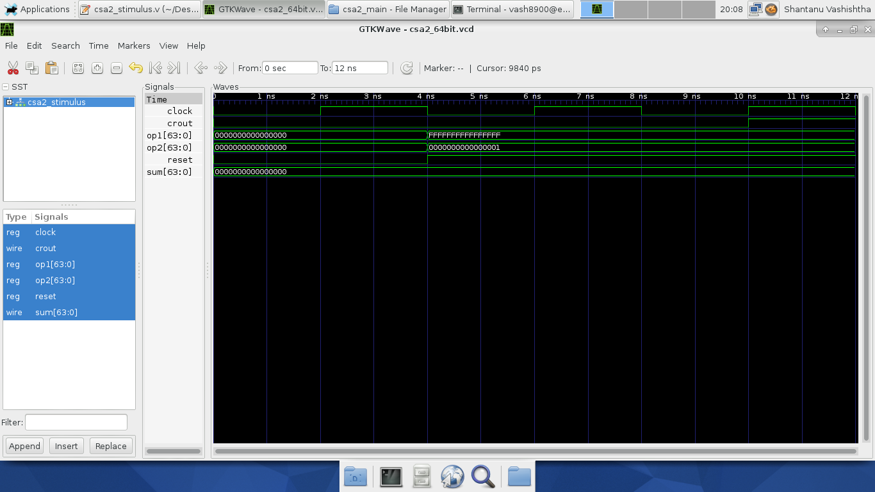

**Figure III.2a**: RTL simulation waveform that contains test case #2 for RCA

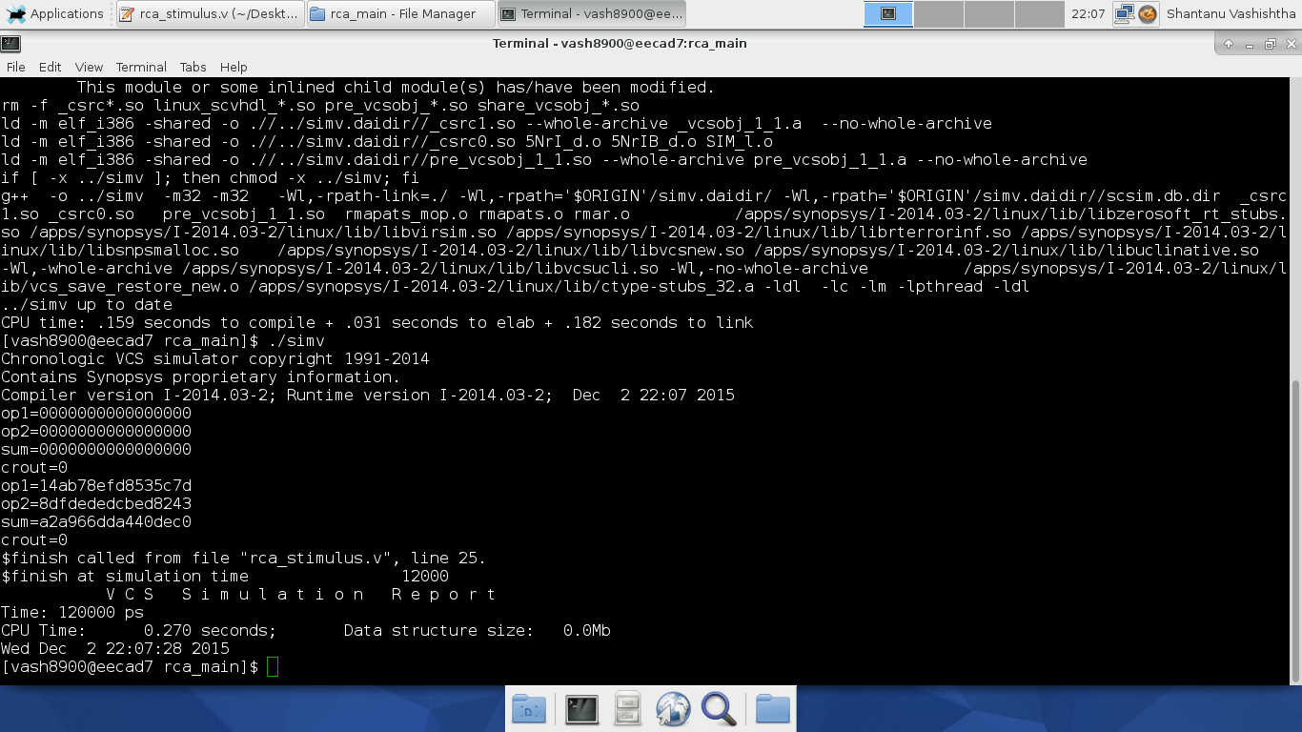

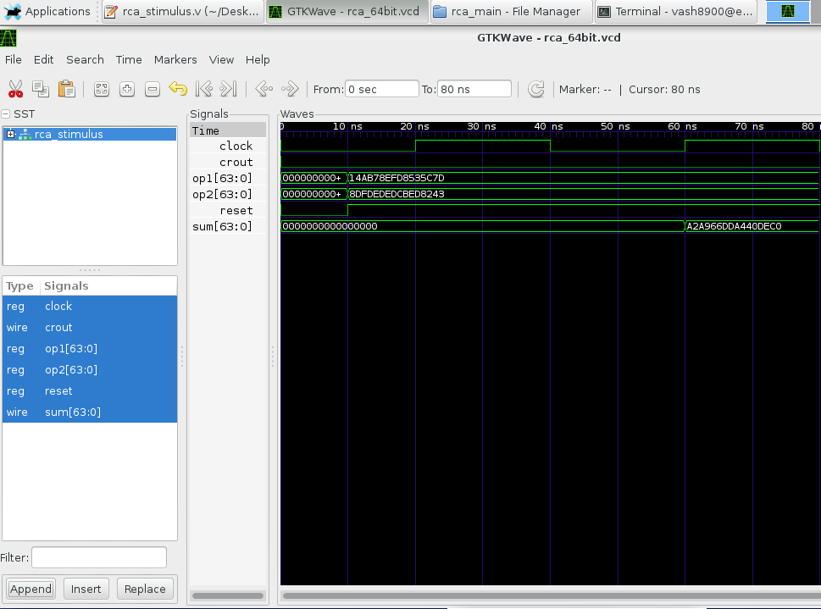

**Figure III.2b**: RTL simulation waveform that contains test case #2 for CLA-2L

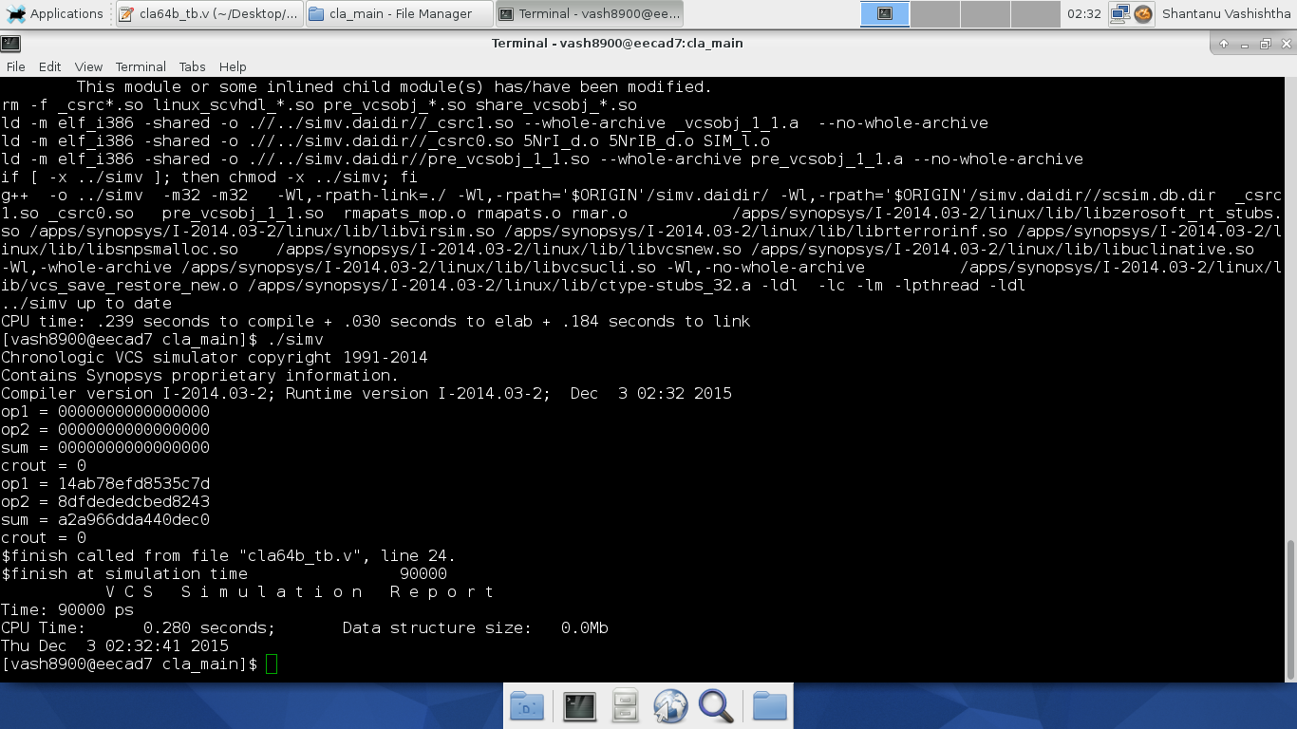

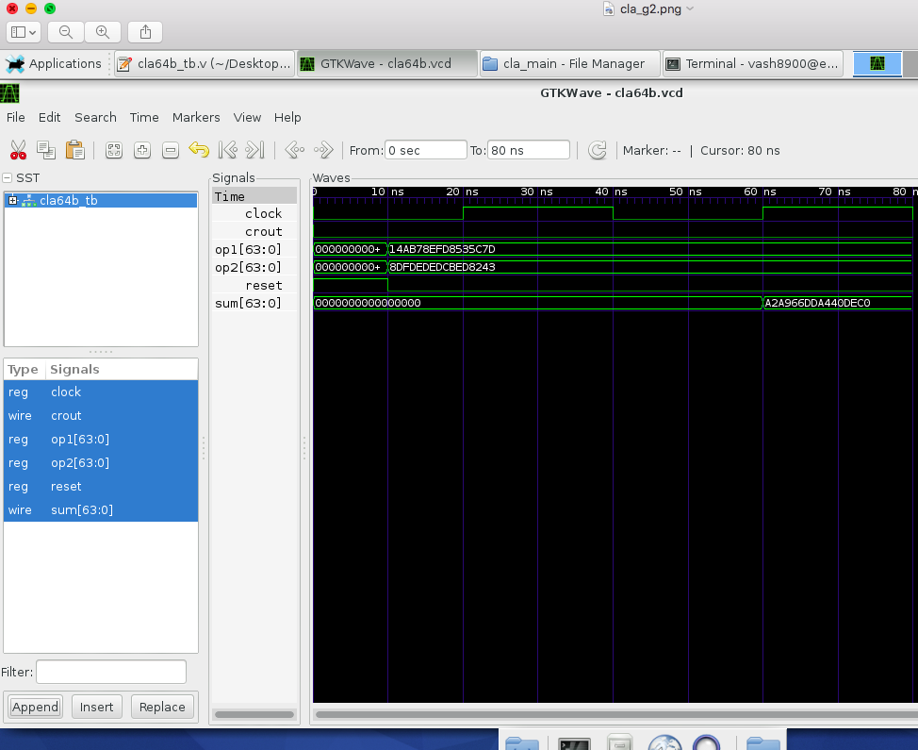

**Figure III.2c**: RTL simulation waveform that contains test case #2 for CSA-EQG

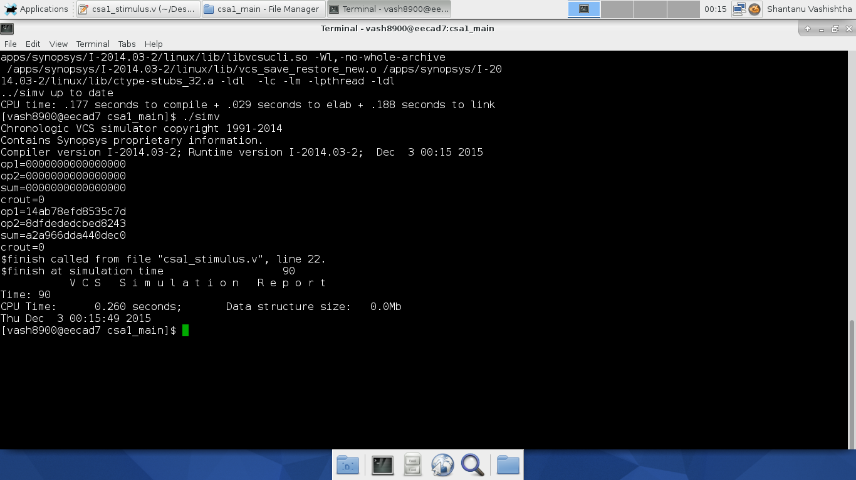

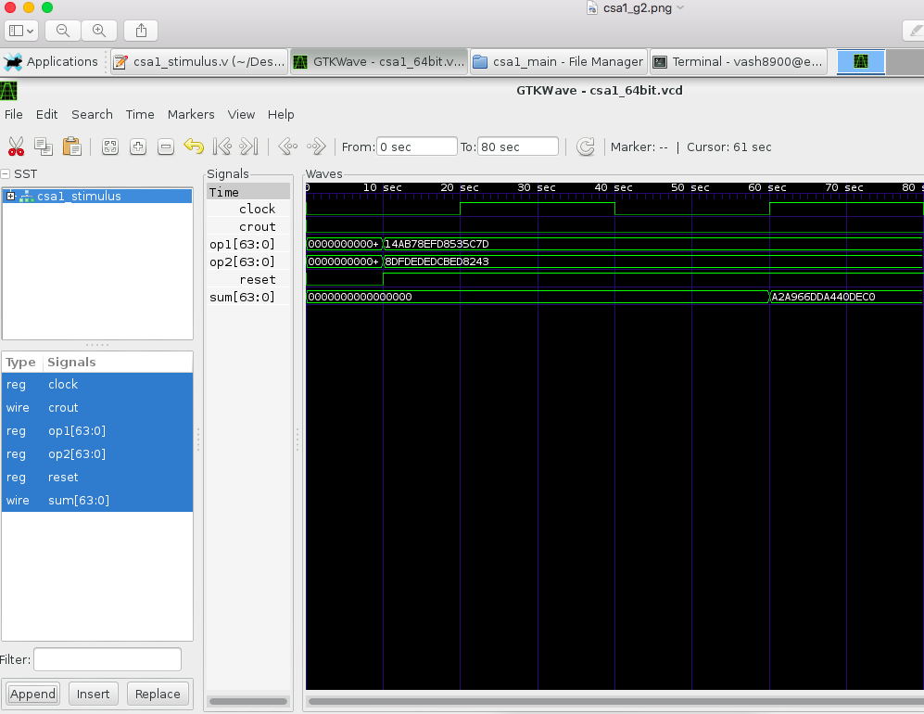

**Figure III.2d**: RTL simulation waveform that contains test case #2 for CSA-UEQG

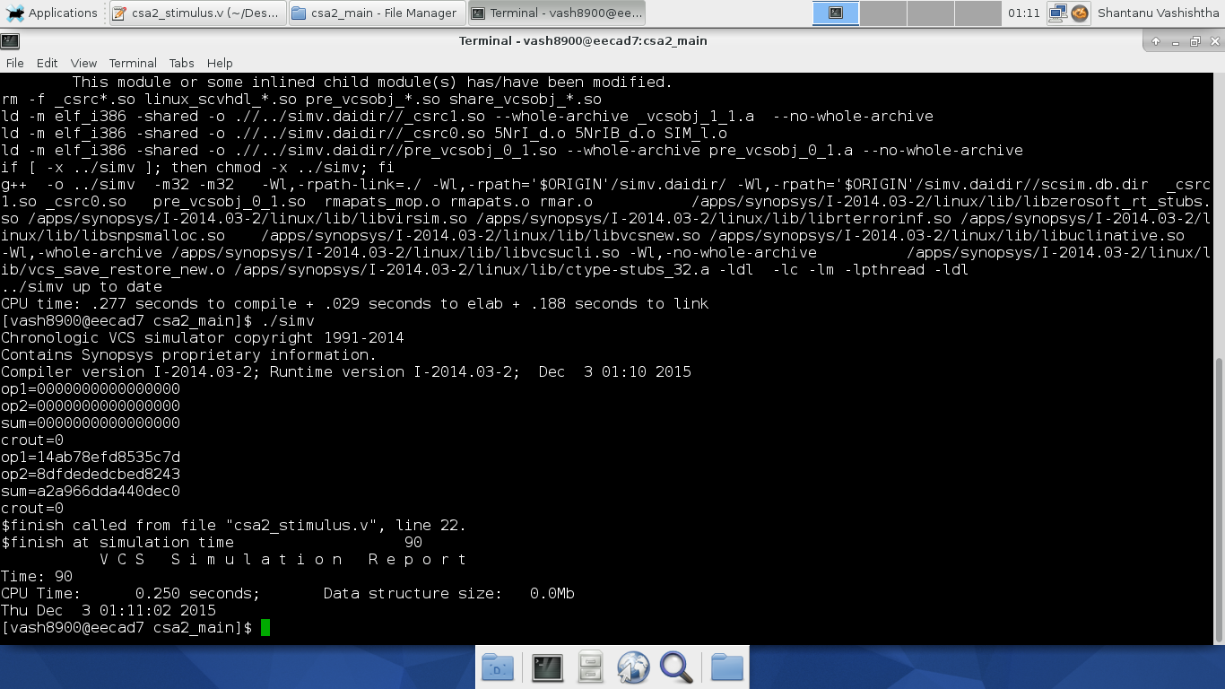

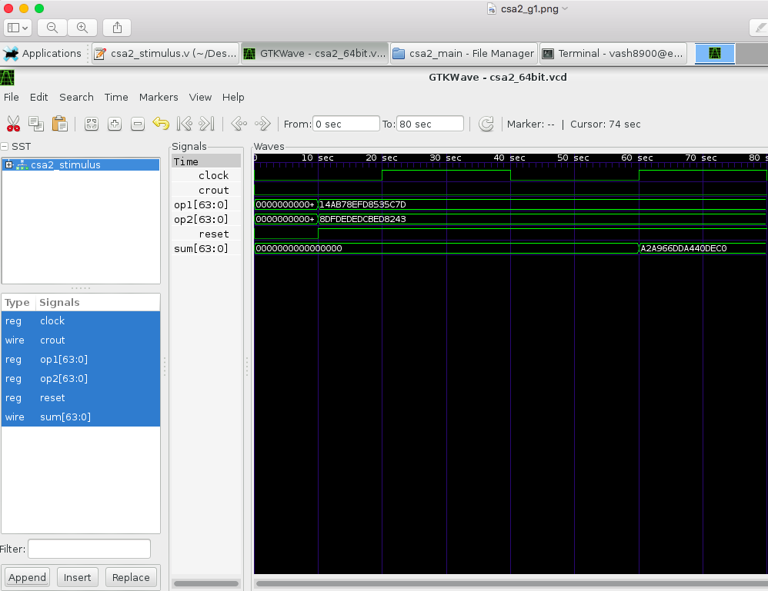

**Figure III.3a**: RTL simulation waveform that contains test case #3 for RCA

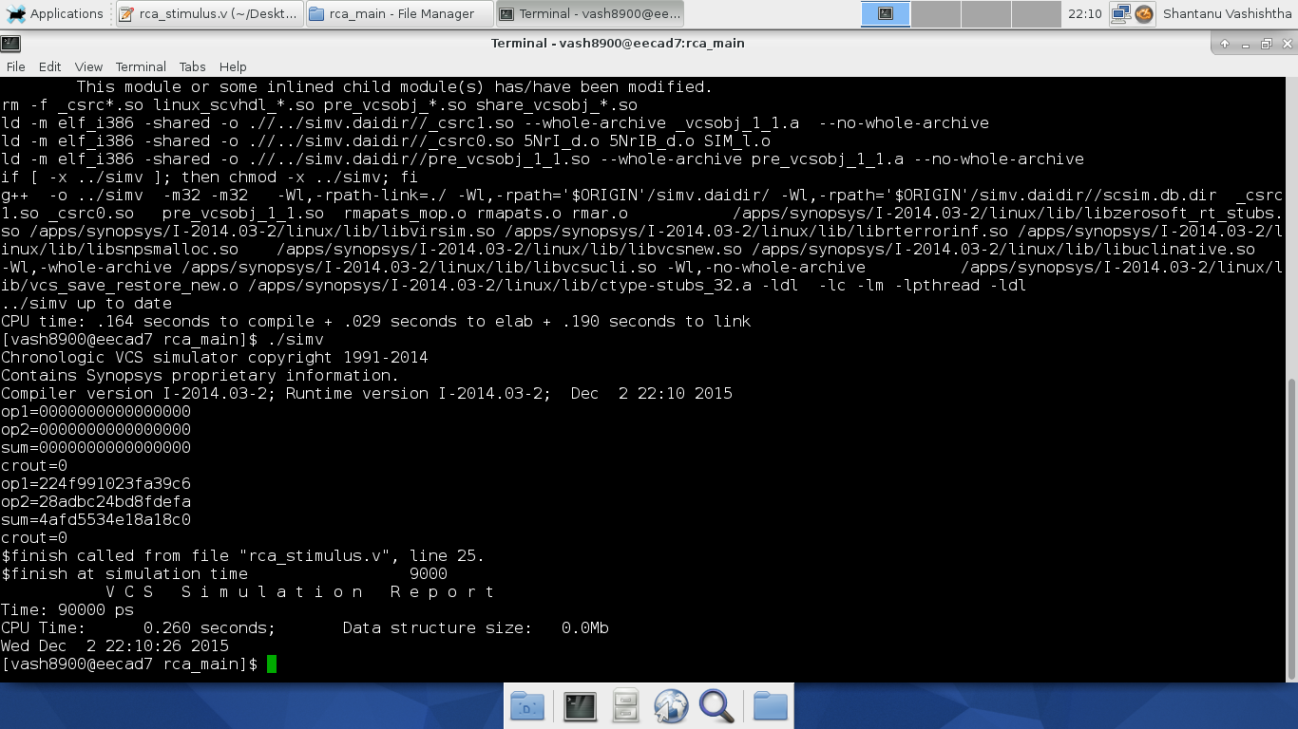

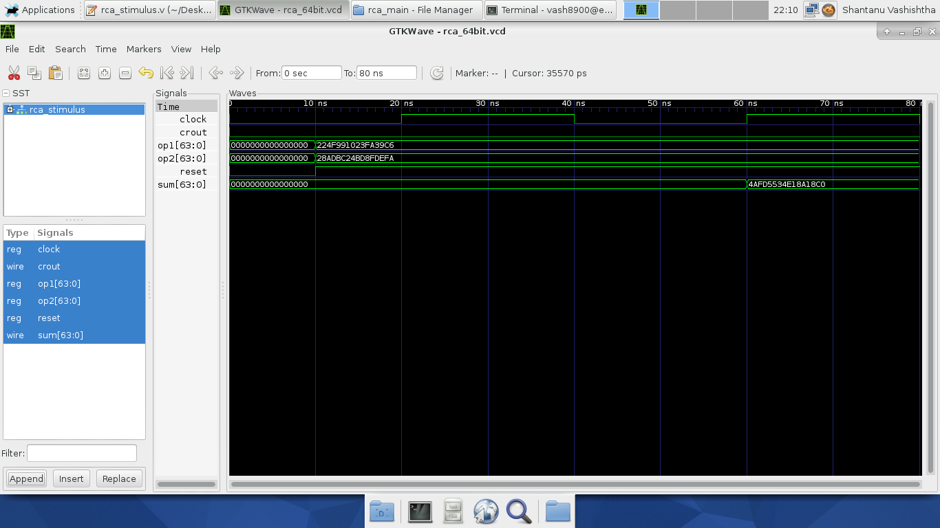

**Figure III.3b**: RTL simulation waveform that contains test case #3 for CLA-2L

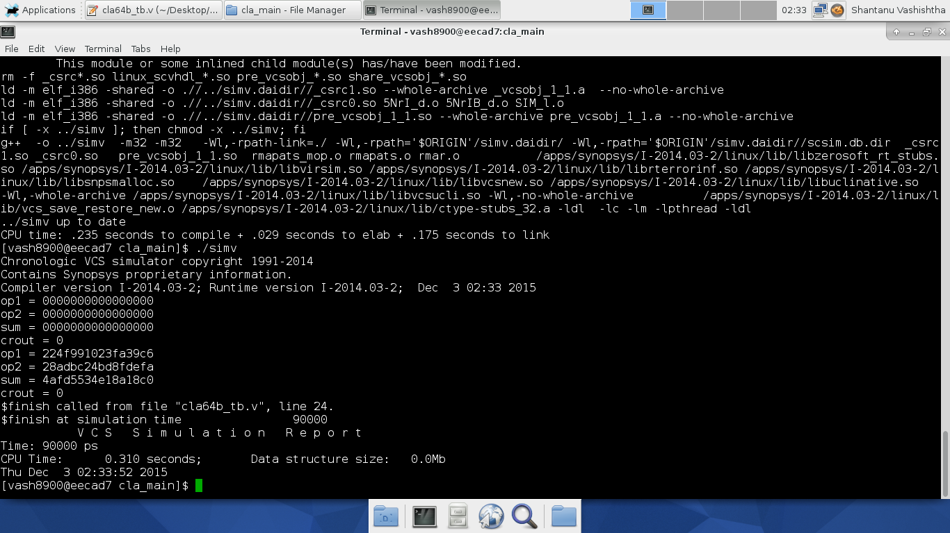

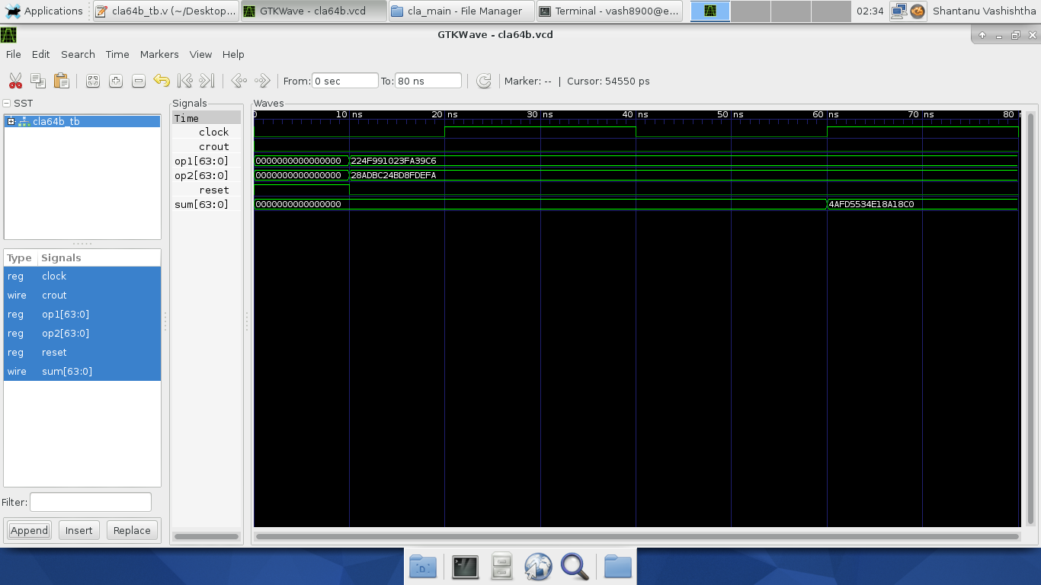

**Figure III.3c**: RTL simulation waveform that contains test case #3 for CSA-EQG

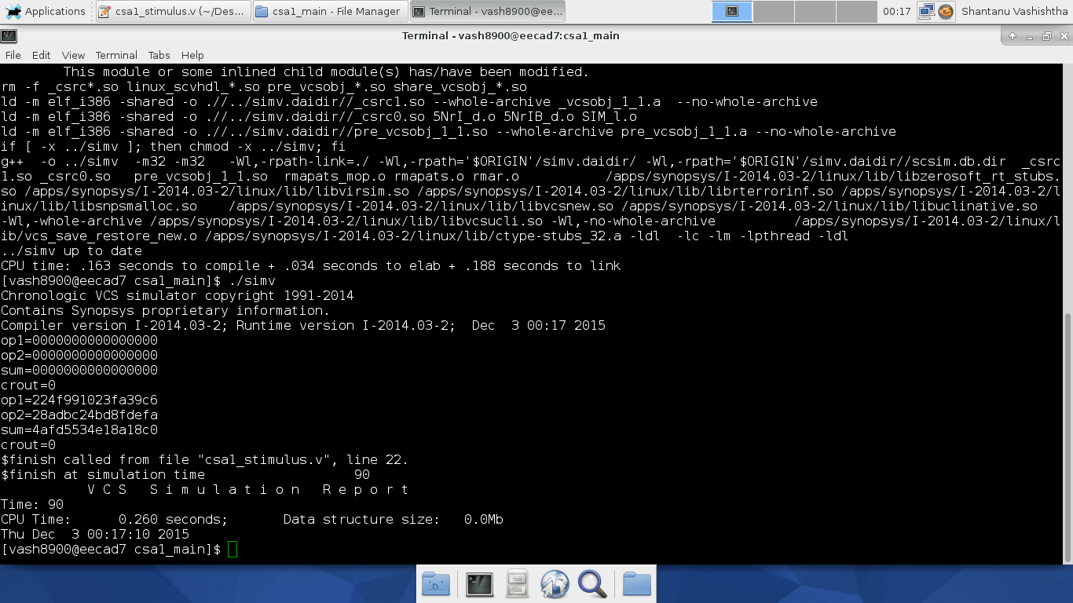

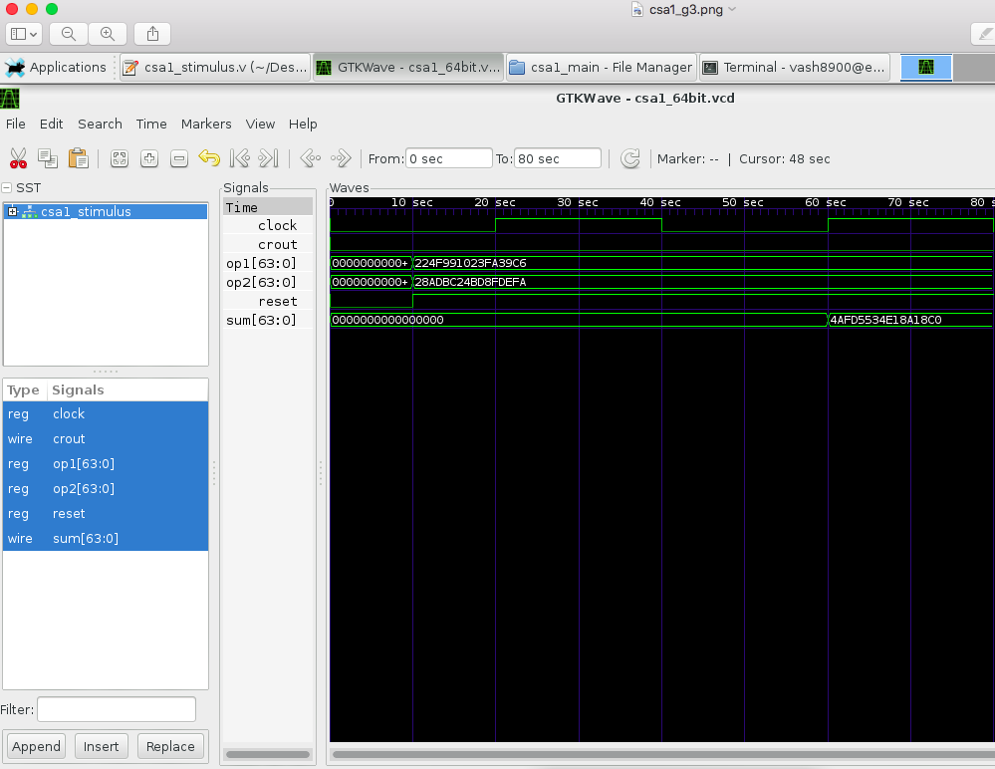

**Figure III.3d**: RTL simulation waveform that contains test case #3 for CSA-UEQG

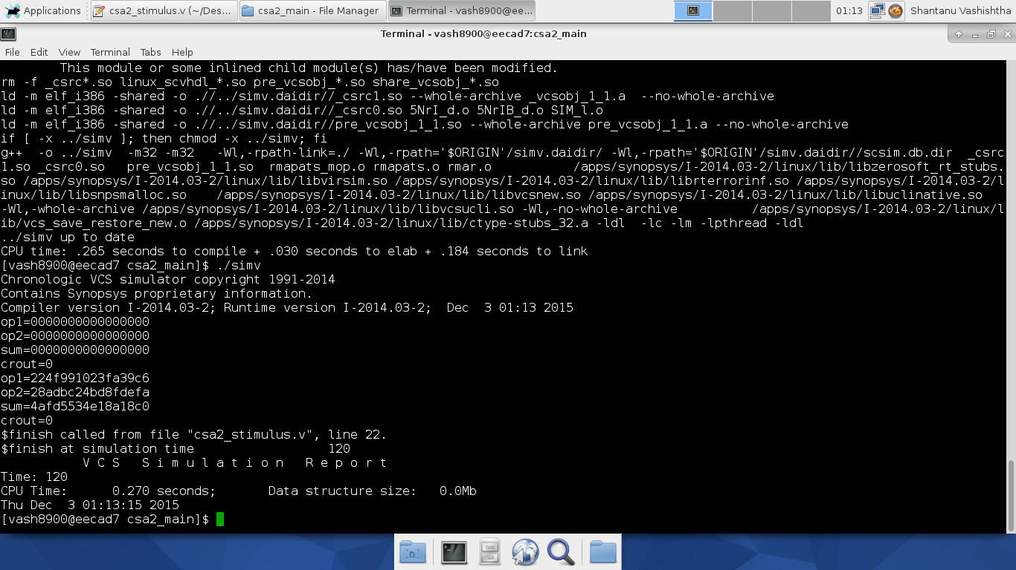

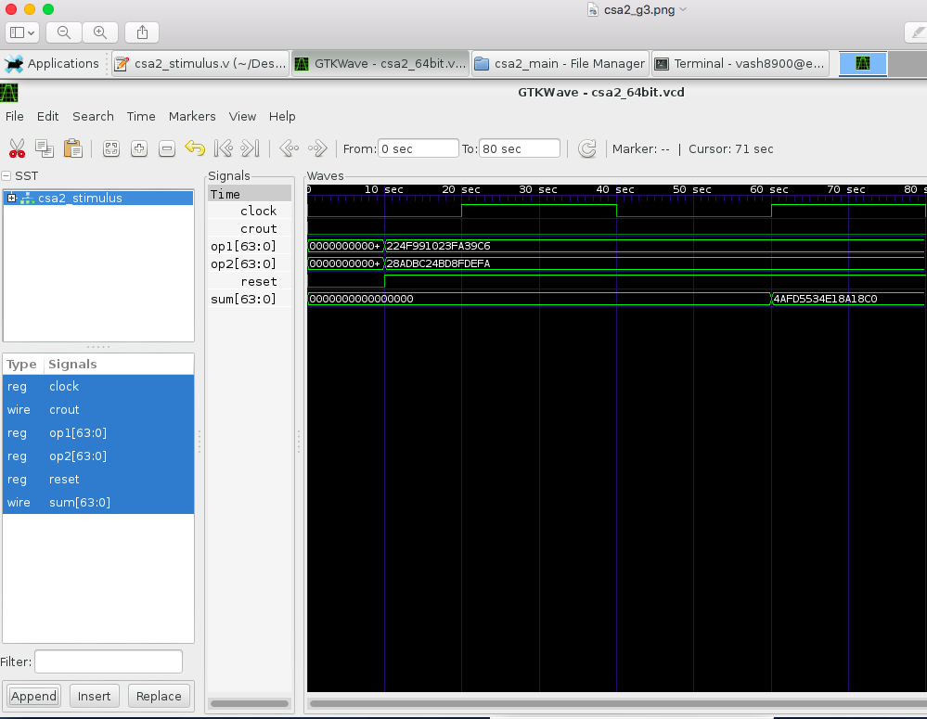

**Figure III.4a**: RTL simulation waveform that contains test case #4 for RCA

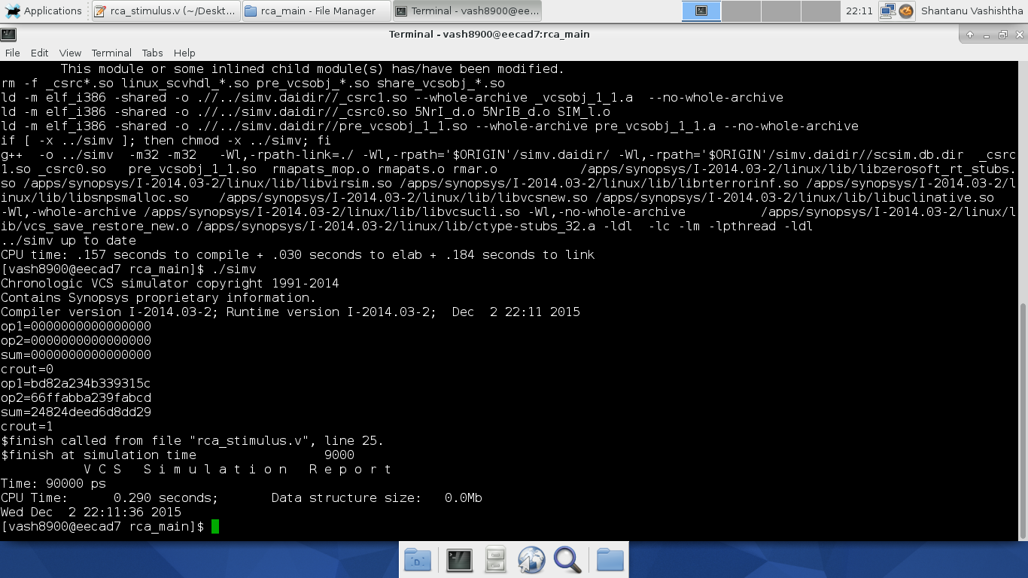

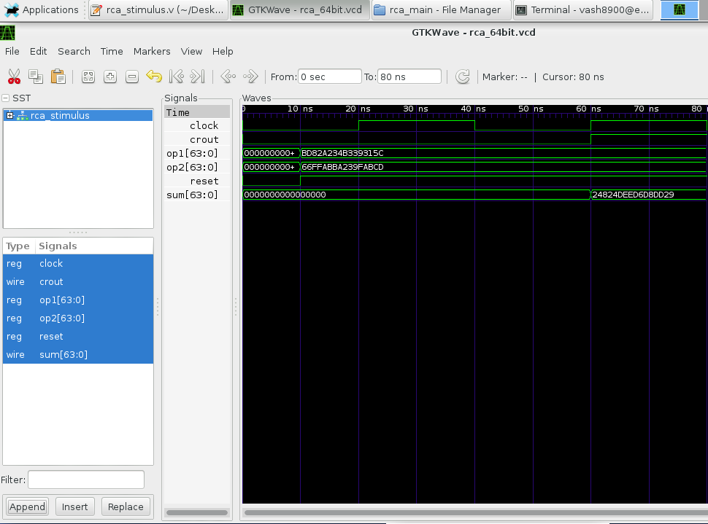

**Figure III.4b**: RTL simulation waveform that contains test case #4 for CLA-2L

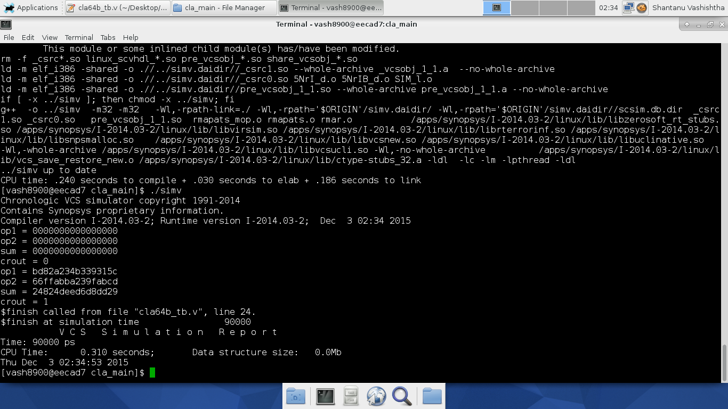

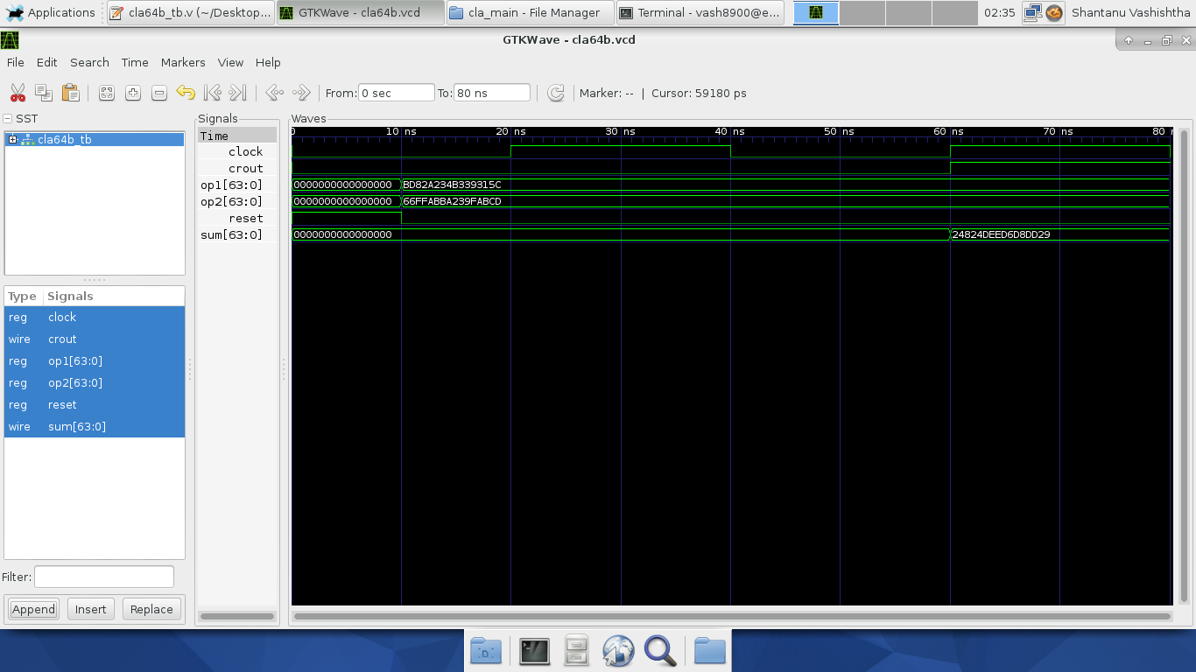

**Figure III.4c**: RTL simulation waveform that contains test case #4 for CSA-EQG

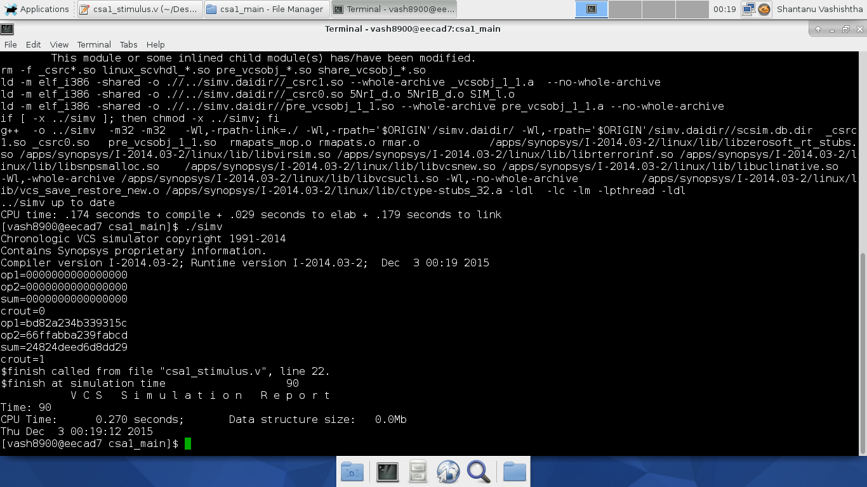

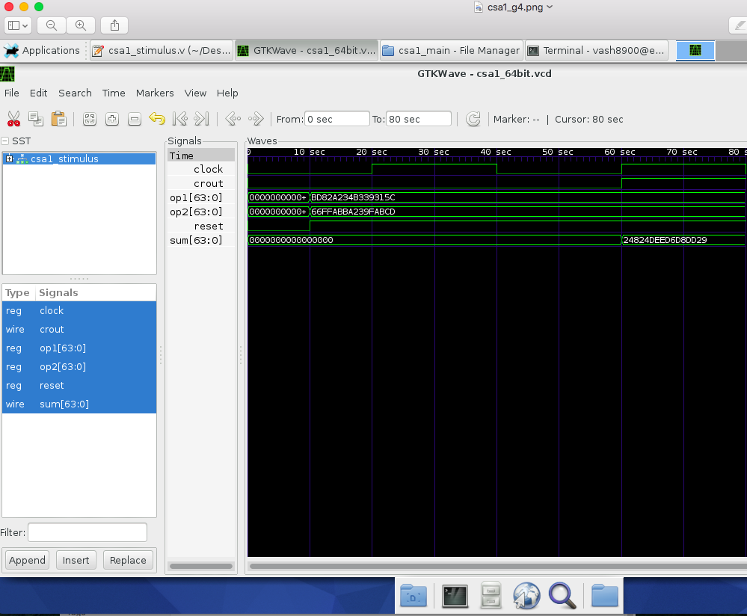

**Figure III.4d**: RTL simulation waveform that contains test case #4 for CSA-UEQG

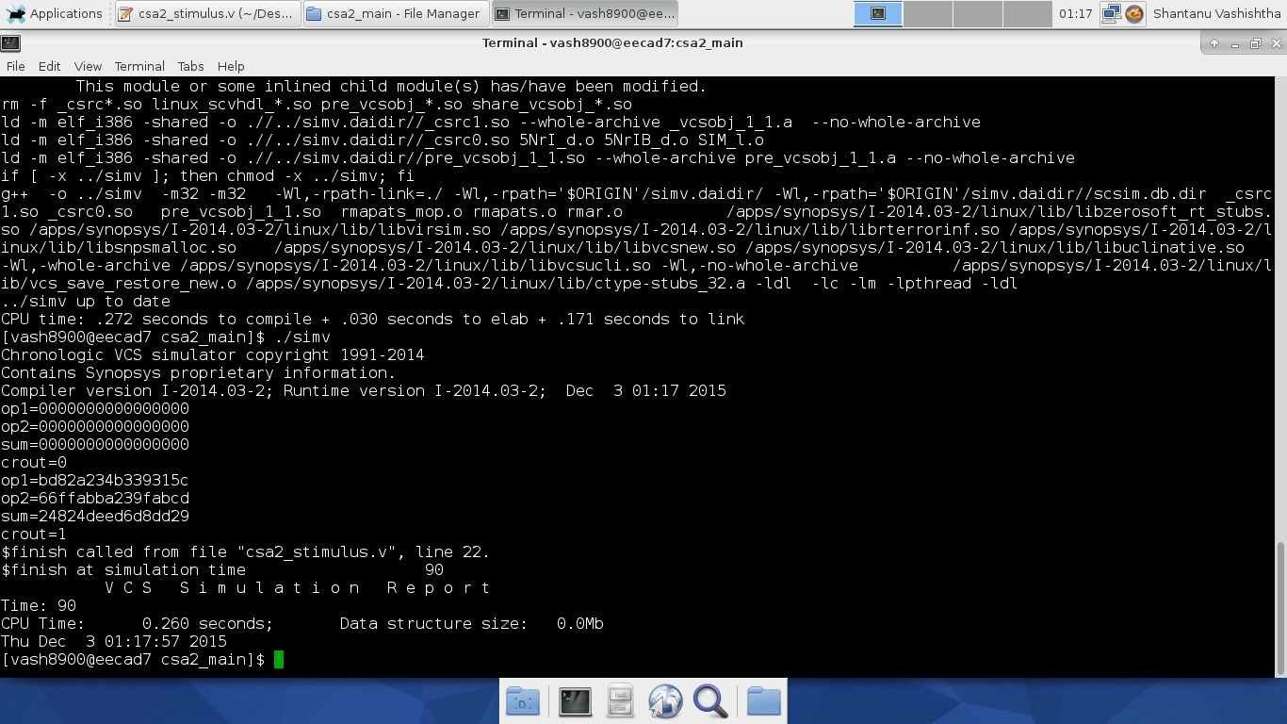

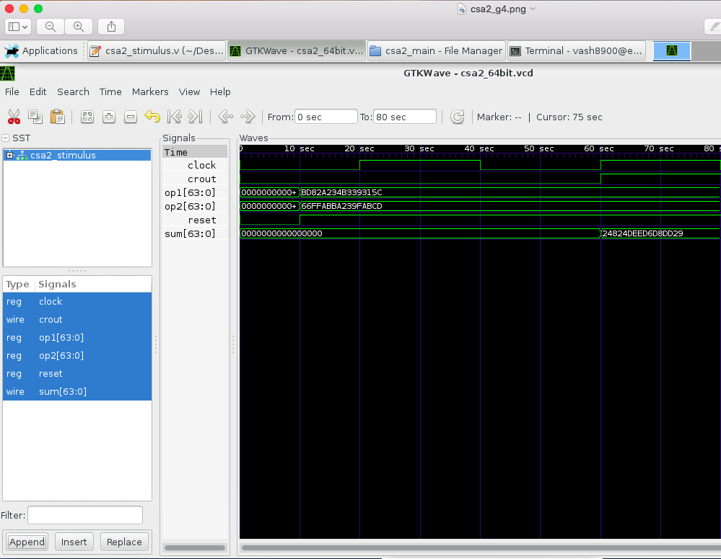

**Figure III.5a**: RTL simulation waveform that contains test case #5 for RCA

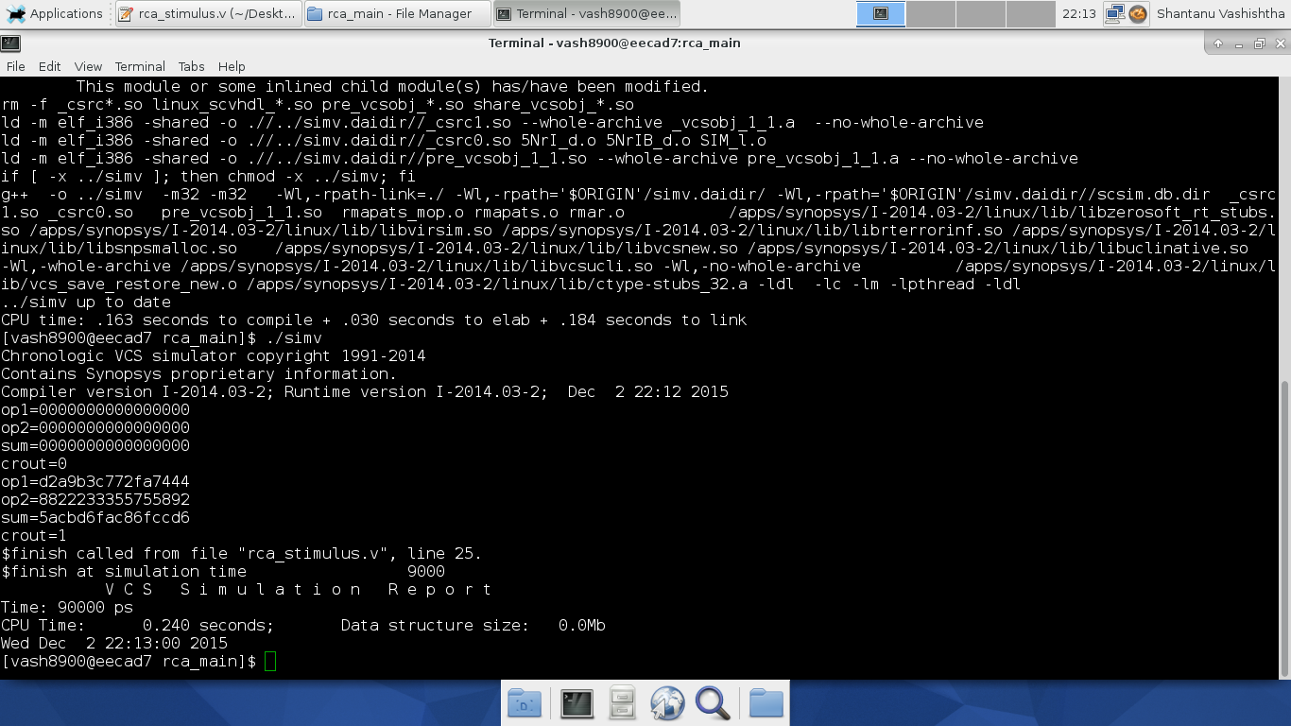

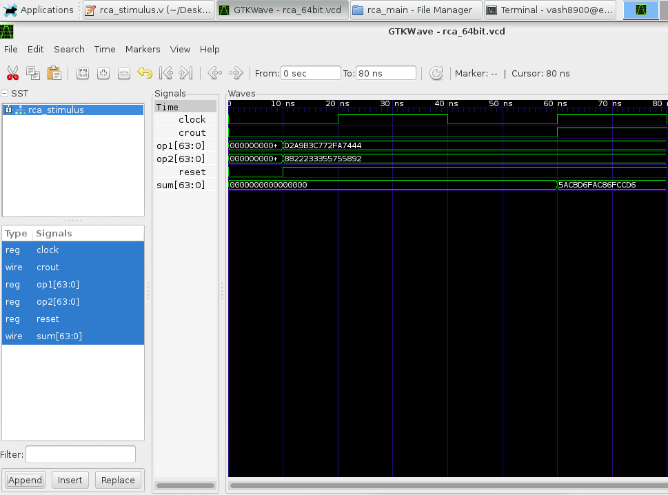

**Figure III.5b**: RTL simulation waveform that contains test case #5 for CLA-2L

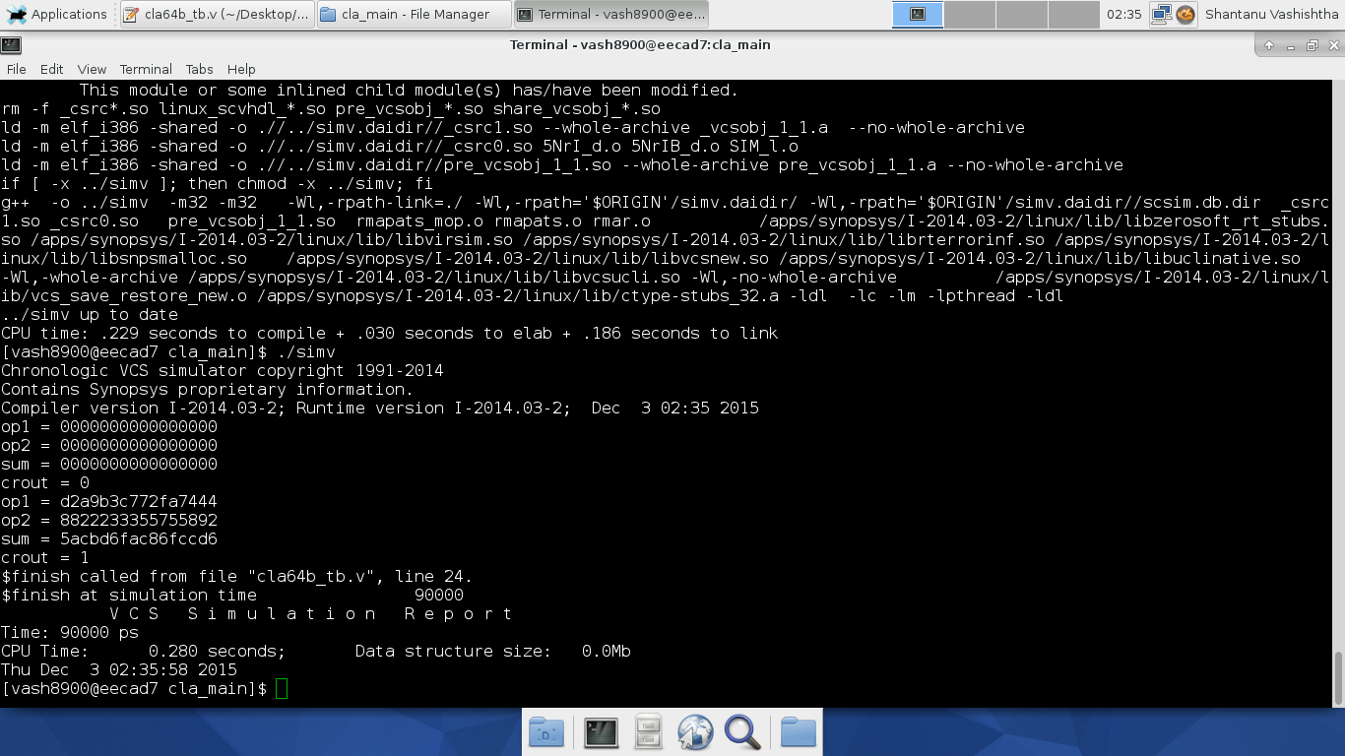

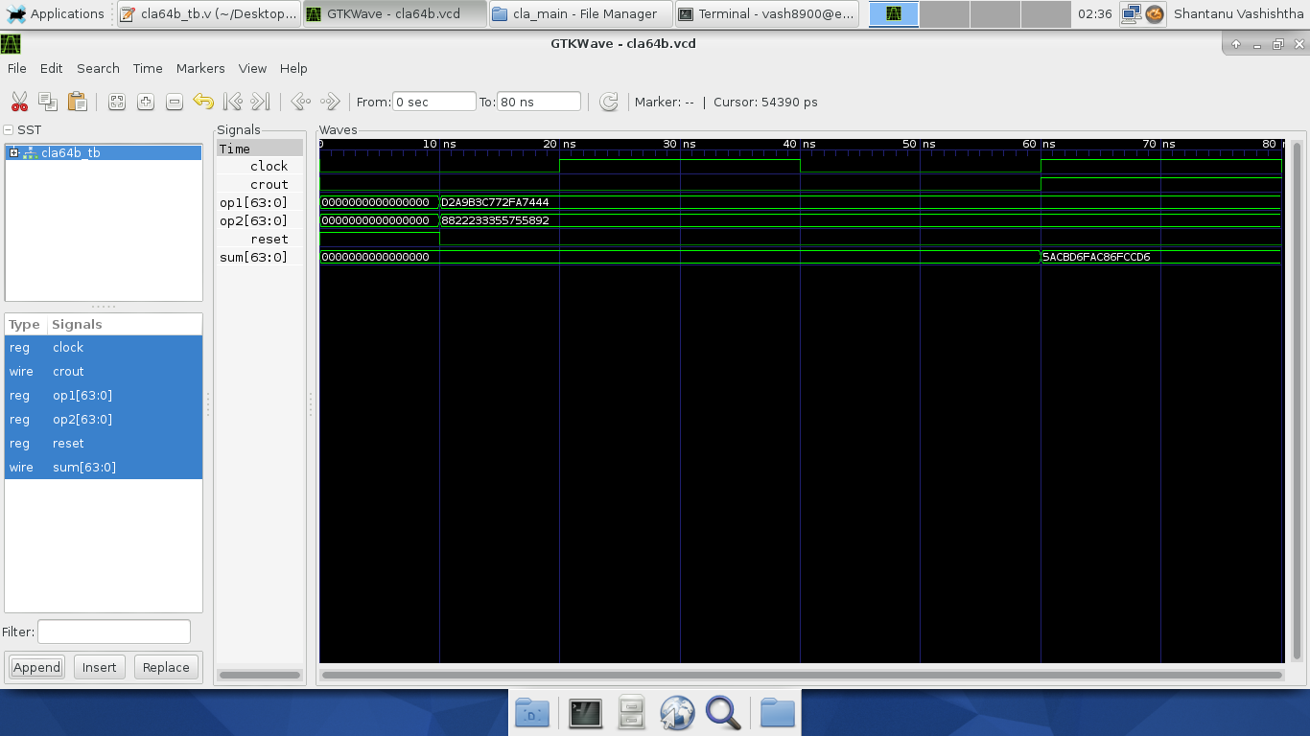

**Figure III.5c**: RTL simulation waveform that contains test case #5 for CSA-EQG

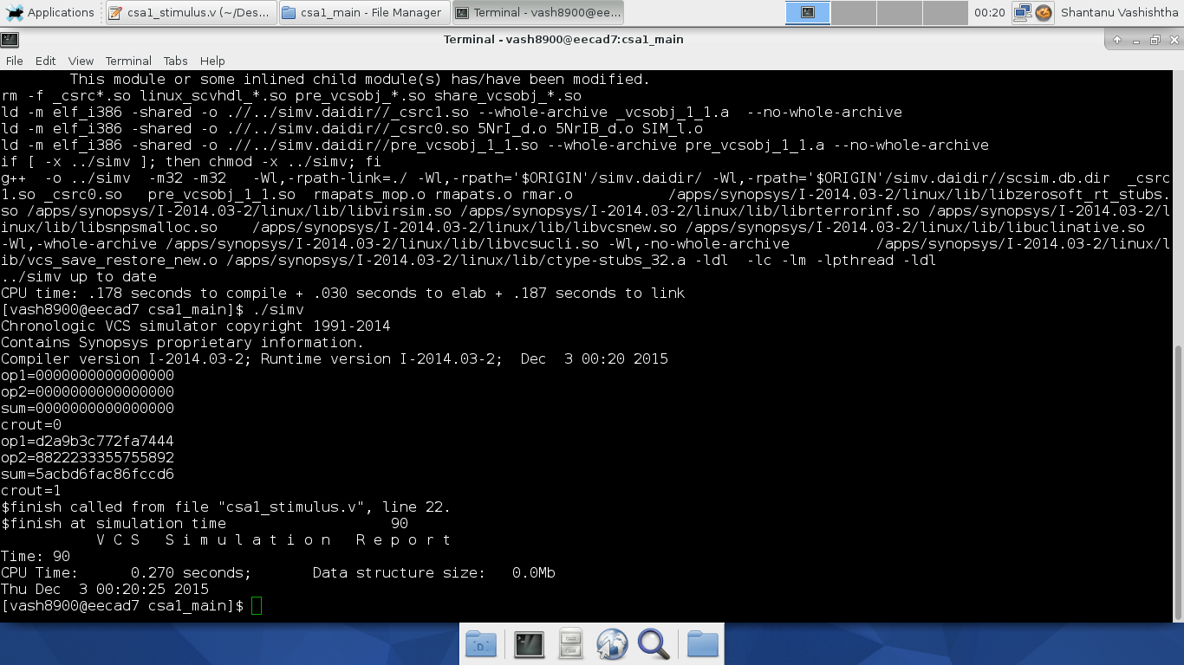

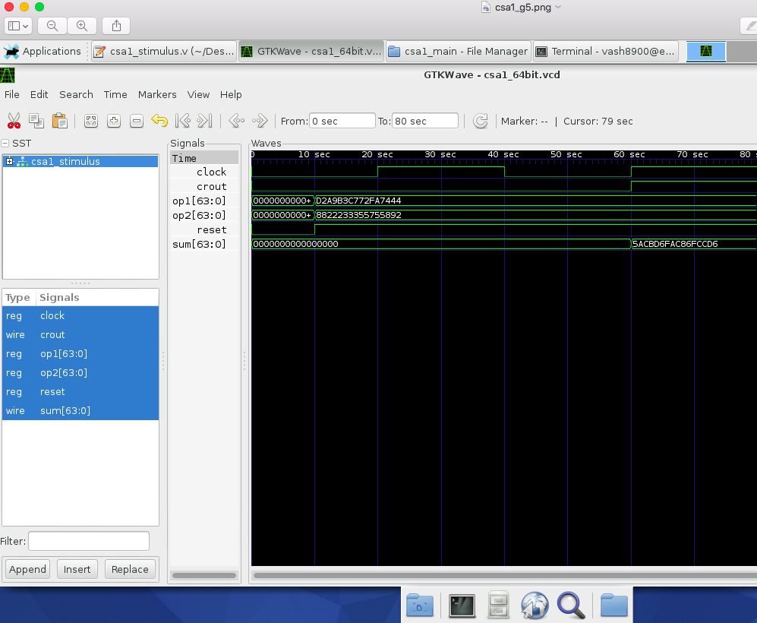

**Figure III.5d**: RTL simulation waveform that contains test case #5 for CSA-UEQG

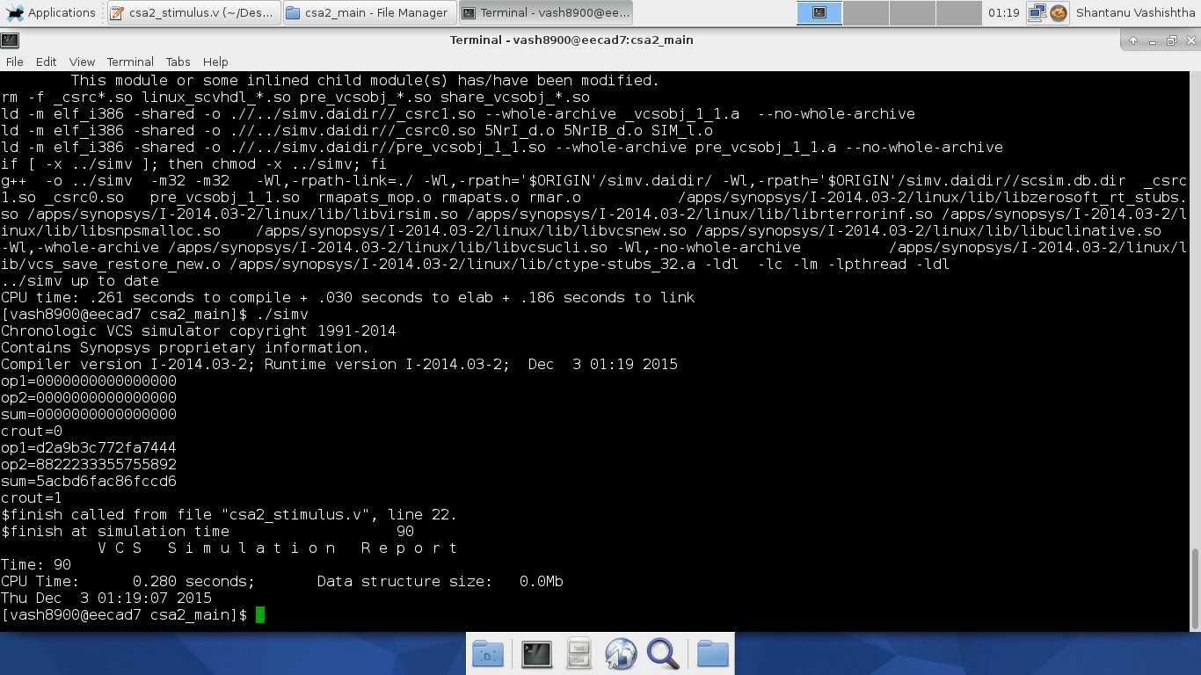

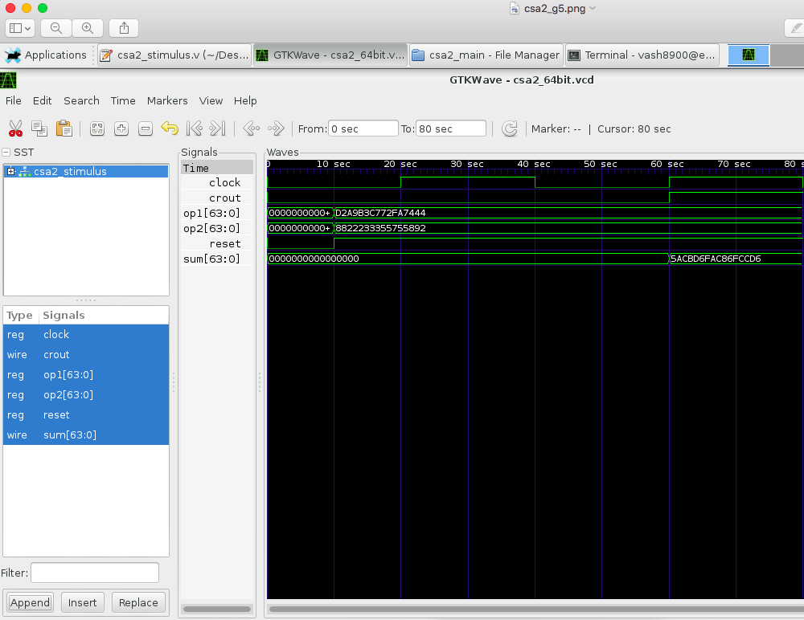

**Figure III.6a**: RTL simulation waveform that contains test case #6 for RCA

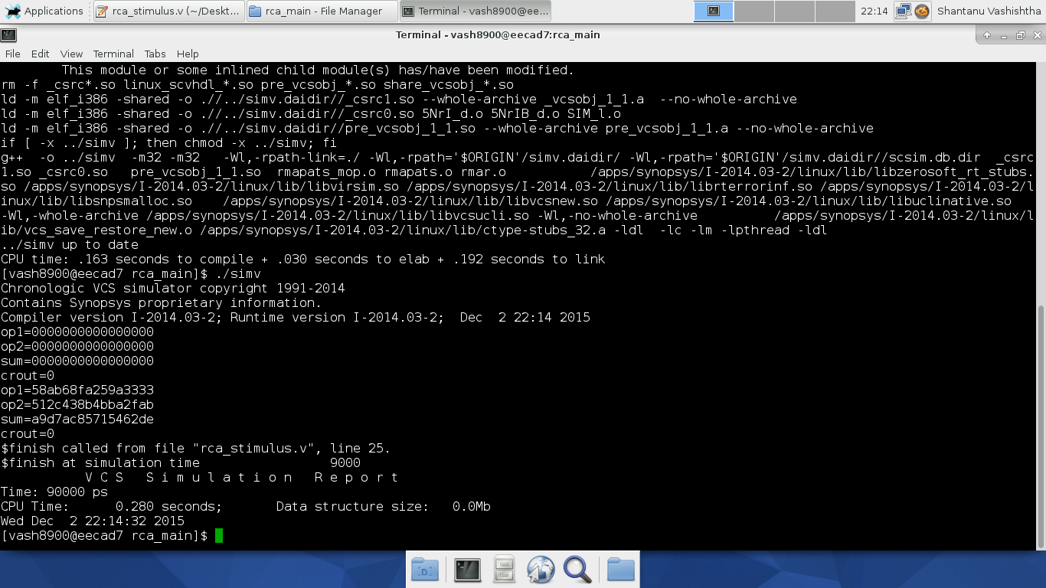

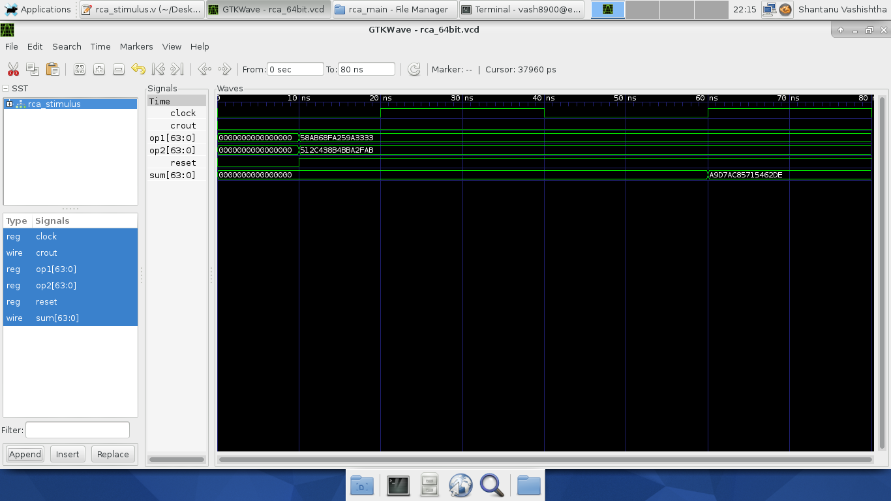

**Figure III.6b**: RTL simulation waveform that contains test case #6 for CLA-2L

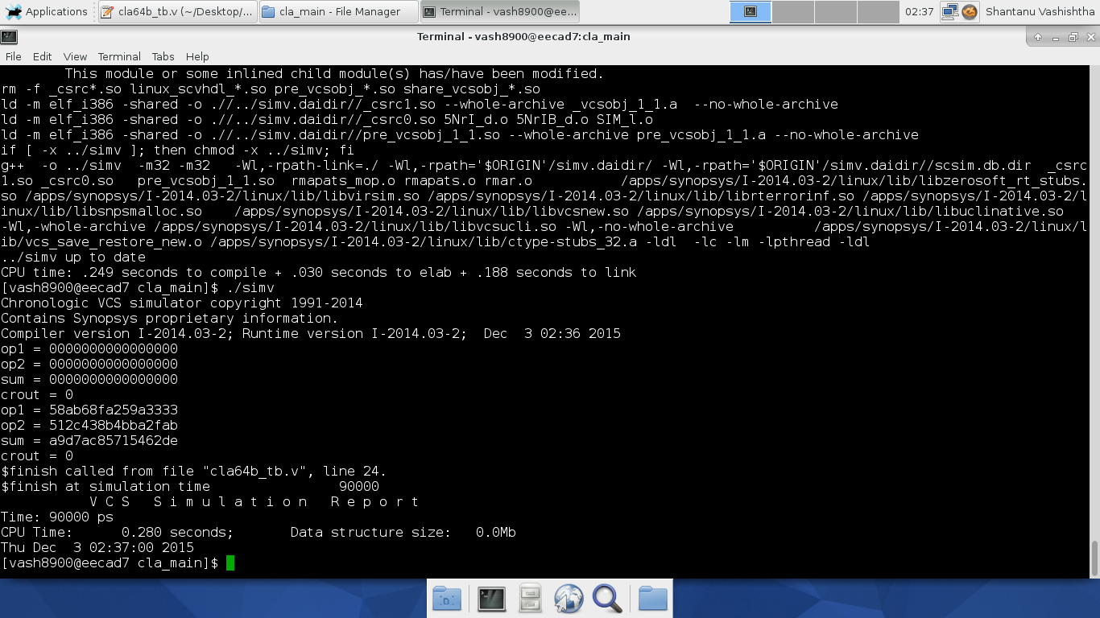

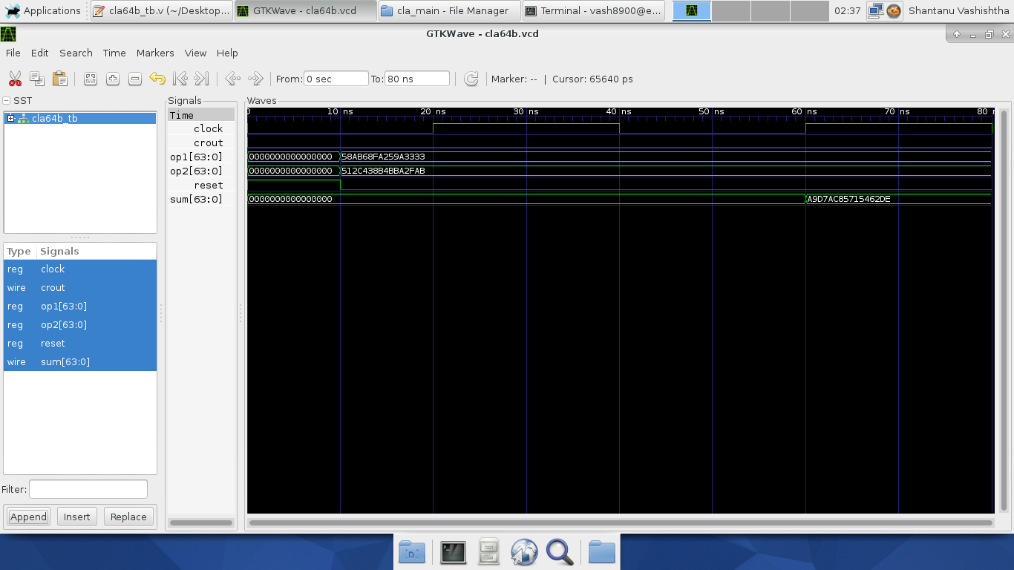

**Figure III.6c**: RTL simulation waveform that contains test case #6 for CSA-EQG

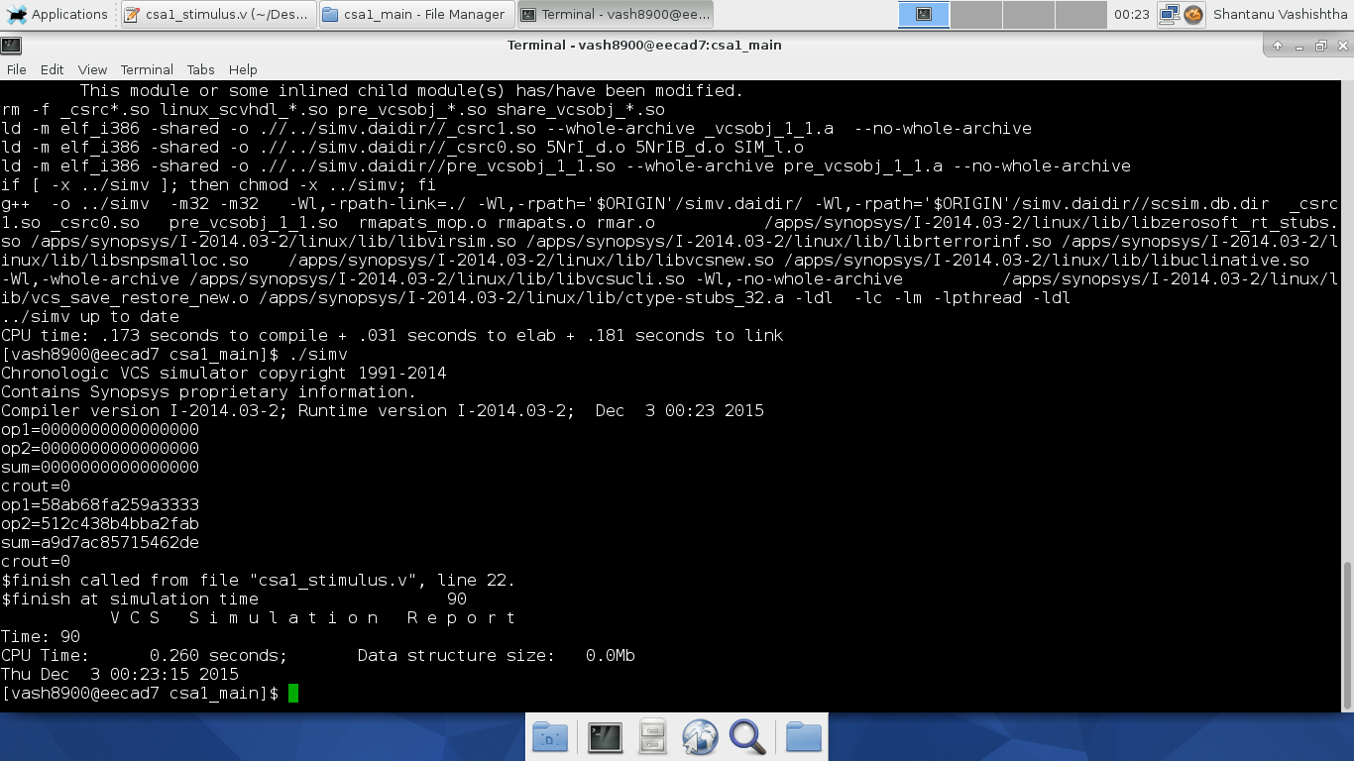

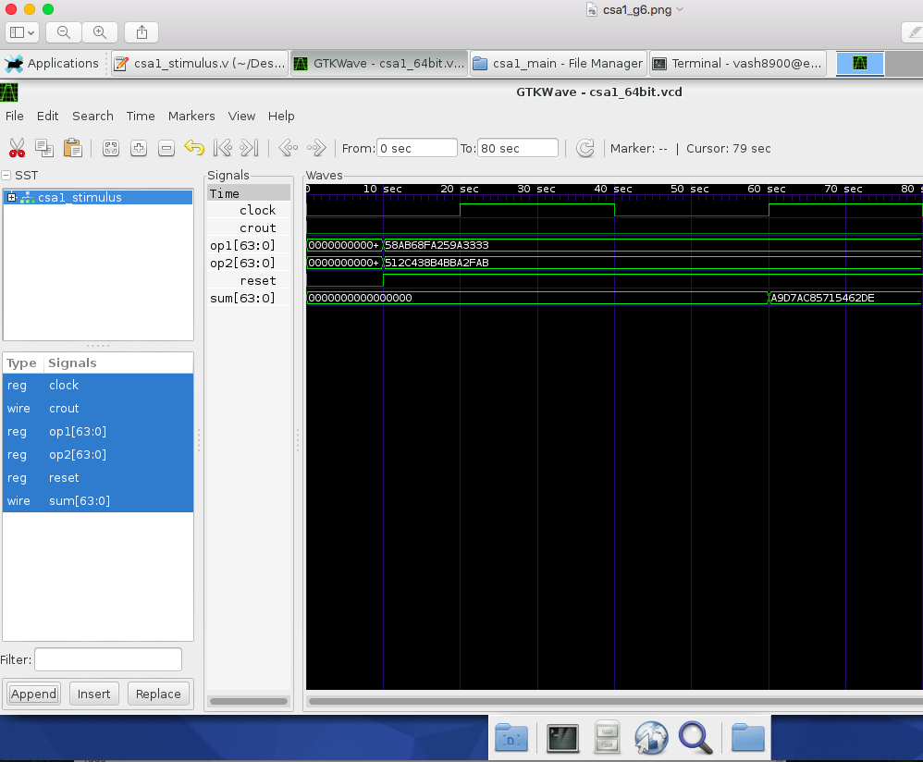

**Figure III.6d**: RTL simulation waveform that contains test case #6 for CSA-UEQG

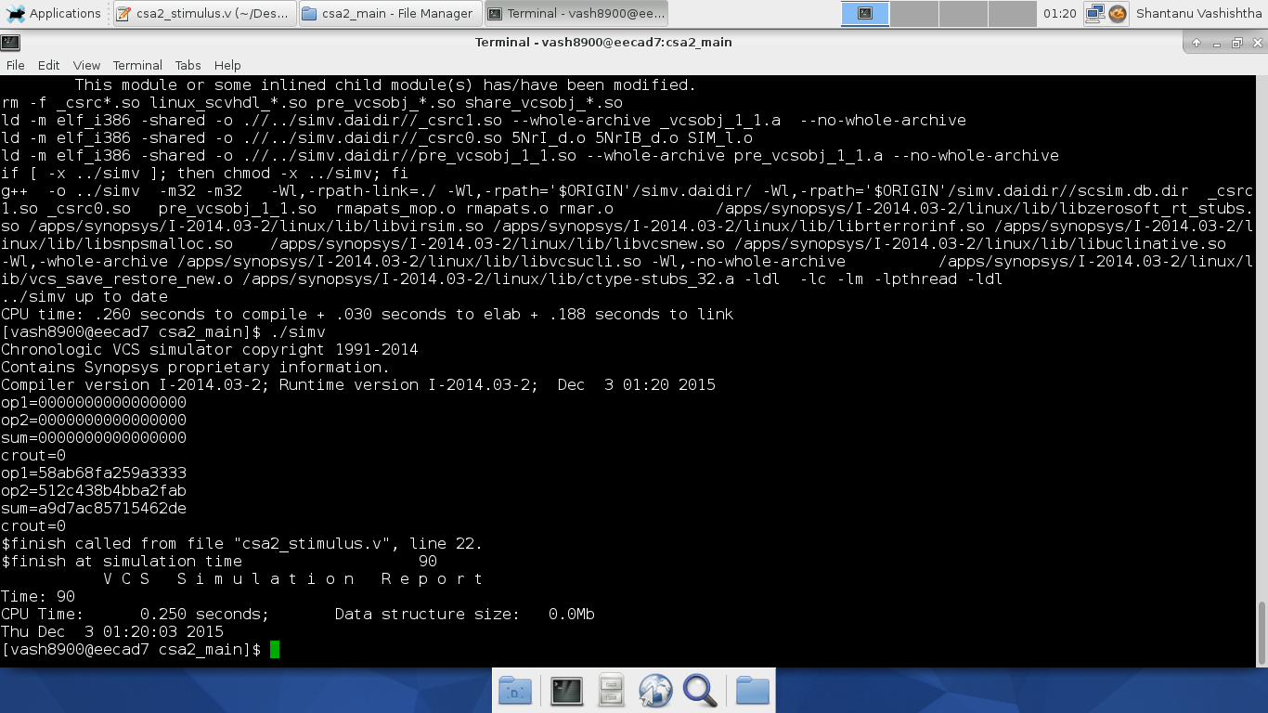

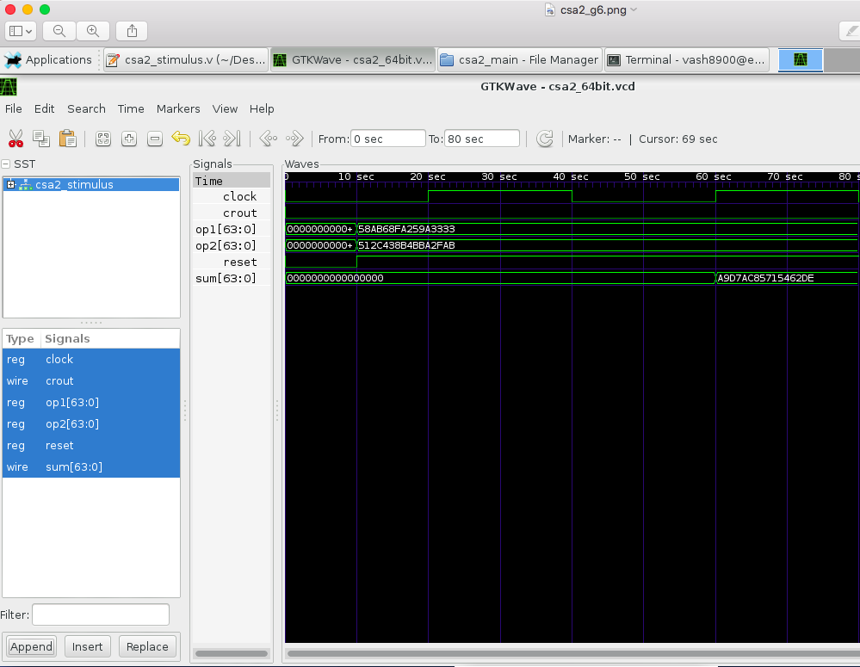

**IV. Synthesis and Optimizations**

From the data given in the tables below for each of the six cases, it can be seen that the last value of every table is the value at which the circuit is most optimized.

## Table IV.1: Synthesis Constraints and Results for RCA

|  |  |  |  |  |  |
| --- | --- | --- | --- | --- | --- |
| **Trial** | **Design Constraint Settings**  (such as area, clock, delay, etc.) | | **Results after Synthesis**  (such as area, time slack, power, etc.) | | |
| **#** | Clock(ns) | Area | Time Slack(ns) | Area | Power(mW) |
| 1. | 10.00 | 2000 | -1.93 | 2570 | 6.9598 |
| 2. | 14.00 | 2000 | 0.01 | 2745 | 7.0992 |
| 3. | 16.00 | 2000 | 0.01 | 2614.50 | 6.3906 |
| 4. | 8.00 | 2000 | -3.92 | 2600.50 | 8.9523 |
| 5. | 20.00 | 2000 | 0.10 | 2007.00 | 2.7995 |
| 6. | 12.04 | 2000 | 0.00 | 2912.00 | 7.9952 |

## Table IV.2: Synthesis Constraints and Results for CLA-2L

|  |  |  |  |  |  |
| --- | --- | --- | --- | --- | --- |
| **Trial** | **Design Constraint Settings**  (such as area, clock, delay, etc.) | | **Results after Synthesis**  (such as area, time slack, power, etc.) | | |
| **#** | Clock(ns) | Area | Time Slack(ns) | Area | Power(mW) |
| 1. | 8.00 | 2000 | 0.49 | 2725.00 | 8.1518 |
| 2. | 10.00 | 2000 | 2.49 | 2725.00 | 6.5215 |
| 3. | 2.00 | 2000 | -1.87 | 3863.50 | 54.8763 |
| 4. | 1.50 | 2000 | -2.09 | 3995.50 | 73.8552 |
| 5. | 4.50 | 2000 | 0.00 | 3429.50 | 23.9543 |
| 6. | 3.70 | 2000 | 0.00 | 3901.50 | 29.4414 |

## Table IV.3: Synthesis Constraints and Results for CSA-EQG

|  |  |  |  |  |  |
| --- | --- | --- | --- | --- | --- |
| **Trial** | **Design Constraint Settings**  (such as area, clock, delay, etc.) | | **Results after Synthesis**  (such as area, time slack, power, etc.) | | |
| **#** | Clock(ns) | Area | Time Slack(ns) | Area | Power(mW) |
| 1. | 7.00 | 2000 | 0.01 | 3061.00 | 15.4426 |
| 2. | 3.00 | 2000 | -2.87 | 3214.00 | 33.9643 |
| 3. | 10.00 | 2000 | 0.03 | 2889.00 | 10.8905 |
| 4. | 4.00 | 2000 | -1.97 | 3087.50 | 23.6289 |
| 5. | 8.00 | 2000 | 0.01 | 2973.00 | 13.4295 |
| 6. | 5.90 | 2000 | 0.00 | 3242.00 | 17.8778 |

## Table IV.4: Synthesis Constraints and Results for CSA-UEQG

|  |  |  |  |  |  |
| --- | --- | --- | --- | --- | --- |
| **Trial** | **Design Constraint Settings**  (such as area, clock, delay, etc.) | | **Results after Synthesis**  (such as area, time slack, power, etc.) | | |
| **#** | Clock(ns) | Area | Time Slack(ns) | Area | Power(mW) |
| 1. | 3.00 | 2000 | -1.20 | 3332.50 | 33.0327 |
| 2. | 5.00 | 2000 | 0.00 | 3006.00 | 19.8607 |
| 3. | 6.00 | 2000 | 0.00 | 2909.00 | 18.0473 |
| 4. | 1.00 | 2000 | -3.09 | 3526.50 | 111.0424 |
| 5. | 10.00 | 2000 | 2.06 | 2498.00 | 6.5036 |
| 6. | 4.10 | 2000 | 0.00 | 3368.00 | 23.0970 |

**Figure IV.1**: Area versus Delay of RCA

**Figure IV.2**: Area versus Delay of CLA-2L

**Figure IV.3**: Area versus Delay of CSA-EQG

**Figure IV.4**: Area versus Delay of CSA-UEQG

From the above Area Vs Delay graphs, it can be seen that the area of the adder changes with change in time period. If clock period increases, then area will decrease. So, it can be concluded that area is inversely proportional to the clock period.

**V. Gate-Level (Post-synthesis) Dynamic Simulations/Tests**

From the below cases, it can be seen that maximum time is taken by the gates when the input fed is the case 1 of the table i.e. (op-1 : ffff_ffff_ffff_ffff and op2: 0000_0000_0000_0001). As it can be seen from the table, that to compute this value RCA takes 14.93 ns as the carry is rippled through each and every bit starting from 0th bit to 64th bit. Similar, is the case with every other adder.

**Table V.1** – Performance of Six Selected Test Cases

|  |  |  |  |  |  |  |
| --- | --- | --- | --- | --- | --- | --- |
| **Test Case** | **op1** (hex) | **op2 (**hex) | **Timings (Delays)** | | | |
| **RCA (ns)** | **CLA-2L (ns)** | **CSA-EQG**  **(ns)** | **CSA-UEQG**  **(ns)** |
| **1** | **ffff_ffff_**  **ffff_ffff** | **0000_0000_**  **0000_0001** | **14.93** | **4.2** | **6.32** | **4.47** |
| **2** | **14ab_78ef_**  **d853_5c7d** | **8dfd_eded_**  **cbed_8243** | **3.53** | **3.46** | **3.46** | **3.45** |
| **3** | **224f_9910_**  **23fa_39c6** | **28ad_bc24_**  **bd8f_18c0** | **3.54** | **3.71** | **4.06** | **3.92** |
| **4** | **bd82_a234_**  **b339_315c** | **66ff_abba_**  **239f_abcd** | **3.07** | **3.57** | **3.53** | **3.81** |
| **5** | **d2a9_b3c7_**  **72fa_7444** | **8822_2333_**  **5575_5892** | **3.5** | **3.64** | **3.51** | **3.31** |
| **6** | **58ab_68fa_**  **259a_3333** | **512c_438b_**  **4bba_2fab** | **3.36** | **3.33** | **3.18** | **3.2** |

**Figure V.1a**: Post-synthesis (dynamic) simulation waveform that contains test case #1 for RCA

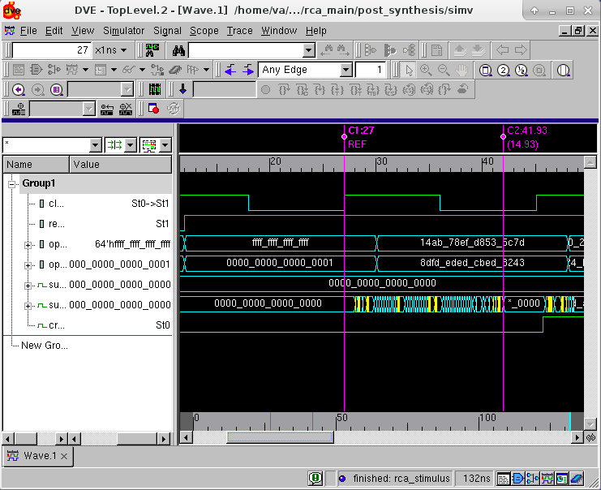

**Figure V.1b**: Post-synthesis (dynamic) simulation waveform that contains test case #1 for CLA-2L

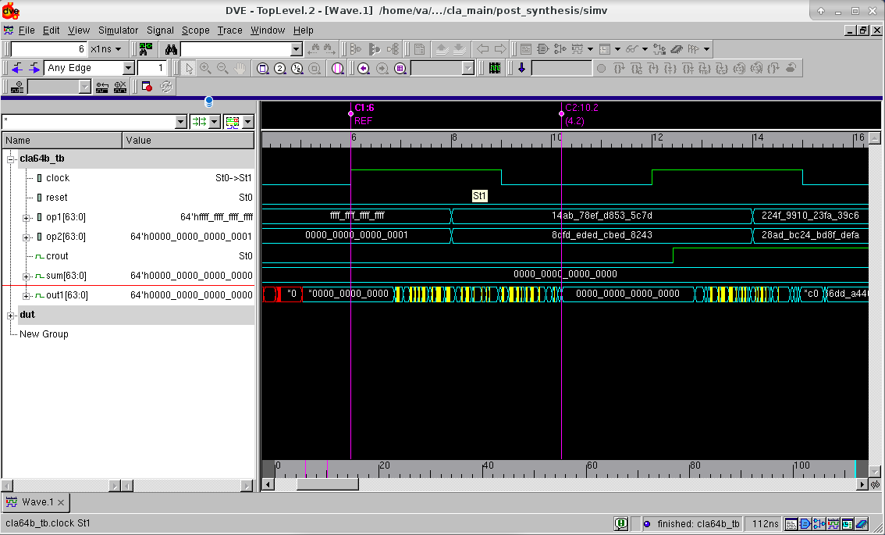

**Figure V.1c**: Post-synthesis (dynamic) simulation waveform that contains test case #1 for CSA-EQG

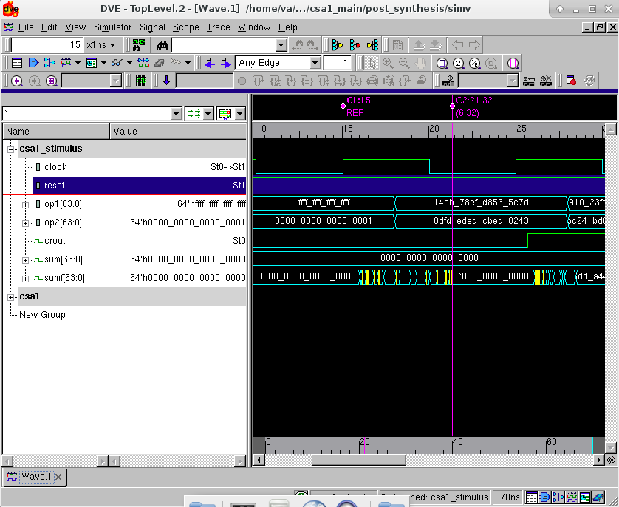

**Figure V.1d**: Post-synthesis (dynamic) simulation waveform that contains test case #1 for CSA-UEQG

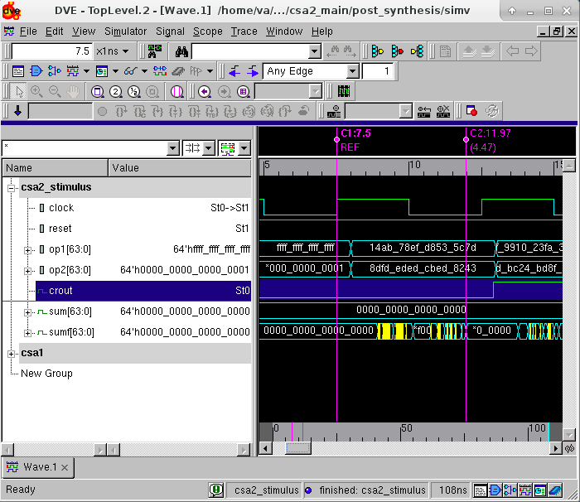

**Figure V.2a**: Post-synthesis (dynamic) simulation waveform that contains test case #2 for RCA

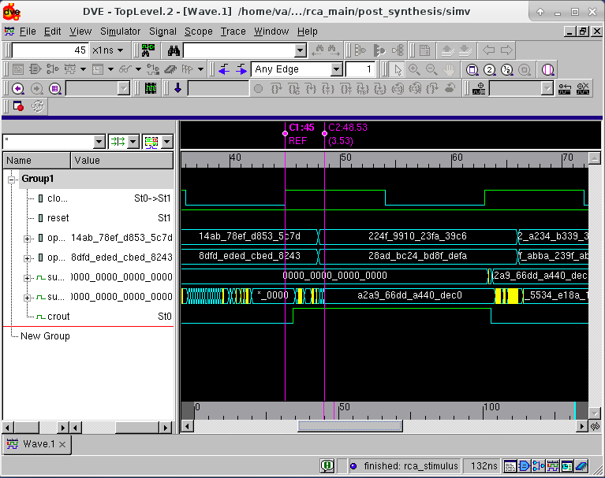

**Figure V.2b**: Post-synthesis (dynamic) simulation waveform that contains test case #2 for CLA-2L

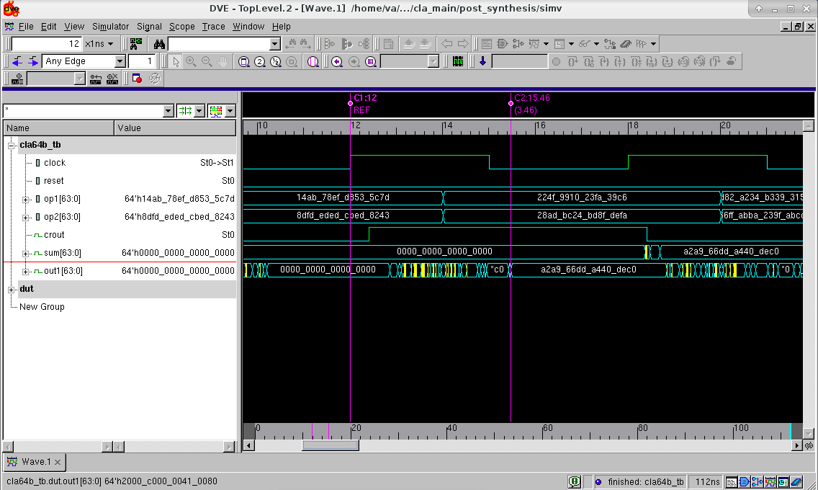

.

**Figure V.2c**: Post-synthesis (dynamic) simulation waveform that contains test case #2 for CSA-EQG

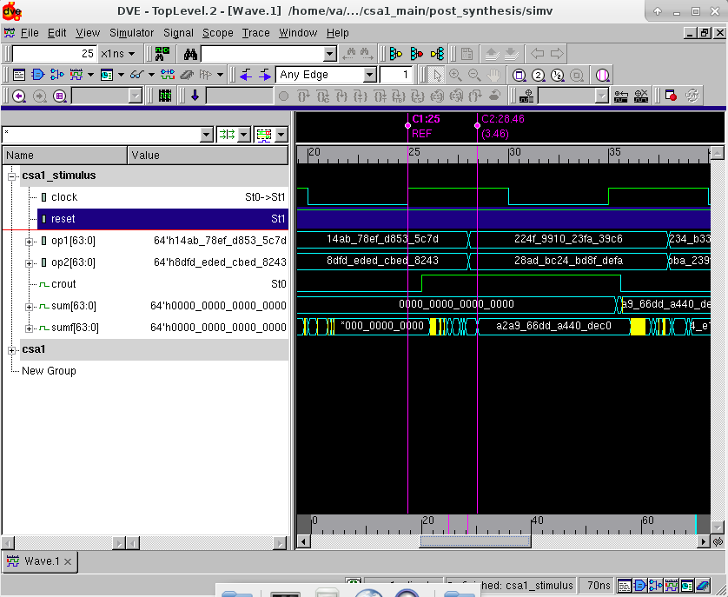

**Figure V.2d**: Post-synthesis (dynamic) simulation waveform that contains test case #2 for CSA-UEQG

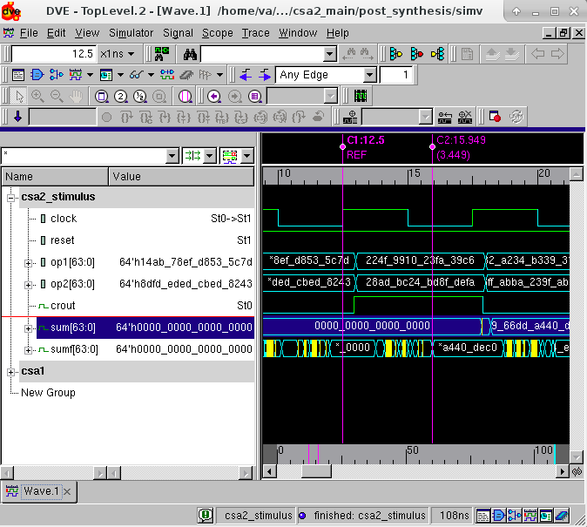

**Figure V.3a**: Post-synthesis (dynamic) simulation waveform that contains test case #3 for RCA

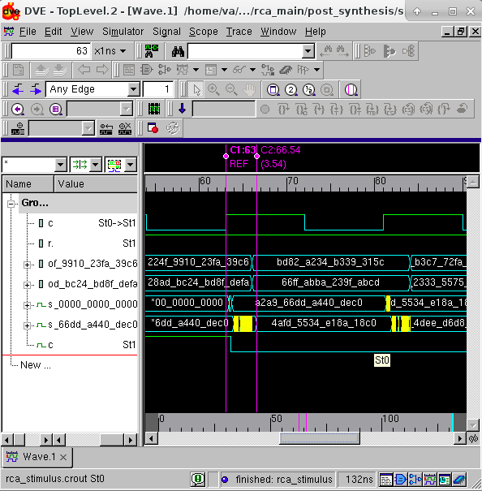

**Figure V.3b**: Post-synthesis (dynamic) simulation waveform that contains test case #3 for CLA-2L

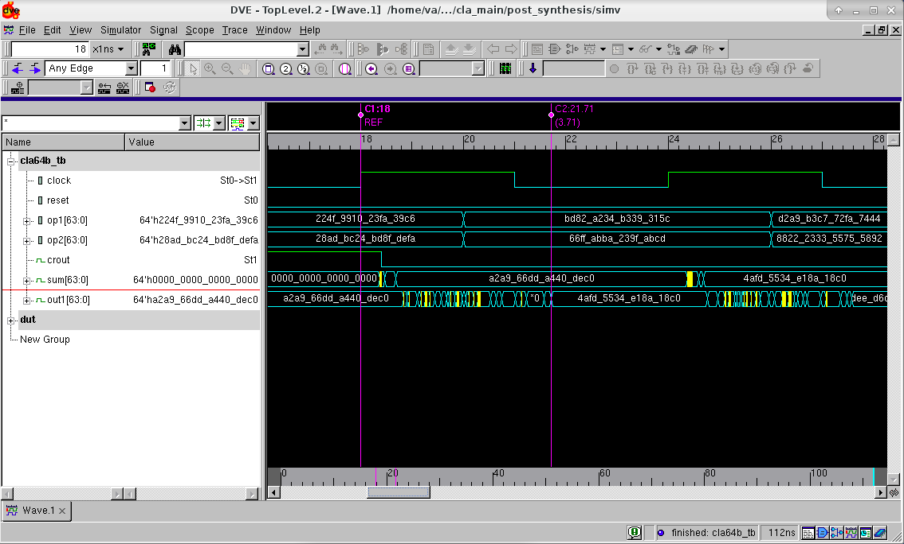

**Figure V.3c**: Post-synthesis (dynamic) simulation waveform that contains test case #3 for CSA-EQG

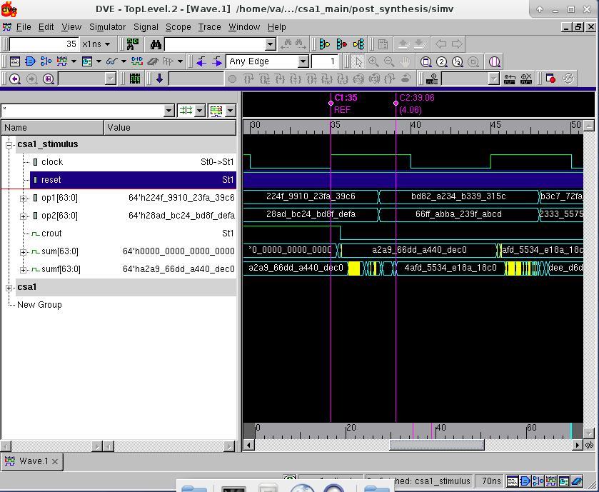

**Figure V.3d**: Post-synthesis (dynamic) simulation waveform that contains test case #3 for CSA-UEQG

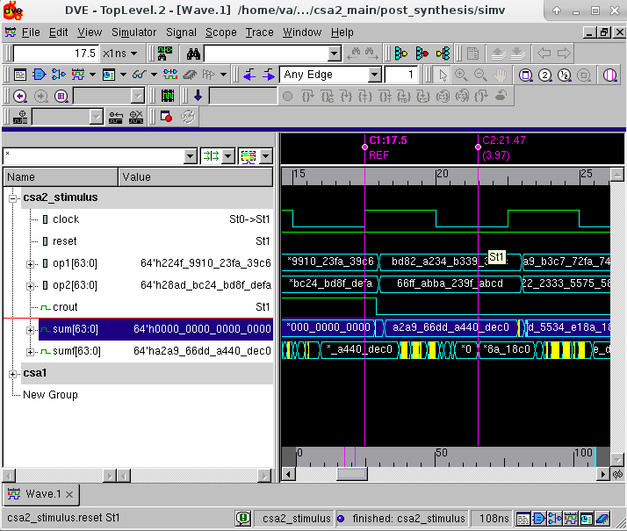

**Figure V.4a**: Post-synthesis (dynamic) simulation waveform that contains test case #4 for RCA

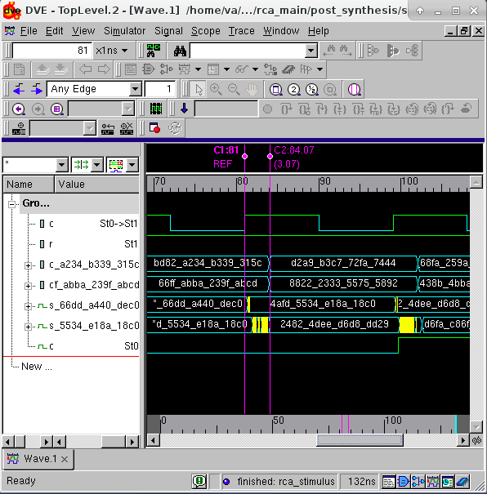

**Figure V.4b**: Post-synthesis (dynamic) simulation waveform that contains test case #4 for CLA-2L

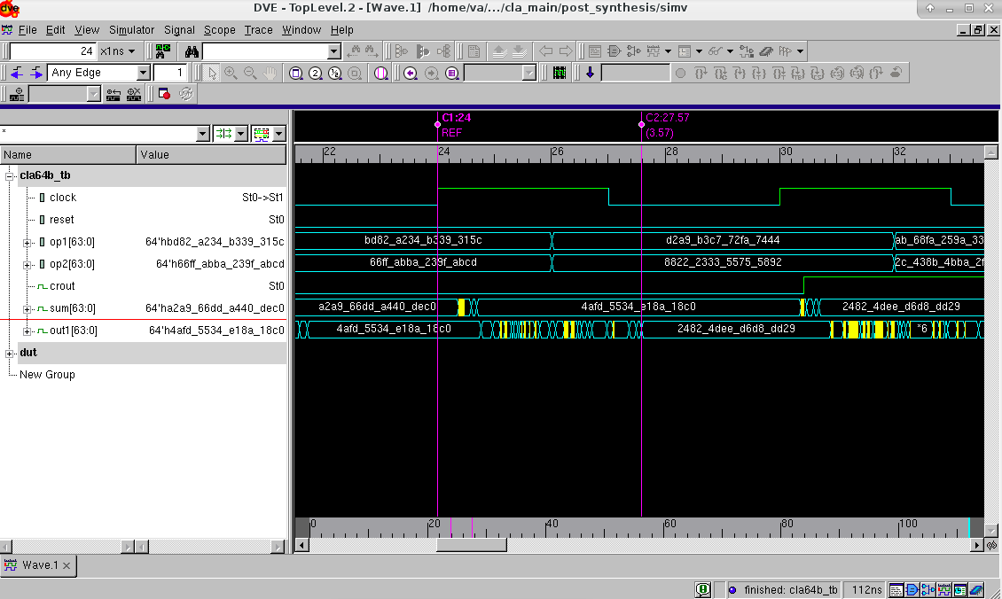

**Figure V.4c**: Post-synthesis (dynamic) simulation waveform that contains test case #4 for CSA-EQG

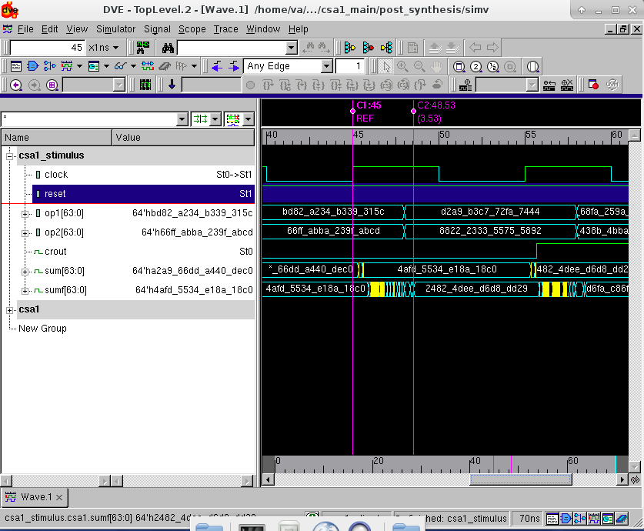

**Figure V.4d**: Post-synthesis (dynamic) simulation waveform that contains test case #4 for CSA-UEQG

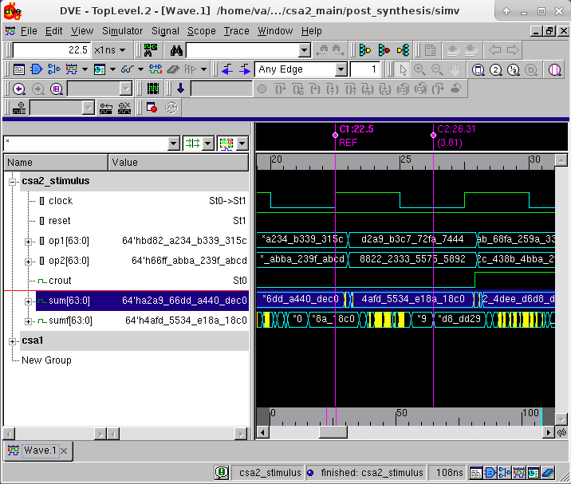

**Figure V.5a**: Post-synthesis (dynamic) simulation waveform that contains test case #5 for RCA

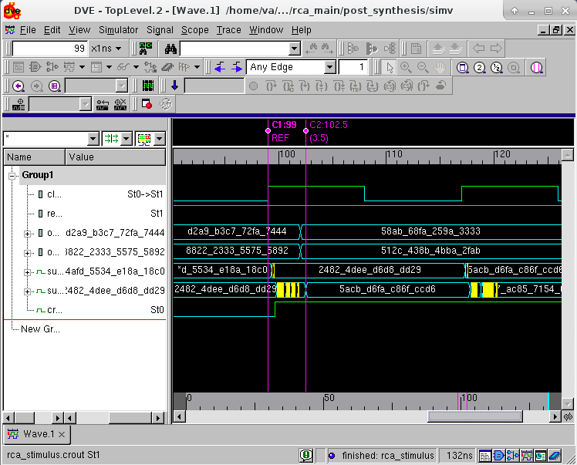

**Figure V.5b**: Post-synthesis (dynamic) simulation waveform that contains test case #5 for CLA-2L

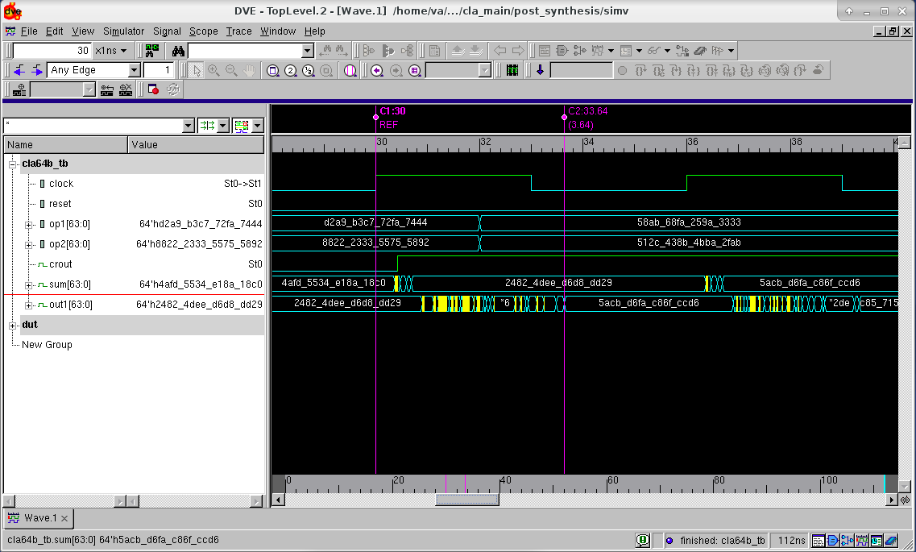

**Figure V.5c**: Post-synthesis (dynamic) simulation waveform that contains test case #5 for CSA-EQG

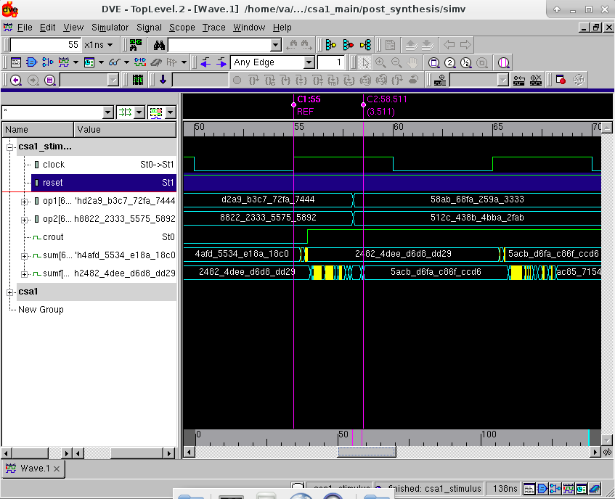

**Figure V.5d**: Post-synthesis (dynamic) simulation waveform that contains test case #5 for CSA-UEQG

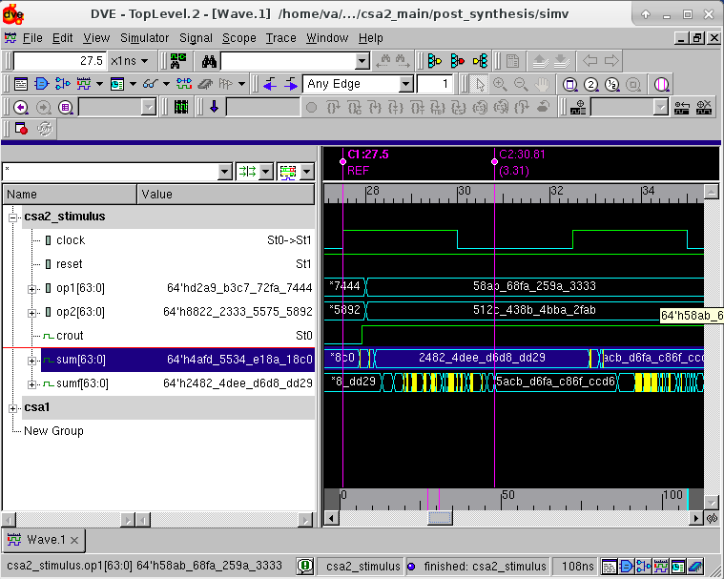

**Figure V.6a**: Post-synthesis (dynamic) simulation waveform that contains test case #6 for RCA

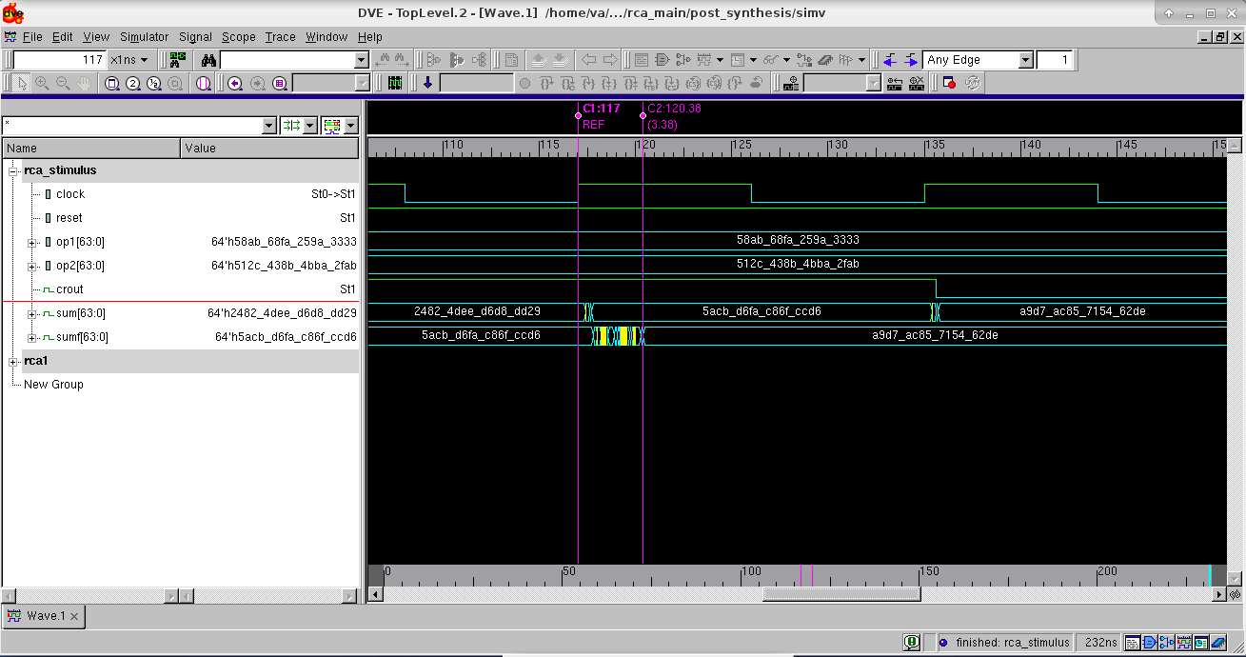

**Figure V.6b**: Post-synthesis (dynamic) simulation waveform that contains test case #6 for CLA-2L

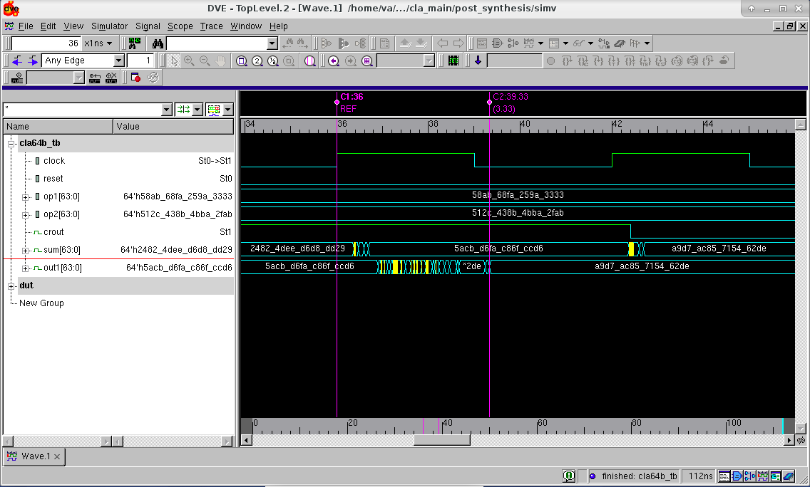

**Figure V.6c**: Post-synthesis (dynamic) simulation waveform that contains test case #6 for CSA-EQG

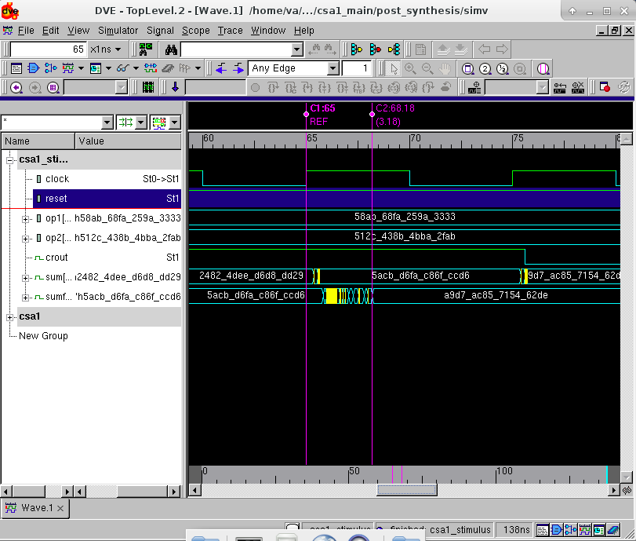

**Figure V.6d**: Post-synthesis (dynamic) simulation waveform that contains test case #6 for CSA-UEQG

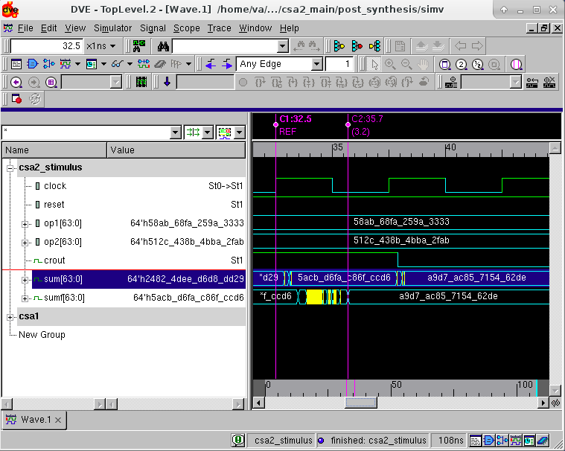

**VI. Conclusion**

In conclusion:

1. More the number of hardware, faster is the operation of circuit.
2. Area is Inversely proportional to delay.
3. Area is Directly proportional to Power of the circuit.
4. Time required by the circuit for stable output depends on the given test case values.

**Appendix A**

**A.1 Contents from EDA Tool Configurations and Setup Files**

VCS tool setup environment file content

setenv VCS_HOME /apps/synopsys/I-2014.03-2

source ${VCS_HOME}/bin/environ.csh

**A.2 Scripts and/or Commands Used for Simulation and Synthesis**

**1. Ripple Carry Adder (Script)**

set search_path {/export/apps/toshiba/sjsu/synopsys/tc240c/}

set link_library {/apps/toshiba/sjsu/synopsys/tc240c/tc240c.db_WCCOM25}

set target_library {/apps/toshiba/sjsu/synopsys/tc240c/tc240c.db_WCCOM25}

set symbol_library {/apps/toshiba/sjsu/synopsys/tc240c/tc240c.workview.sdb}

set synthetic_library {dw_foundation.sldb standard.sldb}

set_min_library /apps/toshiba/sjsu/synopsys/tc240c/tc240c.db_WCCOM25 -min_version /apps/toshiba/sjsu/synopsys/tc240c/tc240c.db_BCCOM25

read_verilog ./rca_64bit.v

analyze -format verilog {./rca_64bit.v}

elaborate rca_64bit

current_design rca_64bit

check_design

create_clock clock -name clock -period 8.00

set_clock_uncertainty 0.25 clock

set_propagated_clock clock

set_dont_touch_network [all_clocks]

set_fix_hold clock

compile -incremental_mapping

report -cell

update_timing

report_timing -max_path 5

set_max_area 2000

report_area

report_power

write -hierarchy -format verilog -output rca_netlist.v

report_qor

quit

----------------------------------------------------------------------

**2. Carry Look-Ahead Adder (Script)**

set search_path {/export/apps/toshiba/sjsu/synopsys/tc240c/}

set link_library {/apps/toshiba/sjsu/synopsys/tc240c/tc240c.db_WCCOM25}

set target_library {/apps/toshiba/sjsu/synopsys/tc240c/tc240c.db_WCCOM25}

set symbol_library {/apps/toshiba/sjsu/synopsys/tc240c/tc240c.workview.sdb}

set synthetic_library {dw_foundation.sldb standard.sldb}

set_min_library /apps/toshiba/sjsu/synopsys/tc240c/tc240c.db_WCCOM25 -min_version /apps/toshiba/sjsu/synopsys/tc240c/tc240c.db_BCCOM25

read_verilog ./cla64b.v

analyze -format verilog {./cla64b.v}

elaborate cla64b

current_design cla64b

check_design

create_clock clock -name clock -period 3.64

set_clock_uncertainty 0.25 clock

set_propagated_clock clock

set_dont_touch_network [all_clocks]

set_fix_hold clock

compile -incremental_mapping

report -cell

update_timing

report_timing -max_path 5

set_max_area 2000

report_area

report_power

write -hierarchy -format verilog -output cla_netlist.v

report_qor

quit

----------------------------------------------------------------------

**3. Carry Select Adder -EQG (Script)**

set search_path {/export/apps/toshiba/sjsu/synopsys/tc240c/}

set link_library {/apps/toshiba/sjsu/synopsys/tc240c/tc240c.db_WCCOM25}

set target_library {/apps/toshiba/sjsu/synopsys/tc240c/tc240c.db_WCCOM25}

set symbol_library {/apps/toshiba/sjsu/synopsys/tc240c/tc240c.workview.sdb}

set synthetic_library {dw_foundation.sldb standard.sldb}

set_min_library /apps/toshiba/sjsu/synopsys/tc240c/tc240c.db_WCCOM25 -min_version /apps/toshiba/sjsu/synopsys/tc240c/tc240c.db_BCCOM25

read_verilog ./csa1_64bit.v

analyze -format verilog {./csa1_64bit.v}

elaborate csa1_64bit

current_design csa1_64bit

check_design

create_clock clock -name clock -period 5.90

set_clock_uncertainty 0.25 clock

set_propagated_clock clock

set_dont_touch_network [all_clocks]

set_fix_hold clock

compile -incremental_mapping

report -cell

update_timing

report_timing -max_path 5

set_max_area 2000

report_area

report_power

write -hierarchy -format verilog -output csa1_netlist.v

report_qor

quit

----------------------------------------------------------------------

**4. Carry Select Adder -UEQG (Script)**

set search_path {/export/apps/toshiba/sjsu/synopsys/tc240c/}

set link_library {/apps/toshiba/sjsu/synopsys/tc240c/tc240c.db_WCCOM25}

set target_library {/apps/toshiba/sjsu/synopsys/tc240c/tc240c.db_WCCOM25}

set symbol_library {/apps/toshiba/sjsu/synopsys/tc240c/tc240c.workview.sdb}

set synthetic_library {dw_foundation.sldb standard.sldb}

set_min_library /apps/toshiba/sjsu/synopsys/tc240c/tc240c.db_WCCOM25 -min_version /apps/toshiba/sjsu/synopsys/tc240c/tc240c.db_BCCOM25

read_verilog ./csa2_64bit.v

analyze -format verilog {./csa2_64bit.v}

elaborate csa2_64bit

current_design csa2_64bit

check_design

create_clock clock -name clock -period 4.10

set_clock_uncertainty 0.25 clock

set_propagated_clock clock

set_dont_touch_network [all_clocks]

set_fix_hold clock

compile -incremental_mapping

report -cell

update_timing

report_timing -max_path 5

set_max_area 2000

report_area

report_power

write -hierarchy -format verilog -output csa2_netlist.v

report_qor

quit

-----------------------------------------------------------------------------

**Commands Used**

**-**      **vcs +v2k –gui file-name.v testbench.v** //to compile source code and test-bench code

**-        ./simv –gui** //Run compiled code

**-**       **vcs +v2k –debug_all –gui –y /apps/toshiba/sjsu/verilog/tc240c +libext+.tsbvlibp (tb_name).v design_netlist.v** //post-synthesis command

**-**        **dc_shell –f synthesis.script | tee (filename).txt** //Pre-synthesis command and generating its report file named log.txt

**-**        **design_vision** // to open a tool- design vision to analyze and elaborate circuit and to analyze the synthesis results*.*

**-** **DVE** // a tool for graphical verification environment that supports debugging for VCS and  
VCS MX simulations.

**Appendix B**

**Completed Verilog Source Codes and Test-benches**

**1. Ripple Carry Adder**

**Code:**

`timescale 1ns/10ps

module half_adder(a, b, sum1, cout1);

input a, b;

output sum1, cout1;

assign sum1= a^b;

assign cout1= a&b;

endmodule

----------------------------------------------------------------

module full_adder(a, b, sum2, cout2, cin);

input a, b, cin;

output sum2, cout2;

wire r1, r2, r3;

assign sum2= a^b^cin;

assign cout2= (a&b) | ((a^b)&cin);

endmodule

----------------------------------------------------------------

module four_1bit (a, b, sum3, cout3, cin);

input [3:0] a, b;

input cin;

output [3:0] sum3;

output cout3;

wire [2:0] r;

full_adder fa1 (a[0], b[0], sum3[0], r[0], cin);

full_adder fa2 (a[1], b[1], sum3[1], r[1], r[0]);

full_adder fa3 (a[2], b[2], sum3[2], r[2], r[1]);

full_adder fa4 (a[3], b[3], sum3[3], cout3, r[2]);

endmodule

----------------------------------------------------------------

module four_0bit (a, b, sum4, cout4);

input [3:0] a, b;

output [3:0] sum4;

output cout4;

wire [2:0] r;

half_adder ha1 (a[0], b[0], sum4[0], r[0]);

full_adder ffa1 (a[1], b[1], sum4[1], r[1], r[0]);

full_adder ffa2 (a[2], b[2], sum4[2], r[2], r[1]);

full_adder ffa3 (a[3], b[3], sum4[3], cout4, r[2]);

endmodule

----------------------------------------------------------------

module rca_64bit (op1, op2, sum, crout, reset, clock);

input [63:0] op1, op2;

input reset, clock;

output reg [63:0] sum;

wire [63:0] sumf;

output reg crout;

wire [14:0] r;

reg [63:0] a, b;

wire coutf;

always @(posedge clock or negedge reset)

begin

if (reset==0)

begin

a<=0;

// $display("op1=%h", a);

b<=0;

// $display("op2=%h", b);

sum<=0;

// $display("sum=%h", sum);

crout<=0;

// $display("crout=%h", crout);

end

else

begin

a<=op1;

$display("op1=%h", a);

b<=op2;

$display("op2=%h", b);

sum<=sumf;

$display("sum=%h", sumf);

crout<=coutf;

$display("crout=%h", coutf);

end

end

four_0bit fa1 (a[3:0], b[3:0], sumf[3:0], r[0]);

four_1bit fa2 (a[7:4], b[7:4], sumf[7:4], r[1], r[0]);

four_1bit fa3 (a[11:8], b[11:8], sumf[11:8], r[2], r[1]);

four_1bit fa4 (a[15:12], b[15:12], sumf[15:12], r[3], r[2]);

four_1bit fa5 (a[19:16], b[19:16], sumf[19:16], r[4], r[3]);

four_1bit fa6 (a[23:20], b[23:20], sumf[23:20], r[5], r[4]);

four_1bit fa7 (a[27:24], b[27:24], sumf[27:24], r[6], r[5]);

four_1bit fa8 (a[31:28], b[31:28], sumf[31:28], r[7], r[6]);

four_1bit fa9 (a[35:32], b[35:32], sumf[35:32], r[8], r[7]);

four_1bit fa10 (a[39:36], b[39:36], sumf[39:36], r[9], r[8]);

four_1bit fa11 (a[43:40], b[43:40], sumf[43:40], r[10], r[9]);

four_1bit fa12 (a[47:44], b[47:44], sumf[47:44], r[11], r[10]);

four_1bit fa13 (a[51:48], b[51:48], sumf[51:48], r[12], r[11]);

four_1bit fa14 (a[55:52], b[55:52], sumf[55:52], r[13], r[12]);

four_1bit fa15 (a[59:56], b[59:56], sumf[59:56], r[14], r[13]);

four_1bit fa16 (a[63:60], b[63:60], sumf[63:60], coutf, r[14]);

endmodule

------------------------------------------------------------------

**Testbench:**

`timescale 1ns/10ps

module rca_stimulus();

reg [63:0] op1, op2;

reg reset, clock;

wire [63:0] sum;

wire crout;

initial begin

$dumpfile("rca_64bit.vcd");

$dumpvars(0, rca_stimulus);

end

initial begin

op1=64'h0000000000000000; op2=64'h0000000000000000; reset=0; clock=0;

#12 op1=64'hffff_ffff_ffff_ffff; op2=64'h0000_0000_0000_0001; reset=1;

#18 op1=64'h14ab_78ef_d853_5c7d; op2=64'h8dfd_eded_cbed_8243; reset=1;

#18 op1=64'h224f_9910_23fa_39c6; op2=64'h28ad_bc24_bd8f_defa; reset=1;

#18 op1=64'hbd82_a234_b339_315c; op2=64'h66ff_abba_239f_abcd; reset=1;

#18 op1=64'hd2a9_b3c7_72fa_7444; op2=64'h8822_2333_5575_5892; reset=1;

#18 op1=64'h58ab_68fa_259a_3333; op2=64'h512c_438b_4bba_2fab; reset=1;

#130 $finish;

end

rca_64bit rca1 (op1, op2, sum, crout, reset, clock);

initial begin

forever #9 clock=~clock;

end

endmodule

----------------------------------------------------------------

**2. Carry Select Adder (EQG)**

**Code:**

`timescale 1ns/1ps

module half_adder(a, b, sum1, cout1);

input a, b;

output sum1, cout1;

assign sum1= a^b;

assign cout1= a&b;

endmodule

----------------------------------------------------------------

module full_adder(a, b, sum2, cout2, cin);

input a, b, cin;

output sum2, cout2;

//wire [2:0] r;

assign sum2= a^b^cin;

assign cout2= (a&b) | ((a^b)&cin);

endmodule

----------------------------------------------------------------

module four_1bit(a, b, sum3, cout3, cin);

input [3:0] a, b;

input cin;

output [3:0] sum3;

output cout3;

wire [2:0] r;

full_adder fa1 (a[0], b[0], sum3[0], r[0], cin);

full_adder fa2 (a[1], b[1], sum3[1], r[1], r[0]);

full_adder fa3 (a[2], b[2], sum3[2], r[2], r[1]);

full_adder fa4 (a[3], b[3], sum3[3], cout3, r[2]);

endmodule

----------------------------------------------------------------

module four_2bit(a, b, sum4, cout4);

input [3:0] a, b;

output [3:0] sum4;

output cout4;

wire [2:0] r;

half_adder ha1 (a[0], b[0], sum4[0], r[0]);

full_adder fa1 (a[1], b[1], sum4[1], r[1], r[0]);

full_adder fa2 (a[2], b[2], sum4[2], r[2], r[1]);

full_adder fa3 (a[3], b[3], sum4[3], cout4, r[2]);

endmodule

----------------------------------------------------------------

module mux(s0, s1, c0, c1, sel, sum_m, cout_m);

input sel;

input [3:0] s0, s1;

input c0, c1;

output [3:0] sum_m;

output cout_m;

assign sum_m= sel? s1 : s0;

assign cout_m= sel? c1 : c0;

endmodule

----------------------------------------------------------------

module csa1_64bit(op1, op2, sum, crout, reset, clock); //inputs are j and k.

input [63:0] op1, op2;

input reset, clock;

output reg [63:0] sum;

wire [63:0] sumf;

wire coutf;

output reg crout;

wire [59:0] x, y;

reg [63:0] a, b;

wire [14:0] w, z;

wire [14:0] cout_m;

always @(posedge clock or negedge reset)

begin

if (reset==0)

begin

sum<=0;

a<=0;

b<=0;

crout<=0;

end

else

begin

a<=op1;

$display("op1=%h", a);

b<=op2;

$display("op2=%h", b);

sum<=sumf;

$display("sum=%h", sumf);

crout<=coutf;

$display("crout=%h", coutf);

end

end

four_2bit fa1 (a[3:0], b[3:0], sumf[3:0], cout_m[0]);

four_1bit fa2 (a[7:4], b[7:4], x[3:0], w[0], 1'b1);

four_2bit fa3 (a[7:4], b[7:4], y[3:0], z[0]);

mux m1 (y[3:0], x[3:0], z[0], w[0], cout_m[0], sumf[7:4], cout_m[1]);

four_1bit fa4 (a[11:8], b[11:8], x[7:4], w[1], 1'b1);

four_2bit fa5 (a[11:8], b[11:8], y[7:4], z[1]);

mux m2 (y[7:4], x[7:4], z[1], w[1], cout_m[1], sumf[11:8], cout_m[2]);

four_1bit fa6 (a[15:12], b[15:12], x[11:8], w[2], 1'b1); //starting with full adder

four_2bit fa7 (a[15:12], b[15:12], y[11:8], z[2]);

mux m3 (y[11:8], x[11:8], z[2], w[2], cout_m[2], sumf[15:12], cout_m[3]);

four_1bit fa8 (a[19:16], b[19:16], x[15:12], w[3], 1'b1);

four_2bit fa9 (a[19:16], b[19:16], y[15:12], z[3]);

mux m4 (y[15:12], x[15:12], z[3], w[3], cout_m[3], sumf[19:16], cout_m[4]);

four_1bit fa10 (a[23:20], b[23:20], x[19:16], w[4], 1'b1);

four_2bit fa11 (a[23:20], b[23:20], y[19:16], z[4]);

mux m5 (y[19:16], x[19:16], z[4], w[4], cout_m[4], sumf[23:20], cout_m[5]);

four_1bit fa12 (a[27:24], b[27:24], x[23:20], w[5], 1'b1);

four_2bit fa13 (a[27:24], b[27:24], y[23:20], z[5]);

mux m6 (y[23:20], x[23:20], z[5], w[5], cout_m[5], sumf[27:24], cout_m[6]);

four_1bit fa14 (a[31:28], b[31:28], x[27:24], w[6], 1'b1);

four_2bit fa15 (a[31:28], b[31:28], y[27:24], z[6]);

mux m7 (y[27:24], x[27:24], z[6], w[6], cout_m[6], sumf[31:28], cout_m[7]);

four_1bit fa16 (a[35:32], b[35:32], x[31:28], w[7], 1'b1);

four_2bit fa17 (a[35:32], b[35:32], y[31:28], z[7]);

mux m8 (y[31:28], x[31:28], z[7], w[7], cout_m[7], sumf[35:32], cout_m[8]);

four_1bit fa18 (a[39:36], b[39:36], x[35:32], w[8], 1'b1);

four_2bit fa19 (a[39:36], b[39:36], y[35:32], z[8]);

mux m9 (y[35:32], x[35:32], z[8], w[8], cout_m[8], sumf[39:36], cout_m[9]);

four_1bit fa20 (a[43:40], b[43:40], x[39:36], w[9], 1'b1);

four_2bit fa21 (a[43:40], b[43:40], y[39:36], z[9]);

mux m10 (y[39:36], x[39:36], z[9], w[9], cout_m[9], sumf[43:40], cout_m[10]);

four_1bit fa22 (a[47:44], b[47:44], x[43:40], w[10], 1'b1);

four_2bit fa23 (a[47:44], b[47:44], y[43:40], z[10]);

mux m11 (y[43:40], x[43:40], z[10], w[10], cout_m[10], sumf[47:44], cout_m[11]);

four_1bit fa24 (a[51:48], b[51:48], x[47:44], w[11], 1'b1);

four_2bit fa25 (a[51:48], b[51:48], y[47:44], z[11]);

mux m12 (y[47:44], x[47:44], z[11], w[11], cout_m[11], sumf[51:48], cout_m[12]);

four_1bit fa26 (a[55:52], b[55:52], x[51:48], w[12], 1'b1);

four_2bit fa27 (a[55:52], b[55:52], y[51:48], z[12]);

mux m13 (y[51:48], x[51:48], z[12], w[12], cout_m[12], sumf[55:52], cout_m[13]);

four_1bit fa28 (a[59:56], b[59:56], x[55:52], w[13], 1'b1);

four_2bit fa29 (a[59:56], b[59:56], y[55:52], z[13]);

mux m14 (y[55:52], x[55:52], z[13], w[13], cout_m[13], sumf[59:56], cout_m[14]);

four_1bit fa30 (a[63:60], b[63:60], x[59:56], w[14], 1'b1);

four_2bit fa31 (a[63:60], b[63:60], y[59:56], z[14]);

mux m15 (y[59:56], x[59:56], z[14], w[14], cout_m[14], sumf[63:60], coutf);

endmodule

----------------------------------------------------------------

**Testbench:**

`timescale 1ns/1ps

module csa1_stimulus();

reg [63:0] op1, op2;

reg reset, clock;

wire [63:0] sum;

wire crout;

initial begin

$dumpfile("csa1_64bit.vcd");

$dumpvars(0, csa1_stimulus);

end

initial begin

op1=64'h0000000000000000; op2=64'h0000000000000000; reset=0; clock=0;

#8 op1=64'hffff_ffff_ffff_ffff; op2=64'h0000_0000_0000_0001; reset=1;

#10 op1=64'h14ab_78ef_d853_5c7d; op2=64'h8dfd_eded_cbed_8243; reset=1;

#10 op1=64'h224f_9910_23fa_39c6; op2=64'h28ad_bc24_bd8f_defa; reset=1;

#10 op1=64'hbd82_a234_b339_315c; op2=64'h66ff_abba_239f_abcd; reset=1;

#10 op1=64'hd2a9_b3c7_72fa_7444; op2=64'h8822_2333_5575_5892; reset=1;

#10 op1=64'h58ab_68fa_259a_3333; op2=64'h512c_438b_4bba_2fab; reset=1;

#80 $finish;

end

csa1_64bit csa1 (op1, op2, sum, crout, reset, clock);

initial begin

forever #5 clock=~clock;

end

endmodule

----------------------------------------------------------------

**3. Carry Select Adder (UEQG)**

**Code:**

`timescale 1ns/1ps

module half_adder(a, b, sum1, cout1);

input a, b;

output sum1, cout1;

assign sum1= a^b;

assign cout1= a&b;

endmodule

----------------------------------------------------------------

module full_adder(a, b, sum2, cout2, cin);

input a, b, cin;

output sum2, cout2;

//wire [2:0] r;

assign sum2= a^b^cin;

assign cout2= (a&b) | ((a^b)&cin);

endmodule

----------------------------------------------------------------

module four_1bit (a, b, sum3, cout3, cin);

input [3:0] a, b;

input cin;

output [3:0] sum3;

output cout3;

wire [2:0] r;

full_adder fa1 (a[0], b[0], sum3[0], r[0], cin);

full_adder fa2 (a[1], b[1], sum3[1], r[1], r[0]);

full_adder fa3 (a[2], b[2], sum3[2], r[2], r[1]);

full_adder fa4 (a[3], b[3], sum3[3], cout3, r[2]);

endmodule

----------------------------------------------------------------

module four_2bit (a, b, sum4, cout4);

input [3:0] a, b;

output [3:0] sum4;

output cout4;

wire [2:0] r;

half_adder ha1 (a[0], b[0], sum4[0], r[0]);

full_adder fa1 (a[1], b[1], sum4[1], r[1], r[0]);

full_adder fa2 (a[2], b[2], sum4[2], r[2], r[1]);

full_adder fa3 (a[3], b[3], sum4[3], cout4, r[2]);

endmodule

----------------------------------------------------------------

module mux_4(s0, s1, c0, c1, sel, sum_m, cout_m);

input sel;

input [3:0] s0, s1;

input c0, c1;

output [3:0] sum_m;

output cout_m;

assign sum_m= sel? s1 : s0;

assign cout_m= sel? c1 : c0;

endmodule

----------------------------------------------------------------

module mux_5(s0, s1, c0, c1, sel, sum_m, cout_m);

input sel;

input [4:0] s0, s1;

input c0, c1;

output [4:0] sum_m;

output cout_m;

assign sum_m= sel? s1 : s0;

assign cout_m= sel? c1 : c0;

endmodule

----------------------------------------------------------------

module mux_6(s0, s1, c0, c1, sel, sum_m, cout_m);

input sel;

input [5:0] s0, s1;

input c0, c1;

output [5:0] sum_m;

output cout_m;

assign sum_m= sel? s1 : s0;

assign cout_m= sel? c1 : c0;

endmodule

----------------------------------------------------------------

module mux_7(s0, s1, c0, c1, sel, sum_m, cout_m);

input sel;

input [6:0] s0, s1;

input c0, c1;

output [6:0] sum_m;

output cout_m;

assign sum_m= sel? s1 : s0;

assign cout_m= sel? c1 : c0;

endmodule

----------------------------------------------------------------

module mux_8(s0, s1, c0, c1, sel, sum_m, cout_m);

input sel;

input [7:0] s0, s1;

input c0, c1;

output [7:0] sum_m;

output cout_m;

assign sum_m= sel? s1 : s0;

assign cout_m= sel? c1 : c0;

endmodule

----------------------------------------------------------------

module mux_9(s0, s1, c0, c1, sel, sum_m, cout_m);

input sel;

input [8:0] s0, s1;

input c0, c1;

output [8:0] sum_m;

output cout_m;

assign sum_m= sel? s1 : s0;

assign cout_m= sel? c1 : c0;

endmodule

----------------------------------------------------------------

module mux_10(s0, s1, c0, c1, sel, sum_m, cout_m);

input sel;

input [9:0] s0, s1;

input c0, c1;

output [9:0] sum_m;

output cout_m;

assign sum_m= sel? s1 : s0;

assign cout_m= sel? c1 : c0;

endmodule

----------------------------------------------------------------

module mux_11(s0, s1, c0, c1, sel, sum_m, cout_m);

input sel;

input [10:0] s0, s1;

input c0, c1;

output [10:0] sum_m;

output cout_m;

assign sum_m= sel? s1 : s0;

assign cout_m= sel? c1 : c0;

endmodule

----------------------------------------------------------------

module four5_1bit (a, b, sum5_1, cout5_1, cin);

input [4:0] a, b;

input cin;

output [4:0] sum5_1;

output cout5_1;

wire [3:0] r;

full_adder fa1 (a[0], b[0], sum5_1[0], r[0], cin);

full_adder fa2 (a[1], b[1], sum5_1[1], r[1], r[0]);

full_adder fa3 (a[2], b[2], sum5_1[2], r[2], r[1]);

full_adder fa4 (a[3], b[3], sum5_1[3], r[3], r[2]);

full_adder fa5 (a[4], b[4], sum5_1[4], cout5_1, r[3]);

endmodule

----------------------------------------------------------------

module four5_0bit (a, b, sum5_0, cout5_0);

input [4:0] a, b;

output [4:0] sum5_0;

output cout5_0;

wire [3:0] r;

half_adder ha1 (a[0], b[0], sum5_0[0], r[0]);

full_adder fa1 (a[1], b[1], sum5_0[1], r[1], r[0]);

full_adder fa2 (a[2], b[2], sum5_0[2], r[2], r[1]);

full_adder fa3 (a[3], b[3], sum5_0[3], r[3], r[2]);

full_adder fa5 (a[4], b[4], sum5_0[4], cout5_0, r[3]);

endmodule

----------------------------------------------------------------

module four6_1bit (a, b, sum6_1, cout6_1, cin);

input [5:0] a, b;

input cin;

output [5:0] sum6_1;

output cout6_1;

wire [4:0] r;

full_adder fa1 (a[0], b[0], sum6_1[0], r[0], cin);

full_adder fa2 (a[1], b[1], sum6_1[1], r[1], r[0]);

full_adder fa3 (a[2], b[2], sum6_1[2], r[2], r[1]);

full_adder fa4 (a[3], b[3], sum6_1[3], r[3], r[2]);

full_adder fa5 (a[4], b[4], sum6_1[4], r[4], r[3]);

full_adder fa6 (a[5], b[5], sum6_1[5], cout6_1, r[4]);

endmodule

----------------------------------------------------------------

module four6_0bit (a, b, sum6_0, cout6_0);

input [5:0] a, b;

output [5:0] sum6_0;

output cout6_0;

wire [4:0] r;

half_adder ha1 (a[0], b[0], sum6_0[0], r[0]);

full_adder fa1 (a[1], b[1], sum6_0[1], r[1], r[0]);

full_adder fa2 (a[2], b[2], sum6_0[2], r[2], r[1]);

full_adder fa3 (a[3], b[3], sum6_0[3], r[3], r[2]);

full_adder fa4 (a[4], b[4], sum6_0[4], r[4], r[3]);

full_adder fa5 (a[5], b[5], sum6_0[5], cout6_0, r[4]);

endmodule

----------------------------------------------------------------

module four7_1bit (a, b, sum7_1, cout7_1, cin);

input [6:0] a, b;

input cin;

output [6:0] sum7_1;

output cout7_1;

wire [5:0] r;

full_adder fa1 (a[0], b[0], sum7_1[0], r[0], cin);

full_adder fa2 (a[1], b[1], sum7_1[1], r[1], r[0]);

full_adder fa3 (a[2], b[2], sum7_1[2], r[2], r[1]);

full_adder fa4 (a[3], b[3], sum7_1[3], r[3], r[2]);

full_adder fa5 (a[4], b[4], sum7_1[4], r[4], r[3]);

full_adder fa6 (a[5], b[5], sum7_1[5], r[5], r[4]);

full_adder fa7 (a[6], b[6], sum7_1[6], cout7_1, r[5]);

endmodule

----------------------------------------------------------------

module four7_0bit (a, b, sum7_0, cout7_0);

input [6:0] a, b;

output [6:0] sum7_0;

output cout7_0;

wire [5:0] r;

half_adder ha1 (a[0], b[0], sum7_0[0], r[0]);

full_adder fa2 (a[1], b[1], sum7_0[1], r[1], r[0]);

full_adder fa3 (a[2], b[2], sum7_0[2], r[2], r[1]);

full_adder fa4 (a[3], b[3], sum7_0[3], r[3], r[2]);

full_adder fa5 (a[4], b[4], sum7_0[4], r[4], r[3]);

full_adder fa6 (a[5], b[5], sum7_0[5], r[5], r[4]);

full_adder fa7 (a[6], b[6], sum7_0[6], cout7_0, r[5]);

endmodule

----------------------------------------------------------------

module four8_1bit (a, b, sum8_1, cout8_1, cin);

input [7:0] a, b;

input cin;

output [7:0] sum8_1;

output cout8_1;

wire [6:0] r;

full_adder fa1 (a[0], b[0], sum8_1[0], r[0], cin);

full_adder fa2 (a[1], b[1], sum8_1[1], r[1], r[0]);

full_adder fa3 (a[2], b[2], sum8_1[2], r[2], r[1]);

full_adder fa4 (a[3], b[3], sum8_1[3], r[3], r[2]);

full_adder fa5 (a[4], b[4], sum8_1[4], r[4], r[3]);

full_adder fa6 (a[5], b[5], sum8_1[5], r[5], r[4]);

full_adder fa7 (a[6], b[6], sum8_1[6], r[6], r[5]);

full_adder fa8 (a[7], b[7], sum8_1[7], cout8_1, r[6]);

endmodule

----------------------------------------------------------------

module four8_0bit (a, b, sum8_0, cout8_0);

input [7:0] a, b;

output [7:0] sum8_0;

output cout8_0;

wire [6:0] r;

half_adder ha1 (a[0], b[0], sum8_0[0], r[0]);

full_adder fa2 (a[1], b[1], sum8_0[1], r[1], r[0]);

full_adder fa3 (a[2], b[2], sum8_0[2], r[2], r[1]);

full_adder fa4 (a[3], b[3], sum8_0[3], r[3], r[2]);

full_adder fa5 (a[4], b[4], sum8_0[4], r[4], r[3]);

full_adder fa6 (a[5], b[5], sum8_0[5], r[5], r[4]);

full_adder fa7 (a[6], b[6], sum8_0[6], r[6], r[5]);

full_adder fa8 (a[7], b[7], sum8_0[7], cout8_0, r[6]);

endmodule

----------------------------------------------------------------

module four9_1bit (a, b, sum9_1, cout9_1, cin);

input [8:0] a, b;

input cin;

output [8:0] sum9_1;

output cout9_1;

wire [7:0] r;

full_adder fa1 (a[0], b[0], sum9_1[0], r[0], cin);

full_adder fa2 (a[1], b[1], sum9_1[1], r[1], r[0]);

full_adder fa3 (a[2], b[2], sum9_1[2], r[2], r[1]);

full_adder fa4 (a[3], b[3], sum9_1[3], r[3], r[2]);

full_adder fa5 (a[4], b[4], sum9_1[4], r[4], r[3]);

full_adder fa6 (a[5], b[5], sum9_1[5], r[5], r[4]);

full_adder fa7 (a[6], b[6], sum9_1[6], r[6], r[5]);

full_adder fa8 (a[7], b[7], sum9_1[7], r[7], r[6]);

full_adder fa9 (a[8], b[8], sum9_1[8], cout9_1, r[7]);

endmodule

----------------------------------------------------------------

module four9_0bit (a, b, sum9_0, cout9_0);

input [8:0] a, b;

output [8:0] sum9_0;

output cout9_0;

wire [7:0] r;

half_adder ha1 (a[0], b[0], sum9_0[0], r[0]);

full_adder fa2 (a[1], b[1], sum9_0[1], r[1], r[0]);

full_adder fa3 (a[2], b[2], sum9_0[2], r[2], r[1]);

full_adder fa4 (a[3], b[3], sum9_0[3], r[3], r[2]);

full_adder fa5 (a[4], b[4], sum9_0[4], r[4], r[3]);

full_adder fa6 (a[5], b[5], sum9_0[5], r[5], r[4]);

full_adder fa7 (a[6], b[6], sum9_0[6], r[6], r[5]);

full_adder fa8 (a[7], b[7], sum9_0[7], r[7], r[6]);

full_adder fa9 (a[8], b[8], sum9_0[8], cout9_0, r[7]);

endmodule

----------------------------------------------------------------

module four10_1bit (a, b, sum10_1, cout10_1, cin);

input [9:0] a, b;

input cin;

output [9:0] sum10_1;

output cout10_1;

wire [8:0] r;

full_adder fa1 (a[0], b[0], sum10_1[0], r[0], cin);

full_adder fa2 (a[1], b[1], sum10_1[1], r[1], r[0]);

full_adder fa3 (a[2], b[2], sum10_1[2], r[2], r[1]);

full_adder fa4 (a[3], b[3], sum10_1[3], r[3], r[2]);

full_adder fa5 (a[4], b[4], sum10_1[4], r[4], r[3]);

full_adder fa6 (a[5], b[5], sum10_1[5], r[5], r[4]);

full_adder fa7 (a[6], b[6], sum10_1[6], r[6], r[5]);

full_adder fa8 (a[7], b[7], sum10_1[7], r[7], r[6]);

full_adder fa9 (a[8], b[8], sum10_1[8], r[8], r[7]);

full_adder fa10 (a[9], b[9], sum10_1[9], cout10_1, r[8]);

endmodule

----------------------------------------------------------------

module four10_0bit (a, b, sum10_0, cout10_0);

input [9:0] a, b;

output [9:0] sum10_0;

output cout10_0;

wire [8:0] r;

half_adder ha1 (a[0], b[0], sum10_0[0], r[0]);

full_adder fa2 (a[1], b[1], sum10_0[1], r[1], r[0]);

full_adder fa3 (a[2], b[2], sum10_0[2], r[2], r[1]);

full_adder fa4 (a[3], b[3], sum10_0[3], r[3], r[2]);

full_adder fa5 (a[4], b[4], sum10_0[4], r[4], r[3]);

full_adder fa6 (a[5], b[5], sum10_0[5], r[5], r[4]);

full_adder fa7 (a[6], b[6], sum10_0[6], r[6], r[5]);

full_adder fa8 (a[7], b[7], sum10_0[7], r[7], r[6]);

full_adder fa9 (a[8], b[8], sum10_0[8], r[8], r[7]);

full_adder fa10 (a[9], b[9], sum10_0[9], cout10_0, r[8]);

endmodule

----------------------------------------------------------------

module four11_1bit (a, b, sum11_1, cout11_1, cin);

input [10:0] a, b;

input cin;

output [10:0] sum11_1;

output cout11_1;

wire [9:0] r;

full_adder fa1 (a[0], b[0], sum11_1[0], r[0], cin);

full_adder fa2 (a[1], b[1], sum11_1[1], r[1], r[0]);

full_adder fa3 (a[2], b[2], sum11_1[2], r[2], r[1]);

full_adder fa4 (a[3], b[3], sum11_1[3], r[3], r[2]);

full_adder fa5 (a[4], b[4], sum11_1[4], r[4], r[3]);

full_adder fa6 (a[5], b[5], sum11_1[5], r[5], r[4]);

full_adder fa7 (a[6], b[6], sum11_1[6], r[6], r[5]);

full_adder fa8 (a[7], b[7], sum11_1[7], r[7], r[6]);

full_adder fa9 (a[8], b[8], sum11_1[8], r[8], r[7]);

full_adder fa10 (a[9], b[9], sum11_1[9], r[9], r[8]);

full_adder fa11 (a[10], b[10], sum11_1[10], cout11_1, r[9]);

endmodule

----------------------------------------------------------------

module four11_0bit (a, b, sum11_0, cout11_0);

input [10:0] a, b;

output [10:0] sum11_0;

output cout11_0;

wire [9:0] r;

half_adder ha1 (a[0], b[0], sum11_0[0], r[0]);

full_adder fa2 (a[1], b[1], sum11_0[1], r[1], r[0]);

full_adder fa3 (a[2], b[2], sum11_0[2], r[2], r[1]);

full_adder fa4 (a[3], b[3], sum11_0[3], r[3], r[2]);

full_adder fa5 (a[4], b[4], sum11_0[4], r[4], r[3]);

full_adder fa6 (a[5], b[5], sum11_0[5], r[5], r[4]);

full_adder fa7 (a[6], b[6], sum11_0[6], r[6], r[5]);

full_adder fa8 (a[7], b[7], sum11_0[7], r[7], r[6]);

full_adder fa9 (a[8], b[8], sum11_0[8], r[8], r[7]);

full_adder fa10 (a[9], b[9], sum11_0[9], r[9], r[8]);

full_adder fa11 (a[10], b[10], sum11_0[10], cout11_0, r[9]);

endmodule

----------------------------------------------------------------

module csa2_64bit (op1, op2, sum, crout, reset, clock);

input [63:0] op1, op2;

input reset, clock;

output reg [63:0] sum;

wire [63:0] sumf;

output reg crout;

wire coutf;

wire [59:0] x, y;

reg [63:0] a, b;

wire [7:0] w, z;

wire [7:0] cout_m;

always @(posedge clock or negedge reset)

begin

if (reset==0)

begin

a<=0;

b<=0;

sum<=0;

crout<=0;

end

else

begin

a<=op1;

$display("op1=%h", a);

b<=op2;

$display("op2=%h", b);

sum<=sumf;

$display("sum=%h", sumf);

crout<= coutf;

$display("crout=%h", coutf);

end

end

four_2bit fa1 (a[3:0], b[3:0], sumf[3:0], cout_m[0]);

four_1bit fa2 (a[7:4], b[7:4], x[3:0], w[0], 1'b1);

four_2bit fa3 (a[7:4], b[7:4], y[3:0], z[0]);

mux_4 m1 (y[3:0], x[3:0], z[0], w[0], cout_m[0], sumf[7:4], cout_m[1]);

four5_1bit fa4 (a[12:8], b[12:8], x[8:4], w[1], 1'b1);

four5_0bit fa5 (a[12:8], b[12:8], y[8:4], z[1]);

mux_5 m2 (y[8:4], x[8:4], z[1], w[1], cout_m[1], sumf[12:8], cout_m[2]);

four6_1bit fa6 (a[18:13], b[18:13], x[14:9], w[2], 1'b1);

four6_0bit fa7 (a[18:13], b[18:13], y[14:9], z[2]);

mux_6 m3 (y[14:9], x[14:9], z[2], w[2], cout_m[2], sumf[18:13], cout_m[3]);

four7_1bit fa8 (a[25:19], b[25:19], x[21:15], w[3], 1'b1);

four7_0bit fa9 (a[25:19], b[25:19], y[21:15], z[3]);

mux_7 m4 (y[21:15], x[21:15], z[3], w[3], cout_m[3], sumf[25:19], cout_m[4]);

four8_1bit fa10 (a[33:26], b[33:26], x[29:22], w[4], 1'b1);

four8_0bit fa11 (a[33:26], b[33:26], y[29:22], z[4]);

mux_8 m5 (y[29:22], x[29:22], z[4], w[4], cout_m[4], sumf[33:26], cout_m[5]);

four9_1bit fa12 (a[42:34], b[42:34], x[38:30], w[5], 1'b1);

four9_0bit fa13 (a[42:34], b[42:34], y[38:30], z[5]);

mux_9 m6 (y[38:30], x[38:30], z[5], w[5], cout_m[5], sumf[42:34], cout_m[6]);

four10_1bit fa14 (a[52:43], b[52:43], x[48:39], w[6], 1'b1);

four10_0bit fa15 (a[52:43], b[52:43], y[48:39], z[6]);

mux_10 m7 (y[48:39], x[48:39], z[6], w[6], cout_m[6], sumf[52:43], cout_m[7]);

four11_1bit fa16 (a[63:53], b[63:53], x[59:49], w[7], 1'b1);

four11_0bit fa17 (a[63:53], b[63:53], y[59:49], z[7]);

mux_11 m8 (y[59:49], x[59:49], z[7], w[7], cout_m[7], sumf[63:53], coutf);

endmodule

----------------------------------------------------------------

**Testbench:**

`timescale 1ns/1ps

module csa2_stimulus();

reg [63:0] op1, op2;

reg reset, clock;

wire [63:0] sum;

wire crout;

initial begin

$dumpfile("csa2_64bit.vcd");

$dumpvars(0, csa2_stimulus);

end

initial begin

op1=64'h0000000000000000; op2=64'h0000000000000000; reset=0; clock=0;

#3 op1=64'hffff_ffff_ffff_ffff; op2=64'h0000_0000_0000_0001; reset=1;

#5 op1=64'h14ab_78ef_d853_5c7d; op2=64'h8dfd_eded_cbed_8243; reset=1;

#5 op1=64'h224f_9910_23fa_39c6; op2=64'h28ad_bc24_bd8f_defa; reset=1;

#5 op1=64'hbd82_a234_b339_315c; op2=64'h66ff_abba_239f_abcd; reset=1;

#5 op1=64'hd2a9_b3c7_72fa_7444; op2=64'h8822_2333_5575_5892; reset=1;

#5 op1=64'h58ab_68fa_259a_3333; op2=64'h512c_438b_4bba_2fab; reset=1;

#80 $finish;

end

csa2_64bit csa1 (op1, op2, sum, crout, reset, clock);

initial begin

forever #2.5 clock=~clock;

end

endmodule

----------------------------------------------------------------

**4. Carry Look-Ahead Adder**

**Code:**

`timescale 1ns/1ps

module cla64b(op1,op2,sum,clock,crout,reset);

input [63:0] op1,op2;

input clock;

input reset;

output reg crout;

output reg [63:0]sum;

wire [63:0] out1,p;

wire out2;

reg [63:0] in1,in2;

wire [62:0] cout;

wire [15:0] G,P;

always @(posedge clock or posedge reset) begin

if(reset==1) begin

in1 <= 64'b0;

//$display ("op1 = %h", in1);

in2 <= 64'b0;

//$display ("op2 = %h", in2);

sum <= 64'b0;

//$display ("sum = %h", out1);

crout <= 1'b0;

//$display ("crout = %h", out2);

end

else begin

in1 <= op1;

$display ("op1 = %h", in1);

in2 <= op2;

$display ("op2 = %h", in2);

sum <= out1;

$display ("sum = %h", out1);

crout <= out2;

$display ("crout = %h", out2);

end

end

cla_gp gp0 (in1[3:0],in2[3:0],G[0],P[0],cout[2:0],p[3:0]);

cla_gpc gp1 (in1[7:4],in2[7:4],cout[3],G[1],P[1],cout[6:4],p[7:4]);

cla_gpc gp2 (in1[11:8],in2[11:8],cout[7],G[2],P[2],cout[10:8],p[11:8]);

cla_gpc gp3 (in1[15:12],in2[15:12],cout[11],G[3],P[3],cout[14:12],p[15:12]);

cla_gpc gp4 (in1[19:16],in2[19:16],cout[15],G[4],P[4],cout[18:16],p[19:16]);

cla_gpc gp5 (in1[23:20],in2[23:20],cout[19],G[5],P[5],cout[22:20],p[23:20]);

cla_gpc gp6 (in1[27:24],in2[27:24],cout[23],G[6],P[6],cout[26:24],p[27:24]);

cla_gpc gp7 (in1[31:28],in2[31:28],cout[27],G[7],P[7],cout[30:28],p[31:28]);

cla_gpc gp8 (in1[35:32],in2[35:32],cout[31],G[8],P[8],cout[34:32],p[35:32]);

cla_gpc gp9 (in1[39:36],in2[39:36],cout[35],G[9],P[9],cout[38:36],p[39:36]);

cla_gpc gp10(in1[43:40],in2[43:40],cout[39],G[10],P[10],cout[42:40],p[43:40]);

cla_gpc gp11(in1[47:44],in2[47:44],cout[43],G[11],P[11],cout[46:44],p[47:44]);

cla_gpc gp12(in1[51:48],in2[51:48],cout[47],G[12],P[12],cout[50:48],p[51:48]);

cla_gpc gp13(in1[55:52],in2[55:52],cout[51],G[13],P[13],cout[54:52],p[55:52]);

cla_gpc gp14(in1[59:56],in2[59:56],cout[55],G[14],P[14],cout[58:56],p[59:56]);

cla_gpc gp15(in1[63:60],in2[63:60],cout[59],G[15],P[15],cout[62:60],p[63:60]);

assign cout[3]=G[0];

assign cout[7]=G[1]|(P[1]&G[0]);

assign cout[11]=G[2]|(P[2]&G[1])|(P[2]&P[1]&G[0]);

assign cout[15]=G[3]|(P[3]&G[2])|(P[3]&P[2]&G[1])|(P[3]&P[2]&P[1]&G[0]);

assign cout[19]=G[4]|(P[4]&G[3])|(P[4]&P[3]&G[2])|(P[4]&P[3]&P[2]&G[1])|(P[4]&P[3]&P[2]&P[1]&G[0]);

assign cout[23]=G[5]|(P[5]&G[4])|(P[5]&P[4]&G[3])|(P[5]&P[4]&P[3]&G[2])|(P[5]&P[4]&P[3]&P[2]&G[1])|(P[5]&P[4]&P[3]&P[2]&P[1]&G[0]);

assign cout[27]=G[6]|(P[6]&G[5])|(P[6]&P[5]&G[4])|(P[6]&P[5]&P[4]&G[3])|(P[6]&P[5]&P[4]&P[3]&G[2])|(P[6]&P[5]&P[4]&P[3]&P[2]&G[1])|(P[6]&P[5]&P[4]&P[3]&P[2]&P[1]&G[0]);

assign cout[31]=G[7]|(P[7]&G[6])|(P[7]&P[6]&G[5])|(P[7]&P[6]&P[5]&G[4])|(P[7]&P[6]&P[5]&P[4]&G[3])|(P[7]&P[6]&P[5]&P[4]&P[3]&G[2])|(P[7]&P[6]&P[5]&P[4]&P[3]&P[2]&G[1])|(P[7]&P[6]&P[5]&P[4]&P[3]&P[2]&P[1]&G[0]);

assign cout[35]=G[8]|(P[8]&G[7])|(P[8]&P[7]&G[6])|(P[8]&P[7]&P[6]&G[5])|(P[8]&P[7]&P[6]&P[5]&G[4])|(P[8]&P[7]&P[6]&P[5]&P[4]&G[3])|(P[8]&P[7]&P[6]&P[5]&P[4]&P[3]&G[2])|(P[8]&P[7]&P[6]&P[5]&P[4]&P[3]&P[2]&G[1])|(P[8]&P[7]&P[6]&P[5]&P[4]&P[3]&P[2]&P[1]&G[0]);

assign cout[39]=G[9]|(P[9]&G[8])|(P[9]&P[8]&G[7])|(P[9]&P[8]&P[7]&G[6])|(P[9]&P[8]&P[7]&P[6]&G[5])|(P[9]&P[8]&P[7]&P[6]&P[5]&G[4])|(P[9]&P[8]&P[7]&P[6]&P[5]&P[4]&G[3])|(P[9]&P[8]&P[7]&P[6]&P[5]&P[4]&P[3]&G[2])|(P[9]&P[8]&P[7]&P[6]&P[5]&P[4]&P[3]&P[2]&G[1])|(P[9]&P[8]&P[7]&P[6]&P[5]&P[4]&P[3]&P[2]&P[1]&G[0]);

assign cout[43]=G[10]|(P[10]&G[9])|(P[10]&P[9]&G[8])|(P[10]&P[9]&P[8]&G[7])|(P[10]&P[9]&P[8]&P[7]&G[6])|(P[10]&P[9]&P[8]&P[7]&P[6]&G[5])|(P[10]&P[9]&P[8]&P[7]&P[6]&P[5]&G[4])|(P[10]&P[9]&P[8]&P[7]&P[6]&P[5]&P[4]&G[3])|(P[10]&P[9]&P[8]&P[7]&P[6]&P[5]&P[4]&P[3]&G[2])|(P[10]&P[9]&P[8]&P[7]&P[6]&P[5]&P[4]&P[3]&P[2]&G[1])|

(P[10]&P[9]&P[8]&P[7]&P[6]&P[5]&P[4]&P[3]&P[2]&P[1]&G[0]);

assign cout[47]=G[11]|(P[11]&G[10])|(P[11]&P[10]&G[9])|(P[11]&P[10]&P[9]&G[8])|(P[11]&P[10]&P[9]&P[8]&G[7])|(P[11]&P[10]&P[9]&P[8]&P[7]&G[6])|(P[11]&P[10]&P[9]&P[8]&P[7]&P[6]&G[5])|(P[11]&P[10]&P[9]&P[8]&P[7]&P[6]&P[5]&G[4])|(P[11]&P[10]&P[9]&P[8]&P[7]&P[6]&P[5]&P[4]&G[3])|(P[11]&P[10]&P[9]&P[8]&P[7]&P[6]&P[5]&P[4]&P[3]&G[2])|

(P[11]&P[10]&P[9]&P[8]&P[7]&P[6]&P[5]&P[4]&P[3]&P[2]&G[1])|(P[11]&P[10]&P[9]&P[8]&P[7]&P[6]&P[5]&P[4]&P[3]&P[2]&P[1]&G[0]);

assign cout[51]=G[12]|(P[12]&G[11])|(P[12]&P[11]&G[10])|(P[12]&P[11]&P[10]&G[9])|(P[12]&P[11]&P[10]&P[9]&G[8])|(P[12]&P[11]&P[10]&P[9]&P[8]&G[7])|(P[12]&P[11]&P[10]&P[9]&P[8]&P[7]&G[6])|(P[12]&P[11]&P[10]&P[9]&P[8]&P[7]&P[6]&G[5])|(P[12]&P[11]&P[10]&P[9]&P[8]&P[7]&P[6]&P[5]&G[4])|(P[12]&P[11]&P[10]&P[9]&P[8]&P[7]&P[6]&P[5]&P[4]&G[3])|

(P[12]&P[11]&P[10]&P[9]&P[8]&P[7]&P[6]&P[5]&P[4]&P[3]&G[2])|(P[12]&P[11]&P[10]&P[9]&P[8]&P[7]&P[6]&P[5]&P[4]&P[3]&P[2]&G[1])|(P[12]&P[11]&P[10]&P[9]&P[8]&P[7]&P[6]&P[5]&P[4]&P[3]&P[2]&P[1]&G[0]);

assign cout[55]=G[13]|(P[13]&G[12])|(P[13]&P[12]&G[11])|(P[13]&P[12]&P[11]&G[10])|(P[13]&P[12]&P[11]&P[10]&G[9])|(P[13]&P[12]&P[11]&P[10]&P[9]&G[8])|(P[13]&P[12]&P[11]&P[10]&P[9]&P[8]&G[7])|(P[13]&P[12]&P[11]&P[10]&P[9]&P[8]&P[7]&G[6])|(P[13]&P[12]&P[11]&P[10]&P[9]&P[8]&P[7]&P[6]&G[5])|(P[13]&P[12]&P[11]&P[10]&P[9]&P[8]&P[7]&P[6]&P[5]&G[4])|

(P[13]&P[12]&P[11]&P[10]&P[9]&P[8]&P[7]&P[6]&P[5]&P[4]&G[3])|(P[13]&P[12]&P[11]&P[10]&P[9]&P[8]&P[7]&P[6]&P[5]&P[4]&P[3]&G[2])|(P[13]&P[12]&P[11]&P[10]&P[9]&P[8]&P[7]&P[6]&P[5]&P[4]&P[3]&P[2]&G[1])|(P[13]&P[12]&P[11]&P[10]&P[9]&P[8]&P[7]&P[6]&P[5]&P[4]&P[3]&P[2]&P[1]&G[0]);

assign cout[59]=G[14]|(P[14]&G[13])|(P[14]&P[13]&G[12])|(P[14]&P[13]&P[12]&G[11])|(P[14]&P[13]&P[12]&P[11]&G[10])|(P[14]&P[13]&P[12]&P[11]&P[10]&G[9])|(P[14]&P[13]&P[12]&P[11]&P[10]&P[9]&G[8])|(P[14]&P[13]&P[12]&P[11]&P[10]&P[9]&P[8]&G[7])|(P[14]&P[13]&P[12]&P[11]&P[10]&P[9]&P[8]&P[7]&G[6])|(P[14]&P[13]&P[12]&P[11]&P[10]&P[9]&P[8]&P[7]&P[6]&G[5])|

(P[14]&P[13]&P[12]&P[11]&P[10]&P[9]&P[8]&P[7]&P[6]&P[5]&G[4])|(P[14]&P[13]&P[12]&P[11]&P[10]&P[9]&P[8]&P[7]&P[6]&P[5]&P[4]&G[3])|(P[14]&P[13]&P[12]&P[11]&P[10]&P[9]&P[8]&P[7]&P[6]&P[5]&P[4]&P[3]&G[2])|(P[14]&P[13]&P[12]&P[11]&P[10]&P[9]&P[8]&P[7]&P[6]&P[5]&P[4]&P[3]&P[2]&G[1])|(P[14]&P[13]&P[12]&P[11]&P[10]&P[9]&P[8]&P[7]&P[6]&P[5]&P[4]&P[3]&P[2]&P[1]&G[0]);

assign out2=G[15]|(P[15]&G[14])|(P[15]&P[14]&G[13])|(P[15]&P[14]&P[13]&G[12])|(P[15]&P[14]&P[13]&P[12]&G[11])|(P[15]&P[14]&P[13]&P[12]&P[11]&G[10])|(P[15]&P[14]&P[13]&P[12]&P[11]&P[10]&G[9])|(P[15]&P[14]&P[13]&P[12]&P[11]&P[10]&P[9]&G[8])|(P[15]&P[14]&P[13]&P[12]&P[11]&P[10]&P[9]&P[8]&G[7])|(P[15]&P[14]&P[13]&P[12]&P[11]&P[10]&P[9]&P[8]&P[7]&G[6])|

(P[15]&P[14]&P[13]&P[12]&P[11]&P[10]&P[9]&P[8]&P[7]&P[6]&G[5])|(P[15]&P[14]&P[13]&P[12]&P[11]&P[10]&P[9]&P[8]&P[7]&P[6]&P[5]&G[4])|(P[15]&P[14]&P[13]&P[12]&P[11]&P[10]&P[9]&P[8]&P[7]&P[6]&P[5]&P[4]&G[3])|(P[15]&P[14]&P[13]&P[12]&P[11]&P[10]&P[9]&P[8]&P[7]&P[6]&P[5]&P[4]&P[3]&G[2])|

(P[15]&P[14]&P[13]&P[12]&P[11]&P[10]&P[9]&P[8]&P[7]&P[6]&P[5]&P[4]&P[3]&P[2]&G[1])|(P[15]&P[14]&P[13]&P[12]&P[11]&P[10]&P[9]&P[8]&P[7]&P[6]&P[5]&P[4]&P[3]&P[2]&P[1]&G[0]);

cla_sum su [63:0] (p,{cout,1'b0},out1);

endmodule

----------------------------------------------------------------

module cla_gp(a,b,G,P,cout,p);

input [3:0] a,b;

output G,P;

output [3:0]p;

wire [3:0] g,p;

output [2:0] cout;

assign cout[0]=g[0];

assign cout[1]=g[1]|(p[1]&g[0]);

assign cout[2]=g[2]|(p[2]&g[1])|(p[2]&p[1]&g[0]);

assign G=g[3]|(p[3]&g[2])|(p[3]&p[2]&g[1])|(p[3]&p[2]&p[1]&g[0]);

assign P=p[0]&p[1]&p[2]&p[3];

assign g=a&b;

assign p=a^b;

endmodule

----------------------------------------------------------------

module cla_gpc(a,b,cin,G,P,cout,p);

input [3:0] a,b;

input cin;

output G,P;

output [3:0]p;

wire [3:0] g,p;

output [2:0] cout;

assign cout[0]=g[0]|(p[0]&cin);

assign cout[1]=g[1]|(p[1]&g[0])|(p[0]&p[1]&cin);

assign cout[2]=g[2]|(p[2]&g[1])|(p[2]&p[1]&g[0])|(p[2]&p[1]&p[0]&cin);

assign G=g[3]|(p[3]&g[2])|(p[3]&p[2]&g[1])|(p[3]&p[2]&p[1]&g[0]);

assign P=p[0]&p[1]&p[2]&p[3];

assign g=a&b;

assign p=a^b;

endmodule

----------------------------------------------------------------

module cla_sum(a,b,sum);

input a,b;

output sum;

assign sum=a^b;

endmodule

----------------------------------------------------------------

**Testbench:**

`timescale 1ns/1ps

module cla64b_tb;

reg [63:0] op1,op2;

reg clock;

reg reset;

wire crout;

wire [63:0]sum;

cla64b dut(op1,op2,sum,clock,crout,reset);

initial begin

clock=1'b1;

forever #3 clock=~clock;

end

initial begin

reset=1;op1=64'h0000000000000000; op2=64'h0000000000000000;

#2; reset=0; op1=64'hffff_ffff_ffff_ffff; op2=64'h0000_0000_0000_0001;

#6; reset=0; op1=64'h14ab_78ef_d853_5c7d; op2=64'h8dfd_eded_cbed_8243;

#6; reset=0; op1=64'h224f_9910_23fa_39c6; op2=64'h28ad_bc24_bd8f_defa;

#6; reset=0; op1=64'hbd82_a234_b339_315c; op2=64'h66ff_abba_239f_abcd;

#6; reset=0; op1=64'hd2a9_b3c7_72fa_7444; op2=64'h8822_2333_5575_5892;

#6; reset=0; op1=64'h58ab_68fa_259a_3333; op2=64'h512c_438b_4bba_2fab;

#80 $finish;

end

initial begin

$dumpfile ("cla64b.vcd");

$dumpvars (0, cla64b_tb);

end

endmodule

----------------------------------------------------------------

**Appendix C**

**Reports and Circuits from EDA Tools**

**C.1 Reports (contents) from RTL (Pre-synthesis) Simulations (VCS or NCVERILOG)**

**(a) Ripple Carry Adder:**

Chronologic VCS simulator copyright 1991-2014

Contains Synopsys proprietary information.

Compiler version I-2014.03-2; Runtime version I-2014.03-2; Dec 5 01:05 2015

op1=0000000000000000

op2=0000000000000000

sum=0000000000000000

crout=0

op1=ffffffffffffffff

op2=0000000000000001

sum=0000000000000000

crout=1

op1=14ab78efd8535c7d

op2=8dfdededcbed8243

sum=a2a966dda440dec0

crout=0

op1=224f991023fa39c6

op2=28adbc24bd8fdefa

sum=4afd5534e18a18c0

crout=0

op1=bd82a234b339315c

op2=66ffabba239fabcd

sum=24824deed6d8dd29

crout=1

op1=d2a9b3c772fa7444

op2=8822233355755892

sum=5acbd6fac86fccd6

crout=1

op1=58ab68fa259a3333

op2=512c438b4bba2fab

sum=a9d7ac85715462de

crout=0

crout=0

$finish called from file "rca_stimulus.v", line 28.

$finish at simulation time 43000

V C S S i m u l a t i o n R e p o r t

Time: 430000 ps

CPU Time: 0.270 seconds; Data structure size: 0.0Mb

Sat Dec 5 01:05:59 2015

----------------------------------------------------------------------

**(b) Carry Look-Ahead Adder:**

Chronologic VCS simulator copyright 1991-2014

Contains Synopsys proprietary information.

Compiler version I-2014.03-2; Runtime version I-2014.03-2; Dec 5 02:54 2015

op1 = 0000000000000000

op2 = 0000000000000000

sum = 0000000000000000

crout = 0

op1 = ffffffffffffffff

op2 = 0000000000000001

sum = 0000000000000000

crout = 1

op1 = 14ab78efd8535c7d

op2 = 8dfdededcbed8243

sum = a2a966dda440dec0

crout = 0

op1 = 224f991023fa39c6

op2 = 28adbc24bd8fdefa

sum = 4afd5534e18a18c0

crout = 0

op1 = bd82a234b339315c

op2 = 66ffabba239fabcd

sum = 24824deed6d8dd29

crout = 1

op1 = d2a9b3c772fa7444

op2 = 8822233355755892

sum = 5acbd6fac86fccd6

crout = 1

op1 = 58ab68fa259a3333

op2 = 512c438b4bba2fab

sum = a9d7ac85715462de

crout = 0

$finish called from file "cla64b_tb.v", line 24.

$finish at simulation time 290000

V C S S i m u l a t i o n R e p o r t

Time: 290000 ps

CPU Time: 0.210 seconds; Data structure size: 0.0Mb

Sat Dec 5 02:54:44 2015

----------------------------------------------------------------------

**(C) Carry Select Adder (EQG):**

Chronologic VCS simulator copyright 1991-2014

Contains Synopsys proprietary information.

Compiler version I-2014.03-2; Runtime version I-2014.03-2; Dec 5 01:44 2015

op1=0000000000000000

op2=0000000000000000

sum=0000000000000000

crout=0

op1=ffffffffffffffff

op2=0000000000000001

sum=0000000000000000

crout=1

op1=14ab78efd8535c7d

op2=8dfdededcbed8243

sum=a2a966dda440dec0

crout=0

op1=224f991023fa39c6

op2=28adbc24bd8fdefa

sum=4afd5534e18a18c0

crout=0

op1=bd82a234b339315c

op2=66ffabba239fabcd

sum=24824deed6d8dd29

crout=1

op1=d2a9b3c772fa7444

op2=8822233355755892

sum=5acbd6fac86fccd6

crout=1

op1=58ab68fa259a3333

op2=512c438b4bba2fab

sum=a9d7ac85715462de

crout=0

$finish called from file "csa1_stimulus.v", line 23.

$finish at simulation time 47000

V C S S i m u l a t i o n R e p o r t

Time: 47000 ps

CPU Time: 0.220 seconds; Data structure size: 0.0Mb

Sat Dec 5 01:44:44 2015

----------------------------------------------------------------------

**(d) Carry Select Adder (U-EQG):**

Chronologic VCS simulator copyright 1991-2014

Contains Synopsys proprietary information.

Compiler version I-2014.03-2; Runtime version I-2014.03-2; Dec 5 02:46 2015

op1=0000000000000000

op2=0000000000000000

sum=0000000000000000

crout=0

op1=ffffffffffffffff

op2=0000000000000001

sum=0000000000000000

crout=1

op1=14ab78efd8535c7d

op2=8dfdededcbed8243

sum=a2a966dda440dec0

crout=0

op1=224f991023fa39c6

op2=28adbc24bd8fdefa

sum=4afd5534e18a18c0

crout=0

op1=bd82a234b339315c

op2=66ffabba239fabcd

sum=24824deed6d8dd29

crout=1

op1=d2a9b3c772fa7444

op2=8822233355755892

sum=5acbd6fac86fccd6

crout=1

op1=58ab68fa259a3333

op2=512c438b4bba2fab

sum=a9d7ac85715462de

crout=0

$finish called from file "csa2_stimulus.v", line 23.

$finish at simulation time 33000

V C S S i m u l a t i o n R e p o r t

Time: 33000 ps

CPU Time: 0.190 seconds; Data structure size: 0.0Mb

Sat Dec 5 02:46:37 2015

----------------------------------------------------------------------

**C.2 Reports (contents) from Netlist (Post-synthesis) Simulations (VCS or NCVERILOG)**

**(a) Ripple Carry Adder:**

Warning-[LNX_OS_VERUN] Unsupported Linux version

Linux version 'Fedora release 22 (Twenty Two)' is not supported on 'x86_64'

officially, assuming linux compatibility by default. Set VCS_ARCH_OVERRIDE

to linux or suse32 to override.

Please refer to release notes for information on supported platforms.

Warning-[LINX_KRNL] Unsupported Linux kernel

Linux kernel '4.2.6-200.fc22.x86_64' is not supported.

Supported versions are 2.4* or 2.6*.

Chronologic VCS (TM)

Version I-2014.03-2 -- Sat Dec 5 01:14:23 2015

Copyright (c) 1991-2014 by Synopsys Inc.

ALL RIGHTS RESERVED

This program is proprietary and confidential information of Synopsys Inc.

and may be used and disclosed only as authorized in a license agreement

controlling such use and disclosure.

Parsing design file 'rca_stimulus.v'

Parsing design file 'rca_netlist.v'

Parsing library directory file '/apps/toshiba/sjsu/verilog/tc240c/CAN2X1.tsbvlibp'

Parsing library directory file '/apps/toshiba/sjsu/verilog/tc240c/CAN2X2.tsbvlibp'

Parsing library directory file '/apps/toshiba/sjsu/verilog/tc240c/CAN2XL.tsbvlibp'

Parsing library directory file '/apps/toshiba/sjsu/verilog/tc240c/CDLY1XL.tsbvlibp'

Parsing library directory file '/apps/toshiba/sjsu/verilog/tc240c/CENX1.tsbvlibp'

Parsing library directory file '/apps/toshiba/sjsu/verilog/tc240c/CENX2.tsbvlibp'

Parsing library directory file '/apps/toshiba/sjsu/verilog/tc240c/CEOX1.tsbvlibp'

Parsing library directory file '/apps/toshiba/sjsu/verilog/tc240c/CEOXL.tsbvlibp'

Parsing library directory file '/apps/toshiba/sjsu/verilog/tc240c/CFD2QX1.tsbvlibp'

Parsing library directory file '/apps/toshiba/sjsu/verilog/tc240c/CFD2QX2.tsbvlibp'

Parsing library directory file '/apps/toshiba/sjsu/verilog/tc240c/CFD2QXL.tsbvlibp'

Parsing library directory file '/apps/toshiba/sjsu/verilog/tc240c/CFD2X1.tsbvlibp'

Parsing library directory file '/apps/toshiba/sjsu/verilog/tc240c/CFD3QX1.tsbvlibp'

Parsing library directory file '/apps/toshiba/sjsu/verilog/tc240c/CIVX1.tsbvlibp'

Parsing library directory file '/apps/toshiba/sjsu/verilog/tc240c/CIVX2.tsbvlibp'

Parsing library directory file '/apps/toshiba/sjsu/verilog/tc240c/CIVX20.tsbvlibp'

Parsing library directory file '/apps/toshiba/sjsu/verilog/tc240c/CIVX8.tsbvlibp'

Parsing library directory file '/apps/toshiba/sjsu/verilog/tc240c/CIVXL.tsbvlibp'

Parsing library directory file '/apps/toshiba/sjsu/verilog/tc240c/CND2IX2.tsbvlibp'

Parsing library directory file '/apps/toshiba/sjsu/verilog/tc240c/CND2X1.tsbvlibp'

Parsing library directory file '/apps/toshiba/sjsu/verilog/tc240c/CND2X2.tsbvlibp'

Parsing library directory file '/apps/toshiba/sjsu/verilog/tc240c/CNIVX1.tsbvlibp'

Parsing library directory file '/apps/toshiba/sjsu/verilog/tc240c/CNIVX2.tsbvlibp'

Parsing library directory file '/apps/toshiba/sjsu/verilog/tc240c/COND2X2.tsbvlibp'

Parsing library directory file '/apps/toshiba/sjsu/verilog/tc240c/tsbCFD2QX1.tsbvlibp'

Parsing library directory file '/apps/toshiba/sjsu/verilog/tc240c/tsbCFD2QX2.tsbvlibp'

Parsing library directory file '/apps/toshiba/sjsu/verilog/tc240c/tsbCFD2QXL.tsbvlibp'

Parsing library directory file '/apps/toshiba/sjsu/verilog/tc240c/tsbCFD2X1.tsbvlibp'

Parsing library directory file '/apps/toshiba/sjsu/verilog/tc240c/tsbCFD3QX1.tsbvlibp'

Parsing library directory file '/apps/toshiba/sjsu/verilog/tc240c/TFDPRBNOprim.tsbvlibp'

Parsing library directory file '/apps/toshiba/sjsu/verilog/tc240c/TFDPRBSBNOprim.tsbvlibp'

Top Level Modules:

rca_stimulus

TimeScale is 1 ns / 10 ps

Warning-[TFIPC] Too few instance port connections

rca_netlist.v, 1605

"CFD2X1 \sum_reg[63] ( .D (sumf[63]), .CP (clock), .CD (reset), .Q (sum[63]));"

The above instance has fewer port connections than the module definition.

Please use '+lint=TFIPC-L' to print out detailed information of unconnected

ports.

Starting vcs inline pass...

23 modules and 2 UDPs read.

However, due to incremental compilation, no re-compilation is necessary.

rm -f _csrc*.so linux_scvhdl_*.so pre_vcsobj_*.so share_vcsobj_*.so

ld -m elf_i386 -shared -o .//../simv.daidir//_csrc0.so SIM_l.o 5NrI_d.o 5NrIB_d.o

ld -m elf_i386 -shared -o .//../simv.daidir//pre_vcsobj_1_1.so --whole-archive pre_vcsobj_1_1.a --no-whole-archive

ld -m elf_i386 -shared -o .//../simv.daidir//pre_vcsobj_1_2.so --whole-archive pre_vcsobj_1_2.a --no-whole-archive

if [ -x ../simv ]; then chmod -x ../simv; fi

g++ -o ../simv -m32 -m32 -Wl,-rpath-link=./ -Wl,-rpath='$ORIGIN'/simv.daidir/ -Wl,-rpath='$ORIGIN'/simv.daidir//scsim.db.dir _csrc0.so pre_vcsobj_1_1.so pre_vcsobj_1_2.so rmapats_mop.o rmapats.o rmar.o /apps/synopsys/I-2014.03-2/linux/lib/libzerosoft_rt_stubs.so /apps/synopsys/I-2014.03-2/linux/lib/libvirsim.so /apps/synopsys/I-2014.03-2/linux/lib/librterrorinf.so /apps/synopsys/I-2014.03-2/linux/lib/libsnpsmalloc.so /apps/synopsys/I-2014.03-2/linux/lib/libvcsnew.so /apps/synopsys/I-2014.03-2/linux/lib/libuclinative.so -Wl,-whole-archive /apps/synopsys/I-2014.03-2/linux/lib/libvcsucli.so -Wl,-no-whole-archive /apps/synopsys/I-2014.03-2/linux/lib/vcs_save_restore_new.o /apps/synopsys/I-2014.03-2/linux/lib/ctype-stubs_32.a -ldl -lm -lc -lpthread -ldl

../simv up to date

CPU time: .608 seconds to compile + .032 seconds to elab + .211 seconds to link

----------------------------------------------------------------------

**(b) Carry Look-Ahead Adder**

Warning-[LNX_OS_VERUN] Unsupported Linux version

Linux version 'Fedora release 22 (Twenty Two)' is not supported on 'x86_64'

officially, assuming linux compatibility by default. Set VCS_ARCH_OVERRIDE

to linux or suse32 to override.

Please refer to release notes for information on supported platforms.

Warning-[LINX_KRNL] Unsupported Linux kernel

Linux kernel '4.2.6-200.fc22.x86_64' is not supported.

Supported versions are 2.4* or 2.6*.

Chronologic VCS (TM)

Version I-2014.03-2 -- Sat Dec 5 02:56:43 2015

Copyright (c) 1991-2014 by Synopsys Inc.

ALL RIGHTS RESERVED

This program is proprietary and confidential information of Synopsys Inc.

and may be used and disclosed only as authorized in a license agreement

controlling such use and disclosure.

Parsing design file 'cla64b_tb.v'

Parsing design file 'cla_netlist.v'

Parsing library directory file '/apps/toshiba/sjsu/verilog/tc240c/CAN2X1.tsbvlibp'

Parsing library directory file '/apps/toshiba/sjsu/verilog/tc240c/CAN2X2.tsbvlibp'

Parsing library directory file '/apps/toshiba/sjsu/verilog/tc240c/CAN2XL.tsbvlibp'

Parsing library directory file '/apps/toshiba/sjsu/verilog/tc240c/CAN3X1.tsbvlibp'

Parsing library directory file '/apps/toshiba/sjsu/verilog/tc240c/CAN4X1.tsbvlibp'

Parsing library directory file '/apps/toshiba/sjsu/verilog/tc240c/CAN4X2.tsbvlibp'

Parsing library directory file '/apps/toshiba/sjsu/verilog/tc240c/CAN4XL.tsbvlibp'

Parsing library directory file '/apps/toshiba/sjsu/verilog/tc240c/CAN6X1.tsbvlibp'

Parsing library directory file '/apps/toshiba/sjsu/verilog/tc240c/CAN6XL.tsbvlibp'

Parsing library directory file '/apps/toshiba/sjsu/verilog/tc240c/CAN8XL.tsbvlibp'

Parsing library directory file '/apps/toshiba/sjsu/verilog/tc240c/CANR11X1.tsbvlibp'

Parsing library directory file '/apps/toshiba/sjsu/verilog/tc240c/CANR11X2.tsbvlibp'

Parsing library directory file '/apps/toshiba/sjsu/verilog/tc240c/CANR1X1.tsbvlibp'

Parsing library directory file '/apps/toshiba/sjsu/verilog/tc240c/CANR2X1.tsbvlibp'

Parsing library directory file '/apps/toshiba/sjsu/verilog/tc240c/CANR2X2.tsbvlibp'

Parsing library directory file '/apps/toshiba/sjsu/verilog/tc240c/CAOR2X1.tsbvlibp'

Parsing library directory file '/apps/toshiba/sjsu/verilog/tc240c/CAOR2XL.tsbvlibp'

Parsing library directory file '/apps/toshiba/sjsu/verilog/tc240c/CDLY1XL.tsbvlibp'

Parsing library directory file '/apps/toshiba/sjsu/verilog/tc240c/CDLY2X2.tsbvlibp'

Parsing library directory file '/apps/toshiba/sjsu/verilog/tc240c/CENX2.tsbvlibp'

Parsing library directory file '/apps/toshiba/sjsu/verilog/tc240c/CEOX1.tsbvlibp'

Parsing library directory file '/apps/toshiba/sjsu/verilog/tc240c/CEOX2.tsbvlibp'

Parsing library directory file '/apps/toshiba/sjsu/verilog/tc240c/CEOXL.tsbvlibp'

Parsing library directory file '/apps/toshiba/sjsu/verilog/tc240c/CFD2QX1.tsbvlibp'

Parsing library directory file '/apps/toshiba/sjsu/verilog/tc240c/CFD2QX2.tsbvlibp'

Parsing library directory file '/apps/toshiba/sjsu/verilog/tc240c/CFD2QX4.tsbvlibp'

Parsing library directory file '/apps/toshiba/sjsu/verilog/tc240c/CFD2QXL.tsbvlibp'

Parsing library directory file '/apps/toshiba/sjsu/verilog/tc240c/CFD2X1.tsbvlibp'

Parsing library directory file '/apps/toshiba/sjsu/verilog/tc240c/CFD2X2.tsbvlibp'

Parsing library directory file '/apps/toshiba/sjsu/verilog/tc240c/CFD2X4.tsbvlibp'

Parsing library directory file '/apps/toshiba/sjsu/verilog/tc240c/CFD3QX1.tsbvlibp'

Parsing library directory file '/apps/toshiba/sjsu/verilog/tc240c/CFD3QX2.tsbvlibp'

Parsing library directory file '/apps/toshiba/sjsu/verilog/tc240c/CIVX1.tsbvlibp'

Parsing library directory file '/apps/toshiba/sjsu/verilog/tc240c/CIVX2.tsbvlibp'

Parsing library directory file '/apps/toshiba/sjsu/verilog/tc240c/CIVX20.tsbvlibp'

Parsing library directory file '/apps/toshiba/sjsu/verilog/tc240c/CIVX3.tsbvlibp'

Parsing library directory file '/apps/toshiba/sjsu/verilog/tc240c/CIVX4.tsbvlibp'

Parsing library directory file '/apps/toshiba/sjsu/verilog/tc240c/CIVXL.tsbvlibp'

Parsing library directory file '/apps/toshiba/sjsu/verilog/tc240c/CND2IX1.tsbvlibp'

Parsing library directory file '/apps/toshiba/sjsu/verilog/tc240c/CND2IX2.tsbvlibp'

Parsing library directory file '/apps/toshiba/sjsu/verilog/tc240c/CND2IX4.tsbvlibp'

Parsing library directory file '/apps/toshiba/sjsu/verilog/tc240c/CND2IXL.tsbvlibp'

Parsing library directory file '/apps/toshiba/sjsu/verilog/tc240c/CND2X1.tsbvlibp'

Parsing library directory file '/apps/toshiba/sjsu/verilog/tc240c/CND2X2.tsbvlibp'

Parsing library directory file '/apps/toshiba/sjsu/verilog/tc240c/CND2XL.tsbvlibp'

Parsing library directory file '/apps/toshiba/sjsu/verilog/tc240c/CND3X1.tsbvlibp'

Parsing library directory file '/apps/toshiba/sjsu/verilog/tc240c/CND3X2.tsbvlibp'

Parsing library directory file '/apps/toshiba/sjsu/verilog/tc240c/CND3XL.tsbvlibp'

Parsing library directory file '/apps/toshiba/sjsu/verilog/tc240c/CND4X1.tsbvlibp'

Parsing library directory file '/apps/toshiba/sjsu/verilog/tc240c/CND4X2.tsbvlibp'

Parsing library directory file '/apps/toshiba/sjsu/verilog/tc240c/CND4XL.tsbvlibp'

Parsing library directory file '/apps/toshiba/sjsu/verilog/tc240c/CNIVX1.tsbvlibp'

Parsing library directory file '/apps/toshiba/sjsu/verilog/tc240c/CNIVXL.tsbvlibp'

Parsing library directory file '/apps/toshiba/sjsu/verilog/tc240c/CNR2IX1.tsbvlibp'

Parsing library directory file '/apps/toshiba/sjsu/verilog/tc240c/CNR2IX2.tsbvlibp'

Parsing library directory file '/apps/toshiba/sjsu/verilog/tc240c/CNR2IXL.tsbvlibp'

Parsing library directory file '/apps/toshiba/sjsu/verilog/tc240c/CNR2X1.tsbvlibp'

Parsing library directory file '/apps/toshiba/sjsu/verilog/tc240c/CNR2X2.tsbvlibp'

Parsing library directory file '/apps/toshiba/sjsu/verilog/tc240c/CNR2XL.tsbvlibp'

Parsing library directory file '/apps/toshiba/sjsu/verilog/tc240c/CNR3X1.tsbvlibp'

Parsing library directory file '/apps/toshiba/sjsu/verilog/tc240c/CNR3X2.tsbvlibp'

Parsing library directory file '/apps/toshiba/sjsu/verilog/tc240c/COAN1X1.tsbvlibp'

Parsing library directory file '/apps/toshiba/sjsu/verilog/tc240c/COND11X1.tsbvlibp'

Parsing library directory file '/apps/toshiba/sjsu/verilog/tc240c/COND11X2.tsbvlibp'

Parsing library directory file '/apps/toshiba/sjsu/verilog/tc240c/COND1X1.tsbvlibp'

Parsing library directory file '/apps/toshiba/sjsu/verilog/tc240c/COND1X2.tsbvlibp'

Parsing library directory file '/apps/toshiba/sjsu/verilog/tc240c/COND2X1.tsbvlibp'

Parsing library directory file '/apps/toshiba/sjsu/verilog/tc240c/COND2X2.tsbvlibp'

Parsing library directory file '/apps/toshiba/sjsu/verilog/tc240c/COND2X4.tsbvlibp'

Parsing library directory file '/apps/toshiba/sjsu/verilog/tc240c/COND3X1.tsbvlibp'

Parsing library directory file '/apps/toshiba/sjsu/verilog/tc240c/COND3XL.tsbvlibp'

Parsing library directory file '/apps/toshiba/sjsu/verilog/tc240c/COND4CX1.tsbvlibp'

Parsing library directory file '/apps/toshiba/sjsu/verilog/tc240c/COND4CX2.tsbvlibp'

Parsing library directory file '/apps/toshiba/sjsu/verilog/tc240c/COND4CX4.tsbvlibp'

Parsing library directory file '/apps/toshiba/sjsu/verilog/tc240c/COR2X1.tsbvlibp'

Parsing library directory file '/apps/toshiba/sjsu/verilog/tc240c/tsbCFD2QX1.tsbvlibp'

Parsing library directory file '/apps/toshiba/sjsu/verilog/tc240c/tsbCFD2QX2.tsbvlibp'

Parsing library directory file '/apps/toshiba/sjsu/verilog/tc240c/tsbCFD2QX4.tsbvlibp'

Parsing library directory file '/apps/toshiba/sjsu/verilog/tc240c/tsbCFD2QXL.tsbvlibp'

Parsing library directory file '/apps/toshiba/sjsu/verilog/tc240c/tsbCFD2X1.tsbvlibp'

Parsing library directory file '/apps/toshiba/sjsu/verilog/tc240c/tsbCFD2X2.tsbvlibp'

Parsing library directory file '/apps/toshiba/sjsu/verilog/tc240c/tsbCFD2X4.tsbvlibp'

Parsing library directory file '/apps/toshiba/sjsu/verilog/tc240c/tsbCFD3QX1.tsbvlibp'

Parsing library directory file '/apps/toshiba/sjsu/verilog/tc240c/tsbCFD3QX2.tsbvlibp'

Parsing library directory file '/apps/toshiba/sjsu/verilog/tc240c/TFDPRBNOprim.tsbvlibp'

Parsing library directory file '/apps/toshiba/sjsu/verilog/tc240c/TFDPRBSBNOprim.tsbvlibp'

Top Level Modules:

cla64b_tb

TimeScale is 1 ns / 1 ps

Warning-[TFIPC] Too few instance port connections

cla_netlist.v, 1600

"cla_gp gp0( .a (in1[3:0]), .b (in2[3:0]), .G (G[0]), .cout ({cout_2, cout_1, cout_0}), .p (p[3:0]));"

The above instance has fewer port connections than the module definition.

Please use '+lint=TFIPC-L' to print out detailed information of unconnected

ports.

Warning-[TFIPC] Too few instance port connections

cla_netlist.v, 1750

"CFD2X2 \sum_reg[35] ( .D (out1[35]), .CP (clock), .CD (n664), .Q (sum[35]));"

The above instance has fewer port connections than the module definition.

Please use '+lint=TFIPC-L' to print out detailed information of unconnected

ports.

Warning-[TFIPC] Too few instance port connections

cla_netlist.v, 1754

"CFD2X4 \sum_reg[19] ( .D (out1[19]), .CP (clock), .CD (n667), .Q (sum[19]));"

The above instance has fewer port connections than the module definition.

Please use '+lint=TFIPC-L' to print out detailed information of unconnected

ports.

Warning-[TFIPC] Too few instance port connections

cla_netlist.v, 1778

"CFD2X4 \sum_reg[51] ( .D (out1[51]), .CP (clock), .CD (n662), .Q (sum[51]));"

The above instance has fewer port connections than the module definition.

Please use '+lint=TFIPC-L' to print out detailed information of unconnected

ports.

Warning-[TFIPC] Too few instance port connections

cla_netlist.v, 1784

"CFD2X2 \sum_reg[55] ( .D (out1[55]), .CP (clock), .CD (n661), .Q (sum[55]));"

The above instance has fewer port connections than the module definition.

Please use '+lint=TFIPC-L' to print out detailed information of unconnected

ports.

Warning-[TFIPC] Too few instance port connections

cla_netlist.v, 1788

"CFD2X2 \sum_reg[59] ( .D (out1[59]), .CP (clock), .CD (n660), .Q (sum[59]));"

The above instance has fewer port connections than the module definition.

Please use '+lint=TFIPC-L' to print out detailed information of unconnected

ports.

Warning-[TFIPC] Too few instance port connections

cla_netlist.v, 1789

"CFD2X4 \sum_reg[63] ( .D (out1[63]), .CP (clock), .CD (n660), .Q (sum[63]));"

The above instance has fewer port connections than the module definition.

Please use '+lint=TFIPC-L' to print out detailed information of unconnected

ports.

Warning-[TFIPC] Too few instance port connections

cla_netlist.v, 1807

"CFD2X1 \sum_reg[47] ( .D (out1[47]), .CP (clock), .CD (n662), .Q (sum[47]));"

The above instance has fewer port connections than the module definition.

Please use '+lint=TFIPC-L' to print out detailed information of unconnected

ports.

Warning-[TFIPC] Too few instance port connections

cla_netlist.v, 1826

"CFD2X2 \sum_reg[39] ( .D (out1[39]), .CP (clock), .CD (n664), .Q (sum[39]));"

The above instance has fewer port connections than the module definition.

Please use '+lint=TFIPC-L' to print out detailed information of unconnected

ports.

Warning-[TFIPC] Too few instance port connections

cla_netlist.v, 1830

"CFD2X1 \sum_reg[42] ( .D (out1[42]), .CP (clock), .CD (n663), .Q (sum[42]));"

The above instance has fewer port connections than the module definition.

Please use '+lint=TFIPC-L' to print out detailed information of unconnected

ports.

Notice: Ports coerced to inout, use -notice for details

Starting vcs inline pass...

103 modules and 2 UDPs read.

However, due to incremental compilation, no re-compilation is necessary.

rm -f _csrc*.so linux_scvhdl_*.so pre_vcsobj_*.so share_vcsobj_*.so

ld -m elf_i386 -shared -o .//../simv.daidir//_csrc0.so SIM_l.o 5NrI_d.o 5NrIB_d.o

ld -m elf_i386 -shared -o .//../simv.daidir//pre_vcsobj_1_1.so --whole-archive pre_vcsobj_1_1.a --no-whole-archive

ld -m elf_i386 -shared -o .//../simv.daidir//pre_vcsobj_1_2.so --whole-archive pre_vcsobj_1_2.a --no-whole-archive

if [ -x ../simv ]; then chmod -x ../simv; fi

g++ -o ../simv -m32 -m32 -Wl,-rpath-link=./ -Wl,-rpath='$ORIGIN'/simv.daidir/ -Wl,-rpath='$ORIGIN'/simv.daidir//scsim.db.dir _csrc0.so pre_vcsobj_1_1.so pre_vcsobj_1_2.so rmapats_mop.o rmapats.o rmar.o /apps/synopsys/I-2014.03-2/linux/lib/libzerosoft_rt_stubs.so /apps/synopsys/I-2014.03-2/linux/lib/libvirsim.so /apps/synopsys/I-2014.03-2/linux/lib/librterrorinf.so /apps/synopsys/I-2014.03-2/linux/lib/libsnpsmalloc.so /apps/synopsys/I-2014.03-2/linux/lib/libvcsnew.so /apps/synopsys/I-2014.03-2/linux/lib/libuclinative.so -Wl,-whole-archive /apps/synopsys/I-2014.03-2/linux/lib/libvcsucli.so -Wl,-no-whole-archive /apps/synopsys/I-2014.03-2/linux/lib/vcs_save_restore_new.o /apps/synopsys/I-2014.03-2/linux/lib/ctype-stubs_32.a -ldl -lm -lc -lpthread -ldl

../simv up to date

CPU time: .672 seconds to compile + .028 seconds to elab + .246 seconds to link

----------------------------------------------------------------------

**(c) Carry Select Adder (EQG):**

Warning-[LNX_OS_VERUN] Unsupported Linux version

Linux version 'Fedora release 22 (Twenty Two)' is not supported on 'x86_64'

officially, assuming linux compatibility by default. Set VCS_ARCH_OVERRIDE

to linux or suse32 to override.

Please refer to release notes for information on supported platforms.

Warning-[LINX_KRNL] Unsupported Linux kernel

Linux kernel '4.2.6-200.fc22.x86_64' is not supported.

Supported versions are 2.4* or 2.6*.

Chronologic VCS (TM)

Version I-2014.03-2 -- Sat Dec 5 02:38:58 2015

Copyright (c) 1991-2014 by Synopsys Inc.

ALL RIGHTS RESERVED

This program is proprietary and confidential information of Synopsys Inc.

and may be used and disclosed only as authorized in a license agreement

controlling such use and disclosure.

Parsing design file 'csa1_stimulus.v'

Parsing design file 'csa1_netlist.v'

Parsing library directory file '/apps/toshiba/sjsu/verilog/tc240c/CAN2X1.tsbvlibp'

Parsing library directory file '/apps/toshiba/sjsu/verilog/tc240c/CAN2X2.tsbvlibp'

Parsing library directory file '/apps/toshiba/sjsu/verilog/tc240c/CAN2X4.tsbvlibp'

Parsing library directory file '/apps/toshiba/sjsu/verilog/tc240c/CAN2XL.tsbvlibp'

Parsing library directory file '/apps/toshiba/sjsu/verilog/tc240c/CAOR2X1.tsbvlibp'

Parsing library directory file '/apps/toshiba/sjsu/verilog/tc240c/CAOR2XL.tsbvlibp'

Parsing library directory file '/apps/toshiba/sjsu/verilog/tc240c/CDLY1X2.tsbvlibp'

Parsing library directory file '/apps/toshiba/sjsu/verilog/tc240c/CDLY1XL.tsbvlibp'

Parsing library directory file '/apps/toshiba/sjsu/verilog/tc240c/CEOX1.tsbvlibp'

Parsing library directory file '/apps/toshiba/sjsu/verilog/tc240c/CEOX2.tsbvlibp'

Parsing library directory file '/apps/toshiba/sjsu/verilog/tc240c/CEOXL.tsbvlibp'

Parsing library directory file '/apps/toshiba/sjsu/verilog/tc240c/CFD2QX1.tsbvlibp'

Parsing library directory file '/apps/toshiba/sjsu/verilog/tc240c/CFD2QX2.tsbvlibp'

Parsing library directory file '/apps/toshiba/sjsu/verilog/tc240c/CFD2QXL.tsbvlibp'

Parsing library directory file '/apps/toshiba/sjsu/verilog/tc240c/CFD2X1.tsbvlibp'

Parsing library directory file '/apps/toshiba/sjsu/verilog/tc240c/CFD2X2.tsbvlibp'

Parsing library directory file '/apps/toshiba/sjsu/verilog/tc240c/CFD2XL.tsbvlibp'

Parsing library directory file '/apps/toshiba/sjsu/verilog/tc240c/CIVX1.tsbvlibp'

Parsing library directory file '/apps/toshiba/sjsu/verilog/tc240c/CIVX2.tsbvlibp'

Parsing library directory file '/apps/toshiba/sjsu/verilog/tc240c/CIVX20.tsbvlibp'

Parsing library directory file '/apps/toshiba/sjsu/verilog/tc240c/CIVX3.tsbvlibp'

Parsing library directory file '/apps/toshiba/sjsu/verilog/tc240c/CIVXL.tsbvlibp'

Parsing library directory file '/apps/toshiba/sjsu/verilog/tc240c/CND2IX1.tsbvlibp'

Parsing library directory file '/apps/toshiba/sjsu/verilog/tc240c/CND2IX2.tsbvlibp'

Parsing library directory file '/apps/toshiba/sjsu/verilog/tc240c/CND2X1.tsbvlibp'

Parsing library directory file '/apps/toshiba/sjsu/verilog/tc240c/CND2X2.tsbvlibp'

Parsing library directory file '/apps/toshiba/sjsu/verilog/tc240c/CND2XL.tsbvlibp'

Parsing library directory file '/apps/toshiba/sjsu/verilog/tc240c/CNIVX1.tsbvlibp'

Parsing library directory file '/apps/toshiba/sjsu/verilog/tc240c/CNIVXL.tsbvlibp'

Parsing library directory file '/apps/toshiba/sjsu/verilog/tc240c/COND2X1.tsbvlibp'

Parsing library directory file '/apps/toshiba/sjsu/verilog/tc240c/COND2X2.tsbvlibp'

Parsing library directory file '/apps/toshiba/sjsu/verilog/tc240c/COND2XL.tsbvlibp'

Parsing library directory file '/apps/toshiba/sjsu/verilog/tc240c/COR2X2.tsbvlibp'

Parsing library directory file '/apps/toshiba/sjsu/verilog/tc240c/tsbCFD2QX1.tsbvlibp'

Parsing library directory file '/apps/toshiba/sjsu/verilog/tc240c/tsbCFD2QX2.tsbvlibp'

Parsing library directory file '/apps/toshiba/sjsu/verilog/tc240c/tsbCFD2QXL.tsbvlibp'

Parsing library directory file '/apps/toshiba/sjsu/verilog/tc240c/tsbCFD2X1.tsbvlibp'

Parsing library directory file '/apps/toshiba/sjsu/verilog/tc240c/tsbCFD2X2.tsbvlibp'

Parsing library directory file '/apps/toshiba/sjsu/verilog/tc240c/tsbCFD2XL.tsbvlibp'

Parsing library directory file '/apps/toshiba/sjsu/verilog/tc240c/TFDPRBNOprim.tsbvlibp'

Top Level Modules:

csa1_stimulus

TimeScale is 1 ns / 1 ps

Warning-[TFIPC] Too few instance port connections

csa1_netlist.v, 2585

"CFD2XL \sum_reg[63] ( .D (sumf[63]), .CP (clock), .CD (reset), .Q (sum[63]));"

The above instance has fewer port connections than the module definition.

Please use '+lint=TFIPC-L' to print out detailed information of unconnected

ports.

Warning-[TFIPC] Too few instance port connections

csa1_netlist.v, 2586

"CFD2XL \sum_reg[62] ( .D (sumf[62]), .CP (clock), .CD (reset), .Q (sum[62]));"

The above instance has fewer port connections than the module definition.

Please use '+lint=TFIPC-L' to print out detailed information of unconnected

ports.

Warning-[TFIPC] Too few instance port connections

csa1_netlist.v, 2587

"CFD2XL crout_reg( .D (coutf), .CP (clock), .CD (reset), .Q (crout));"

The above instance has fewer port connections than the module definition.

Please use '+lint=TFIPC-L' to print out detailed information of unconnected

ports.

Warning-[TFIPC] Too few instance port connections

csa1_netlist.v, 2588

"CFD2XL \sum_reg[61] ( .D (sumf[61]), .CP (clock), .CD (reset), .Q (sum[61]));"

The above instance has fewer port connections than the module definition.

Please use '+lint=TFIPC-L' to print out detailed information of unconnected

ports.

Warning-[TFIPC] Too few instance port connections

csa1_netlist.v, 2601

"CFD2X1 \sum_reg[60] ( .D (sumf[60]), .CP (clock), .CD (reset), .Q (sum[60]));"

The above instance has fewer port connections than the module definition.

Please use '+lint=TFIPC-L' to print out detailed information of unconnected

ports.

Warning-[TFIPC] Too few instance port connections

csa1_netlist.v, 2604

"CFD2X2 \sum_reg[59] ( .D (sumf[59]), .CP (clock), .CD (reset), .Q (sum[59]));"

The above instance has fewer port connections than the module definition.

Please use '+lint=TFIPC-L' to print out detailed information of unconnected

ports.

Warning-[TFIPC] Too few instance port connections

csa1_netlist.v, 2605

"CFD2X2 \sum_reg[56] ( .D (sumf[56]), .CP (clock), .CD (reset), .Q (sum[56]));"

The above instance has fewer port connections than the module definition.

Please use '+lint=TFIPC-L' to print out detailed information of unconnected

ports.

Warning-[TFIPC] Too few instance port connections

csa1_netlist.v, 2606

"CFD2X2 \sum_reg[57] ( .D (sumf[57]), .CP (clock), .CD (reset), .Q (sum[57]));"

The above instance has fewer port connections than the module definition.

Please use '+lint=TFIPC-L' to print out detailed information of unconnected

ports.

Warning-[TFIPC] Too few instance port connections

csa1_netlist.v, 2607

"CFD2X2 \sum_reg[58] ( .D (sumf[58]), .CP (clock), .CD (reset), .Q (sum[58]));"

The above instance has fewer port connections than the module definition.

Please use '+lint=TFIPC-L' to print out detailed information of unconnected

ports.

Starting vcs inline pass...

64 modules and 1 UDP read.

However, due to incremental compilation, no re-compilation is necessary.

rm -f _csrc*.so linux_scvhdl_*.so pre_vcsobj_*.so share_vcsobj_*.so

ld -m elf_i386 -shared -o .//../simv.daidir//_csrc0.so SIM_l.o 5NrI_d.o 5NrIB_d.o

ld -m elf_i386 -shared -o .//../simv.daidir//pre_vcsobj_1_1.so --whole-archive pre_vcsobj_1_1.a --no-whole-archive

ld -m elf_i386 -shared -o .//../simv.daidir//pre_vcsobj_1_2.so --whole-archive pre_vcsobj_1_2.a --no-whole-archive

if [ -x ../simv ]; then chmod -x ../simv; fi

g++ -o ../simv -m32 -m32 -Wl,-rpath-link=./ -Wl,-rpath='$ORIGIN'/simv.daidir/ -Wl,-rpath='$ORIGIN'/simv.daidir//scsim.db.dir _csrc0.so pre_vcsobj_1_1.so pre_vcsobj_1_2.so rmapats_mop.o rmapats.o rmar.o /apps/synopsys/I-2014.03-2/linux/lib/libzerosoft_rt_stubs.so /apps/synopsys/I-2014.03-2/linux/lib/libvirsim.so /apps/synopsys/I-2014.03-2/linux/lib/librterrorinf.so /apps/synopsys/I-2014.03-2/linux/lib/libsnpsmalloc.so /apps/synopsys/I-2014.03-2/linux/lib/libvcsnew.so /apps/synopsys/I-2014.03-2/linux/lib/libuclinative.so -Wl,-whole-archive /apps/synopsys/I-2014.03-2/linux/lib/libvcsucli.so -Wl,-no-whole-archive /apps/synopsys/I-2014.03-2/linux/lib/vcs_save_restore_new.o /apps/synopsys/I-2014.03-2/linux/lib/ctype-stubs_32.a -ldl -lm -lc -lpthread -ldl

../simv up to date

CPU time: .698 seconds to compile + .029 seconds to elab + .227 seconds to link

----------------------------------------------------------------------

**(d) Carry Select Adder (U-EQG):**

Warning-[LNX_OS_VERUN] Unsupported Linux version

Linux version 'Fedora release 22 (Twenty Two)' is not supported on 'x86_64'

officially, assuming linux compatibility by default. Set VCS_ARCH_OVERRIDE

to linux or suse32 to override.

Please refer to release notes for information on supported platforms.

Warning-[LINX_KRNL] Unsupported Linux kernel

Linux kernel '4.2.6-200.fc22.x86_64' is not supported.

Supported versions are 2.4* or 2.6*.

Chronologic VCS (TM)

Version I-2014.03-2 -- Sat Dec 5 02:48:09 2015

Copyright (c) 1991-2014 by Synopsys Inc.

ALL RIGHTS RESERVED

This program is proprietary and confidential information of Synopsys Inc.

and may be used and disclosed only as authorized in a license agreement

controlling such use and disclosure.

Parsing design file 'csa2_stimulus.v'

Parsing design file 'csa2_netlist.v'

Parsing library directory file '/apps/toshiba/sjsu/verilog/tc240c/CAN2X1.tsbvlibp'

Parsing library directory file '/apps/toshiba/sjsu/verilog/tc240c/CAN2XL.tsbvlibp'

Parsing library directory file '/apps/toshiba/sjsu/verilog/tc240c/CANR5CX1.tsbvlibp'

Parsing library directory file '/apps/toshiba/sjsu/verilog/tc240c/CAOR2X1.tsbvlibp'

Parsing library directory file '/apps/toshiba/sjsu/verilog/tc240c/CAOR2XL.tsbvlibp'

Parsing library directory file '/apps/toshiba/sjsu/verilog/tc240c/CDLY1XL.tsbvlibp'

Parsing library directory file '/apps/toshiba/sjsu/verilog/tc240c/CENXL.tsbvlibp'

Parsing library directory file '/apps/toshiba/sjsu/verilog/tc240c/CEOX1.tsbvlibp'

Parsing library directory file '/apps/toshiba/sjsu/verilog/tc240c/CEOX2.tsbvlibp'

Parsing library directory file '/apps/toshiba/sjsu/verilog/tc240c/CEOXL.tsbvlibp'

Parsing library directory file '/apps/toshiba/sjsu/verilog/tc240c/CFD2QX1.tsbvlibp'

Parsing library directory file '/apps/toshiba/sjsu/verilog/tc240c/CFD2QX2.tsbvlibp'

Parsing library directory file '/apps/toshiba/sjsu/verilog/tc240c/CFD2QX4.tsbvlibp'

Parsing library directory file '/apps/toshiba/sjsu/verilog/tc240c/CFD2QXL.tsbvlibp'

Parsing library directory file '/apps/toshiba/sjsu/verilog/tc240c/CFD2X2.tsbvlibp'

Parsing library directory file '/apps/toshiba/sjsu/verilog/tc240c/CFD2XL.tsbvlibp'

Parsing library directory file '/apps/toshiba/sjsu/verilog/tc240c/CFD3QX1.tsbvlibp'

Parsing library directory file '/apps/toshiba/sjsu/verilog/tc240c/CFD3QX2.tsbvlibp'

Parsing library directory file '/apps/toshiba/sjsu/verilog/tc240c/CIVX1.tsbvlibp'

Parsing library directory file '/apps/toshiba/sjsu/verilog/tc240c/CIVX2.tsbvlibp'

Parsing library directory file '/apps/toshiba/sjsu/verilog/tc240c/CIVX20.tsbvlibp'

Parsing library directory file '/apps/toshiba/sjsu/verilog/tc240c/CIVX4.tsbvlibp'

Parsing library directory file '/apps/toshiba/sjsu/verilog/tc240c/CIVXL.tsbvlibp'

Parsing library directory file '/apps/toshiba/sjsu/verilog/tc240c/CND2IX1.tsbvlibp'

Parsing library directory file '/apps/toshiba/sjsu/verilog/tc240c/CND2IX2.tsbvlibp'

Parsing library directory file '/apps/toshiba/sjsu/verilog/tc240c/CND2IXL.tsbvlibp'

Parsing library directory file '/apps/toshiba/sjsu/verilog/tc240c/CND2X1.tsbvlibp'

Parsing library directory file '/apps/toshiba/sjsu/verilog/tc240c/CND2X2.tsbvlibp'

Parsing library directory file '/apps/toshiba/sjsu/verilog/tc240c/CND2X4.tsbvlibp'

Parsing library directory file '/apps/toshiba/sjsu/verilog/tc240c/CND2XL.tsbvlibp'

Parsing library directory file '/apps/toshiba/sjsu/verilog/tc240c/CNIVX1.tsbvlibp'

Parsing library directory file '/apps/toshiba/sjsu/verilog/tc240c/CNIVXL.tsbvlibp'

Parsing library directory file '/apps/toshiba/sjsu/verilog/tc240c/CNR2X1.tsbvlibp'

Parsing library directory file '/apps/toshiba/sjsu/verilog/tc240c/COND2X2.tsbvlibp'

Parsing library directory file '/apps/toshiba/sjsu/verilog/tc240c/tsbCFD2QX1.tsbvlibp'

Parsing library directory file '/apps/toshiba/sjsu/verilog/tc240c/tsbCFD2QX2.tsbvlibp'

Parsing library directory file '/apps/toshiba/sjsu/verilog/tc240c/tsbCFD2QX4.tsbvlibp'

Parsing library directory file '/apps/toshiba/sjsu/verilog/tc240c/tsbCFD2QXL.tsbvlibp'

Parsing library directory file '/apps/toshiba/sjsu/verilog/tc240c/tsbCFD2X2.tsbvlibp'

Parsing library directory file '/apps/toshiba/sjsu/verilog/tc240c/tsbCFD2XL.tsbvlibp'

Parsing library directory file '/apps/toshiba/sjsu/verilog/tc240c/tsbCFD3QX1.tsbvlibp'

Parsing library directory file '/apps/toshiba/sjsu/verilog/tc240c/tsbCFD3QX2.tsbvlibp'

Parsing library directory file '/apps/toshiba/sjsu/verilog/tc240c/TFDPRBNOprim.tsbvlibp'

Parsing library directory file '/apps/toshiba/sjsu/verilog/tc240c/TFDPRBSBNOprim.tsbvlibp'

Top Level Modules:

csa2_stimulus

TimeScale is 1 ns / 1 ps

Warning-[TFIPC] Too few instance port connections

csa2_netlist.v, 2589

"CFD2X2 \sum_reg[61] ( .D (sumf[61]), .CP (clock), .CD (reset), .Q (sum[61]));"

The above instance has fewer port connections than the module definition.

Please use '+lint=TFIPC-L' to print out detailed information of unconnected

ports.

Warning-[TFIPC] Too few instance port connections

csa2_netlist.v, 2662

"CFD2XL \sum_reg[52] ( .D (sumf[52]), .CP (clock), .CD (reset), .Q (sum[52]));"

The above instance has fewer port connections than the module definition.

Please use '+lint=TFIPC-L' to print out detailed information of unconnected

ports.

Warning-[TFIPC] Too few instance port connections

csa2_netlist.v, 2666

"CFD2XL \sum_reg[60] ( .D (sumf[60]), .CP (clock), .CD (reset), .Q (sum[60]));"

The above instance has fewer port connections than the module definition.

Please use '+lint=TFIPC-L' to print out detailed information of unconnected

ports.

Starting vcs inline pass...

45 modules and 2 UDPs read.

However, due to incremental compilation, no re-compilation is necessary.

rm -f _csrc*.so linux_scvhdl_*.so pre_vcsobj_*.so share_vcsobj_*.so

ld -m elf_i386 -shared -o .//../simv.daidir//_csrc0.so SIM_l.o 5NrI_d.o 5NrIB_d.o

ld -m elf_i386 -shared -o .//../simv.daidir//pre_vcsobj_1_1.so --whole-archive pre_vcsobj_1_1.a --no-whole-archive

ld -m elf_i386 -shared -o .//../simv.daidir//pre_vcsobj_1_2.so --whole-archive pre_vcsobj_1_2.a --no-whole-archive

if [ -x ../simv ]; then chmod -x ../simv; fi

g++ -o ../simv -m32 -m32 -Wl,-rpath-link=./ -Wl,-rpath='$ORIGIN'/simv.daidir/ -Wl,-rpath='$ORIGIN'/simv.daidir//scsim.db.dir _csrc0.so pre_vcsobj_1_1.so pre_vcsobj_1_2.so rmapats_mop.o rmapats.o rmar.o /apps/synopsys/I-2014.03-2/linux/lib/libzerosoft_rt_stubs.so /apps/synopsys/I-2014.03-2/linux/lib/libvirsim.so /apps/synopsys/I-2014.03-2/linux/lib/librterrorinf.so /apps/synopsys/I-2014.03-2/linux/lib/libsnpsmalloc.so /apps/synopsys/I-2014.03-2/linux/lib/libvcsnew.so /apps/synopsys/I-2014.03-2/linux/lib/libuclinative.so -Wl,-whole-archive /apps/synopsys/I-2014.03-2/linux/lib/libvcsucli.so -Wl,-no-whole-archive /apps/synopsys/I-2014.03-2/linux/lib/vcs_save_restore_new.o /apps/synopsys/I-2014.03-2/linux/lib/ctype-stubs_32.a -ldl -lm -lc -lpthread -ldl

../simv up to date

CPU time: .691 seconds to compile + .029 seconds to elab + .220 seconds to link

----------------------------------------------------------------------

**C.3 Reports (contents) from Synthesis (Design Compiler)**

**(a) Ripple Carry Adder:**

DC Professional (TM)

DC Expert (TM)

DC Ultra (TM)

FloorPlan Manager (TM)

HDL Compiler (TM)

VHDL Compiler (TM)

Library Compiler (TM)

DesignWare Developer (TM)

DFT Compiler (TM)

BSD Compiler

Power Compiler (TM)

Version C-2009.06-SP5 for linux -- Jan 15, 2010

Copyright (c) 1988-2009 by Synopsys, Inc.

ALL RIGHTS RESERVED

This software and the associated documentation are confidential and

proprietary to Synopsys, Inc. Your use or disclosure of this software

is subject to the terms and conditions of a written license agreement

between you, or your company, and Synopsys, Inc.

The above trademark notice does not imply that you are licensed to use

all of the listed products. You are licensed to use only those products

for which you have lawfully obtained a valid license key.

Initializing...

set search_path {/export/apps/toshiba/sjsu/synopsys/tc240c/}

/export/apps/toshiba/sjsu/synopsys/tc240c/

set link_library {/apps/toshiba/sjsu/synopsys/tc240c/tc240c.db_WCCOM25}

/apps/toshiba/sjsu/synopsys/tc240c/tc240c.db_WCCOM25

set target_library {/apps/toshiba/sjsu/synopsys/tc240c/tc240c.db_WCCOM25}

/apps/toshiba/sjsu/synopsys/tc240c/tc240c.db_WCCOM25

set symbol_library {/apps/toshiba/sjsu/synopsys/tc240c/tc240c.workview.sdb}

/apps/toshiba/sjsu/synopsys/tc240c/tc240c.workview.sdb

set synthetic_library {dw_foundation.sldb standard.sldb}

dw_foundation.sldb standard.sldb

set_min_library /apps/toshiba/sjsu/synopsys/tc240c/tc240c.db_WCCOM25 -min_version /apps/toshiba/sjsu/synopsys/tc240c/tc240c.db_BCCOM25

Loading db file '/apps/toshiba/sjsu/synopsys/tc240c/tc240c.db_WCCOM25'

Loading db file '/apps/toshiba/sjsu/synopsys/tc240c/tc240c.db_BCCOM25'

Warning: Function '=' leaked 1 allocations for 16 bytes. (EQN-21)

1

read_verilog ./rca_64bit.v

Loading db file '/apps/synopsys/SYNTH/libraries/syn/gtech.db'

Loading db file '/apps/synopsys/SYNTH/libraries/syn/standard.sldb'

Loading link library 'tc240c'

Loading link library 'gtech'

Loading verilog file '/home/va/vash8900/Desktop/final_project/rca_main/pre_synthesis/rca_64bit.v'

Detecting input file type automatically (-rtl or -netlist).

Running DC verilog reader

Reading with Presto HDL Compiler (equivalent to -rtl option).

Running PRESTO HDLC

Loading db file '/apps/synopsys/SYNTH/libraries/syn/dw_foundation.sldb'

Warning: The following synthetic libraries should be added to

the list of link libraries:

'dw_foundation.sldb'. (UISN-26)

Compiling source file /home/va/vash8900/Desktop/final_project/rca_main/pre_synthesis/rca_64bit.v

$display output: op1=????????????????

$display output: op2=????????????????

$display output: sum=????????????????

$display output: crout=?

Inferred memory devices in process

in routine rca_64bit line 58 in file

'/home/va/vash8900/Desktop/final_project/rca_main/pre_synthesis/rca_64bit.v'.

===============================================================================

| Register Name | Type | Width | Bus | MB | AR | AS | SR | SS | ST |

===============================================================================

| sum_reg | Flip-flop | 64 | Y | N | Y | N | N | N | N |

| crout_reg | Flip-flop | 1 | N | N | Y | N | N | N | N |

| b_reg | Flip-flop | 64 | Y | N | Y | N | N | N | N |

| a_reg | Flip-flop | 64 | Y | N | Y | N | N | N | N |

===============================================================================

Presto compilation completed successfully.

Current design is now '/home/va/vash8900/Desktop/final_project/rca_main/pre_synthesis/half_adder.db:half_adder'

Loaded 5 designs.

Current design is 'half_adder'.

half_adder full_adder four_1bit four_0bit rca_64bit

analyze -format verilog {./rca_64bit.v}

Running PRESTO HDLC

Compiling source file ./rca_64bit.v

Presto compilation completed successfully.

1

elaborate rca_64bit

Running PRESTO HDLC

$display output: op1=????????????????

$display output: op2=????????????????

$display output: sum=????????????????

$display output: crout=?

Inferred memory devices in process

in routine rca_64bit line 58 in file

'./rca_64bit.v'.

===============================================================================

| Register Name | Type | Width | Bus | MB | AR | AS | SR | SS | ST |

===============================================================================

| sum_reg | Flip-flop | 64 | Y | N | Y | N | N | N | N |

| crout_reg | Flip-flop | 1 | N | N | Y | N | N | N | N |

| b_reg | Flip-flop | 64 | Y | N | Y | N | N | N | N |

| a_reg | Flip-flop | 64 | Y | N | Y | N | N | N | N |

===============================================================================

Presto compilation completed successfully.

Warning: Overwriting design file '/home/va/vash8900/Desktop/final_project/rca_main/pre_synthesis/rca_64bit.db'. (DDB-24)

Elaborated 1 design.

Current design is now 'rca_64bit'.

1

current_design rca_64bit

Current design is 'rca_64bit'.

{rca_64bit}

check_design

Information: Design 'rca_64bit' has multiply instantiated designs. Use the '-multiple_designs' switch for more information. (LINT-78)

1

create_clock clock -name clock -period 12.04

1

set_clock_uncertainty 0.25 clock

1

set_propagated_clock clock

Information: set_input_delay values are added to the propagated clock skew. (TIM-113)

1

set_dont_touch_network [all_clocks]

1

set_fix_hold clock

1

compile -incremental_mapping

Warning: The following synthetic libraries should be added to

the list of link libraries:

'dw_foundation.sldb'. (UISN-26)

Information: Evaluating DesignWare library utilization. (UISN-27)

============================================================================

| DesignWare Building Block Library | Version | Available |

============================================================================

| Basic DW Building Blocks | C-2009.06-DWBB_0912 | * |

| Licensed DW Building Blocks | C-2009.06-DWBB_0912 | |

============================================================================

Warning: Operating condition WCCOM25 set on design rca_64bit has different process,

voltage and temperatures parameters than the parameters at which target library

tc240c is characterized. Delays may be inaccurate as a result. (OPT-998)

Beginning Pass 1 Mapping (Incremental)

------------------------

Processing 'full_adder_0'

Processing 'half_adder'

Processing 'rca_64bit'

Updating timing information

Information: Updating design information... (UID-85)

Information: Input delay ('fall') on clock port 'clock' will be added to the clock's propagated skew. (TIM-112)

Information: Input delay ('rise') on clock port 'clock' will be added to the clock's propagated skew. (TIM-112)

Information: Input delay ('fall') on clock port 'clock' will be added to the clock's propagated skew. (TIM-112)

Information: Input delay ('rise') on clock port 'clock' will be added to the clock's propagated skew. (TIM-112)

Beginning Mapping Optimizations (Medium effort) (Incremental)

-------------------------------

Beginning Incremental Implementation Selection

----------------------------------------------

Information: Input delay ('fall') on clock port 'clock' will be added to the clock's propagated skew. (TIM-112)

Information: Input delay ('rise') on clock port 'clock' will be added to the clock's propagated skew. (TIM-112)

Beginning Delay Optimization Phase

----------------------------------

ELAPSED WORST NEG TOTAL NEG DESIGN MIN DELAY

TIME AREA SLACK SLACK RULE COST ENDPOINT COST

--------- --------- --------- --------- --------- ------------------------- ---------

0:00:01 1764.0 11.44 202.3 0.0 0.00

0:00:02 1936.0 5.06 53.9 0.0 crout_reg/D 0.00

0:00:03 2056.0 2.73 23.5 0.0 sum_reg[63]/D 0.00

0:00:03 2106.0 1.97 14.1 0.0 sum_reg[63]/D 0.00

0:00:03 2231.0 0.63 2.8 0.0 sum_reg[63]/D 0.00

0:00:04 2259.5 0.32 1.3 0.0 sum_reg[63]/D 0.00

0:00:04 2327.5 0.23 0.9 0.0 sum_reg[63]/D 0.00

0:00:04 2314.5 0.16 0.5 0.0 sum_reg[63]/D 0.00

0:00:05 2329.0 0.12 0.5 0.0 sum_reg[63]/D 0.00

0:00:05 2334.5 0.05 0.1 0.0 sum_reg[63]/D 0.00

0:00:05 2335.0 0.04 0.1 0.0 sum_reg[63]/D 0.00

0:00:06 2335.5 0.03 0.1 0.0 sum_reg[63]/D 0.00

Information: Input delay ('fall') on clock port 'clock' will be added to the clock's propagated skew. (TIM-112)

Information: Input delay ('rise') on clock port 'clock' will be added to the clock's propagated skew. (TIM-112)

0:00:07 2334.0 0.00 0.0 0.0 -92.24

Beginning Design Rule Fixing (min_path)

----------------------------

ELAPSED WORST NEG TOTAL NEG DESIGN MIN DELAY

TIME AREA SLACK SLACK RULE COST ENDPOINT COST

--------- --------- --------- --------- --------- ------------------------- ---------

0:00:07 2334.0 0.00 0.0 0.0 -92.24

0:00:08 2912.0 0.00 0.0 0.0 0.00

Loading db file '/apps/toshiba/sjsu/synopsys/tc240c/tc240c.db_BCCOM25'

Loading db file '/apps/toshiba/sjsu/synopsys/tc240c/tc240c.db_WCCOM25'

Optimization Complete

---------------------

1

report -cell

report_cell

Information: Updating design information... (UID-85)

****************************************

Report : cell

Design : rca_64bit

Version: C-2009.06-SP5

Date : Sat Dec 5 01:19:21 2015

****************************************

Attributes:

b - black box (unknown)

h - hierarchical

n - noncombinational

r - removable

u - contains unmapped logic

Cell Reference Library Area Attributes

--------------------------------------------------------------------------------

U3 CDLY1XL tc240c 3.500000

U4 CNIVX1 tc240c 1.000000

U5 CDLY1XL tc240c 3.500000

U6 CNIVX1 tc240c 1.000000

U7 CDLY1XL tc240c 3.500000

U8 CNIVX1 tc240c 1.000000

U9 CDLY1XL tc240c 3.500000

U10 CNIVX1 tc240c 1.000000

U11 CDLY1XL tc240c 3.500000

U12 CNIVX1 tc240c 1.000000

U13 CDLY1XL tc240c 3.500000

U14 CNIVX1 tc240c 1.000000

U15 CDLY1XL tc240c 3.500000

U16 CNIVX1 tc240c 1.000000

U17 CDLY1XL tc240c 3.500000

U18 CNIVX1 tc240c 1.000000

U19 CDLY1XL tc240c 3.500000

U20 CNIVX1 tc240c 1.000000

U21 CDLY1XL tc240c 3.500000

U22 CNIVX1 tc240c 1.000000

U23 CDLY1XL tc240c 3.500000

U24 CNIVX1 tc240c 1.000000

U25 CDLY1XL tc240c 3.500000

U26 CNIVX1 tc240c 1.000000

U27 CDLY1XL tc240c 3.500000

U28 CNIVX1 tc240c 1.000000

U29 CDLY1XL tc240c 3.500000

U30 CNIVX1 tc240c 1.000000

U31 CDLY1XL tc240c 3.500000

U32 CNIVX1 tc240c 1.000000

U33 CDLY1XL tc240c 3.500000

U34 CNIVX1 tc240c 1.000000

U35 CDLY1XL tc240c 3.500000

U36 CNIVX1 tc240c 1.000000

U37 CDLY1XL tc240c 3.500000

U38 CNIVX1 tc240c 1.000000

U39 CDLY1XL tc240c 3.500000

U40 CNIVX1 tc240c 1.000000

U41 CDLY1XL tc240c 3.500000

U42 CNIVX1 tc240c 1.000000

U43 CDLY1XL tc240c 3.500000

U44 CNIVX1 tc240c 1.000000

U45 CDLY1XL tc240c 3.500000

U46 CNIVX1 tc240c 1.000000

U47 CDLY1XL tc240c 3.500000

U48 CNIVX1 tc240c 1.000000

U49 CDLY1XL tc240c 3.500000

U50 CNIVX1 tc240c 1.000000

U51 CDLY1XL tc240c 3.500000

U52 CNIVX1 tc240c 1.000000

U53 CDLY1XL tc240c 3.500000

U54 CNIVX1 tc240c 1.000000

U55 CDLY1XL tc240c 3.500000

U56 CNIVX1 tc240c 1.000000

U57 CDLY1XL tc240c 3.500000

U58 CNIVX1 tc240c 1.000000

U59 CDLY1XL tc240c 3.500000

U60 CNIVX1 tc240c 1.000000

U61 CDLY1XL tc240c 3.500000

U62 CNIVX1 tc240c 1.000000

U63 CDLY1XL tc240c 3.500000

U64 CNIVX1 tc240c 1.000000

U65 CDLY1XL tc240c 3.500000

U66 CNIVX1 tc240c 1.000000

U67 CDLY1XL tc240c 3.500000

U68 CNIVX1 tc240c 1.000000

U69 CDLY1XL tc240c 3.500000

U70 CNIVX1 tc240c 1.000000

U71 CDLY1XL tc240c 3.500000

U72 CNIVX1 tc240c 1.000000

U73 CDLY1XL tc240c 3.500000

U74 CNIVX1 tc240c 1.000000

U75 CDLY1XL tc240c 3.500000

U76 CNIVX1 tc240c 1.000000

U77 CDLY1XL tc240c 3.500000

U78 CNIVX1 tc240c 1.000000

U79 CDLY1XL tc240c 3.500000

U80 CNIVX1 tc240c 1.000000

U81 CDLY1XL tc240c 3.500000

U82 CNIVX1 tc240c 1.000000

U83 CDLY1XL tc240c 3.500000

U84 CNIVX1 tc240c 1.000000

U85 CDLY1XL tc240c 3.500000

U86 CNIVX1 tc240c 1.000000

U87 CDLY1XL tc240c 3.500000

U88 CNIVX1 tc240c 1.000000

U89 CDLY1XL tc240c 3.500000

U90 CNIVX1 tc240c 1.000000

U91 CDLY1XL tc240c 3.500000

U92 CNIVX1 tc240c 1.000000

U93 CDLY1XL tc240c 3.500000

U94 CNIVX1 tc240c 1.000000

U95 CDLY1XL tc240c 3.500000

U96 CNIVX1 tc240c 1.000000

U97 CDLY1XL tc240c 3.500000

U98 CNIVX1 tc240c 1.000000

U99 CDLY1XL tc240c 3.500000

U100 CNIVX1 tc240c 1.000000

U101 CDLY1XL tc240c 3.500000

U102 CNIVX1 tc240c 1.000000

U103 CDLY1XL tc240c 3.500000

U104 CNIVX1 tc240c 1.000000

U105 CDLY1XL tc240c 3.500000

U106 CNIVX1 tc240c 1.000000

U107 CDLY1XL tc240c 3.500000

U108 CNIVX1 tc240c 1.000000

U109 CDLY1XL tc240c 3.500000

U110 CNIVX1 tc240c 1.000000

U111 CDLY1XL tc240c 3.500000

U112 CNIVX1 tc240c 1.000000

U113 CDLY1XL tc240c 3.500000

U114 CNIVX1 tc240c 1.000000

U115 CDLY1XL tc240c 3.500000

U116 CNIVX1 tc240c 1.000000

U117 CDLY1XL tc240c 3.500000

U118 CNIVX1 tc240c 1.000000

U119 CDLY1XL tc240c 3.500000

U120 CNIVX1 tc240c 1.000000

U121 CDLY1XL tc240c 3.500000

U122 CNIVX1 tc240c 1.000000

U123 CDLY1XL tc240c 3.500000

U124 CNIVX1 tc240c 1.000000

U125 CDLY1XL tc240c 3.500000

U126 CNIVX1 tc240c 1.000000

U127 CDLY1XL tc240c 3.500000

U128 CNIVX1 tc240c 1.000000

U129 CDLY1XL tc240c 3.500000

U130 CNIVX1 tc240c 1.000000

U131 CDLY1XL tc240c 3.500000

U132 CNIVX1 tc240c 1.000000

U133 CDLY1XL tc240c 3.500000

U134 CNIVX1 tc240c 1.000000

U135 CDLY1XL tc240c 3.500000

U136 CNIVX1 tc240c 1.000000

U137 CDLY1XL tc240c 3.500000

U138 CNIVX1 tc240c 1.000000

U139 CDLY1XL tc240c 3.500000

U140 CNIVX1 tc240c 1.000000

U141 CDLY1XL tc240c 3.500000

U142 CNIVX1 tc240c 1.000000

U143 CDLY1XL tc240c 3.500000

U144 CNIVX1 tc240c 1.000000

U145 CDLY1XL tc240c 3.500000

U146 CNIVX1 tc240c 1.000000

U147 CDLY1XL tc240c 3.500000

U148 CNIVX1 tc240c 1.000000

U149 CDLY1XL tc240c 3.500000

U150 CNIVX1 tc240c 1.000000

U151 CDLY1XL tc240c 3.500000

U152 CNIVX1 tc240c 1.000000

U153 CDLY1XL tc240c 3.500000

U154 CNIVX1 tc240c 1.000000

U155 CDLY1XL tc240c 3.500000

U156 CNIVX1 tc240c 1.000000

U157 CDLY1XL tc240c 3.500000

U158 CNIVX1 tc240c 1.000000

U159 CDLY1XL tc240c 3.500000

U160 CNIVX1 tc240c 1.000000

U161 CDLY1XL tc240c 3.500000

U162 CNIVX1 tc240c 1.000000

U163 CDLY1XL tc240c 3.500000

U164 CNIVX1 tc240c 1.000000

U165 CDLY1XL tc240c 3.500000

U166 CNIVX1 tc240c 1.000000

U167 CDLY1XL tc240c 3.500000

U168 CNIVX1 tc240c 1.000000

U169 CDLY1XL tc240c 3.500000

U170 CNIVX1 tc240c 1.000000

U171 CDLY1XL tc240c 3.500000

U172 CNIVX1 tc240c 1.000000

U173 CDLY1XL tc240c 3.500000

U174 CNIVX1 tc240c 1.000000

U175 CDLY1XL tc240c 3.500000

U176 CNIVX1 tc240c 1.000000

U177 CDLY1XL tc240c 3.500000

U178 CNIVX1 tc240c 1.000000

U179 CDLY1XL tc240c 3.500000

U180 CNIVX1 tc240c 1.000000

U181 CDLY1XL tc240c 3.500000

U182 CNIVX1 tc240c 1.000000

U183 CDLY1XL tc240c 3.500000

U184 CNIVX1 tc240c 1.000000

U185 CDLY1XL tc240c 3.500000

U186 CNIVX1 tc240c 1.000000

U187 CDLY1XL tc240c 3.500000

U188 CNIVX1 tc240c 1.000000

U189 CDLY1XL tc240c 3.500000

U190 CNIVX1 tc240c 1.000000

U191 CDLY1XL tc240c 3.500000

U192 CNIVX1 tc240c 1.000000

U193 CDLY1XL tc240c 3.500000

U194 CNIVX1 tc240c 1.000000

U195 CDLY1XL tc240c 3.500000

U196 CNIVX1 tc240c 1.000000

U197 CDLY1XL tc240c 3.500000

U198 CNIVX1 tc240c 1.000000

U199 CDLY1XL tc240c 3.500000

U200 CNIVX1 tc240c 1.000000

U201 CDLY1XL tc240c 3.500000

U202 CNIVX1 tc240c 1.000000

U203 CDLY1XL tc240c 3.500000

U204 CNIVX1 tc240c 1.000000

U205 CDLY1XL tc240c 3.500000

U206 CNIVX1 tc240c 1.000000

U207 CDLY1XL tc240c 3.500000

U208 CNIVX1 tc240c 1.000000

U209 CDLY1XL tc240c 3.500000

U210 CNIVX1 tc240c 1.000000

U211 CDLY1XL tc240c 3.500000

U212 CNIVX1 tc240c 1.000000

U213 CDLY1XL tc240c 3.500000

U214 CNIVX1 tc240c 1.000000

U215 CDLY1XL tc240c 3.500000

U216 CNIVX1 tc240c 1.000000

U217 CDLY1XL tc240c 3.500000

U218 CNIVX1 tc240c 1.000000

U219 CDLY1XL tc240c 3.500000

U220 CNIVX1 tc240c 1.000000

U221 CDLY1XL tc240c 3.500000

U222 CNIVX1 tc240c 1.000000

U223 CDLY1XL tc240c 3.500000

U224 CNIVX1 tc240c 1.000000

U225 CDLY1XL tc240c 3.500000

U226 CNIVX1 tc240c 1.000000

U227 CDLY1XL tc240c 3.500000

U228 CNIVX1 tc240c 1.000000

U229 CDLY1XL tc240c 3.500000

U230 CNIVX1 tc240c 1.000000

U231 CDLY1XL tc240c 3.500000

U232 CNIVX1 tc240c 1.000000

U233 CDLY1XL tc240c 3.500000

U234 CNIVX1 tc240c 1.000000

U235 CDLY1XL tc240c 3.500000

U236 CNIVX1 tc240c 1.000000

U237 CDLY1XL tc240c 3.500000

U238 CNIVX1 tc240c 1.000000

U239 CDLY1XL tc240c 3.500000

U240 CNIVX1 tc240c 1.000000

U241 CDLY1XL tc240c 3.500000

U242 CNIVX1 tc240c 1.000000

U243 CDLY1XL tc240c 3.500000

U244 CNIVX1 tc240c 1.000000

U245 CDLY1XL tc240c 3.500000

U246 CNIVX1 tc240c 1.000000

U247 CDLY1XL tc240c 3.500000

U248 CNIVX1 tc240c 1.000000

U249 CDLY1XL tc240c 3.500000

U250 CNIVX1 tc240c 1.000000

U251 CDLY1XL tc240c 3.500000

U252 CNIVX1 tc240c 1.000000

U253 CDLY1XL tc240c 3.500000

U254 CNIVX1 tc240c 1.000000

U255 CDLY1XL tc240c 3.500000

U256 CNIVX1 tc240c 1.000000

U257 CDLY1XL tc240c 3.500000

U258 CNIVX1 tc240c 1.000000

a_reg[0] CFD2QX1 tc240c 7.000000 n

a_reg[1] CFD3QX1 tc240c 8.000000 n

a_reg[2] CFD2QX1 tc240c 7.000000 n

a_reg[3] CFD2QX1 tc240c 7.000000 n

a_reg[4] CFD2QX1 tc240c 7.000000 n

a_reg[5] CFD2QX1 tc240c 7.000000 n

a_reg[6] CFD2QX1 tc240c 7.000000 n

a_reg[7] CFD2QXL tc240c 5.000000 n

a_reg[8] CFD2QXL tc240c 5.000000 n

a_reg[9] CFD2QX1 tc240c 7.000000 n

a_reg[10] CFD2QXL tc240c 5.000000 n

a_reg[11] CFD2QX1 tc240c 7.000000 n

a_reg[12] CFD2QXL tc240c 5.000000 n

a_reg[13] CFD2QX1 tc240c 7.000000 n

a_reg[14] CFD2QXL tc240c 5.000000 n

a_reg[15] CFD2QXL tc240c 5.000000 n

a_reg[16] CFD2QX1 tc240c 7.000000 n

a_reg[17] CFD2QX1 tc240c 7.000000 n

a_reg[18] CFD2QXL tc240c 5.000000 n

a_reg[19] CFD2QX1 tc240c 7.000000 n

a_reg[20] CFD2QX1 tc240c 7.000000 n

a_reg[21] CFD2QX1 tc240c 7.000000 n

a_reg[22] CFD2QXL tc240c 5.000000 n

a_reg[23] CFD2QX1 tc240c 7.000000 n

a_reg[24] CFD2QXL tc240c 5.000000 n

a_reg[25] CFD2QX1 tc240c 7.000000 n

a_reg[26] CFD2QXL tc240c 5.000000 n

a_reg[27] CFD2QXL tc240c 5.000000 n

a_reg[28] CFD2QX1 tc240c 7.000000 n

a_reg[29] CFD2QXL tc240c 5.000000 n

a_reg[30] CFD2QX1 tc240c 7.000000 n

a_reg[31] CFD2QXL tc240c 5.000000 n

a_reg[32] CFD2QX1 tc240c 7.000000 n

a_reg[33] CFD2QXL tc240c 5.000000 n

a_reg[34] CFD2QX1 tc240c 7.000000 n

a_reg[35] CFD2QXL tc240c 5.000000 n

a_reg[36] CFD2QXL tc240c 5.000000 n

a_reg[37] CFD2QX1 tc240c 7.000000 n

a_reg[38] CFD2QX1 tc240c 7.000000 n

a_reg[39] CFD2QXL tc240c 5.000000 n

a_reg[40] CFD2QX1 tc240c 7.000000 n

a_reg[41] CFD2QX1 tc240c 7.000000 n

a_reg[42] CFD2QX1 tc240c 7.000000 n

a_reg[43] CFD2QX1 tc240c 7.000000 n

a_reg[44] CFD2QXL tc240c 5.000000 n

a_reg[45] CFD2QX1 tc240c 7.000000 n

a_reg[46] CFD2QXL tc240c 5.000000 n

a_reg[47] CFD2QX1 tc240c 7.000000 n

a_reg[48] CFD2QX1 tc240c 7.000000 n

a_reg[49] CFD2QXL tc240c 5.000000 n

a_reg[50] CFD2QX1 tc240c 7.000000 n

a_reg[51] CFD2QXL tc240c 5.000000 n

a_reg[52] CFD2QX1 tc240c 7.000000 n

a_reg[53] CFD2QX1 tc240c 7.000000 n

a_reg[54] CFD2QX1 tc240c 7.000000 n

a_reg[55] CFD2QXL tc240c 5.000000 n

a_reg[56] CFD2QX1 tc240c 7.000000 n

a_reg[57] CFD2QX1 tc240c 7.000000 n

a_reg[58] CFD2QX1 tc240c 7.000000 n

a_reg[59] CFD2QX1 tc240c 7.000000 n

a_reg[60] CFD2QX1 tc240c 7.000000 n

a_reg[61] CFD2QXL tc240c 5.000000 n

a_reg[62] CFD2QX1 tc240c 7.000000 n

a_reg[63] CFD2QX1 tc240c 7.000000 n

b_reg[0] CFD2QX1 tc240c 7.000000 n

b_reg[1] CFD2QX1 tc240c 7.000000 n

b_reg[2] CFD2QX1 tc240c 7.000000 n

b_reg[3] CFD2QX1 tc240c 7.000000 n

b_reg[4] CFD2QX1 tc240c 7.000000 n

b_reg[5] CFD2QX1 tc240c 7.000000 n

b_reg[6] CFD2QX1 tc240c 7.000000 n

b_reg[7] CFD2QXL tc240c 5.000000 n

b_reg[8] CFD2QXL tc240c 5.000000 n

b_reg[9] CFD2QX1 tc240c 7.000000 n

b_reg[10] CFD2QXL tc240c 5.000000 n

b_reg[11] CFD2QX1 tc240c 7.000000 n

b_reg[12] CFD2QXL tc240c 5.000000 n

b_reg[13] CFD2QX1 tc240c 7.000000 n

b_reg[14] CFD2QXL tc240c 5.000000 n

b_reg[15] CFD2QXL tc240c 5.000000 n

b_reg[16] CFD2QX1 tc240c 7.000000 n

b_reg[17] CFD2QX1 tc240c 7.000000 n

b_reg[18] CFD2QXL tc240c 5.000000 n

b_reg[19] CFD2QX1 tc240c 7.000000 n

b_reg[20] CFD2QX1 tc240c 7.000000 n

b_reg[21] CFD2QX1 tc240c 7.000000 n

b_reg[22] CFD2QXL tc240c 5.000000 n

b_reg[23] CFD2QX1 tc240c 7.000000 n

b_reg[24] CFD2QXL tc240c 5.000000 n

b_reg[25] CFD2QX1 tc240c 7.000000 n

b_reg[26] CFD2QXL tc240c 5.000000 n

b_reg[27] CFD2QXL tc240c 5.000000 n

b_reg[28] CFD2QX1 tc240c 7.000000 n

b_reg[29] CFD2QXL tc240c 5.000000 n

b_reg[30] CFD2QX1 tc240c 7.000000 n

b_reg[31] CFD2QXL tc240c 5.000000 n

b_reg[32] CFD2QX1 tc240c 7.000000 n

b_reg[33] CFD2QXL tc240c 5.000000 n

b_reg[34] CFD2QX1 tc240c 7.000000 n

b_reg[35] CFD2QXL tc240c 5.000000 n

b_reg[36] CFD2QXL tc240c 5.000000 n

b_reg[37] CFD2QX1 tc240c 7.000000 n

b_reg[38] CFD2QX1 tc240c 7.000000 n

b_reg[39] CFD2QXL tc240c 5.000000 n

b_reg[40] CFD2QX1 tc240c 7.000000 n

b_reg[41] CFD2QX1 tc240c 7.000000 n

b_reg[42] CFD2QX1 tc240c 7.000000 n

b_reg[43] CFD2QX1 tc240c 7.000000 n

b_reg[44] CFD2QXL tc240c 5.000000 n

b_reg[45] CFD2QX1 tc240c 7.000000 n

b_reg[46] CFD2QXL tc240c 5.000000 n

b_reg[47] CFD2QX1 tc240c 7.000000 n

b_reg[48] CFD2QX1 tc240c 7.000000 n

b_reg[49] CFD2QXL tc240c 5.000000 n

b_reg[50] CFD2QX1 tc240c 7.000000 n

b_reg[51] CFD2QXL tc240c 5.000000 n

b_reg[52] CFD2QX1 tc240c 7.000000 n

b_reg[53] CFD2QX1 tc240c 7.000000 n

b_reg[54] CFD2QX1 tc240c 7.000000 n

b_reg[55] CFD2QXL tc240c 5.000000 n

b_reg[56] CFD2QX1 tc240c 7.000000 n

b_reg[57] CFD2QX1 tc240c 7.000000 n

b_reg[58] CFD2QX1 tc240c 7.000000 n

b_reg[59] CFD2QX1 tc240c 7.000000 n

b_reg[60] CFD2QX1 tc240c 7.000000 n

b_reg[61] CFD2QXL tc240c 5.000000 n

b_reg[62] CFD2QX1 tc240c 7.000000 n

b_reg[63] CFD2QXL tc240c 5.000000 n

crout_reg CFD2QXL tc240c 5.000000 n

fa1 four_0bit 50.500000 h

fa2 four_1bit_0 63.500000 h

fa3 four_1bit_14 77.000000 h

fa4 four_1bit_13 91.000000 h

fa5 four_1bit_12 58.000000 h

fa6 four_1bit_11 75.500000 h

fa7 four_1bit_10 92.000000 h

fa8 four_1bit_9 64.500000 h

fa9 four_1bit_8 65.500000 h

fa10 four_1bit_7 84.000000 h

fa11 four_1bit_6 60.000000 h

fa12 four_1bit_5 59.500000 h

fa13 four_1bit_4 66.000000 h

fa14 four_1bit_3 75.500000 h

fa15 four_1bit_2 60.500000 h

fa16 four_1bit_1 68.000000 h

sum_reg[0] CFD2QX1 tc240c 7.000000 n

sum_reg[1] CFD2QX1 tc240c 7.000000 n

sum_reg[2] CFD2QXL tc240c 5.000000 n

sum_reg[3] CFD2QXL tc240c 5.000000 n

sum_reg[4] CFD2QXL tc240c 5.000000 n

sum_reg[5] CFD2QX1 tc240c 7.000000 n

sum_reg[6] CFD2QX1 tc240c 7.000000 n

sum_reg[7] CFD2QX1 tc240c 7.000000 n

sum_reg[8] CFD2QX1 tc240c 7.000000 n

sum_reg[9] CFD2QX1 tc240c 7.000000 n

sum_reg[10] CFD2QX1 tc240c 7.000000 n

sum_reg[11] CFD2QXL tc240c 5.000000 n

sum_reg[12] CFD2QXL tc240c 5.000000 n

sum_reg[13] CFD2QX1 tc240c 7.000000 n

sum_reg[14] CFD2QX1 tc240c 7.000000 n

sum_reg[15] CFD2QX1 tc240c 7.000000 n

sum_reg[16] CFD2QXL tc240c 5.000000 n

sum_reg[17] CFD2QXL tc240c 5.000000 n

sum_reg[18] CFD2QX1 tc240c 7.000000 n

sum_reg[19] CFD2QX1 tc240c 7.000000 n

sum_reg[20] CFD2QX1 tc240c 7.000000 n

sum_reg[21] CFD2QX1 tc240c 7.000000 n

sum_reg[22] CFD2QX1 tc240c 7.000000 n

sum_reg[23] CFD2QX1 tc240c 7.000000 n

sum_reg[24] CFD2QX1 tc240c 7.000000 n

sum_reg[25] CFD2QX1 tc240c 7.000000 n

sum_reg[26] CFD2QX1 tc240c 7.000000 n

sum_reg[27] CFD2QX1 tc240c 7.000000 n

sum_reg[28] CFD2QX1 tc240c 7.000000 n

sum_reg[29] CFD2QXL tc240c 5.000000 n

sum_reg[30] CFD2QXL tc240c 5.000000 n

sum_reg[31] CFD2QX1 tc240c 7.000000 n

sum_reg[32] CFD2QXL tc240c 5.000000 n

sum_reg[33] CFD2QX1 tc240c 7.000000 n

sum_reg[34] CFD2QX1 tc240c 7.000000 n

sum_reg[35] CFD2QX1 tc240c 7.000000 n

sum_reg[36] CFD2QX1 tc240c 7.000000 n

sum_reg[37] CFD2QX1 tc240c 7.000000 n

sum_reg[38] CFD2QXL tc240c 5.000000 n

sum_reg[39] CFD2QXL tc240c 5.000000 n

sum_reg[40] CFD2QX1 tc240c 7.000000 n

sum_reg[41] CFD2QXL tc240c 5.000000 n

sum_reg[42] CFD2QXL tc240c 5.000000 n

sum_reg[43] CFD2QX1 tc240c 7.000000 n

sum_reg[44] CFD2QX1 tc240c 7.000000 n

sum_reg[45] CFD2QX1 tc240c 7.000000 n

sum_reg[46] CFD2QX1 tc240c 7.000000 n

sum_reg[47] CFD2QX1 tc240c 7.000000 n

sum_reg[48] CFD2QX1 tc240c 7.000000 n

sum_reg[49] CFD2QXL tc240c 5.000000 n

sum_reg[50] CFD2QX1 tc240c 7.000000 n

sum_reg[51] CFD2QX1 tc240c 7.000000 n

sum_reg[52] CFD2QX1 tc240c 7.000000 n

sum_reg[53] CFD2QX1 tc240c 7.000000 n

sum_reg[54] CFD2QX1 tc240c 7.000000 n

sum_reg[55] CFD2QX1 tc240c 7.000000 n

sum_reg[56] CFD2QX1 tc240c 7.000000 n

sum_reg[57] CFD2QXL tc240c 5.000000 n

sum_reg[58] CFD2QX1 tc240c 7.000000 n

sum_reg[59] CFD2QX1 tc240c 7.000000 n

sum_reg[60] CFD2QX1 tc240c 7.000000 n

sum_reg[61] CFD2QX1 tc240c 7.000000 n

sum_reg[62] CFD2QX2 tc240c 7.500000 n

sum_reg[63] CFD2X1 tc240c 7.500000 n

--------------------------------------------------------------------------------

Total 465 cells 2912.000000

1

update_timing

Information: Updating design information... (UID-85)

Information: Input delay ('fall') on clock port 'clock' will be added to the clock's propagated skew. (TIM-112)

Information: Input delay ('rise') on clock port 'clock' will be added to the clock's propagated skew. (TIM-112)

1

report_timing -max_path 5

****************************************

Report : timing

-path full

-delay max

-max_paths 5

Design : rca_64bit

Version: C-2009.06-SP5

Date : Sat Dec 5 01:19:21 2015

****************************************

Operating Conditions: WCCOM25 Library: tc240c

Wire Load Model Mode: top

Startpoint: b_reg[1] (rising edge-triggered flip-flop clocked by clock)

Endpoint: sum_reg[63]

(rising edge-triggered flip-flop clocked by clock)

Path Group: clock

Path Type: max

Point Incr Path

-----------------------------------------------------------

clock clock (rise edge) 0.00 0.00

clock network delay (propagated) 0.00 0.00

b_reg[1]/CP (CFD2QX1) 0.00 0.00 r

b_reg[1]/Q (CFD2QX1) 0.46 0.46 f

fa1/b[1] (four_0bit) 0.00 0.46 f

fa1/ffa1/b (full_adder_0) 0.00 0.46 f

fa1/ffa1/U2/Z (CIVX2) 0.06 0.52 r

fa1/ffa1/U4/Z (CND2X1) 0.09 0.61 f

fa1/ffa1/U9/Z (CND2X1) 0.11 0.72 r

fa1/ffa1/U6/Z (CND2X2) 0.11 0.83 f

fa1/ffa1/U7/Z (CND2IX2) 0.08 0.90 r

fa1/ffa1/cout2 (full_adder_0) 0.00 0.90 r

fa1/ffa2/cin (full_adder_62) 0.00 0.90 r

fa1/ffa2/U5/Z (CND2X2) 0.09 1.00 f

fa1/ffa2/U2/Z (CND2IX2) 0.08 1.07 r

fa1/ffa2/cout2 (full_adder_62) 0.00 1.07 r

fa1/ffa3/cin (full_adder_61) 0.00 1.07 r

fa1/ffa3/U4/Z (CND2X2) 0.09 1.17 f

fa1/ffa3/U5/Z (CND2X2) 0.08 1.24 r

fa1/ffa3/cout2 (full_adder_61) 0.00 1.24 r

fa1/cout4 (four_0bit) 0.00 1.24 r

fa2/cin (four_1bit_0) 0.00 1.24 r

fa2/fa1/cin (full_adder_60) 0.00 1.24 r

fa2/fa1/U6/Z (CND2X2) 0.09 1.34 f

fa2/fa1/U7/Z (CND2X2) 0.07 1.41 r

fa2/fa1/cout2 (full_adder_60) 0.00 1.41 r

fa2/fa2/cin (full_adder_59) 0.00 1.41 r

fa2/fa2/U6/Z (CIVX2) 0.07 1.48 f

fa2/fa2/U8/Z (COND2X2) 0.15 1.62 r

fa2/fa2/cout2 (full_adder_59) 0.00 1.62 r

fa2/fa3/cin (full_adder_58) 0.00 1.62 r

fa2/fa3/U7/Z (CND2X2) 0.13 1.76 f

fa2/fa3/U5/Z (CND2IX2) 0.08 1.83 r

fa2/fa3/cout2 (full_adder_58) 0.00 1.83 r

fa2/fa4/cin (full_adder_57) 0.00 1.83 r

fa2/fa4/U7/Z (CND2X2) 0.09 1.92 f

fa2/fa4/U5/Z (CND2IX2) 0.07 2.00 r

fa2/fa4/cout2 (full_adder_57) 0.00 2.00 r

fa2/cout3 (four_1bit_0) 0.00 2.00 r

fa3/cin (four_1bit_14) 0.00 2.00 r

fa3/fa1/cin (full_adder_56) 0.00 2.00 r

fa3/fa1/U6/Z (CND2IX2) 0.09 2.09 f

fa3/fa1/U7/Z (CND2IX2) 0.07 2.17 r

fa3/fa1/cout2 (full_adder_56) 0.00 2.17 r

fa3/fa2/cin (full_adder_55) 0.00 2.17 r

fa3/fa2/U7/Z (CND2IX2) 0.09 2.26 f

fa3/fa2/U5/Z (CND2IX2) 0.07 2.33 r

fa3/fa2/cout2 (full_adder_55) 0.00 2.33 r

fa3/fa3/cin (full_adder_54) 0.00 2.33 r

fa3/fa3/U7/Z (CND2IX2) 0.09 2.42 f

fa3/fa3/U5/Z (CND2IX2) 0.08 2.50 r

fa3/fa3/cout2 (full_adder_54) 0.00 2.50 r

fa3/fa4/cin (full_adder_53) 0.00 2.50 r

fa3/fa4/U4/Z (CND2X2) 0.09 2.59 f

fa3/fa4/U1/Z (CND2IX2) 0.07 2.67 r

fa3/fa4/cout2 (full_adder_53) 0.00 2.67 r

fa3/cout3 (four_1bit_14) 0.00 2.67 r

fa4/cin (four_1bit_13) 0.00 2.67 r

fa4/fa1/cin (full_adder_52) 0.00 2.67 r

fa4/fa1/U5/Z (CND2IX2) 0.09 2.76 f

fa4/fa1/U8/Z (CND2X2) 0.07 2.84 r

fa4/fa1/cout2 (full_adder_52) 0.00 2.84 r

fa4/fa2/cin (full_adder_51) 0.00 2.84 r

fa4/fa2/U7/Z (CND2IX2) 0.09 2.93 f

fa4/fa2/U1/Z (CND2IX2) 0.07 3.00 r

fa4/fa2/cout2 (full_adder_51) 0.00 3.00 r

fa4/fa3/cin (full_adder_50) 0.00 3.00 r

fa4/fa3/U7/Z (CND2IX2) 0.09 3.09 f

fa4/fa3/U5/Z (CND2IX2) 0.07 3.17 r

fa4/fa3/cout2 (full_adder_50) 0.00 3.17 r

fa4/fa4/cin (full_adder_49) 0.00 3.17 r

fa4/fa4/U5/Z (CND2IX2) 0.09 3.26 f

fa4/fa4/U8/Z (CND2X2) 0.08 3.34 r

fa4/fa4/cout2 (full_adder_49) 0.00 3.34 r

fa4/cout3 (four_1bit_13) 0.00 3.34 r

fa5/cin (four_1bit_12) 0.00 3.34 r

fa5/fa1/cin (full_adder_48) 0.00 3.34 r

fa5/fa1/U4/Z (CND2X2) 0.09 3.43 f

fa5/fa1/U1/Z (CND2IX2) 0.08 3.50 r

fa5/fa1/cout2 (full_adder_48) 0.00 3.50 r

fa5/fa2/cin (full_adder_47) 0.00 3.50 r

fa5/fa2/U7/Z (CND2X2) 0.09 3.60 f

fa5/fa2/U5/Z (CND2IX2) 0.08 3.67 r

fa5/fa2/cout2 (full_adder_47) 0.00 3.67 r

fa5/fa3/cin (full_adder_46) 0.00 3.67 r

fa5/fa3/U7/Z (CND2X2) 0.09 3.77 f

fa5/fa3/U5/Z (CND2IX2) 0.08 3.84 r

fa5/fa3/cout2 (full_adder_46) 0.00 3.84 r

fa5/fa4/cin (full_adder_45) 0.00 3.84 r

fa5/fa4/U4/Z (CND2X2) 0.09 3.94 f

fa5/fa4/U1/Z (CND2IX2) 0.08 4.01 r

fa5/fa4/cout2 (full_adder_45) 0.00 4.01 r

fa5/cout3 (four_1bit_12) 0.00 4.01 r

fa6/cin (four_1bit_11) 0.00 4.01 r

fa6/fa1/cin (full_adder_44) 0.00 4.01 r

fa6/fa1/U7/Z (CND2X2) 0.09 4.10 f

fa6/fa1/U2/Z (CND2IX2) 0.08 4.18 r

fa6/fa1/cout2 (full_adder_44) 0.00 4.18 r

fa6/fa2/cin (full_adder_43) 0.00 4.18 r

fa6/fa2/U7/Z (CND2X2) 0.09 4.27 f

fa6/fa2/U2/Z (CND2IX2) 0.07 4.35 r

fa6/fa2/cout2 (full_adder_43) 0.00 4.35 r

fa6/fa3/cin (full_adder_42) 0.00 4.35 r

fa6/fa3/U5/Z (CND2IX2) 0.09 4.44 f

fa6/fa3/U8/Z (CND2X2) 0.07 4.52 r

fa6/fa3/cout2 (full_adder_42) 0.00 4.52 r

fa6/fa4/cin (full_adder_41) 0.00 4.52 r

fa6/fa4/U7/Z (CND2IX2) 0.09 4.61 f

fa6/fa4/U5/Z (CND2IX2) 0.07 4.68 r

fa6/fa4/cout2 (full_adder_41) 0.00 4.68 r

fa6/cout3 (four_1bit_11) 0.00 4.68 r

fa7/cin (four_1bit_10) 0.00 4.68 r

fa7/fa1/cin (full_adder_40) 0.00 4.68 r

fa7/fa1/U5/Z (CND2IX2) 0.09 4.77 f

fa7/fa1/U7/Z (CND2IX2) 0.07 4.85 r

fa7/fa1/cout2 (full_adder_40) 0.00 4.85 r

fa7/fa2/cin (full_adder_39) 0.00 4.85 r

fa7/fa2/U7/Z (CND2IX2) 0.09 4.94 f

fa7/fa2/U2/Z (CND2IX2) 0.07 5.01 r

fa7/fa2/cout2 (full_adder_39) 0.00 5.01 r

fa7/fa3/cin (full_adder_38) 0.00 5.01 r

fa7/fa3/U5/Z (CND2IX2) 0.09 5.11 f

fa7/fa3/U7/Z (CND2IX2) 0.07 5.18 r

fa7/fa3/cout2 (full_adder_38) 0.00 5.18 r

fa7/fa4/cin (full_adder_37) 0.00 5.18 r

fa7/fa4/U5/Z (CND2IX2) 0.09 5.27 f

fa7/fa4/U7/Z (CND2IX2) 0.07 5.35 r

fa7/fa4/cout2 (full_adder_37) 0.00 5.35 r

fa7/cout3 (four_1bit_10) 0.00 5.35 r

fa8/cin (four_1bit_9) 0.00 5.35 r

fa8/fa1/cin (full_adder_36) 0.00 5.35 r

fa8/fa1/U5/Z (CND2IX2) 0.09 5.44 f

fa8/fa1/U8/Z (CND2X2) 0.08 5.52 r

fa8/fa1/cout2 (full_adder_36) 0.00 5.52 r

fa8/fa2/cin (full_adder_35) 0.00 5.52 r

fa8/fa2/U2/Z (CND2X2) 0.09 5.61 f

fa8/fa2/U4/Z (CND2X2) 0.08 5.68 r

fa8/fa2/cout2 (full_adder_35) 0.00 5.68 r

fa8/fa3/cin (full_adder_34) 0.00 5.68 r

fa8/fa3/U4/Z (CND2X2) 0.09 5.78 f

fa8/fa3/U5/Z (CND2X2) 0.08 5.85 r

fa8/fa3/cout2 (full_adder_34) 0.00 5.85 r

fa8/fa4/cin (full_adder_33) 0.00 5.85 r

fa8/fa4/U7/Z (CND2X2) 0.09 5.95 f

fa8/fa4/U5/Z (CND2IX2) 0.08 6.02 r

fa8/fa4/cout2 (full_adder_33) 0.00 6.02 r

fa8/cout3 (four_1bit_9) 0.00 6.02 r

fa9/cin (four_1bit_8) 0.00 6.02 r

fa9/fa1/cin (full_adder_32) 0.00 6.02 r

fa9/fa1/U4/Z (CND2X2) 0.09 6.12 f

fa9/fa1/U1/Z (CND2IX2) 0.08 6.19 r

fa9/fa1/cout2 (full_adder_32) 0.00 6.19 r

fa9/fa2/cin (full_adder_31) 0.00 6.19 r

fa9/fa2/U5/Z (CND2X2) 0.09 6.28 f

fa9/fa2/U2/Z (CND2IX2) 0.08 6.36 r

fa9/fa2/cout2 (full_adder_31) 0.00 6.36 r

fa9/fa3/cin (full_adder_30) 0.00 6.36 r

fa9/fa3/U6/Z (CND2X2) 0.09 6.45 f

fa9/fa3/U7/Z (CND2X2) 0.07 6.53 r

fa9/fa3/cout2 (full_adder_30) 0.00 6.53 r

fa9/fa4/cin (full_adder_29) 0.00 6.53 r

fa9/fa4/U5/Z (CND2IX2) 0.09 6.62 f

fa9/fa4/U7/Z (CND2IX2) 0.07 6.69 r

fa9/fa4/cout2 (full_adder_29) 0.00 6.69 r

fa9/cout3 (four_1bit_8) 0.00 6.69 r

fa10/cin (four_1bit_7) 0.00 6.69 r

fa10/fa1/cin (full_adder_28) 0.00 6.69 r

fa10/fa1/U7/Z (CND2IX2) 0.09 6.79 f

fa10/fa1/U2/Z (CND2IX2) 0.07 6.86 r

fa10/fa1/cout2 (full_adder_28) 0.00 6.86 r

fa10/fa2/cin (full_adder_27) 0.00 6.86 r

fa10/fa2/U7/Z (CND2IX2) 0.09 6.95 f

fa10/fa2/U5/Z (CND2IX2) 0.08 7.03 r

fa10/fa2/cout2 (full_adder_27) 0.00 7.03 r

fa10/fa3/cin (full_adder_26) 0.00 7.03 r

fa10/fa3/U7/Z (CND2X2) 0.09 7.12 f

fa10/fa3/U5/Z (CND2IX2) 0.07 7.20 r

fa10/fa3/cout2 (full_adder_26) 0.00 7.20 r

fa10/fa4/cin (full_adder_25) 0.00 7.20 r

fa10/fa4/U5/Z (CND2IX2) 0.09 7.29 f

fa10/fa4/U7/Z (CND2IX2) 0.08 7.36 r

fa10/fa4/cout2 (full_adder_25) 0.00 7.36 r

fa10/cout3 (four_1bit_7) 0.00 7.36 r

fa11/cin (four_1bit_6) 0.00 7.36 r

fa11/fa1/cin (full_adder_24) 0.00 7.36 r

fa11/fa1/U7/Z (CND2X2) 0.09 7.46 f

fa11/fa1/U5/Z (CND2IX2) 0.08 7.53 r

fa11/fa1/cout2 (full_adder_24) 0.00 7.53 r

fa11/fa2/cin (full_adder_23) 0.00 7.53 r

fa11/fa2/U7/Z (CND2X2) 0.09 7.63 f

fa11/fa2/U2/Z (CND2IX2) 0.08 7.70 r

fa11/fa2/cout2 (full_adder_23) 0.00 7.70 r

fa11/fa3/cin (full_adder_22) 0.00 7.70 r

fa11/fa3/U4/Z (CND2X2) 0.09 7.80 f

fa11/fa3/U1/Z (CND2IX2) 0.08 7.87 r

fa11/fa3/cout2 (full_adder_22) 0.00 7.87 r

fa11/fa4/cin (full_adder_21) 0.00 7.87 r

fa11/fa4/U5/Z (CND2X2) 0.09 7.96 f

fa11/fa4/U1/Z (CND2IX2) 0.08 8.04 r

fa11/fa4/cout2 (full_adder_21) 0.00 8.04 r

fa11/cout3 (four_1bit_6) 0.00 8.04 r

fa12/cin (four_1bit_5) 0.00 8.04 r

fa12/fa1/cin (full_adder_20) 0.00 8.04 r

fa12/fa1/U7/Z (CND2X2) 0.09 8.13 f

fa12/fa1/U5/Z (CND2IX2) 0.08 8.21 r

fa12/fa1/cout2 (full_adder_20) 0.00 8.21 r

fa12/fa2/cin (full_adder_19) 0.00 8.21 r

fa12/fa2/U7/Z (CND2X2) 0.09 8.30 f

fa12/fa2/U2/Z (CND2IX2) 0.08 8.38 r

fa12/fa2/cout2 (full_adder_19) 0.00 8.38 r

fa12/fa3/cin (full_adder_18) 0.00 8.38 r

fa12/fa3/U7/Z (CND2X2) 0.09 8.47 f

fa12/fa3/U5/Z (CND2IX2) 0.08 8.55 r

fa12/fa3/cout2 (full_adder_18) 0.00 8.55 r

fa12/fa4/cin (full_adder_17) 0.00 8.55 r

fa12/fa4/U2/Z (CND2X2) 0.09 8.64 f

fa12/fa4/U4/Z (CND2X2) 0.07 8.72 r

fa12/fa4/cout2 (full_adder_17) 0.00 8.72 r

fa12/cout3 (four_1bit_5) 0.00 8.72 r

fa13/cin (four_1bit_4) 0.00 8.72 r

fa13/fa1/cin (full_adder_16) 0.00 8.72 r

fa13/fa1/U7/Z (CND2IX2) 0.09 8.81 f

fa13/fa1/U5/Z (CND2IX2) 0.08 8.88 r

fa13/fa1/cout2 (full_adder_16) 0.00 8.88 r

fa13/fa2/cin (full_adder_15) 0.00 8.88 r

fa13/fa2/U4/Z (CND2X2) 0.09 8.98 f

fa13/fa2/U1/Z (CND2IX2) 0.08 9.05 r

fa13/fa2/cout2 (full_adder_15) 0.00 9.05 r

fa13/fa3/cin (full_adder_14) 0.00 9.05 r

fa13/fa3/U7/Z (CND2X2) 0.09 9.14 f

fa13/fa3/U5/Z (CND2IX2) 0.08 9.22 r

fa13/fa3/cout2 (full_adder_14) 0.00 9.22 r

fa13/fa4/cin (full_adder_13) 0.00 9.22 r

fa13/fa4/U7/Z (CND2X2) 0.09 9.31 f

fa13/fa4/U5/Z (CND2IX2) 0.08 9.39 r

fa13/fa4/cout2 (full_adder_13) 0.00 9.39 r

fa13/cout3 (four_1bit_4) 0.00 9.39 r

fa14/cin (four_1bit_3) 0.00 9.39 r

fa14/fa1/cin (full_adder_12) 0.00 9.39 r

fa14/fa1/U5/Z (CND2X2) 0.09 9.48 f

fa14/fa1/U2/Z (CND2IX2) 0.08 9.56 r

fa14/fa1/cout2 (full_adder_12) 0.00 9.56 r

fa14/fa2/cin (full_adder_11) 0.00 9.56 r

fa14/fa2/U7/Z (CND2X2) 0.09 9.65 f

fa14/fa2/U5/Z (CND2IX2) 0.07 9.73 r

fa14/fa2/cout2 (full_adder_11) 0.00 9.73 r

fa14/fa3/cin (full_adder_10) 0.00 9.73 r

fa14/fa3/U5/Z (CND2IX2) 0.09 9.82 f

fa14/fa3/U8/Z (CND2X2) 0.07 9.89 r

fa14/fa3/cout2 (full_adder_10) 0.00 9.89 r

fa14/fa4/cin (full_adder_9) 0.00 9.89 r

fa14/fa4/U5/Z (CND2IX2) 0.09 9.98 f

fa14/fa4/U6/Z (CND2IX2) 0.08 10.06 r

fa14/fa4/cout2 (full_adder_9) 0.00 10.06 r

fa14/cout3 (four_1bit_3) 0.00 10.06 r

fa15/cin (four_1bit_2) 0.00 10.06 r

fa15/fa1/cin (full_adder_8) 0.00 10.06 r

fa15/fa1/U5/Z (CND2X2) 0.09 10.15 f

fa15/fa1/U2/Z (CND2IX2) 0.08 10.23 r

fa15/fa1/cout2 (full_adder_8) 0.00 10.23 r

fa15/fa2/cin (full_adder_7) 0.00 10.23 r

fa15/fa2/U7/Z (CND2X2) 0.09 10.32 f

fa15/fa2/U5/Z (CND2IX2) 0.07 10.40 r

fa15/fa2/cout2 (full_adder_7) 0.00 10.40 r

fa15/fa3/cin (full_adder_6) 0.00 10.40 r

fa15/fa3/U4/Z (CND2IX2) 0.09 10.49 f

fa15/fa3/U7/Z (CND2X2) 0.08 10.56 r

fa15/fa3/cout2 (full_adder_6) 0.00 10.56 r

fa15/fa4/cin (full_adder_5) 0.00 10.56 r

fa15/fa4/U6/Z (CND2X2) 0.09 10.66 f

fa15/fa4/U4/Z (CND2IX2) 0.07 10.73 r

fa15/fa4/cout2 (full_adder_5) 0.00 10.73 r

fa15/cout3 (four_1bit_2) 0.00 10.73 r

fa16/cin (four_1bit_1) 0.00 10.73 r

fa16/fa1/cin (full_adder_4) 0.00 10.73 r

fa16/fa1/U4/Z (CND2IX2) 0.09 10.82 f

fa16/fa1/U5/Z (CND2IX2) 0.08 10.90 r

fa16/fa1/cout2 (full_adder_4) 0.00 10.90 r

fa16/fa2/cin (full_adder_3) 0.00 10.90 r

fa16/fa2/U5/Z (CND2X2) 0.09 10.99 f

fa16/fa2/U6/Z (CND2X2) 0.08 11.07 r

fa16/fa2/cout2 (full_adder_3) 0.00 11.07 r

fa16/fa3/cin (full_adder_2) 0.00 11.07 r

fa16/fa3/U7/Z (CND2X2) 0.10 11.17 f

fa16/fa3/U2/Z (CND2IX2) 0.08 11.25 r

fa16/fa3/cout2 (full_adder_2) 0.00 11.25 r

fa16/fa4/cin (full_adder_1) 0.00 11.25 r

fa16/fa4/U5/Z (CENX1) 0.23 11.48 r

fa16/fa4/sum2 (full_adder_1) 0.00 11.48 r

fa16/sum3[3] (four_1bit_1) 0.00 11.48 r

sum_reg[63]/D (CFD2X1) 0.00 11.48 r

data arrival time 11.48

clock clock (rise edge) 12.04 12.04

clock network delay (propagated) 0.00 12.04

clock uncertainty -0.25 11.79

sum_reg[63]/CP (CFD2X1) 0.00 11.79 r

library setup time -0.31 11.48

data required time 11.48

-----------------------------------------------------------

data required time 11.48

data arrival time -11.48

-----------------------------------------------------------

slack (MET) 0.00

Startpoint: b_reg[1] (rising edge-triggered flip-flop clocked by clock)

Endpoint: crout_reg (rising edge-triggered flip-flop clocked by clock)

Path Group: clock

Path Type: max

Point Incr Path

-----------------------------------------------------------

clock clock (rise edge) 0.00 0.00

clock network delay (propagated) 0.00 0.00

b_reg[1]/CP (CFD2QX1) 0.00 0.00 r

b_reg[1]/Q (CFD2QX1) 0.46 0.46 f

fa1/b[1] (four_0bit) 0.00 0.46 f

fa1/ffa1/b (full_adder_0) 0.00 0.46 f

fa1/ffa1/U2/Z (CIVX2) 0.06 0.52 r

fa1/ffa1/U4/Z (CND2X1) 0.09 0.61 f

fa1/ffa1/U9/Z (CND2X1) 0.11 0.72 r

fa1/ffa1/U6/Z (CND2X2) 0.11 0.83 f

fa1/ffa1/U7/Z (CND2IX2) 0.08 0.90 r

fa1/ffa1/cout2 (full_adder_0) 0.00 0.90 r

fa1/ffa2/cin (full_adder_62) 0.00 0.90 r

fa1/ffa2/U5/Z (CND2X2) 0.09 1.00 f

fa1/ffa2/U2/Z (CND2IX2) 0.08 1.07 r

fa1/ffa2/cout2 (full_adder_62) 0.00 1.07 r

fa1/ffa3/cin (full_adder_61) 0.00 1.07 r

fa1/ffa3/U4/Z (CND2X2) 0.09 1.17 f

fa1/ffa3/U5/Z (CND2X2) 0.08 1.24 r

fa1/ffa3/cout2 (full_adder_61) 0.00 1.24 r

fa1/cout4 (four_0bit) 0.00 1.24 r

fa2/cin (four_1bit_0) 0.00 1.24 r

fa2/fa1/cin (full_adder_60) 0.00 1.24 r

fa2/fa1/U6/Z (CND2X2) 0.09 1.34 f

fa2/fa1/U7/Z (CND2X2) 0.07 1.41 r

fa2/fa1/cout2 (full_adder_60) 0.00 1.41 r

fa2/fa2/cin (full_adder_59) 0.00 1.41 r

fa2/fa2/U6/Z (CIVX2) 0.07 1.48 f

fa2/fa2/U8/Z (COND2X2) 0.15 1.62 r

fa2/fa2/cout2 (full_adder_59) 0.00 1.62 r

fa2/fa3/cin (full_adder_58) 0.00 1.62 r

fa2/fa3/U7/Z (CND2X2) 0.13 1.76 f

fa2/fa3/U5/Z (CND2IX2) 0.08 1.83 r

fa2/fa3/cout2 (full_adder_58) 0.00 1.83 r

fa2/fa4/cin (full_adder_57) 0.00 1.83 r

fa2/fa4/U7/Z (CND2X2) 0.09 1.92 f

fa2/fa4/U5/Z (CND2IX2) 0.07 2.00 r

fa2/fa4/cout2 (full_adder_57) 0.00 2.00 r

fa2/cout3 (four_1bit_0) 0.00 2.00 r

fa3/cin (four_1bit_14) 0.00 2.00 r

fa3/fa1/cin (full_adder_56) 0.00 2.00 r

fa3/fa1/U6/Z (CND2IX2) 0.09 2.09 f

fa3/fa1/U7/Z (CND2IX2) 0.07 2.17 r

fa3/fa1/cout2 (full_adder_56) 0.00 2.17 r

fa3/fa2/cin (full_adder_55) 0.00 2.17 r

fa3/fa2/U7/Z (CND2IX2) 0.09 2.26 f

fa3/fa2/U5/Z (CND2IX2) 0.07 2.33 r

fa3/fa2/cout2 (full_adder_55) 0.00 2.33 r

fa3/fa3/cin (full_adder_54) 0.00 2.33 r

fa3/fa3/U7/Z (CND2IX2) 0.09 2.42 f

fa3/fa3/U5/Z (CND2IX2) 0.08 2.50 r

fa3/fa3/cout2 (full_adder_54) 0.00 2.50 r

fa3/fa4/cin (full_adder_53) 0.00 2.50 r

fa3/fa4/U4/Z (CND2X2) 0.09 2.59 f

fa3/fa4/U1/Z (CND2IX2) 0.07 2.67 r

fa3/fa4/cout2 (full_adder_53) 0.00 2.67 r

fa3/cout3 (four_1bit_14) 0.00 2.67 r

fa4/cin (four_1bit_13) 0.00 2.67 r

fa4/fa1/cin (full_adder_52) 0.00 2.67 r

fa4/fa1/U5/Z (CND2IX2) 0.09 2.76 f

fa4/fa1/U8/Z (CND2X2) 0.07 2.84 r

fa4/fa1/cout2 (full_adder_52) 0.00 2.84 r

fa4/fa2/cin (full_adder_51) 0.00 2.84 r

fa4/fa2/U7/Z (CND2IX2) 0.09 2.93 f

fa4/fa2/U1/Z (CND2IX2) 0.07 3.00 r

fa4/fa2/cout2 (full_adder_51) 0.00 3.00 r

fa4/fa3/cin (full_adder_50) 0.00 3.00 r

fa4/fa3/U7/Z (CND2IX2) 0.09 3.09 f

fa4/fa3/U5/Z (CND2IX2) 0.07 3.17 r

fa4/fa3/cout2 (full_adder_50) 0.00 3.17 r

fa4/fa4/cin (full_adder_49) 0.00 3.17 r

fa4/fa4/U5/Z (CND2IX2) 0.09 3.26 f

fa4/fa4/U8/Z (CND2X2) 0.08 3.34 r

fa4/fa4/cout2 (full_adder_49) 0.00 3.34 r

fa4/cout3 (four_1bit_13) 0.00 3.34 r

fa5/cin (four_1bit_12) 0.00 3.34 r

fa5/fa1/cin (full_adder_48) 0.00 3.34 r

fa5/fa1/U4/Z (CND2X2) 0.09 3.43 f

fa5/fa1/U1/Z (CND2IX2) 0.08 3.50 r

fa5/fa1/cout2 (full_adder_48) 0.00 3.50 r

fa5/fa2/cin (full_adder_47) 0.00 3.50 r

fa5/fa2/U7/Z (CND2X2) 0.09 3.60 f

fa5/fa2/U5/Z (CND2IX2) 0.08 3.67 r

fa5/fa2/cout2 (full_adder_47) 0.00 3.67 r

fa5/fa3/cin (full_adder_46) 0.00 3.67 r

fa5/fa3/U7/Z (CND2X2) 0.09 3.77 f

fa5/fa3/U5/Z (CND2IX2) 0.08 3.84 r

fa5/fa3/cout2 (full_adder_46) 0.00 3.84 r

fa5/fa4/cin (full_adder_45) 0.00 3.84 r

fa5/fa4/U4/Z (CND2X2) 0.09 3.94 f

fa5/fa4/U1/Z (CND2IX2) 0.08 4.01 r

fa5/fa4/cout2 (full_adder_45) 0.00 4.01 r

fa5/cout3 (four_1bit_12) 0.00 4.01 r

fa6/cin (four_1bit_11) 0.00 4.01 r

fa6/fa1/cin (full_adder_44) 0.00 4.01 r

fa6/fa1/U7/Z (CND2X2) 0.09 4.10 f

fa6/fa1/U2/Z (CND2IX2) 0.08 4.18 r

fa6/fa1/cout2 (full_adder_44) 0.00 4.18 r

fa6/fa2/cin (full_adder_43) 0.00 4.18 r

fa6/fa2/U7/Z (CND2X2) 0.09 4.27 f

fa6/fa2/U2/Z (CND2IX2) 0.07 4.35 r

fa6/fa2/cout2 (full_adder_43) 0.00 4.35 r

fa6/fa3/cin (full_adder_42) 0.00 4.35 r

fa6/fa3/U5/Z (CND2IX2) 0.09 4.44 f

fa6/fa3/U8/Z (CND2X2) 0.07 4.52 r

fa6/fa3/cout2 (full_adder_42) 0.00 4.52 r

fa6/fa4/cin (full_adder_41) 0.00 4.52 r

fa6/fa4/U7/Z (CND2IX2) 0.09 4.61 f

fa6/fa4/U5/Z (CND2IX2) 0.07 4.68 r

fa6/fa4/cout2 (full_adder_41) 0.00 4.68 r

fa6/cout3 (four_1bit_11) 0.00 4.68 r

fa7/cin (four_1bit_10) 0.00 4.68 r

fa7/fa1/cin (full_adder_40) 0.00 4.68 r

fa7/fa1/U5/Z (CND2IX2) 0.09 4.77 f

fa7/fa1/U7/Z (CND2IX2) 0.07 4.85 r

fa7/fa1/cout2 (full_adder_40) 0.00 4.85 r

fa7/fa2/cin (full_adder_39) 0.00 4.85 r

fa7/fa2/U7/Z (CND2IX2) 0.09 4.94 f

fa7/fa2/U2/Z (CND2IX2) 0.07 5.01 r

fa7/fa2/cout2 (full_adder_39) 0.00 5.01 r

fa7/fa3/cin (full_adder_38) 0.00 5.01 r

fa7/fa3/U5/Z (CND2IX2) 0.09 5.11 f

fa7/fa3/U7/Z (CND2IX2) 0.07 5.18 r

fa7/fa3/cout2 (full_adder_38) 0.00 5.18 r

fa7/fa4/cin (full_adder_37) 0.00 5.18 r

fa7/fa4/U5/Z (CND2IX2) 0.09 5.27 f

fa7/fa4/U7/Z (CND2IX2) 0.07 5.35 r

fa7/fa4/cout2 (full_adder_37) 0.00 5.35 r

fa7/cout3 (four_1bit_10) 0.00 5.35 r

fa8/cin (four_1bit_9) 0.00 5.35 r

fa8/fa1/cin (full_adder_36) 0.00 5.35 r

fa8/fa1/U5/Z (CND2IX2) 0.09 5.44 f

fa8/fa1/U8/Z (CND2X2) 0.08 5.52 r

fa8/fa1/cout2 (full_adder_36) 0.00 5.52 r

fa8/fa2/cin (full_adder_35) 0.00 5.52 r

fa8/fa2/U2/Z (CND2X2) 0.09 5.61 f

fa8/fa2/U4/Z (CND2X2) 0.08 5.68 r

fa8/fa2/cout2 (full_adder_35) 0.00 5.68 r

fa8/fa3/cin (full_adder_34) 0.00 5.68 r

fa8/fa3/U4/Z (CND2X2) 0.09 5.78 f

fa8/fa3/U5/Z (CND2X2) 0.08 5.85 r

fa8/fa3/cout2 (full_adder_34) 0.00 5.85 r

fa8/fa4/cin (full_adder_33) 0.00 5.85 r

fa8/fa4/U7/Z (CND2X2) 0.09 5.95 f

fa8/fa4/U5/Z (CND2IX2) 0.08 6.02 r

fa8/fa4/cout2 (full_adder_33) 0.00 6.02 r

fa8/cout3 (four_1bit_9) 0.00 6.02 r

fa9/cin (four_1bit_8) 0.00 6.02 r

fa9/fa1/cin (full_adder_32) 0.00 6.02 r

fa9/fa1/U4/Z (CND2X2) 0.09 6.12 f

fa9/fa1/U1/Z (CND2IX2) 0.08 6.19 r

fa9/fa1/cout2 (full_adder_32) 0.00 6.19 r

fa9/fa2/cin (full_adder_31) 0.00 6.19 r

fa9/fa2/U5/Z (CND2X2) 0.09 6.28 f

fa9/fa2/U2/Z (CND2IX2) 0.08 6.36 r

fa9/fa2/cout2 (full_adder_31) 0.00 6.36 r

fa9/fa3/cin (full_adder_30) 0.00 6.36 r

fa9/fa3/U6/Z (CND2X2) 0.09 6.45 f

fa9/fa3/U7/Z (CND2X2) 0.07 6.53 r

fa9/fa3/cout2 (full_adder_30) 0.00 6.53 r

fa9/fa4/cin (full_adder_29) 0.00 6.53 r

fa9/fa4/U5/Z (CND2IX2) 0.09 6.62 f

fa9/fa4/U7/Z (CND2IX2) 0.07 6.69 r

fa9/fa4/cout2 (full_adder_29) 0.00 6.69 r

fa9/cout3 (four_1bit_8) 0.00 6.69 r

fa10/cin (four_1bit_7) 0.00 6.69 r

fa10/fa1/cin (full_adder_28) 0.00 6.69 r

fa10/fa1/U7/Z (CND2IX2) 0.09 6.79 f

fa10/fa1/U2/Z (CND2IX2) 0.07 6.86 r

fa10/fa1/cout2 (full_adder_28) 0.00 6.86 r

fa10/fa2/cin (full_adder_27) 0.00 6.86 r

fa10/fa2/U7/Z (CND2IX2) 0.09 6.95 f

fa10/fa2/U5/Z (CND2IX2) 0.08 7.03 r

fa10/fa2/cout2 (full_adder_27) 0.00 7.03 r

fa10/fa3/cin (full_adder_26) 0.00 7.03 r

fa10/fa3/U7/Z (CND2X2) 0.09 7.12 f

fa10/fa3/U5/Z (CND2IX2) 0.07 7.20 r

fa10/fa3/cout2 (full_adder_26) 0.00 7.20 r

fa10/fa4/cin (full_adder_25) 0.00 7.20 r

fa10/fa4/U5/Z (CND2IX2) 0.09 7.29 f

fa10/fa4/U7/Z (CND2IX2) 0.08 7.36 r

fa10/fa4/cout2 (full_adder_25) 0.00 7.36 r

fa10/cout3 (four_1bit_7) 0.00 7.36 r

fa11/cin (four_1bit_6) 0.00 7.36 r

fa11/fa1/cin (full_adder_24) 0.00 7.36 r

fa11/fa1/U7/Z (CND2X2) 0.09 7.46 f

fa11/fa1/U5/Z (CND2IX2) 0.08 7.53 r

fa11/fa1/cout2 (full_adder_24) 0.00 7.53 r

fa11/fa2/cin (full_adder_23) 0.00 7.53 r

fa11/fa2/U7/Z (CND2X2) 0.09 7.63 f

fa11/fa2/U2/Z (CND2IX2) 0.08 7.70 r

fa11/fa2/cout2 (full_adder_23) 0.00 7.70 r

fa11/fa3/cin (full_adder_22) 0.00 7.70 r

fa11/fa3/U4/Z (CND2X2) 0.09 7.80 f

fa11/fa3/U1/Z (CND2IX2) 0.08 7.87 r

fa11/fa3/cout2 (full_adder_22) 0.00 7.87 r

fa11/fa4/cin (full_adder_21) 0.00 7.87 r

fa11/fa4/U5/Z (CND2X2) 0.09 7.96 f

fa11/fa4/U1/Z (CND2IX2) 0.08 8.04 r

fa11/fa4/cout2 (full_adder_21) 0.00 8.04 r

fa11/cout3 (four_1bit_6) 0.00 8.04 r

fa12/cin (four_1bit_5) 0.00 8.04 r

fa12/fa1/cin (full_adder_20) 0.00 8.04 r

fa12/fa1/U7/Z (CND2X2) 0.09 8.13 f

fa12/fa1/U5/Z (CND2IX2) 0.08 8.21 r

fa12/fa1/cout2 (full_adder_20) 0.00 8.21 r

fa12/fa2/cin (full_adder_19) 0.00 8.21 r

fa12/fa2/U7/Z (CND2X2) 0.09 8.30 f

fa12/fa2/U2/Z (CND2IX2) 0.08 8.38 r

fa12/fa2/cout2 (full_adder_19) 0.00 8.38 r

fa12/fa3/cin (full_adder_18) 0.00 8.38 r

fa12/fa3/U7/Z (CND2X2) 0.09 8.47 f

fa12/fa3/U5/Z (CND2IX2) 0.08 8.55 r

fa12/fa3/cout2 (full_adder_18) 0.00 8.55 r

fa12/fa4/cin (full_adder_17) 0.00 8.55 r

fa12/fa4/U2/Z (CND2X2) 0.09 8.64 f

fa12/fa4/U4/Z (CND2X2) 0.07 8.72 r

fa12/fa4/cout2 (full_adder_17) 0.00 8.72 r

fa12/cout3 (four_1bit_5) 0.00 8.72 r

fa13/cin (four_1bit_4) 0.00 8.72 r

fa13/fa1/cin (full_adder_16) 0.00 8.72 r

fa13/fa1/U7/Z (CND2IX2) 0.09 8.81 f

fa13/fa1/U5/Z (CND2IX2) 0.08 8.88 r

fa13/fa1/cout2 (full_adder_16) 0.00 8.88 r

fa13/fa2/cin (full_adder_15) 0.00 8.88 r

fa13/fa2/U4/Z (CND2X2) 0.09 8.98 f

fa13/fa2/U1/Z (CND2IX2) 0.08 9.05 r

fa13/fa2/cout2 (full_adder_15) 0.00 9.05 r

fa13/fa3/cin (full_adder_14) 0.00 9.05 r

fa13/fa3/U7/Z (CND2X2) 0.09 9.14 f

fa13/fa3/U5/Z (CND2IX2) 0.08 9.22 r

fa13/fa3/cout2 (full_adder_14) 0.00 9.22 r

fa13/fa4/cin (full_adder_13) 0.00 9.22 r

fa13/fa4/U7/Z (CND2X2) 0.09 9.31 f

fa13/fa4/U5/Z (CND2IX2) 0.08 9.39 r

fa13/fa4/cout2 (full_adder_13) 0.00 9.39 r

fa13/cout3 (four_1bit_4) 0.00 9.39 r

fa14/cin (four_1bit_3) 0.00 9.39 r

fa14/fa1/cin (full_adder_12) 0.00 9.39 r

fa14/fa1/U5/Z (CND2X2) 0.09 9.48 f

fa14/fa1/U2/Z (CND2IX2) 0.08 9.56 r

fa14/fa1/cout2 (full_adder_12) 0.00 9.56 r

fa14/fa2/cin (full_adder_11) 0.00 9.56 r

fa14/fa2/U7/Z (CND2X2) 0.09 9.65 f

fa14/fa2/U5/Z (CND2IX2) 0.07 9.73 r

fa14/fa2/cout2 (full_adder_11) 0.00 9.73 r

fa14/fa3/cin (full_adder_10) 0.00 9.73 r

fa14/fa3/U5/Z (CND2IX2) 0.09 9.82 f

fa14/fa3/U8/Z (CND2X2) 0.07 9.89 r

fa14/fa3/cout2 (full_adder_10) 0.00 9.89 r

fa14/fa4/cin (full_adder_9) 0.00 9.89 r

fa14/fa4/U5/Z (CND2IX2) 0.09 9.98 f

fa14/fa4/U6/Z (CND2IX2) 0.08 10.06 r

fa14/fa4/cout2 (full_adder_9) 0.00 10.06 r

fa14/cout3 (four_1bit_3) 0.00 10.06 r

fa15/cin (four_1bit_2) 0.00 10.06 r

fa15/fa1/cin (full_adder_8) 0.00 10.06 r

fa15/fa1/U5/Z (CND2X2) 0.09 10.15 f

fa15/fa1/U2/Z (CND2IX2) 0.08 10.23 r

fa15/fa1/cout2 (full_adder_8) 0.00 10.23 r

fa15/fa2/cin (full_adder_7) 0.00 10.23 r

fa15/fa2/U7/Z (CND2X2) 0.09 10.32 f

fa15/fa2/U5/Z (CND2IX2) 0.07 10.40 r

fa15/fa2/cout2 (full_adder_7) 0.00 10.40 r

fa15/fa3/cin (full_adder_6) 0.00 10.40 r

fa15/fa3/U4/Z (CND2IX2) 0.09 10.49 f

fa15/fa3/U7/Z (CND2X2) 0.08 10.56 r

fa15/fa3/cout2 (full_adder_6) 0.00 10.56 r

fa15/fa4/cin (full_adder_5) 0.00 10.56 r

fa15/fa4/U6/Z (CND2X2) 0.09 10.66 f

fa15/fa4/U4/Z (CND2IX2) 0.07 10.73 r

fa15/fa4/cout2 (full_adder_5) 0.00 10.73 r

fa15/cout3 (four_1bit_2) 0.00 10.73 r

fa16/cin (four_1bit_1) 0.00 10.73 r

fa16/fa1/cin (full_adder_4) 0.00 10.73 r

fa16/fa1/U4/Z (CND2IX2) 0.09 10.82 f

fa16/fa1/U5/Z (CND2IX2) 0.08 10.90 r

fa16/fa1/cout2 (full_adder_4) 0.00 10.90 r

fa16/fa2/cin (full_adder_3) 0.00 10.90 r

fa16/fa2/U5/Z (CND2X2) 0.09 10.99 f

fa16/fa2/U6/Z (CND2X2) 0.08 11.07 r

fa16/fa2/cout2 (full_adder_3) 0.00 11.07 r

fa16/fa3/cin (full_adder_2) 0.00 11.07 r

fa16/fa3/U7/Z (CND2X2) 0.10 11.17 f

fa16/fa3/U2/Z (CND2IX2) 0.08 11.25 r

fa16/fa3/cout2 (full_adder_2) 0.00 11.25 r

fa16/fa4/cin (full_adder_1) 0.00 11.25 r

fa16/fa4/U4/Z (CND2X1) 0.10 11.35 f

fa16/fa4/U2/Z (CND2X1) 0.06 11.41 r

fa16/fa4/cout2 (full_adder_1) 0.00 11.41 r

fa16/cout3 (four_1bit_1) 0.00 11.41 r

crout_reg/D (CFD2QXL) 0.00 11.41 r

data arrival time 11.41

clock clock (rise edge) 12.04 12.04

clock network delay (propagated) 0.00 12.04

clock uncertainty -0.25 11.79

crout_reg/CP (CFD2QXL) 0.00 11.79 r

library setup time -0.37 11.42

data required time 11.42

-----------------------------------------------------------

data required time 11.42

data arrival time -11.41

-----------------------------------------------------------

slack (MET) 0.01

Startpoint: b_reg[1] (rising edge-triggered flip-flop clocked by clock)

Endpoint: sum_reg[62]

(rising edge-triggered flip-flop clocked by clock)

Path Group: clock

Path Type: max

Point Incr Path

-----------------------------------------------------------

clock clock (rise edge) 0.00 0.00

clock network delay (propagated) 0.00 0.00

b_reg[1]/CP (CFD2QX1) 0.00 0.00 r

b_reg[1]/Q (CFD2QX1) 0.46 0.46 f

fa1/b[1] (four_0bit) 0.00 0.46 f

fa1/ffa1/b (full_adder_0) 0.00 0.46 f

fa1/ffa1/U2/Z (CIVX2) 0.06 0.52 r

fa1/ffa1/U4/Z (CND2X1) 0.09 0.61 f

fa1/ffa1/U9/Z (CND2X1) 0.11 0.72 r

fa1/ffa1/U6/Z (CND2X2) 0.11 0.83 f

fa1/ffa1/U7/Z (CND2IX2) 0.08 0.90 r

fa1/ffa1/cout2 (full_adder_0) 0.00 0.90 r

fa1/ffa2/cin (full_adder_62) 0.00 0.90 r

fa1/ffa2/U5/Z (CND2X2) 0.09 1.00 f

fa1/ffa2/U2/Z (CND2IX2) 0.08 1.07 r

fa1/ffa2/cout2 (full_adder_62) 0.00 1.07 r

fa1/ffa3/cin (full_adder_61) 0.00 1.07 r

fa1/ffa3/U4/Z (CND2X2) 0.09 1.17 f

fa1/ffa3/U5/Z (CND2X2) 0.08 1.24 r

fa1/ffa3/cout2 (full_adder_61) 0.00 1.24 r

fa1/cout4 (four_0bit) 0.00 1.24 r

fa2/cin (four_1bit_0) 0.00 1.24 r

fa2/fa1/cin (full_adder_60) 0.00 1.24 r

fa2/fa1/U6/Z (CND2X2) 0.09 1.34 f

fa2/fa1/U7/Z (CND2X2) 0.07 1.41 r

fa2/fa1/cout2 (full_adder_60) 0.00 1.41 r

fa2/fa2/cin (full_adder_59) 0.00 1.41 r

fa2/fa2/U6/Z (CIVX2) 0.07 1.48 f

fa2/fa2/U8/Z (COND2X2) 0.15 1.62 r

fa2/fa2/cout2 (full_adder_59) 0.00 1.62 r

fa2/fa3/cin (full_adder_58) 0.00 1.62 r

fa2/fa3/U7/Z (CND2X2) 0.13 1.76 f

fa2/fa3/U5/Z (CND2IX2) 0.08 1.83 r

fa2/fa3/cout2 (full_adder_58) 0.00 1.83 r

fa2/fa4/cin (full_adder_57) 0.00 1.83 r

fa2/fa4/U7/Z (CND2X2) 0.09 1.92 f

fa2/fa4/U5/Z (CND2IX2) 0.07 2.00 r

fa2/fa4/cout2 (full_adder_57) 0.00 2.00 r

fa2/cout3 (four_1bit_0) 0.00 2.00 r

fa3/cin (four_1bit_14) 0.00 2.00 r

fa3/fa1/cin (full_adder_56) 0.00 2.00 r

fa3/fa1/U6/Z (CND2IX2) 0.09 2.09 f

fa3/fa1/U7/Z (CND2IX2) 0.07 2.17 r

fa3/fa1/cout2 (full_adder_56) 0.00 2.17 r

fa3/fa2/cin (full_adder_55) 0.00 2.17 r

fa3/fa2/U7/Z (CND2IX2) 0.09 2.26 f

fa3/fa2/U5/Z (CND2IX2) 0.07 2.33 r

fa3/fa2/cout2 (full_adder_55) 0.00 2.33 r

fa3/fa3/cin (full_adder_54) 0.00 2.33 r

fa3/fa3/U7/Z (CND2IX2) 0.09 2.42 f

fa3/fa3/U5/Z (CND2IX2) 0.08 2.50 r

fa3/fa3/cout2 (full_adder_54) 0.00 2.50 r

fa3/fa4/cin (full_adder_53) 0.00 2.50 r

fa3/fa4/U4/Z (CND2X2) 0.09 2.59 f

fa3/fa4/U1/Z (CND2IX2) 0.07 2.67 r

fa3/fa4/cout2 (full_adder_53) 0.00 2.67 r

fa3/cout3 (four_1bit_14) 0.00 2.67 r

fa4/cin (four_1bit_13) 0.00 2.67 r

fa4/fa1/cin (full_adder_52) 0.00 2.67 r

fa4/fa1/U5/Z (CND2IX2) 0.09 2.76 f

fa4/fa1/U8/Z (CND2X2) 0.07 2.84 r

fa4/fa1/cout2 (full_adder_52) 0.00 2.84 r

fa4/fa2/cin (full_adder_51) 0.00 2.84 r

fa4/fa2/U7/Z (CND2IX2) 0.09 2.93 f

fa4/fa2/U1/Z (CND2IX2) 0.07 3.00 r

fa4/fa2/cout2 (full_adder_51) 0.00 3.00 r

fa4/fa3/cin (full_adder_50) 0.00 3.00 r

fa4/fa3/U7/Z (CND2IX2) 0.09 3.09 f

fa4/fa3/U5/Z (CND2IX2) 0.07 3.17 r

fa4/fa3/cout2 (full_adder_50) 0.00 3.17 r

fa4/fa4/cin (full_adder_49) 0.00 3.17 r

fa4/fa4/U5/Z (CND2IX2) 0.09 3.26 f

fa4/fa4/U8/Z (CND2X2) 0.08 3.34 r

fa4/fa4/cout2 (full_adder_49) 0.00 3.34 r

fa4/cout3 (four_1bit_13) 0.00 3.34 r

fa5/cin (four_1bit_12) 0.00 3.34 r

fa5/fa1/cin (full_adder_48) 0.00 3.34 r

fa5/fa1/U4/Z (CND2X2) 0.09 3.43 f

fa5/fa1/U1/Z (CND2IX2) 0.08 3.50 r

fa5/fa1/cout2 (full_adder_48) 0.00 3.50 r

fa5/fa2/cin (full_adder_47) 0.00 3.50 r

fa5/fa2/U7/Z (CND2X2) 0.09 3.60 f

fa5/fa2/U5/Z (CND2IX2) 0.08 3.67 r

fa5/fa2/cout2 (full_adder_47) 0.00 3.67 r

fa5/fa3/cin (full_adder_46) 0.00 3.67 r

fa5/fa3/U7/Z (CND2X2) 0.09 3.77 f

fa5/fa3/U5/Z (CND2IX2) 0.08 3.84 r

fa5/fa3/cout2 (full_adder_46) 0.00 3.84 r

fa5/fa4/cin (full_adder_45) 0.00 3.84 r

fa5/fa4/U4/Z (CND2X2) 0.09 3.94 f

fa5/fa4/U1/Z (CND2IX2) 0.08 4.01 r

fa5/fa4/cout2 (full_adder_45) 0.00 4.01 r

fa5/cout3 (four_1bit_12) 0.00 4.01 r

fa6/cin (four_1bit_11) 0.00 4.01 r

fa6/fa1/cin (full_adder_44) 0.00 4.01 r

fa6/fa1/U7/Z (CND2X2) 0.09 4.10 f

fa6/fa1/U2/Z (CND2IX2) 0.08 4.18 r

fa6/fa1/cout2 (full_adder_44) 0.00 4.18 r

fa6/fa2/cin (full_adder_43) 0.00 4.18 r

fa6/fa2/U7/Z (CND2X2) 0.09 4.27 f

fa6/fa2/U2/Z (CND2IX2) 0.07 4.35 r

fa6/fa2/cout2 (full_adder_43) 0.00 4.35 r

fa6/fa3/cin (full_adder_42) 0.00 4.35 r

fa6/fa3/U5/Z (CND2IX2) 0.09 4.44 f

fa6/fa3/U8/Z (CND2X2) 0.07 4.52 r

fa6/fa3/cout2 (full_adder_42) 0.00 4.52 r

fa6/fa4/cin (full_adder_41) 0.00 4.52 r

fa6/fa4/U7/Z (CND2IX2) 0.09 4.61 f

fa6/fa4/U5/Z (CND2IX2) 0.07 4.68 r

fa6/fa4/cout2 (full_adder_41) 0.00 4.68 r

fa6/cout3 (four_1bit_11) 0.00 4.68 r

fa7/cin (four_1bit_10) 0.00 4.68 r

fa7/fa1/cin (full_adder_40) 0.00 4.68 r

fa7/fa1/U5/Z (CND2IX2) 0.09 4.77 f

fa7/fa1/U7/Z (CND2IX2) 0.07 4.85 r

fa7/fa1/cout2 (full_adder_40) 0.00 4.85 r

fa7/fa2/cin (full_adder_39) 0.00 4.85 r

fa7/fa2/U7/Z (CND2IX2) 0.09 4.94 f

fa7/fa2/U2/Z (CND2IX2) 0.07 5.01 r

fa7/fa2/cout2 (full_adder_39) 0.00 5.01 r

fa7/fa3/cin (full_adder_38) 0.00 5.01 r

fa7/fa3/U5/Z (CND2IX2) 0.09 5.11 f

fa7/fa3/U7/Z (CND2IX2) 0.07 5.18 r

fa7/fa3/cout2 (full_adder_38) 0.00 5.18 r

fa7/fa4/cin (full_adder_37) 0.00 5.18 r

fa7/fa4/U5/Z (CND2IX2) 0.09 5.27 f

fa7/fa4/U7/Z (CND2IX2) 0.07 5.35 r

fa7/fa4/cout2 (full_adder_37) 0.00 5.35 r

fa7/cout3 (four_1bit_10) 0.00 5.35 r

fa8/cin (four_1bit_9) 0.00 5.35 r

fa8/fa1/cin (full_adder_36) 0.00 5.35 r

fa8/fa1/U5/Z (CND2IX2) 0.09 5.44 f

fa8/fa1/U8/Z (CND2X2) 0.08 5.52 r

fa8/fa1/cout2 (full_adder_36) 0.00 5.52 r

fa8/fa2/cin (full_adder_35) 0.00 5.52 r

fa8/fa2/U2/Z (CND2X2) 0.09 5.61 f

fa8/fa2/U4/Z (CND2X2) 0.08 5.68 r

fa8/fa2/cout2 (full_adder_35) 0.00 5.68 r

fa8/fa3/cin (full_adder_34) 0.00 5.68 r

fa8/fa3/U4/Z (CND2X2) 0.09 5.78 f

fa8/fa3/U5/Z (CND2X2) 0.08 5.85 r

fa8/fa3/cout2 (full_adder_34) 0.00 5.85 r

fa8/fa4/cin (full_adder_33) 0.00 5.85 r

fa8/fa4/U7/Z (CND2X2) 0.09 5.95 f

fa8/fa4/U5/Z (CND2IX2) 0.08 6.02 r

fa8/fa4/cout2 (full_adder_33) 0.00 6.02 r

fa8/cout3 (four_1bit_9) 0.00 6.02 r

fa9/cin (four_1bit_8) 0.00 6.02 r

fa9/fa1/cin (full_adder_32) 0.00 6.02 r

fa9/fa1/U4/Z (CND2X2) 0.09 6.12 f

fa9/fa1/U1/Z (CND2IX2) 0.08 6.19 r

fa9/fa1/cout2 (full_adder_32) 0.00 6.19 r

fa9/fa2/cin (full_adder_31) 0.00 6.19 r

fa9/fa2/U5/Z (CND2X2) 0.09 6.28 f

fa9/fa2/U2/Z (CND2IX2) 0.08 6.36 r

fa9/fa2/cout2 (full_adder_31) 0.00 6.36 r

fa9/fa3/cin (full_adder_30) 0.00 6.36 r

fa9/fa3/U6/Z (CND2X2) 0.09 6.45 f

fa9/fa3/U7/Z (CND2X2) 0.07 6.53 r

fa9/fa3/cout2 (full_adder_30) 0.00 6.53 r

fa9/fa4/cin (full_adder_29) 0.00 6.53 r

fa9/fa4/U5/Z (CND2IX2) 0.09 6.62 f

fa9/fa4/U7/Z (CND2IX2) 0.07 6.69 r

fa9/fa4/cout2 (full_adder_29) 0.00 6.69 r

fa9/cout3 (four_1bit_8) 0.00 6.69 r

fa10/cin (four_1bit_7) 0.00 6.69 r

fa10/fa1/cin (full_adder_28) 0.00 6.69 r

fa10/fa1/U7/Z (CND2IX2) 0.09 6.79 f

fa10/fa1/U2/Z (CND2IX2) 0.07 6.86 r

fa10/fa1/cout2 (full_adder_28) 0.00 6.86 r

fa10/fa2/cin (full_adder_27) 0.00 6.86 r

fa10/fa2/U7/Z (CND2IX2) 0.09 6.95 f

fa10/fa2/U5/Z (CND2IX2) 0.08 7.03 r

fa10/fa2/cout2 (full_adder_27) 0.00 7.03 r

fa10/fa3/cin (full_adder_26) 0.00 7.03 r

fa10/fa3/U7/Z (CND2X2) 0.09 7.12 f

fa10/fa3/U5/Z (CND2IX2) 0.07 7.20 r

fa10/fa3/cout2 (full_adder_26) 0.00 7.20 r

fa10/fa4/cin (full_adder_25) 0.00 7.20 r

fa10/fa4/U5/Z (CND2IX2) 0.09 7.29 f

fa10/fa4/U7/Z (CND2IX2) 0.08 7.36 r

fa10/fa4/cout2 (full_adder_25) 0.00 7.36 r

fa10/cout3 (four_1bit_7) 0.00 7.36 r

fa11/cin (four_1bit_6) 0.00 7.36 r

fa11/fa1/cin (full_adder_24) 0.00 7.36 r

fa11/fa1/U7/Z (CND2X2) 0.09 7.46 f

fa11/fa1/U5/Z (CND2IX2) 0.08 7.53 r

fa11/fa1/cout2 (full_adder_24) 0.00 7.53 r

fa11/fa2/cin (full_adder_23) 0.00 7.53 r

fa11/fa2/U7/Z (CND2X2) 0.09 7.63 f

fa11/fa2/U2/Z (CND2IX2) 0.08 7.70 r

fa11/fa2/cout2 (full_adder_23) 0.00 7.70 r

fa11/fa3/cin (full_adder_22) 0.00 7.70 r

fa11/fa3/U4/Z (CND2X2) 0.09 7.80 f

fa11/fa3/U1/Z (CND2IX2) 0.08 7.87 r

fa11/fa3/cout2 (full_adder_22) 0.00 7.87 r

fa11/fa4/cin (full_adder_21) 0.00 7.87 r

fa11/fa4/U5/Z (CND2X2) 0.09 7.96 f

fa11/fa4/U1/Z (CND2IX2) 0.08 8.04 r

fa11/fa4/cout2 (full_adder_21) 0.00 8.04 r

fa11/cout3 (four_1bit_6) 0.00 8.04 r

fa12/cin (four_1bit_5) 0.00 8.04 r

fa12/fa1/cin (full_adder_20) 0.00 8.04 r

fa12/fa1/U7/Z (CND2X2) 0.09 8.13 f

fa12/fa1/U5/Z (CND2IX2) 0.08 8.21 r

fa12/fa1/cout2 (full_adder_20) 0.00 8.21 r

fa12/fa2/cin (full_adder_19) 0.00 8.21 r

fa12/fa2/U7/Z (CND2X2) 0.09 8.30 f

fa12/fa2/U2/Z (CND2IX2) 0.08 8.38 r

fa12/fa2/cout2 (full_adder_19) 0.00 8.38 r

fa12/fa3/cin (full_adder_18) 0.00 8.38 r

fa12/fa3/U7/Z (CND2X2) 0.09 8.47 f

fa12/fa3/U5/Z (CND2IX2) 0.08 8.55 r

fa12/fa3/cout2 (full_adder_18) 0.00 8.55 r

fa12/fa4/cin (full_adder_17) 0.00 8.55 r

fa12/fa4/U2/Z (CND2X2) 0.09 8.64 f

fa12/fa4/U4/Z (CND2X2) 0.07 8.72 r

fa12/fa4/cout2 (full_adder_17) 0.00 8.72 r

fa12/cout3 (four_1bit_5) 0.00 8.72 r

fa13/cin (four_1bit_4) 0.00 8.72 r

fa13/fa1/cin (full_adder_16) 0.00 8.72 r

fa13/fa1/U7/Z (CND2IX2) 0.09 8.81 f

fa13/fa1/U5/Z (CND2IX2) 0.08 8.88 r

fa13/fa1/cout2 (full_adder_16) 0.00 8.88 r

fa13/fa2/cin (full_adder_15) 0.00 8.88 r

fa13/fa2/U4/Z (CND2X2) 0.09 8.98 f

fa13/fa2/U1/Z (CND2IX2) 0.08 9.05 r

fa13/fa2/cout2 (full_adder_15) 0.00 9.05 r

fa13/fa3/cin (full_adder_14) 0.00 9.05 r

fa13/fa3/U7/Z (CND2X2) 0.09 9.14 f

fa13/fa3/U5/Z (CND2IX2) 0.08 9.22 r

fa13/fa3/cout2 (full_adder_14) 0.00 9.22 r

fa13/fa4/cin (full_adder_13) 0.00 9.22 r

fa13/fa4/U7/Z (CND2X2) 0.09 9.31 f

fa13/fa4/U5/Z (CND2IX2) 0.08 9.39 r

fa13/fa4/cout2 (full_adder_13) 0.00 9.39 r

fa13/cout3 (four_1bit_4) 0.00 9.39 r

fa14/cin (four_1bit_3) 0.00 9.39 r

fa14/fa1/cin (full_adder_12) 0.00 9.39 r

fa14/fa1/U5/Z (CND2X2) 0.09 9.48 f

fa14/fa1/U2/Z (CND2IX2) 0.08 9.56 r

fa14/fa1/cout2 (full_adder_12) 0.00 9.56 r

fa14/fa2/cin (full_adder_11) 0.00 9.56 r

fa14/fa2/U7/Z (CND2X2) 0.09 9.65 f

fa14/fa2/U5/Z (CND2IX2) 0.07 9.73 r

fa14/fa2/cout2 (full_adder_11) 0.00 9.73 r

fa14/fa3/cin (full_adder_10) 0.00 9.73 r

fa14/fa3/U5/Z (CND2IX2) 0.09 9.82 f

fa14/fa3/U8/Z (CND2X2) 0.07 9.89 r

fa14/fa3/cout2 (full_adder_10) 0.00 9.89 r

fa14/fa4/cin (full_adder_9) 0.00 9.89 r

fa14/fa4/U5/Z (CND2IX2) 0.09 9.98 f

fa14/fa4/U6/Z (CND2IX2) 0.08 10.06 r

fa14/fa4/cout2 (full_adder_9) 0.00 10.06 r

fa14/cout3 (four_1bit_3) 0.00 10.06 r

fa15/cin (four_1bit_2) 0.00 10.06 r

fa15/fa1/cin (full_adder_8) 0.00 10.06 r

fa15/fa1/U5/Z (CND2X2) 0.09 10.15 f

fa15/fa1/U2/Z (CND2IX2) 0.08 10.23 r

fa15/fa1/cout2 (full_adder_8) 0.00 10.23 r

fa15/fa2/cin (full_adder_7) 0.00 10.23 r

fa15/fa2/U7/Z (CND2X2) 0.09 10.32 f

fa15/fa2/U5/Z (CND2IX2) 0.07 10.40 r

fa15/fa2/cout2 (full_adder_7) 0.00 10.40 r

fa15/fa3/cin (full_adder_6) 0.00 10.40 r

fa15/fa3/U4/Z (CND2IX2) 0.09 10.49 f

fa15/fa3/U7/Z (CND2X2) 0.08 10.56 r

fa15/fa3/cout2 (full_adder_6) 0.00 10.56 r

fa15/fa4/cin (full_adder_5) 0.00 10.56 r

fa15/fa4/U6/Z (CND2X2) 0.09 10.66 f

fa15/fa4/U4/Z (CND2IX2) 0.07 10.73 r

fa15/fa4/cout2 (full_adder_5) 0.00 10.73 r

fa15/cout3 (four_1bit_2) 0.00 10.73 r

fa16/cin (four_1bit_1) 0.00 10.73 r

fa16/fa1/cin (full_adder_4) 0.00 10.73 r

fa16/fa1/U4/Z (CND2IX2) 0.09 10.82 f

fa16/fa1/U5/Z (CND2IX2) 0.08 10.90 r

fa16/fa1/cout2 (full_adder_4) 0.00 10.90 r

fa16/fa2/cin (full_adder_3) 0.00 10.90 r

fa16/fa2/U5/Z (CND2X2) 0.09 10.99 f

fa16/fa2/U6/Z (CND2X2) 0.08 11.07 r

fa16/fa2/cout2 (full_adder_3) 0.00 11.07 r

fa16/fa3/cin (full_adder_2) 0.00 11.07 r

fa16/fa3/U1/Z (CNIVX2) 0.19 11.26 r

fa16/fa3/U5/Z (CENX2) 0.19 11.45 r

fa16/fa3/sum2 (full_adder_2) 0.00 11.45 r

fa16/sum3[2] (four_1bit_1) 0.00 11.45 r

sum_reg[62]/D (CFD2QX2) 0.00 11.45 r

data arrival time 11.45

clock clock (rise edge) 12.04 12.04

clock network delay (propagated) 0.00 12.04

clock uncertainty -0.25 11.79

sum_reg[62]/CP (CFD2QX2) 0.00 11.79 r

library setup time -0.33 11.46

data required time 11.46

-----------------------------------------------------------

data required time 11.46

data arrival time -11.45

-----------------------------------------------------------

slack (MET) 0.01

Startpoint: b_reg[1] (rising edge-triggered flip-flop clocked by clock)

Endpoint: sum_reg[61]

(rising edge-triggered flip-flop clocked by clock)

Path Group: clock

Path Type: max

Point Incr Path

-----------------------------------------------------------

clock clock (rise edge) 0.00 0.00

clock network delay (propagated) 0.00 0.00

b_reg[1]/CP (CFD2QX1) 0.00 0.00 r

b_reg[1]/Q (CFD2QX1) 0.46 0.46 f

fa1/b[1] (four_0bit) 0.00 0.46 f

fa1/ffa1/b (full_adder_0) 0.00 0.46 f

fa1/ffa1/U2/Z (CIVX2) 0.06 0.52 r

fa1/ffa1/U4/Z (CND2X1) 0.09 0.61 f

fa1/ffa1/U9/Z (CND2X1) 0.11 0.72 r

fa1/ffa1/U6/Z (CND2X2) 0.11 0.83 f

fa1/ffa1/U7/Z (CND2IX2) 0.08 0.90 r

fa1/ffa1/cout2 (full_adder_0) 0.00 0.90 r

fa1/ffa2/cin (full_adder_62) 0.00 0.90 r

fa1/ffa2/U5/Z (CND2X2) 0.09 1.00 f

fa1/ffa2/U2/Z (CND2IX2) 0.08 1.07 r

fa1/ffa2/cout2 (full_adder_62) 0.00 1.07 r

fa1/ffa3/cin (full_adder_61) 0.00 1.07 r

fa1/ffa3/U4/Z (CND2X2) 0.09 1.17 f

fa1/ffa3/U5/Z (CND2X2) 0.08 1.24 r

fa1/ffa3/cout2 (full_adder_61) 0.00 1.24 r

fa1/cout4 (four_0bit) 0.00 1.24 r

fa2/cin (four_1bit_0) 0.00 1.24 r

fa2/fa1/cin (full_adder_60) 0.00 1.24 r

fa2/fa1/U6/Z (CND2X2) 0.09 1.34 f

fa2/fa1/U7/Z (CND2X2) 0.07 1.41 r

fa2/fa1/cout2 (full_adder_60) 0.00 1.41 r

fa2/fa2/cin (full_adder_59) 0.00 1.41 r

fa2/fa2/U6/Z (CIVX2) 0.07 1.48 f

fa2/fa2/U8/Z (COND2X2) 0.15 1.62 r

fa2/fa2/cout2 (full_adder_59) 0.00 1.62 r

fa2/fa3/cin (full_adder_58) 0.00 1.62 r

fa2/fa3/U7/Z (CND2X2) 0.13 1.76 f

fa2/fa3/U5/Z (CND2IX2) 0.08 1.83 r

fa2/fa3/cout2 (full_adder_58) 0.00 1.83 r

fa2/fa4/cin (full_adder_57) 0.00 1.83 r

fa2/fa4/U7/Z (CND2X2) 0.09 1.92 f

fa2/fa4/U5/Z (CND2IX2) 0.07 2.00 r

fa2/fa4/cout2 (full_adder_57) 0.00 2.00 r

fa2/cout3 (four_1bit_0) 0.00 2.00 r

fa3/cin (four_1bit_14) 0.00 2.00 r

fa3/fa1/cin (full_adder_56) 0.00 2.00 r

fa3/fa1/U6/Z (CND2IX2) 0.09 2.09 f

fa3/fa1/U7/Z (CND2IX2) 0.07 2.17 r

fa3/fa1/cout2 (full_adder_56) 0.00 2.17 r

fa3/fa2/cin (full_adder_55) 0.00 2.17 r

fa3/fa2/U7/Z (CND2IX2) 0.09 2.26 f

fa3/fa2/U5/Z (CND2IX2) 0.07 2.33 r

fa3/fa2/cout2 (full_adder_55) 0.00 2.33 r

fa3/fa3/cin (full_adder_54) 0.00 2.33 r

fa3/fa3/U7/Z (CND2IX2) 0.09 2.42 f

fa3/fa3/U5/Z (CND2IX2) 0.08 2.50 r

fa3/fa3/cout2 (full_adder_54) 0.00 2.50 r

fa3/fa4/cin (full_adder_53) 0.00 2.50 r

fa3/fa4/U4/Z (CND2X2) 0.09 2.59 f

fa3/fa4/U1/Z (CND2IX2) 0.07 2.67 r

fa3/fa4/cout2 (full_adder_53) 0.00 2.67 r

fa3/cout3 (four_1bit_14) 0.00 2.67 r

fa4/cin (four_1bit_13) 0.00 2.67 r

fa4/fa1/cin (full_adder_52) 0.00 2.67 r

fa4/fa1/U5/Z (CND2IX2) 0.09 2.76 f

fa4/fa1/U8/Z (CND2X2) 0.07 2.84 r

fa4/fa1/cout2 (full_adder_52) 0.00 2.84 r

fa4/fa2/cin (full_adder_51) 0.00 2.84 r

fa4/fa2/U7/Z (CND2IX2) 0.09 2.93 f

fa4/fa2/U1/Z (CND2IX2) 0.07 3.00 r

fa4/fa2/cout2 (full_adder_51) 0.00 3.00 r

fa4/fa3/cin (full_adder_50) 0.00 3.00 r

fa4/fa3/U7/Z (CND2IX2) 0.09 3.09 f

fa4/fa3/U5/Z (CND2IX2) 0.07 3.17 r

fa4/fa3/cout2 (full_adder_50) 0.00 3.17 r

fa4/fa4/cin (full_adder_49) 0.00 3.17 r

fa4/fa4/U5/Z (CND2IX2) 0.09 3.26 f

fa4/fa4/U8/Z (CND2X2) 0.08 3.34 r

fa4/fa4/cout2 (full_adder_49) 0.00 3.34 r

fa4/cout3 (four_1bit_13) 0.00 3.34 r

fa5/cin (four_1bit_12) 0.00 3.34 r

fa5/fa1/cin (full_adder_48) 0.00 3.34 r

fa5/fa1/U4/Z (CND2X2) 0.09 3.43 f

fa5/fa1/U1/Z (CND2IX2) 0.08 3.50 r

fa5/fa1/cout2 (full_adder_48) 0.00 3.50 r

fa5/fa2/cin (full_adder_47) 0.00 3.50 r

fa5/fa2/U7/Z (CND2X2) 0.09 3.60 f

fa5/fa2/U5/Z (CND2IX2) 0.08 3.67 r

fa5/fa2/cout2 (full_adder_47) 0.00 3.67 r

fa5/fa3/cin (full_adder_46) 0.00 3.67 r

fa5/fa3/U7/Z (CND2X2) 0.09 3.77 f

fa5/fa3/U5/Z (CND2IX2) 0.08 3.84 r

fa5/fa3/cout2 (full_adder_46) 0.00 3.84 r

fa5/fa4/cin (full_adder_45) 0.00 3.84 r

fa5/fa4/U4/Z (CND2X2) 0.09 3.94 f

fa5/fa4/U1/Z (CND2IX2) 0.08 4.01 r

fa5/fa4/cout2 (full_adder_45) 0.00 4.01 r

fa5/cout3 (four_1bit_12) 0.00 4.01 r

fa6/cin (four_1bit_11) 0.00 4.01 r

fa6/fa1/cin (full_adder_44) 0.00 4.01 r

fa6/fa1/U7/Z (CND2X2) 0.09 4.10 f

fa6/fa1/U2/Z (CND2IX2) 0.08 4.18 r

fa6/fa1/cout2 (full_adder_44) 0.00 4.18 r

fa6/fa2/cin (full_adder_43) 0.00 4.18 r

fa6/fa2/U7/Z (CND2X2) 0.09 4.27 f

fa6/fa2/U2/Z (CND2IX2) 0.07 4.35 r

fa6/fa2/cout2 (full_adder_43) 0.00 4.35 r

fa6/fa3/cin (full_adder_42) 0.00 4.35 r

fa6/fa3/U5/Z (CND2IX2) 0.09 4.44 f

fa6/fa3/U8/Z (CND2X2) 0.07 4.52 r

fa6/fa3/cout2 (full_adder_42) 0.00 4.52 r

fa6/fa4/cin (full_adder_41) 0.00 4.52 r

fa6/fa4/U7/Z (CND2IX2) 0.09 4.61 f

fa6/fa4/U5/Z (CND2IX2) 0.07 4.68 r

fa6/fa4/cout2 (full_adder_41) 0.00 4.68 r

fa6/cout3 (four_1bit_11) 0.00 4.68 r

fa7/cin (four_1bit_10) 0.00 4.68 r

fa7/fa1/cin (full_adder_40) 0.00 4.68 r

fa7/fa1/U5/Z (CND2IX2) 0.09 4.77 f

fa7/fa1/U7/Z (CND2IX2) 0.07 4.85 r

fa7/fa1/cout2 (full_adder_40) 0.00 4.85 r

fa7/fa2/cin (full_adder_39) 0.00 4.85 r

fa7/fa2/U7/Z (CND2IX2) 0.09 4.94 f

fa7/fa2/U2/Z (CND2IX2) 0.07 5.01 r

fa7/fa2/cout2 (full_adder_39) 0.00 5.01 r

fa7/fa3/cin (full_adder_38) 0.00 5.01 r

fa7/fa3/U5/Z (CND2IX2) 0.09 5.11 f

fa7/fa3/U7/Z (CND2IX2) 0.07 5.18 r

fa7/fa3/cout2 (full_adder_38) 0.00 5.18 r

fa7/fa4/cin (full_adder_37) 0.00 5.18 r

fa7/fa4/U5/Z (CND2IX2) 0.09 5.27 f

fa7/fa4/U7/Z (CND2IX2) 0.07 5.35 r

fa7/fa4/cout2 (full_adder_37) 0.00 5.35 r

fa7/cout3 (four_1bit_10) 0.00 5.35 r

fa8/cin (four_1bit_9) 0.00 5.35 r

fa8/fa1/cin (full_adder_36) 0.00 5.35 r

fa8/fa1/U5/Z (CND2IX2) 0.09 5.44 f

fa8/fa1/U8/Z (CND2X2) 0.08 5.52 r

fa8/fa1/cout2 (full_adder_36) 0.00 5.52 r

fa8/fa2/cin (full_adder_35) 0.00 5.52 r

fa8/fa2/U2/Z (CND2X2) 0.09 5.61 f

fa8/fa2/U4/Z (CND2X2) 0.08 5.68 r

fa8/fa2/cout2 (full_adder_35) 0.00 5.68 r

fa8/fa3/cin (full_adder_34) 0.00 5.68 r

fa8/fa3/U4/Z (CND2X2) 0.09 5.78 f

fa8/fa3/U5/Z (CND2X2) 0.08 5.85 r

fa8/fa3/cout2 (full_adder_34) 0.00 5.85 r

fa8/fa4/cin (full_adder_33) 0.00 5.85 r

fa8/fa4/U7/Z (CND2X2) 0.09 5.95 f

fa8/fa4/U5/Z (CND2IX2) 0.08 6.02 r

fa8/fa4/cout2 (full_adder_33) 0.00 6.02 r

fa8/cout3 (four_1bit_9) 0.00 6.02 r

fa9/cin (four_1bit_8) 0.00 6.02 r

fa9/fa1/cin (full_adder_32) 0.00 6.02 r

fa9/fa1/U4/Z (CND2X2) 0.09 6.12 f

fa9/fa1/U1/Z (CND2IX2) 0.08 6.19 r

fa9/fa1/cout2 (full_adder_32) 0.00 6.19 r

fa9/fa2/cin (full_adder_31) 0.00 6.19 r

fa9/fa2/U5/Z (CND2X2) 0.09 6.28 f

fa9/fa2/U2/Z (CND2IX2) 0.08 6.36 r

fa9/fa2/cout2 (full_adder_31) 0.00 6.36 r

fa9/fa3/cin (full_adder_30) 0.00 6.36 r

fa9/fa3/U6/Z (CND2X2) 0.09 6.45 f

fa9/fa3/U7/Z (CND2X2) 0.07 6.53 r

fa9/fa3/cout2 (full_adder_30) 0.00 6.53 r

fa9/fa4/cin (full_adder_29) 0.00 6.53 r

fa9/fa4/U5/Z (CND2IX2) 0.09 6.62 f

fa9/fa4/U7/Z (CND2IX2) 0.07 6.69 r

fa9/fa4/cout2 (full_adder_29) 0.00 6.69 r

fa9/cout3 (four_1bit_8) 0.00 6.69 r

fa10/cin (four_1bit_7) 0.00 6.69 r

fa10/fa1/cin (full_adder_28) 0.00 6.69 r

fa10/fa1/U7/Z (CND2IX2) 0.09 6.79 f

fa10/fa1/U2/Z (CND2IX2) 0.07 6.86 r

fa10/fa1/cout2 (full_adder_28) 0.00 6.86 r

fa10/fa2/cin (full_adder_27) 0.00 6.86 r

fa10/fa2/U7/Z (CND2IX2) 0.09 6.95 f

fa10/fa2/U5/Z (CND2IX2) 0.08 7.03 r

fa10/fa2/cout2 (full_adder_27) 0.00 7.03 r

fa10/fa3/cin (full_adder_26) 0.00 7.03 r

fa10/fa3/U7/Z (CND2X2) 0.09 7.12 f

fa10/fa3/U5/Z (CND2IX2) 0.07 7.20 r

fa10/fa3/cout2 (full_adder_26) 0.00 7.20 r

fa10/fa4/cin (full_adder_25) 0.00 7.20 r

fa10/fa4/U5/Z (CND2IX2) 0.09 7.29 f

fa10/fa4/U7/Z (CND2IX2) 0.08 7.36 r

fa10/fa4/cout2 (full_adder_25) 0.00 7.36 r

fa10/cout3 (four_1bit_7) 0.00 7.36 r

fa11/cin (four_1bit_6) 0.00 7.36 r

fa11/fa1/cin (full_adder_24) 0.00 7.36 r

fa11/fa1/U7/Z (CND2X2) 0.09 7.46 f

fa11/fa1/U5/Z (CND2IX2) 0.08 7.53 r

fa11/fa1/cout2 (full_adder_24) 0.00 7.53 r

fa11/fa2/cin (full_adder_23) 0.00 7.53 r

fa11/fa2/U7/Z (CND2X2) 0.09 7.63 f

fa11/fa2/U2/Z (CND2IX2) 0.08 7.70 r

fa11/fa2/cout2 (full_adder_23) 0.00 7.70 r

fa11/fa3/cin (full_adder_22) 0.00 7.70 r

fa11/fa3/U4/Z (CND2X2) 0.09 7.80 f

fa11/fa3/U1/Z (CND2IX2) 0.08 7.87 r

fa11/fa3/cout2 (full_adder_22) 0.00 7.87 r

fa11/fa4/cin (full_adder_21) 0.00 7.87 r

fa11/fa4/U5/Z (CND2X2) 0.09 7.96 f

fa11/fa4/U1/Z (CND2IX2) 0.08 8.04 r

fa11/fa4/cout2 (full_adder_21) 0.00 8.04 r

fa11/cout3 (four_1bit_6) 0.00 8.04 r

fa12/cin (four_1bit_5) 0.00 8.04 r

fa12/fa1/cin (full_adder_20) 0.00 8.04 r

fa12/fa1/U7/Z (CND2X2) 0.09 8.13 f

fa12/fa1/U5/Z (CND2IX2) 0.08 8.21 r

fa12/fa1/cout2 (full_adder_20) 0.00 8.21 r

fa12/fa2/cin (full_adder_19) 0.00 8.21 r

fa12/fa2/U7/Z (CND2X2) 0.09 8.30 f

fa12/fa2/U2/Z (CND2IX2) 0.08 8.38 r

fa12/fa2/cout2 (full_adder_19) 0.00 8.38 r

fa12/fa3/cin (full_adder_18) 0.00 8.38 r

fa12/fa3/U7/Z (CND2X2) 0.09 8.47 f

fa12/fa3/U5/Z (CND2IX2) 0.08 8.55 r

fa12/fa3/cout2 (full_adder_18) 0.00 8.55 r

fa12/fa4/cin (full_adder_17) 0.00 8.55 r

fa12/fa4/U2/Z (CND2X2) 0.09 8.64 f

fa12/fa4/U4/Z (CND2X2) 0.07 8.72 r

fa12/fa4/cout2 (full_adder_17) 0.00 8.72 r

fa12/cout3 (four_1bit_5) 0.00 8.72 r

fa13/cin (four_1bit_4) 0.00 8.72 r

fa13/fa1/cin (full_adder_16) 0.00 8.72 r

fa13/fa1/U7/Z (CND2IX2) 0.09 8.81 f

fa13/fa1/U5/Z (CND2IX2) 0.08 8.88 r

fa13/fa1/cout2 (full_adder_16) 0.00 8.88 r

fa13/fa2/cin (full_adder_15) 0.00 8.88 r

fa13/fa2/U4/Z (CND2X2) 0.09 8.98 f

fa13/fa2/U1/Z (CND2IX2) 0.08 9.05 r

fa13/fa2/cout2 (full_adder_15) 0.00 9.05 r

fa13/fa3/cin (full_adder_14) 0.00 9.05 r

fa13/fa3/U7/Z (CND2X2) 0.09 9.14 f

fa13/fa3/U5/Z (CND2IX2) 0.08 9.22 r

fa13/fa3/cout2 (full_adder_14) 0.00 9.22 r

fa13/fa4/cin (full_adder_13) 0.00 9.22 r

fa13/fa4/U7/Z (CND2X2) 0.09 9.31 f

fa13/fa4/U5/Z (CND2IX2) 0.08 9.39 r

fa13/fa4/cout2 (full_adder_13) 0.00 9.39 r

fa13/cout3 (four_1bit_4) 0.00 9.39 r

fa14/cin (four_1bit_3) 0.00 9.39 r

fa14/fa1/cin (full_adder_12) 0.00 9.39 r

fa14/fa1/U5/Z (CND2X2) 0.09 9.48 f

fa14/fa1/U2/Z (CND2IX2) 0.08 9.56 r

fa14/fa1/cout2 (full_adder_12) 0.00 9.56 r

fa14/fa2/cin (full_adder_11) 0.00 9.56 r

fa14/fa2/U7/Z (CND2X2) 0.09 9.65 f

fa14/fa2/U5/Z (CND2IX2) 0.07 9.73 r

fa14/fa2/cout2 (full_adder_11) 0.00 9.73 r

fa14/fa3/cin (full_adder_10) 0.00 9.73 r

fa14/fa3/U5/Z (CND2IX2) 0.09 9.82 f

fa14/fa3/U8/Z (CND2X2) 0.07 9.89 r

fa14/fa3/cout2 (full_adder_10) 0.00 9.89 r

fa14/fa4/cin (full_adder_9) 0.00 9.89 r

fa14/fa4/U5/Z (CND2IX2) 0.09 9.98 f

fa14/fa4/U6/Z (CND2IX2) 0.08 10.06 r

fa14/fa4/cout2 (full_adder_9) 0.00 10.06 r

fa14/cout3 (four_1bit_3) 0.00 10.06 r

fa15/cin (four_1bit_2) 0.00 10.06 r

fa15/fa1/cin (full_adder_8) 0.00 10.06 r

fa15/fa1/U5/Z (CND2X2) 0.09 10.15 f

fa15/fa1/U2/Z (CND2IX2) 0.08 10.23 r

fa15/fa1/cout2 (full_adder_8) 0.00 10.23 r

fa15/fa2/cin (full_adder_7) 0.00 10.23 r

fa15/fa2/U7/Z (CND2X2) 0.09 10.32 f

fa15/fa2/U5/Z (CND2IX2) 0.07 10.40 r

fa15/fa2/cout2 (full_adder_7) 0.00 10.40 r

fa15/fa3/cin (full_adder_6) 0.00 10.40 r

fa15/fa3/U4/Z (CND2IX2) 0.09 10.49 f

fa15/fa3/U7/Z (CND2X2) 0.08 10.56 r

fa15/fa3/cout2 (full_adder_6) 0.00 10.56 r

fa15/fa4/cin (full_adder_5) 0.00 10.56 r

fa15/fa4/U6/Z (CND2X2) 0.09 10.66 f

fa15/fa4/U4/Z (CND2IX2) 0.07 10.73 r

fa15/fa4/cout2 (full_adder_5) 0.00 10.73 r

fa15/cout3 (four_1bit_2) 0.00 10.73 r

fa16/cin (four_1bit_1) 0.00 10.73 r

fa16/fa1/cin (full_adder_4) 0.00 10.73 r

fa16/fa1/U4/Z (CND2IX2) 0.09 10.82 f

fa16/fa1/U5/Z (CND2IX2) 0.08 10.90 r

fa16/fa1/cout2 (full_adder_4) 0.00 10.90 r

fa16/fa2/cin (full_adder_3) 0.00 10.90 r

fa16/fa2/U1/Z (CIVXL) 0.08 10.98 f

fa16/fa2/U2/Z (CIVXL) 0.10 11.08 r

fa16/fa2/U7/Z (CEOXL) 0.35 11.44 r

fa16/fa2/sum2 (full_adder_3) 0.00 11.44 r

fa16/sum3[1] (four_1bit_1) 0.00 11.44 r

sum_reg[61]/D (CFD2QX1) 0.00 11.44 r

data arrival time 11.44

clock clock (rise edge) 12.04 12.04

clock network delay (propagated) 0.00 12.04

clock uncertainty -0.25 11.79

sum_reg[61]/CP (CFD2QX1) 0.00 11.79 r

library setup time -0.34 11.45

data required time 11.45

-----------------------------------------------------------

data required time 11.45

data arrival time -11.44

-----------------------------------------------------------

slack (MET) 0.01

Startpoint: a_reg[1] (rising edge-triggered flip-flop clocked by clock)

Endpoint: sum_reg[57]

(rising edge-triggered flip-flop clocked by clock)

Path Group: clock

Path Type: max

Point Incr Path

-----------------------------------------------------------

clock clock (rise edge) 0.00 0.00

clock network delay (propagated) 0.00 0.00

a_reg[1]/CP (CFD3QX1) 0.00 0.00 r

a_reg[1]/Q (CFD3QX1) 0.47 0.47 r

fa1/a[1] (four_0bit) 0.00 0.47 r

fa1/ffa1/a (full_adder_0) 0.00 0.47 r

fa1/ffa1/U5/Z (CIVX2) 0.08 0.55 f

fa1/ffa1/U3/Z (CND2X1) 0.09 0.64 r

fa1/ffa1/U9/Z (CND2X1) 0.14 0.78 f

fa1/ffa1/U6/Z (CND2X2) 0.08 0.86 r

fa1/ffa1/U7/Z (CND2IX2) 0.09 0.96 f

fa1/ffa1/cout2 (full_adder_0) 0.00 0.96 f

fa1/ffa2/cin (full_adder_62) 0.00 0.96 f

fa1/ffa2/U5/Z (CND2X2) 0.07 1.03 r

fa1/ffa2/U2/Z (CND2IX2) 0.09 1.12 f

fa1/ffa2/cout2 (full_adder_62) 0.00 1.12 f

fa1/ffa3/cin (full_adder_61) 0.00 1.12 f

fa1/ffa3/U4/Z (CND2X2) 0.07 1.19 r

fa1/ffa3/U5/Z (CND2X2) 0.10 1.29 f

fa1/ffa3/cout2 (full_adder_61) 0.00 1.29 f

fa1/cout4 (four_0bit) 0.00 1.29 f

fa2/cin (four_1bit_0) 0.00 1.29 f

fa2/fa1/cin (full_adder_60) 0.00 1.29 f

fa2/fa1/U6/Z (CND2X2) 0.07 1.36 r

fa2/fa1/U7/Z (CND2X2) 0.09 1.45 f

fa2/fa1/cout2 (full_adder_60) 0.00 1.45 f

fa2/fa2/cin (full_adder_59) 0.00 1.45 f

fa2/fa2/U6/Z (CIVX2) 0.07 1.52 r

fa2/fa2/U8/Z (COND2X2) 0.13 1.65 f

fa2/fa2/cout2 (full_adder_59) 0.00 1.65 f

fa2/fa3/cin (full_adder_58) 0.00 1.65 f

fa2/fa3/U7/Z (CND2X2) 0.09 1.75 r

fa2/fa3/U5/Z (CND2IX2) 0.09 1.84 f

fa2/fa3/cout2 (full_adder_58) 0.00 1.84 f

fa2/fa4/cin (full_adder_57) 0.00 1.84 f

fa2/fa4/U7/Z (CND2X2) 0.07 1.91 r

fa2/fa4/U5/Z (CND2IX2) 0.09 2.01 f

fa2/fa4/cout2 (full_adder_57) 0.00 2.01 f

fa2/cout3 (four_1bit_0) 0.00 2.01 f

fa3/cin (four_1bit_14) 0.00 2.01 f

fa3/fa1/cin (full_adder_56) 0.00 2.01 f

fa3/fa1/U6/Z (CND2IX2) 0.07 2.08 r

fa3/fa1/U7/Z (CND2IX2) 0.09 2.17 f

fa3/fa1/cout2 (full_adder_56) 0.00 2.17 f

fa3/fa2/cin (full_adder_55) 0.00 2.17 f

fa3/fa2/U7/Z (CND2IX2) 0.07 2.25 r

fa3/fa2/U5/Z (CND2IX2) 0.09 2.34 f

fa3/fa2/cout2 (full_adder_55) 0.00 2.34 f

fa3/fa3/cin (full_adder_54) 0.00 2.34 f

fa3/fa3/U7/Z (CND2IX2) 0.07 2.41 r

fa3/fa3/U5/Z (CND2IX2) 0.09 2.51 f

fa3/fa3/cout2 (full_adder_54) 0.00 2.51 f

fa3/fa4/cin (full_adder_53) 0.00 2.51 f

fa3/fa4/U4/Z (CND2X2) 0.07 2.58 r

fa3/fa4/U1/Z (CND2IX2) 0.09 2.67 f

fa3/fa4/cout2 (full_adder_53) 0.00 2.67 f

fa3/cout3 (four_1bit_14) 0.00 2.67 f

fa4/cin (four_1bit_13) 0.00 2.67 f

fa4/fa1/cin (full_adder_52) 0.00 2.67 f

fa4/fa1/U5/Z (CND2IX2) 0.07 2.74 r

fa4/fa1/U8/Z (CND2X2) 0.10 2.84 f

fa4/fa1/cout2 (full_adder_52) 0.00 2.84 f

fa4/fa2/cin (full_adder_51) 0.00 2.84 f

fa4/fa2/U7/Z (CND2IX2) 0.07 2.91 r

fa4/fa2/U1/Z (CND2IX2) 0.09 3.00 f

fa4/fa2/cout2 (full_adder_51) 0.00 3.00 f

fa4/fa3/cin (full_adder_50) 0.00 3.00 f

fa4/fa3/U7/Z (CND2IX2) 0.07 3.08 r

fa4/fa3/U5/Z (CND2IX2) 0.09 3.17 f

fa4/fa3/cout2 (full_adder_50) 0.00 3.17 f

fa4/fa4/cin (full_adder_49) 0.00 3.17 f

fa4/fa4/U5/Z (CND2IX2) 0.07 3.24 r

fa4/fa4/U8/Z (CND2X2) 0.10 3.34 f

fa4/fa4/cout2 (full_adder_49) 0.00 3.34 f

fa4/cout3 (four_1bit_13) 0.00 3.34 f

fa5/cin (four_1bit_12) 0.00 3.34 f

fa5/fa1/cin (full_adder_48) 0.00 3.34 f

fa5/fa1/U4/Z (CND2X2) 0.07 3.41 r

fa5/fa1/U1/Z (CND2IX2) 0.09 3.50 f

fa5/fa1/cout2 (full_adder_48) 0.00 3.50 f

fa5/fa2/cin (full_adder_47) 0.00 3.50 f

fa5/fa2/U7/Z (CND2X2) 0.07 3.58 r

fa5/fa2/U5/Z (CND2IX2) 0.09 3.67 f

fa5/fa2/cout2 (full_adder_47) 0.00 3.67 f

fa5/fa3/cin (full_adder_46) 0.00 3.67 f

fa5/fa3/U7/Z (CND2X2) 0.07 3.74 r

fa5/fa3/U5/Z (CND2IX2) 0.09 3.84 f

fa5/fa3/cout2 (full_adder_46) 0.00 3.84 f

fa5/fa4/cin (full_adder_45) 0.00 3.84 f

fa5/fa4/U4/Z (CND2X2) 0.07 3.91 r

fa5/fa4/U1/Z (CND2IX2) 0.09 4.00 f

fa5/fa4/cout2 (full_adder_45) 0.00 4.00 f

fa5/cout3 (four_1bit_12) 0.00 4.00 f

fa6/cin (four_1bit_11) 0.00 4.00 f

fa6/fa1/cin (full_adder_44) 0.00 4.00 f

fa6/fa1/U7/Z (CND2X2) 0.07 4.07 r

fa6/fa1/U2/Z (CND2IX2) 0.09 4.17 f

fa6/fa1/cout2 (full_adder_44) 0.00 4.17 f

fa6/fa2/cin (full_adder_43) 0.00 4.17 f

fa6/fa2/U7/Z (CND2X2) 0.07 4.24 r

fa6/fa2/U2/Z (CND2IX2) 0.09 4.33 f

fa6/fa2/cout2 (full_adder_43) 0.00 4.33 f

fa6/fa3/cin (full_adder_42) 0.00 4.33 f

fa6/fa3/U5/Z (CND2IX2) 0.07 4.40 r

fa6/fa3/U8/Z (CND2X2) 0.10 4.50 f

fa6/fa3/cout2 (full_adder_42) 0.00 4.50 f

fa6/fa4/cin (full_adder_41) 0.00 4.50 f

fa6/fa4/U7/Z (CND2IX2) 0.07 4.57 r

fa6/fa4/U5/Z (CND2IX2) 0.09 4.67 f

fa6/fa4/cout2 (full_adder_41) 0.00 4.67 f

fa6/cout3 (four_1bit_11) 0.00 4.67 f

fa7/cin (four_1bit_10) 0.00 4.67 f

fa7/fa1/cin (full_adder_40) 0.00 4.67 f

fa7/fa1/U5/Z (CND2IX2) 0.07 4.74 r

fa7/fa1/U7/Z (CND2IX2) 0.09 4.83 f

fa7/fa1/cout2 (full_adder_40) 0.00 4.83 f

fa7/fa2/cin (full_adder_39) 0.00 4.83 f

fa7/fa2/U7/Z (CND2IX2) 0.07 4.90 r

fa7/fa2/U2/Z (CND2IX2) 0.09 5.00 f

fa7/fa2/cout2 (full_adder_39) 0.00 5.00 f

fa7/fa3/cin (full_adder_38) 0.00 5.00 f

fa7/fa3/U5/Z (CND2IX2) 0.07 5.07 r

fa7/fa3/U7/Z (CND2IX2) 0.09 5.16 f

fa7/fa3/cout2 (full_adder_38) 0.00 5.16 f

fa7/fa4/cin (full_adder_37) 0.00 5.16 f

fa7/fa4/U5/Z (CND2IX2) 0.07 5.24 r

fa7/fa4/U7/Z (CND2IX2) 0.09 5.33 f

fa7/fa4/cout2 (full_adder_37) 0.00 5.33 f

fa7/cout3 (four_1bit_10) 0.00 5.33 f

fa8/cin (four_1bit_9) 0.00 5.33 f

fa8/fa1/cin (full_adder_36) 0.00 5.33 f

fa8/fa1/U5/Z (CND2IX2) 0.07 5.40 r

fa8/fa1/U8/Z (CND2X2) 0.10 5.50 f

fa8/fa1/cout2 (full_adder_36) 0.00 5.50 f

fa8/fa2/cin (full_adder_35) 0.00 5.50 f

fa8/fa2/U2/Z (CND2X2) 0.07 5.57 r

fa8/fa2/U4/Z (CND2X2) 0.10 5.67 f

fa8/fa2/cout2 (full_adder_35) 0.00 5.67 f

fa8/fa3/cin (full_adder_34) 0.00 5.67 f

fa8/fa3/U4/Z (CND2X2) 0.07 5.74 r

fa8/fa3/U5/Z (CND2X2) 0.10 5.83 f

fa8/fa3/cout2 (full_adder_34) 0.00 5.83 f

fa8/fa4/cin (full_adder_33) 0.00 5.83 f

fa8/fa4/U7/Z (CND2X2) 0.07 5.91 r

fa8/fa4/U5/Z (CND2IX2) 0.09 6.00 f

fa8/fa4/cout2 (full_adder_33) 0.00 6.00 f

fa8/cout3 (four_1bit_9) 0.00 6.00 f

fa9/cin (four_1bit_8) 0.00 6.00 f

fa9/fa1/cin (full_adder_32) 0.00 6.00 f

fa9/fa1/U4/Z (CND2X2) 0.07 6.07 r

fa9/fa1/U1/Z (CND2IX2) 0.09 6.17 f

fa9/fa1/cout2 (full_adder_32) 0.00 6.17 f

fa9/fa2/cin (full_adder_31) 0.00 6.17 f

fa9/fa2/U5/Z (CND2X2) 0.07 6.24 r

fa9/fa2/U2/Z (CND2IX2) 0.09 6.33 f

fa9/fa2/cout2 (full_adder_31) 0.00 6.33 f

fa9/fa3/cin (full_adder_30) 0.00 6.33 f

fa9/fa3/U6/Z (CND2X2) 0.07 6.40 r

fa9/fa3/U7/Z (CND2X2) 0.10 6.50 f

fa9/fa3/cout2 (full_adder_30) 0.00 6.50 f

fa9/fa4/cin (full_adder_29) 0.00 6.50 f

fa9/fa4/U5/Z (CND2IX2) 0.07 6.57 r

fa9/fa4/U7/Z (CND2IX2) 0.09 6.66 f

fa9/fa4/cout2 (full_adder_29) 0.00 6.66 f

fa9/cout3 (four_1bit_8) 0.00 6.66 f

fa10/cin (four_1bit_7) 0.00 6.66 f

fa10/fa1/cin (full_adder_28) 0.00 6.66 f

fa10/fa1/U7/Z (CND2IX2) 0.07 6.74 r

fa10/fa1/U2/Z (CND2IX2) 0.09 6.83 f

fa10/fa1/cout2 (full_adder_28) 0.00 6.83 f

fa10/fa2/cin (full_adder_27) 0.00 6.83 f

fa10/fa2/U7/Z (CND2IX2) 0.07 6.90 r

fa10/fa2/U5/Z (CND2IX2) 0.09 7.00 f

fa10/fa2/cout2 (full_adder_27) 0.00 7.00 f

fa10/fa3/cin (full_adder_26) 0.00 7.00 f

fa10/fa3/U7/Z (CND2X2) 0.07 7.07 r

fa10/fa3/U5/Z (CND2IX2) 0.09 7.16 f

fa10/fa3/cout2 (full_adder_26) 0.00 7.16 f

fa10/fa4/cin (full_adder_25) 0.00 7.16 f

fa10/fa4/U5/Z (CND2IX2) 0.07 7.23 r

fa10/fa4/U7/Z (CND2IX2) 0.09 7.33 f

fa10/fa4/cout2 (full_adder_25) 0.00 7.33 f

fa10/cout3 (four_1bit_7) 0.00 7.33 f

fa11/cin (four_1bit_6) 0.00 7.33 f

fa11/fa1/cin (full_adder_24) 0.00 7.33 f

fa11/fa1/U7/Z (CND2X2) 0.07 7.40 r

fa11/fa1/U5/Z (CND2IX2) 0.09 7.49 f

fa11/fa1/cout2 (full_adder_24) 0.00 7.49 f

fa11/fa2/cin (full_adder_23) 0.00 7.49 f

fa11/fa2/U7/Z (CND2X2) 0.07 7.57 r

fa11/fa2/U2/Z (CND2IX2) 0.09 7.66 f

fa11/fa2/cout2 (full_adder_23) 0.00 7.66 f

fa11/fa3/cin (full_adder_22) 0.00 7.66 f

fa11/fa3/U4/Z (CND2X2) 0.07 7.73 r

fa11/fa3/U1/Z (CND2IX2) 0.09 7.83 f

fa11/fa3/cout2 (full_adder_22) 0.00 7.83 f

fa11/fa4/cin (full_adder_21) 0.00 7.83 f

fa11/fa4/U5/Z (CND2X2) 0.07 7.90 r

fa11/fa4/U1/Z (CND2IX2) 0.09 7.99 f

fa11/fa4/cout2 (full_adder_21) 0.00 7.99 f

fa11/cout3 (four_1bit_6) 0.00 7.99 f

fa12/cin (four_1bit_5) 0.00 7.99 f

fa12/fa1/cin (full_adder_20) 0.00 7.99 f

fa12/fa1/U7/Z (CND2X2) 0.07 8.06 r

fa12/fa1/U5/Z (CND2IX2) 0.09 8.16 f

fa12/fa1/cout2 (full_adder_20) 0.00 8.16 f

fa12/fa2/cin (full_adder_19) 0.00 8.16 f

fa12/fa2/U7/Z (CND2X2) 0.07 8.23 r

fa12/fa2/U2/Z (CND2IX2) 0.09 8.32 f

fa12/fa2/cout2 (full_adder_19) 0.00 8.32 f

fa12/fa3/cin (full_adder_18) 0.00 8.32 f

fa12/fa3/U7/Z (CND2X2) 0.07 8.39 r

fa12/fa3/U5/Z (CND2IX2) 0.09 8.49 f

fa12/fa3/cout2 (full_adder_18) 0.00 8.49 f

fa12/fa4/cin (full_adder_17) 0.00 8.49 f

fa12/fa4/U2/Z (CND2X2) 0.07 8.56 r

fa12/fa4/U4/Z (CND2X2) 0.10 8.66 f

fa12/fa4/cout2 (full_adder_17) 0.00 8.66 f

fa12/cout3 (four_1bit_5) 0.00 8.66 f

fa13/cin (four_1bit_4) 0.00 8.66 f

fa13/fa1/cin (full_adder_16) 0.00 8.66 f

fa13/fa1/U7/Z (CND2IX2) 0.07 8.73 r

fa13/fa1/U5/Z (CND2IX2) 0.09 8.82 f

fa13/fa1/cout2 (full_adder_16) 0.00 8.82 f

fa13/fa2/cin (full_adder_15) 0.00 8.82 f

fa13/fa2/U4/Z (CND2X2) 0.07 8.89 r

fa13/fa2/U1/Z (CND2IX2) 0.09 8.99 f

fa13/fa2/cout2 (full_adder_15) 0.00 8.99 f

fa13/fa3/cin (full_adder_14) 0.00 8.99 f

fa13/fa3/U7/Z (CND2X2) 0.07 9.06 r

fa13/fa3/U5/Z (CND2IX2) 0.09 9.15 f

fa13/fa3/cout2 (full_adder_14) 0.00 9.15 f

fa13/fa4/cin (full_adder_13) 0.00 9.15 f

fa13/fa4/U7/Z (CND2X2) 0.07 9.23 r

fa13/fa4/U5/Z (CND2IX2) 0.09 9.32 f

fa13/fa4/cout2 (full_adder_13) 0.00 9.32 f

fa13/cout3 (four_1bit_4) 0.00 9.32 f

fa14/cin (four_1bit_3) 0.00 9.32 f

fa14/fa1/cin (full_adder_12) 0.00 9.32 f

fa14/fa1/U5/Z (CND2X2) 0.07 9.39 r

fa14/fa1/U2/Z (CND2IX2) 0.09 9.49 f

fa14/fa1/cout2 (full_adder_12) 0.00 9.49 f

fa14/fa2/cin (full_adder_11) 0.00 9.49 f

fa14/fa2/U7/Z (CND2X2) 0.07 9.56 r

fa14/fa2/U5/Z (CND2IX2) 0.09 9.65 f

fa14/fa2/cout2 (full_adder_11) 0.00 9.65 f

fa14/fa3/cin (full_adder_10) 0.00 9.65 f

fa14/fa3/U5/Z (CND2IX2) 0.07 9.72 r

fa14/fa3/U8/Z (CND2X2) 0.10 9.82 f

fa14/fa3/cout2 (full_adder_10) 0.00 9.82 f

fa14/fa4/cin (full_adder_9) 0.00 9.82 f

fa14/fa4/U5/Z (CND2IX2) 0.07 9.89 r

fa14/fa4/U6/Z (CND2IX2) 0.09 9.99 f

fa14/fa4/cout2 (full_adder_9) 0.00 9.99 f

fa14/cout3 (four_1bit_3) 0.00 9.99 f

fa15/cin (four_1bit_2) 0.00 9.99 f

fa15/fa1/cin (full_adder_8) 0.00 9.99 f

fa15/fa1/U5/Z (CND2X2) 0.07 10.06 r

fa15/fa1/U2/Z (CND2IX2) 0.09 10.15 f

fa15/fa1/cout2 (full_adder_8) 0.00 10.15 f

fa15/fa2/cin (full_adder_7) 0.00 10.15 f

fa15/fa2/U1/Z (CDLY1XL) 0.64 10.79 f

fa15/fa2/U2/Z (CIVXL) 0.15 10.94 r

fa15/fa2/U4/Z (CIVX2) 0.08 11.03 f

fa15/fa2/U8/Z (CEOXL) 0.33 11.36 f

fa15/fa2/sum2 (full_adder_7) 0.00 11.36 f

fa15/sum3[1] (four_1bit_2) 0.00 11.36 f

sum_reg[57]/D (CFD2QXL) 0.00 11.36 f

data arrival time 11.36

clock clock (rise edge) 12.04 12.04

clock network delay (propagated) 0.00 12.04

clock uncertainty -0.25 11.79

sum_reg[57]/CP (CFD2QXL) 0.00 11.79 r

library setup time -0.37 11.42

data required time 11.42

-----------------------------------------------------------

data required time 11.42

data arrival time -11.36

-----------------------------------------------------------

slack (MET) 0.06

1

set_max_area 2000

1

report_area

****************************************

Report : area

Design : rca_64bit

Version: C-2009.06-SP5

Date : Sat Dec 5 01:19:21 2015

****************************************

Library(s) Used:

tc240c (File: /apps/toshiba/sjsu/synopsys/tc240c/tc240c.db_WCCOM25)

Number of ports: 195

Number of nets: 660

Number of cells: 465

Number of references: 23

Combinational area: 1687.000000

Noncombinational area: 1225.000000

Net Interconnect area: undefined (No wire load specified)

Total cell area: 2912.000000

Total area: undefined

1

report_power

Loading db file '/apps/toshiba/sjsu/synopsys/tc240c/tc240c.db_BCCOM25'

Loading db file '/apps/toshiba/sjsu/synopsys/tc240c/tc240c.db_WCCOM25'

Warning: Main library 'tc240c' does not specify the following unit required for power: 'Leakage Power'. (PWR-424)

Information: Propagating switching activity (low effort zero delay simulation). (PWR-6)

Warning: Design has unannotated primary inputs. (PWR-414)

Warning: Design has unannotated sequential cell outputs. (PWR-415)

****************************************

Report : power

-analysis_effort low

Design : rca_64bit

Version: C-2009.06-SP5

Date : Sat Dec 5 01:19:22 2015

****************************************

Library(s) Used:

tc240c (File: /apps/toshiba/sjsu/synopsys/tc240c/tc240c.db_WCCOM25)

Operating Conditions: WCCOM25 Library: tc240c

Wire Load Model Mode: top

Global Operating Voltage = 2.3

Power-specific unit information :

Voltage Units = 1V

Capacitance Units = 1.000000ff

Time Units = 1ns

Dynamic Power Units = 1uW (derived from V,C,T units)

Leakage Power Units = Unitless

Cell Internal Power = 7.5710 mW (95%)

Net Switching Power = 424.2357 uW (5%)

---------

Total Dynamic Power = 7.9952 mW (100%)

Cell Leakage Power = 0.0000

1

write -hierarchy -format verilog -output rca_netlist.v

Writing verilog file '/home/va/vash8900/Desktop/final_project/rca_main/pre_synthesis/rca_netlist.v'.

1

report_qor

****************************************

Report : qor

Design : rca_64bit

Version: C-2009.06-SP5

Date : Sat Dec 5 01:19:23 2015

****************************************

Timing Path Group 'clock'

-----------------------------------

Levels of Logic: 128.00

Critical Path Length: 11.48

Critical Path Slack: 0.00

Critical Path Clk Period: 12.04

Total Negative Slack: 0.00

No. of Violating Paths: 0.00

Worst Hold Violation: 0.00

Total Hold Violation: 0.00

No. of Hold Violations: 0.00

-----------------------------------

Cell Count

-----------------------------------

Hierarchical Cell Count: 80

Hierarchical Port Count: 542

Leaf Cell Count: 968

Buf/Inv Cell Count: 458

CT Buf/Inv Cell Count: 0

-----------------------------------

Area

-----------------------------------

Combinational Area: 1687.000000

Noncombinational Area: 1225.000000

Net Area: 0.000000

-----------------------------------

Cell Area: 2912.000000

Design Area: 2912.000000

Design Rules

-----------------------------------

Total Number of Nets: 1099

Nets With Violations: 0

-----------------------------------

Hostname: eecad7.engr.sjsu.edu

Compile CPU Statistics

-----------------------------------

Resource Sharing: 0.00

Logic Optimization: 0.19

Mapping Optimization: 6.42

-----------------------------------

Overall Compile Time: 8.29

1

quit

Thank you...

----------------------------------------------------------------------

**(b) Carry Look-Ahead Adder:**

DC Professional (TM)

DC Expert (TM)

DC Ultra (TM)

FloorPlan Manager (TM)

HDL Compiler (TM)

VHDL Compiler (TM)

Library Compiler (TM)

DesignWare Developer (TM)

DFT Compiler (TM)

BSD Compiler

Power Compiler (TM)

Version C-2009.06-SP5 for linux -- Jan 15, 2010

Copyright (c) 1988-2009 by Synopsys, Inc.

ALL RIGHTS RESERVED

This software and the associated documentation are confidential and

proprietary to Synopsys, Inc. Your use or disclosure of this software

is subject to the terms and conditions of a written license agreement

between you, or your company, and Synopsys, Inc.

The above trademark notice does not imply that you are licensed to use

all of the listed products. You are licensed to use only those products

for which you have lawfully obtained a valid license key.

Initializing...

set search_path {/export/apps/toshiba/sjsu/synopsys/tc240c/}

/export/apps/toshiba/sjsu/synopsys/tc240c/

set link_library {/apps/toshiba/sjsu/synopsys/tc240c/tc240c.db_WCCOM25}

/apps/toshiba/sjsu/synopsys/tc240c/tc240c.db_WCCOM25

set target_library {/apps/toshiba/sjsu/synopsys/tc240c/tc240c.db_WCCOM25}

/apps/toshiba/sjsu/synopsys/tc240c/tc240c.db_WCCOM25

set symbol_library {/apps/toshiba/sjsu/synopsys/tc240c/tc240c.workview.sdb}

/apps/toshiba/sjsu/synopsys/tc240c/tc240c.workview.sdb

set synthetic_library {dw_foundation.sldb standard.sldb}

dw_foundation.sldb standard.sldb

set_min_library /apps/toshiba/sjsu/synopsys/tc240c/tc240c.db_WCCOM25 -min_version /apps/toshiba/sjsu/synopsys/tc240c/tc240c.db_BCCOM25

Loading db file '/apps/toshiba/sjsu/synopsys/tc240c/tc240c.db_WCCOM25'

Loading db file '/apps/toshiba/sjsu/synopsys/tc240c/tc240c.db_BCCOM25'

Warning: Function '=' leaked 1 allocations for 16 bytes. (EQN-21)

1

read_verilog ./cla64b.v

Loading db file '/apps/synopsys/SYNTH/libraries/syn/gtech.db'

Loading db file '/apps/synopsys/SYNTH/libraries/syn/standard.sldb'

Loading link library 'tc240c'

Loading link library 'gtech'

Loading verilog file '/home/va/vash8900/Desktop/final_project/cla_main/pre_synthesis/cla64b.v'

Detecting input file type automatically (-rtl or -netlist).

Running DC verilog reader

Reading with Presto HDL Compiler (equivalent to -rtl option).

Running PRESTO HDLC

Loading db file '/apps/synopsys/SYNTH/libraries/syn/dw_foundation.sldb'

Warning: The following synthetic libraries should be added to

the list of link libraries:

'dw_foundation.sldb'. (UISN-26)

Compiling source file /home/va/vash8900/Desktop/final_project/cla_main/pre_synthesis/cla64b.v

$display output: op1 = ????????????????

$display output: op2 = ????????????????

$display output: sum = ????????????????

$display output: crout = ?

Inferred memory devices in process

in routine cla64b line 15 in file

'/home/va/vash8900/Desktop/final_project/cla_main/pre_synthesis/cla64b.v'.

===============================================================================

| Register Name | Type | Width | Bus | MB | AR | AS | SR | SS | ST |

===============================================================================

| sum_reg | Flip-flop | 64 | Y | N | Y | N | N | N | N |

| crout_reg | Flip-flop | 1 | N | N | Y | N | N | N | N |

| in1_reg | Flip-flop | 64 | Y | N | Y | N | N | N | N |

| in2_reg | Flip-flop | 64 | Y | N | Y | N | N | N | N |

===============================================================================

Presto compilation completed successfully.

Current design is now '/home/va/vash8900/Desktop/final_project/cla_main/pre_synthesis/cla64b.db:cla64b'

Loaded 4 designs.

Current design is 'cla64b'.

cla64b cla_gp cla_gpc cla_sum

analyze -format verilog {./cla64b.v}

Running PRESTO HDLC

Compiling source file ./cla64b.v

Presto compilation completed successfully.

1

elaborate cla64b

Running PRESTO HDLC

$display output: op1 = ????????????????

$display output: op2 = ????????????????

$display output: sum = ????????????????

$display output: crout = ?

Inferred memory devices in process

in routine cla64b line 15 in file

'./cla64b.v'.

===============================================================================

| Register Name | Type | Width | Bus | MB | AR | AS | SR | SS | ST |

===============================================================================

| sum_reg | Flip-flop | 64 | Y | N | Y | N | N | N | N |

| crout_reg | Flip-flop | 1 | N | N | Y | N | N | N | N |

| in1_reg | Flip-flop | 64 | Y | N | Y | N | N | N | N |

| in2_reg | Flip-flop | 64 | Y | N | Y | N | N | N | N |

===============================================================================

Presto compilation completed successfully.

Warning: Overwriting design file '/home/va/vash8900/Desktop/final_project/cla_main/pre_synthesis/cla64b.db'. (DDB-24)

Elaborated 1 design.

Current design is now 'cla64b'.

1

current_design cla64b

Current design is 'cla64b'.

{cla64b}

check_design

Warning: In design 'cla64b', a pin on submodule 'su[0]' is connected to logic 1 or logic 0. (LINT-32)

Pin 'b' is connected to logic 0.

Warning: In design 'cla64b', net 'P[0]' driven by pin 'gp0/P' has no loads. (LINT-2)

Information: Design 'cla64b' has multiply instantiated designs. Use the '-multiple_designs' switch for more information. (LINT-78)

1

create_clock clock -name clock -period 3.70

1

set_clock_uncertainty 0.25 clock

1

set_propagated_clock clock

Information: set_input_delay values are added to the propagated clock skew. (TIM-113)

1

set_dont_touch_network [all_clocks]

1

set_fix_hold clock

1

compile -incremental_mapping

Warning: The following synthetic libraries should be added to

the list of link libraries:

'dw_foundation.sldb'. (UISN-26)

Information: Evaluating DesignWare library utilization. (UISN-27)

============================================================================

| DesignWare Building Block Library | Version | Available |

============================================================================

| Basic DW Building Blocks | C-2009.06-DWBB_0912 | * |

| Licensed DW Building Blocks | C-2009.06-DWBB_0912 | |

============================================================================

Information: There are 2 potential problems in your design. Please run 'check_design' for more information. (LINT-99)

Warning: Operating condition WCCOM25 set on design cla64b has different process,

voltage and temperatures parameters than the parameters at which target library

tc240c is characterized. Delays may be inaccurate as a result. (OPT-998)

Beginning Pass 1 Mapping (Incremental)

------------------------

Processing 'cla_sum_0'

Processing 'cla_gpc_0'

Processing 'cla_gp'

Processing 'cla64b'

Updating timing information

Information: Updating design information... (UID-85)

Information: Input delay ('fall') on clock port 'clock' will be added to the clock's propagated skew. (TIM-112)

Information: Input delay ('rise') on clock port 'clock' will be added to the clock's propagated skew. (TIM-112)

Information: Input delay ('fall') on clock port 'clock' will be added to the clock's propagated skew. (TIM-112)

Information: Input delay ('rise') on clock port 'clock' will be added to the clock's propagated skew. (TIM-112)

Beginning Mapping Optimizations (Medium effort) (Incremental)

-------------------------------

Beginning Incremental Implementation Selection

----------------------------------------------

Information: Input delay ('fall') on clock port 'clock' will be added to the clock's propagated skew. (TIM-112)

Information: Input delay ('rise') on clock port 'clock' will be added to the clock's propagated skew. (TIM-112)

Beginning Delay Optimization Phase

----------------------------------

ELAPSED WORST NEG TOTAL NEG DESIGN MIN DELAY

TIME AREA SLACK SLACK RULE COST ENDPOINT COST

--------- --------- --------- --------- --------- ------------------------- ---------

0:00:01 2534.0 3.54 92.4 1890.1 0.00

0:00:02 2733.0 1.84 66.1 0.0 crout_reg/D 0.00

0:00:02 2785.5 1.40 52.5 0.0 sum_reg[63]/D 0.00

0:00:03 2853.5 1.12 40.2 0.0 sum_reg[59]/D 0.00

0:00:03 2884.0 0.90 33.3 0.0 sum_reg[63]/D 0.00

0:00:04 2916.0 0.81 27.6 0.0 sum_reg[63]/D 0.00

0:00:04 2917.5 0.69 22.8 0.0 sum_reg[55]/D 0.00

0:00:05 2943.5 0.58 18.7 0.0 sum_reg[63]/D 0.00

0:00:05 2986.0 0.50 15.8 0.0 sum_reg[47]/D 0.00

0:00:06 3024.0 0.46 14.7 0.0 sum_reg[59]/D 0.00

0:00:06 3051.0 0.43 13.6 0.0 sum_reg[59]/D 0.00

0:00:07 3076.0 0.40 12.8 0.0 sum_reg[35]/D 0.00

0:00:07 3097.5 0.37 11.7 0.0 sum_reg[35]/D 0.00

0:00:08 3127.5 0.35 10.5 0.0 sum_reg[59]/D 0.00

0:00:10 3211.0 0.26 6.5 0.0 sum_reg[63]/D 0.00

0:00:12 3301.0 0.11 2.0 0.0 sum_reg[51]/D 0.00

0:00:13 3300.0 0.08 1.5 0.0 -92.91

Beginning Design Rule Fixing (min_path)

----------------------------

ELAPSED WORST NEG TOTAL NEG DESIGN MIN DELAY

TIME AREA SLACK SLACK RULE COST ENDPOINT COST

--------- --------- --------- --------- --------- ------------------------- ---------

0:00:13 3300.0 0.08 1.5 0.0 -92.91

0:00:14 3896.0 0.02 0.3 0.0 sum_reg[59]/D 0.00

0:00:15 3902.0 0.00 0.0 0.0 sum_reg[51]/D 0.00

0:00:15 3901.5 0.00 0.0 0.0 0.00

Loading db file '/apps/toshiba/sjsu/synopsys/tc240c/tc240c.db_BCCOM25'

Loading db file '/apps/toshiba/sjsu/synopsys/tc240c/tc240c.db_WCCOM25'

Optimization Complete

---------------------

1

report -cell

report_cell

Information: Updating design information... (UID-85)

****************************************

Report : cell

Design : cla64b

Version: C-2009.06-SP5

Date : Sun Dec 6 22:17:18 2015

****************************************

Attributes:

b - black box (unknown)

h - hierarchical

n - noncombinational

r - removable

u - contains unmapped logic

Cell Reference Library Area Attributes

--------------------------------------------------------------------------------

C519 CAN2X2 tc240c 2.000000

C521 CAN2X2 tc240c 2.000000

C530 CAN2X2 tc240c 2.000000

C532 CAN2X2 tc240c 2.000000

C533 CAN2X2 tc240c 2.000000

C544 CAN2X2 tc240c 2.000000

C546 CAN2X2 tc240c 2.000000

C547 CAN2X2 tc240c 2.000000

C821 COR2X1 tc240c 1.500000

C822 COR2X1 tc240c 1.500000

U3 CIVX2 tc240c 1.000000

U4 CND2IX1 tc240c 1.500000

U5 CND2XL tc240c 1.000000

U6 CAN2XL tc240c 1.500000

U7 CAN2X1 tc240c 1.500000

U8 CAN6X2 tc240c 4.000000

U9 CIVX2 tc240c 1.000000

U10 CIVXL tc240c 1.000000

U11 CAN2X1 tc240c 1.500000

U12 CNR2IX1 tc240c 1.500000

U13 CNR2X1 tc240c 1.000000

U14 CND3X1 tc240c 2.000000

U15 CND3X2 tc240c 3.000000

U16 CND3X1 tc240c 2.000000

U17 CIVX2 tc240c 1.000000

U18 CNIVXL tc240c 1.000000

U19 CIVX1 tc240c 1.000000

U20 CNR3X1 tc240c 2.000000

U21 CND4X1 tc240c 2.000000

U22 CIVX1 tc240c 1.000000

U23 CIVX1 tc240c 1.000000

U24 CIVX1 tc240c 1.000000

U25 CIVX1 tc240c 1.000000

U26 CIVX1 tc240c 1.000000

U27 CAN2X1 tc240c 1.500000

U28 CAN2X1 tc240c 1.500000

U29 CND2XL tc240c 1.000000

U30 CND2X1 tc240c 1.000000

U31 CAN2X1 tc240c 1.500000

U32 CND4X1 tc240c 2.000000

U33 CIVXL tc240c 1.000000

U34 CAN2XL tc240c 1.500000

U35 CNIVXL tc240c 1.000000

U36 CND2XL tc240c 1.000000

U37 CND3XL tc240c 1.500000

U38 CIVX2 tc240c 1.000000

U39 CIVX1 tc240c 1.000000

U40 CNR2IX2 tc240c 2.000000

U41 CIVX2 tc240c 1.000000

U42 CNR2IX1 tc240c 1.500000

U43 CAN8X1 tc240c 4.000000

U44 CND2X1 tc240c 1.000000

U45 CIVX2 tc240c 1.000000

U46 CND2X1 tc240c 1.000000

U47 CAN2X1 tc240c 1.500000

U48 CND2X1 tc240c 1.000000

U49 CAN2X2 tc240c 2.000000

U50 CNR2XL tc240c 1.000000

U51 CIVX2 tc240c 1.000000

U52 CND4X1 tc240c 2.000000

U53 CIVX2 tc240c 1.000000

U54 CIVX1 tc240c 1.000000

U55 CIVXL tc240c 1.000000

U56 CAN2X1 tc240c 1.500000

U57 CAN2X1 tc240c 1.500000

U58 CND2X1 tc240c 1.000000

U59 CNR2IXL tc240c 1.500000

U60 CAN2X1 tc240c 1.500000

U61 CND2X1 tc240c 1.000000

U62 CIVX2 tc240c 1.000000

U63 CAN2XL tc240c 1.500000

U64 CIVX1 tc240c 1.000000

U65 CAN4XL tc240c 2.500000

U66 CND2X1 tc240c 1.000000

U67 CNIVX1 tc240c 1.000000

U68 CND2XL tc240c 1.000000

U69 CAN2XL tc240c 1.500000

U70 CND2X2 tc240c 2.000000

U71 CND2IXL tc240c 1.500000

U72 CNR2X1 tc240c 1.000000

U73 CIVX2 tc240c 1.000000

U74 CAN2XL tc240c 1.500000

U75 CAN6X1 tc240c 3.500000

U76 CAN2XL tc240c 1.500000

U77 CAN2X1 tc240c 1.500000

U78 CIVX3 tc240c 1.500000

U79 CND2X1 tc240c 1.000000

U80 CAN2X1 tc240c 1.500000

U81 CAN2XL tc240c 1.500000

U82 CAN2XL tc240c 1.500000

U83 CAN2X1 tc240c 1.500000

U84 CAN2X1 tc240c 1.500000

U85 CAN2X1 tc240c 1.500000

U86 COND4CXL tc240c 2.000000

U87 CND3X1 tc240c 2.000000

U88 CND2X2 tc240c 2.000000

U89 CAN2X1 tc240c 1.500000

U90 CND3X2 tc240c 3.000000

U91 CND3X1 tc240c 2.000000

U92 CND2XL tc240c 1.000000

U93 CND4X1 tc240c 2.000000

U94 CND4X1 tc240c 2.000000

U95 CNR2IX1 tc240c 1.500000

U96 CDLY1XL tc240c 3.500000

U97 CNIVX1 tc240c 1.000000

U98 CDLY1XL tc240c 3.500000

U99 CNIVX1 tc240c 1.000000

U100 CDLY1XL tc240c 3.500000

U101 CNIVX1 tc240c 1.000000

U102 CDLY1XL tc240c 3.500000

U103 CNIVX1 tc240c 1.000000

U104 CDLY1XL tc240c 3.500000

U105 CNIVX1 tc240c 1.000000

U106 CDLY1XL tc240c 3.500000

U107 CNIVX1 tc240c 1.000000

U108 CDLY1XL tc240c 3.500000

U109 CNIVX1 tc240c 1.000000

U110 CDLY1XL tc240c 3.500000

U111 CNIVX1 tc240c 1.000000

U112 CDLY1XL tc240c 3.500000

U113 CNIVX1 tc240c 1.000000

U114 CDLY1XL tc240c 3.500000

U115 CNIVX1 tc240c 1.000000

U116 CDLY1XL tc240c 3.500000

U117 CNIVX1 tc240c 1.000000

U118 CDLY1XL tc240c 3.500000

U119 CNIVX1 tc240c 1.000000

U120 CDLY1XL tc240c 3.500000

U121 CNIVX1 tc240c 1.000000

U122 CDLY1XL tc240c 3.500000

U123 CNIVX1 tc240c 1.000000

U124 CDLY1XL tc240c 3.500000

U125 CNIVX1 tc240c 1.000000

U126 CDLY1XL tc240c 3.500000

U127 CNIVX1 tc240c 1.000000

U128 CDLY1XL tc240c 3.500000

U129 CNIVX1 tc240c 1.000000

U130 CDLY1XL tc240c 3.500000

U131 CNIVX1 tc240c 1.000000

U132 CDLY1XL tc240c 3.500000

U133 CNIVX1 tc240c 1.000000

U134 CDLY1XL tc240c 3.500000

U135 CNIVX1 tc240c 1.000000

U136 CDLY1XL tc240c 3.500000

U137 CNIVX1 tc240c 1.000000

U138 CDLY1XL tc240c 3.500000

U139 CNIVX1 tc240c 1.000000

U140 CDLY1XL tc240c 3.500000

U141 CNIVX1 tc240c 1.000000

U142 CDLY1XL tc240c 3.500000

U143 CNIVX1 tc240c 1.000000

U144 CDLY1XL tc240c 3.500000

U145 CNIVX1 tc240c 1.000000

U146 CDLY1XL tc240c 3.500000

U147 CNIVX1 tc240c 1.000000

U148 CDLY1XL tc240c 3.500000

U149 CNIVX1 tc240c 1.000000

U150 CDLY1XL tc240c 3.500000

U151 CNIVX1 tc240c 1.000000

U152 CDLY1XL tc240c 3.500000

U153 CNIVX1 tc240c 1.000000

U154 CDLY1XL tc240c 3.500000

U155 CNIVX1 tc240c 1.000000

U156 CDLY1XL tc240c 3.500000

U157 CNIVX1 tc240c 1.000000

U158 CDLY1XL tc240c 3.500000

U159 CNIVX1 tc240c 1.000000

U160 CDLY1XL tc240c 3.500000

U161 CNIVX1 tc240c 1.000000

U162 CDLY1XL tc240c 3.500000

U163 CNIVX1 tc240c 1.000000

U164 CDLY1XL tc240c 3.500000

U165 CNIVX1 tc240c 1.000000

U166 CDLY1XL tc240c 3.500000

U167 CNIVX1 tc240c 1.000000

U168 CDLY1XL tc240c 3.500000

U169 CNIVX1 tc240c 1.000000

U170 CDLY1XL tc240c 3.500000

U171 CNIVX1 tc240c 1.000000

U172 CDLY1XL tc240c 3.500000

U173 CNIVX1 tc240c 1.000000

U174 CDLY1XL tc240c 3.500000

U175 CNIVX1 tc240c 1.000000

U176 CDLY1XL tc240c 3.500000

U177 CNIVX1 tc240c 1.000000

U178 CDLY1XL tc240c 3.500000

U179 CNIVX1 tc240c 1.000000

U180 CDLY1XL tc240c 3.500000

U181 CNIVX1 tc240c 1.000000

U182 CDLY1XL tc240c 3.500000

U183 CNIVX1 tc240c 1.000000

U184 CDLY1XL tc240c 3.500000

U185 CNIVX1 tc240c 1.000000

U186 CDLY1XL tc240c 3.500000

U187 CNIVX1 tc240c 1.000000

U188 CDLY1XL tc240c 3.500000

U189 CNIVX1 tc240c 1.000000

U190 CDLY1XL tc240c 3.500000

U191 CNIVX1 tc240c 1.000000

U192 CDLY1XL tc240c 3.500000

U193 CNIVX1 tc240c 1.000000

U194 CDLY1XL tc240c 3.500000

U195 CNIVX1 tc240c 1.000000

U196 CDLY1XL tc240c 3.500000

U197 CNIVX1 tc240c 1.000000

U198 CDLY1XL tc240c 3.500000

U199 CNIVX1 tc240c 1.000000

U200 CDLY1XL tc240c 3.500000

U201 CNIVX1 tc240c 1.000000

U202 CDLY1XL tc240c 3.500000

U203 CNIVX1 tc240c 1.000000

U204 CDLY1XL tc240c 3.500000

U205 CNIVX1 tc240c 1.000000

U206 CDLY1XL tc240c 3.500000

U207 CNIVX1 tc240c 1.000000

U208 CDLY1XL tc240c 3.500000

U209 CNIVX1 tc240c 1.000000

U210 CDLY1XL tc240c 3.500000

U211 CNIVX1 tc240c 1.000000

U212 CDLY1XL tc240c 3.500000

U213 CNIVX1 tc240c 1.000000

U214 CDLY1XL tc240c 3.500000

U215 CNIVX1 tc240c 1.000000

U216 CDLY1XL tc240c 3.500000

U217 CNIVX1 tc240c 1.000000

U218 CDLY1XL tc240c 3.500000

U219 CNIVX1 tc240c 1.000000

U220 CDLY1XL tc240c 3.500000

U221 CNIVX1 tc240c 1.000000

U222 CDLY1XL tc240c 3.500000

U223 CNIVX1 tc240c 1.000000

U224 CDLY1XL tc240c 3.500000

U225 CNIVX1 tc240c 1.000000

U226 CDLY1XL tc240c 3.500000

U227 CNIVX1 tc240c 1.000000

U228 CDLY1XL tc240c 3.500000

U229 CNIVX1 tc240c 1.000000

U230 CDLY1XL tc240c 3.500000

U231 CNIVX1 tc240c 1.000000

U232 CDLY1XL tc240c 3.500000

U233 CNIVX1 tc240c 1.000000

U234 CDLY1XL tc240c 3.500000

U235 CNIVX1 tc240c 1.000000

U236 CDLY1XL tc240c 3.500000

U237 CNIVX1 tc240c 1.000000

U238 CDLY1XL tc240c 3.500000

U239 CNIVX1 tc240c 1.000000

U240 CDLY1XL tc240c 3.500000

U241 CNIVX1 tc240c 1.000000

U242 CDLY1XL tc240c 3.500000

U243 CNIVX1 tc240c 1.000000

U244 CDLY1XL tc240c 3.500000

U245 CNIVX1 tc240c 1.000000

U246 CDLY1XL tc240c 3.500000

U247 CNIVX1 tc240c 1.000000

U248 CDLY1XL tc240c 3.500000

U249 CNIVX1 tc240c 1.000000

U250 CDLY1XL tc240c 3.500000

U251 CNIVX1 tc240c 1.000000

U252 CDLY1XL tc240c 3.500000

U253 CNIVX1 tc240c 1.000000

U254 CDLY1XL tc240c 3.500000

U255 CNIVX1 tc240c 1.000000

U256 CDLY1XL tc240c 3.500000

U257 CNIVX1 tc240c 1.000000

U258 CDLY1XL tc240c 3.500000

U259 CNIVX1 tc240c 1.000000

U260 CDLY1XL tc240c 3.500000

U261 CNIVX1 tc240c 1.000000

U262 CDLY1XL tc240c 3.500000

U263 CNIVX1 tc240c 1.000000

U264 CDLY1XL tc240c 3.500000

U265 CNIVX1 tc240c 1.000000

U266 CDLY1XL tc240c 3.500000

U267 CNIVX1 tc240c 1.000000

U268 CDLY1XL tc240c 3.500000

U269 CNIVX1 tc240c 1.000000

U270 CDLY1XL tc240c 3.500000

U271 CNIVX1 tc240c 1.000000

U272 CDLY1XL tc240c 3.500000

U273 CNIVX1 tc240c 1.000000

U274 CDLY1XL tc240c 3.500000

U275 CNIVX1 tc240c 1.000000

U276 CDLY1XL tc240c 3.500000

U277 CNIVX1 tc240c 1.000000

U278 CDLY1XL tc240c 3.500000

U279 CNIVX1 tc240c 1.000000

U280 CDLY1XL tc240c 3.500000

U281 CNIVX1 tc240c 1.000000

U282 CDLY1XL tc240c 3.500000

U283 CNIVX1 tc240c 1.000000

U284 CDLY1XL tc240c 3.500000

U285 CNIVX1 tc240c 1.000000

U286 CDLY1XL tc240c 3.500000

U287 CNIVX1 tc240c 1.000000

U288 CDLY1XL tc240c 3.500000

U289 CNIVX1 tc240c 1.000000

U290 CDLY1XL tc240c 3.500000

U291 CNIVX1 tc240c 1.000000

U292 CDLY1XL tc240c 3.500000

U293 CNIVX1 tc240c 1.000000

U294 CDLY1XL tc240c 3.500000

U295 CNIVX1 tc240c 1.000000

U296 CDLY1XL tc240c 3.500000

U297 CNIVX1 tc240c 1.000000

U298 CDLY1XL tc240c 3.500000

U299 CNIVX1 tc240c 1.000000

U300 CDLY1XL tc240c 3.500000

U301 CNIVX1 tc240c 1.000000

U302 CDLY1XL tc240c 3.500000

U303 CNIVX1 tc240c 1.000000

U304 CDLY1XL tc240c 3.500000

U305 CNIVX1 tc240c 1.000000

U306 CDLY1XL tc240c 3.500000

U307 CNIVX1 tc240c 1.000000

U308 CDLY1XL tc240c 3.500000

U309 CNIVX1 tc240c 1.000000

U310 CDLY1XL tc240c 3.500000

U311 CNIVX1 tc240c 1.000000

U312 CDLY1XL tc240c 3.500000

U313 CNIVX1 tc240c 1.000000

U314 CDLY1XL tc240c 3.500000

U315 CNIVX1 tc240c 1.000000

U316 CDLY1XL tc240c 3.500000

U317 CNIVX1 tc240c 1.000000

U318 CDLY1XL tc240c 3.500000

U319 CNIVX1 tc240c 1.000000

U320 CDLY1XL tc240c 3.500000

U321 CNIVX1 tc240c 1.000000

U322 CDLY1XL tc240c 3.500000

U323 CNIVX1 tc240c 1.000000

U324 CDLY1XL tc240c 3.500000

U325 CNIVX1 tc240c 1.000000

U326 CDLY1XL tc240c 3.500000

U327 CNIVX1 tc240c 1.000000

U328 CDLY1XL tc240c 3.500000

U329 CNIVX1 tc240c 1.000000

U330 CDLY1XL tc240c 3.500000

U331 CNIVX1 tc240c 1.000000

U332 CDLY1XL tc240c 3.500000

U333 CNIVX1 tc240c 1.000000

U334 CDLY1XL tc240c 3.500000

U335 CNIVX1 tc240c 1.000000

U336 CDLY1XL tc240c 3.500000

U337 CNIVX1 tc240c 1.000000

U338 CDLY1XL tc240c 3.500000

U339 CNIVX1 tc240c 1.000000

U340 CDLY1XL tc240c 3.500000

U341 CNIVX1 tc240c 1.000000

U342 CDLY1XL tc240c 3.500000

U343 CNIVX1 tc240c 1.000000

U344 CDLY1XL tc240c 3.500000

U345 CNIVX1 tc240c 1.000000

U346 CDLY1XL tc240c 3.500000

U347 CNIVX1 tc240c 1.000000

U348 CDLY1XL tc240c 3.500000

U349 CNIVX1 tc240c 1.000000

U350 CDLY1XL tc240c 3.500000

U351 CNIVX1 tc240c 1.000000

U353 CNR5X1 tc240c 3.500000

U354 CIVXL tc240c 1.000000

U355 CIVXL tc240c 1.000000

U356 CIVXL tc240c 1.000000

U357 CND2X1 tc240c 1.000000

U358 COR6X1 tc240c 3.500000

U359 CAN4XL tc240c 2.500000

U360 CIVX2 tc240c 1.000000

U361 CND2X1 tc240c 1.000000

U362 CND3XL tc240c 1.500000

U363 CIVX1 tc240c 1.000000

U364 CIVX1 tc240c 1.000000

U365 CND4X1 tc240c 2.000000

U366 CIVX1 tc240c 1.000000

U367 CND2X1 tc240c 1.000000

U368 CNR3X2 tc240c 3.000000

U369 CIVX2 tc240c 1.000000

U370 CND3XL tc240c 1.500000

U371 CIVXL tc240c 1.000000

U372 CIVXL tc240c 1.000000

U373 CND4XL tc240c 2.000000

U374 CNR2IX2 tc240c 2.000000

U375 CIVX2 tc240c 1.000000

U376 CIVX1 tc240c 1.000000

U377 CND4XL tc240c 2.000000

U378 CND3XL tc240c 1.500000

U379 CND4X1 tc240c 2.000000

U380 CANR2X1 tc240c 2.000000

U381 CIVX2 tc240c 1.000000

U382 COND3X4 tc240c 6.500000

U383 CIVX1 tc240c 1.000000

U384 CIVX2 tc240c 1.000000

U385 CND2X2 tc240c 2.000000

U386 CIVX1 tc240c 1.000000

U387 CIVX1 tc240c 1.000000

U388 CND3XL tc240c 1.500000

U389 CND2X2 tc240c 2.000000

U390 CAN3X1 tc240c 2.000000

U391 CNR2IX1 tc240c 1.500000

U392 COR6X1 tc240c 3.500000

U393 CIVXL tc240c 1.000000

U394 CIVXL tc240c 1.000000

U395 CIVX2 tc240c 1.000000

U396 CND2X1 tc240c 1.000000

U397 CND3XL tc240c 1.500000

U398 CNR2IX1 tc240c 1.500000

U399 CND3XL tc240c 1.500000

U400 CIVX1 tc240c 1.000000

U401 CND2X2 tc240c 2.000000

U402 CND3XL tc240c 1.500000

U403 CIVX2 tc240c 1.000000

U404 CND3XL tc240c 1.500000

U405 CAN8XL tc240c 4.000000

U406 CIVXL tc240c 1.000000

U407 CIVXL tc240c 1.000000

U408 CIVXL tc240c 1.000000

U409 COND4CX1 tc240c 2.000000

U410 CND3XL tc240c 1.500000

U411 CAN3X1 tc240c 2.000000

U412 CND4XL tc240c 2.000000

U413 CND4XL tc240c 2.000000

U414 CND2XL tc240c 1.000000

U415 CND4XL tc240c 2.000000

U416 CND4X1 tc240c 2.000000

U417 CIVXL tc240c 1.000000

U418 CIVXL tc240c 1.000000

U419 CIVX1 tc240c 1.000000

U420 CIVX1 tc240c 1.000000

U421 CIVX2 tc240c 1.000000

U422 COND3X1 tc240c 2.000000

U423 CND3X1 tc240c 2.000000

U424 CIVX2 tc240c 1.000000

U425 CND3XL tc240c 1.500000

U426 CND3X2 tc240c 3.000000

U427 CNR2X1 tc240c 1.000000

U428 COND4CX1 tc240c 2.000000

U429 CIVXL tc240c 1.000000

U430 CND3XL tc240c 1.500000

U431 CIVXL tc240c 1.000000

U432 COND4CXL tc240c 2.000000

U433 CND3XL tc240c 1.500000

U434 CIVX1 tc240c 1.000000

U435 CND3XL tc240c 1.500000

U436 CND4XL tc240c 2.000000

U437 CIVXL tc240c 1.000000

U438 CAN6X1 tc240c 3.500000

U439 CIVX1 tc240c 1.000000

U440 CIVX2 tc240c 1.000000

U441 CIVX2 tc240c 1.000000

U442 CIVXL tc240c 1.000000

U443 CIVX2 tc240c 1.000000

U444 CND3XL tc240c 1.500000

U445 COND4CX1 tc240c 2.000000

U446 CIVXL tc240c 1.000000

U447 COND3X1 tc240c 2.000000

U448 CIVX1 tc240c 1.000000

U449 CIVX2 tc240c 1.000000

U450 CND5X1 tc240c 3.500000

U451 CIVX1 tc240c 1.000000

U452 CIVX2 tc240c 1.000000

U453 CIVX2 tc240c 1.000000

U454 CND2X2 tc240c 2.000000

U455 COND3X1 tc240c 2.000000

U456 CIVXL tc240c 1.000000

U457 CIVX1 tc240c 1.000000

U458 CND2XL tc240c 1.000000

U459 CND2X2 tc240c 2.000000

U460 CIVX2 tc240c 1.000000

U461 CNR3X2 tc240c 3.000000

U462 CIVX1 tc240c 1.000000

U463 COND3X1 tc240c 2.000000

U464 CIVXL tc240c 1.000000

U465 CND2IX1 tc240c 1.500000

U466 CANR2X1 tc240c 2.000000

U467 CIVX1 tc240c 1.000000

U468 CIVXL tc240c 1.000000

U469 CNR2X1 tc240c 1.000000

U470 CIVX2 tc240c 1.000000

U471 COND1XL tc240c 1.500000

U472 CIVXL tc240c 1.000000

U473 CIVXL tc240c 1.000000

U474 CIVXL tc240c 1.000000

U475 CND3XL tc240c 1.500000

U476 CND3XL tc240c 1.500000

U477 CIVX2 tc240c 1.000000

U478 COND4CX1 tc240c 2.000000

U479 CIVX1 tc240c 1.000000

U480 CND3XL tc240c 1.500000

U481 CANR1X1 tc240c 2.000000

U482 COAN1XL tc240c 2.000000

U483 CIVXL tc240c 1.000000

U484 CANR3X1 tc240c 2.000000

U485 CIVX1 tc240c 1.000000

U486 COND2X1 tc240c 2.000000

U487 CIVXL tc240c 1.000000

U488 CIVXL tc240c 1.000000

U489 CND4XL tc240c 2.000000

U490 CIVXL tc240c 1.000000

U491 CIVX1 tc240c 1.000000

U492 CND4XL tc240c 2.000000

U493 CIVXL tc240c 1.000000

U494 CND4XL tc240c 2.000000

U495 CNR3X2 tc240c 3.000000

U496 CIVXL tc240c 1.000000

U497 CIVXL tc240c 1.000000

U498 CND3X2 tc240c 3.000000

U499 CIVX1 tc240c 1.000000

U500 CND2XL tc240c 1.000000

U501 CND2X1 tc240c 1.000000

U502 CIVXL tc240c 1.000000

U503 CND3XL tc240c 1.500000

U504 CIVX1 tc240c 1.000000

U505 COND1X1 tc240c 2.000000

U506 CIVX1 tc240c 1.000000

U507 CIVXL tc240c 1.000000

U508 CIVX2 tc240c 1.000000

U509 CANR4CX1 tc240c 2.000000

U510 CIVX1 tc240c 1.000000

U511 CND2IXL tc240c 1.500000

U512 CNR2X2 tc240c 2.000000

U513 CND2IX1 tc240c 1.500000

U514 CIVXL tc240c 1.000000

U515 CIVXL tc240c 1.000000

U516 COND3X1 tc240c 2.000000

U517 CIVX2 tc240c 1.000000

U518 CNR4X1 tc240c 2.000000

U519 CIVXL tc240c 1.000000

U520 CND4XL tc240c 2.000000

U521 CIVXL tc240c 1.000000

U522 CND3X2 tc240c 3.000000

U523 CIVX2 tc240c 1.000000

U524 COND1X1 tc240c 2.000000

U525 CIVX1 tc240c 1.000000

U526 CIVX2 tc240c 1.000000

U527 CIVX2 tc240c 1.000000

U528 CIVXL tc240c 1.000000

U529 COND4CXL tc240c 2.000000

U530 CIVX1 tc240c 1.000000

U531 CND3XL tc240c 1.500000

U532 CIVX2 tc240c 1.000000

U533 CND4XL tc240c 2.000000

U534 CIVX1 tc240c 1.000000

U535 CIVX2 tc240c 1.000000

U536 CND3X2 tc240c 3.000000

U537 CIVX2 tc240c 1.000000

U538 CIVX2 tc240c 1.000000

U539 CIVXL tc240c 1.000000

U540 CIVXL tc240c 1.000000

U541 CIVX2 tc240c 1.000000

U542 CNR3X1 tc240c 2.000000

U543 CIVXL tc240c 1.000000

U544 CIVXL tc240c 1.000000

U545 CND2X2 tc240c 2.000000

U546 CANR2X1 tc240c 2.000000

U547 CNR2IX2 tc240c 2.000000

U548 CND2IXL tc240c 1.500000

U549 CND2IX2 tc240c 2.000000

U550 CNIVX1 tc240c 1.000000

U551 CAN2X2 tc240c 2.000000

U552 CNR2X2 tc240c 2.000000

U553 CIVXL tc240c 1.000000

U554 CIVXL tc240c 1.000000

U555 CAN2XL tc240c 1.500000

U556 CND2IX1 tc240c 1.500000

U557 CAN2X2 tc240c 2.000000

U558 CAN2X1 tc240c 1.500000

U559 CNIVX1 tc240c 1.000000

U560 CIVXL tc240c 1.000000

U561 CIVXL tc240c 1.000000

U562 CIVXL tc240c 1.000000

U563 CIVXL tc240c 1.000000

U564 CIVXL tc240c 1.000000

U565 CND2XL tc240c 1.000000

U566 CND2XL tc240c 1.000000

U567 CND2X1 tc240c 1.000000

U568 CAN2X1 tc240c 1.500000

U569 CND2XL tc240c 1.000000

U570 CAN2X1 tc240c 1.500000

U571 CAN2XL tc240c 1.500000

U572 CAN2X1 tc240c 1.500000

U573 CAN2XL tc240c 1.500000

U574 CAN2X2 tc240c 2.000000

U575 CND2XL tc240c 1.000000

U576 CND2IXL tc240c 1.500000

U577 CAN2XL tc240c 1.500000

U578 CNR2X2 tc240c 2.000000

U579 CND2X2 tc240c 2.000000

U580 CND2X1 tc240c 1.000000

U581 CND2XL tc240c 1.000000

U582 CAN2X1 tc240c 1.500000

U583 CND2IX2 tc240c 2.000000

U584 CNIVXL tc240c 1.000000

U585 COR2X1 tc240c 1.500000

U586 CAN2X1 tc240c 1.500000

U587 CAN2X1 tc240c 1.500000

U588 CAN2X1 tc240c 1.500000

U589 CAN2X1 tc240c 1.500000

U590 CAN2X1 tc240c 1.500000

U591 CND2X1 tc240c 1.000000

U592 CIVXL tc240c 1.000000

U593 CND2X2 tc240c 2.000000

U594 CIVX2 tc240c 1.000000

U595 CND2XL tc240c 1.000000

U596 CND2X1 tc240c 1.000000

U597 CNR2XL tc240c 1.000000

U598 CNR2X2 tc240c 2.000000

U599 CAN2XL tc240c 1.500000

U600 CND2IX1 tc240c 1.500000

U601 CIVX1 tc240c 1.000000

U602 CIVX1 tc240c 1.000000

U603 CIVXL tc240c 1.000000

U604 CNR2X2 tc240c 2.000000

U605 CND2X1 tc240c 1.000000

U606 CAN2XL tc240c 1.500000

U607 CND2XL tc240c 1.000000

U608 CAN2X1 tc240c 1.500000

U609 CND2XL tc240c 1.000000

U610 CNR2X1 tc240c 1.000000

U611 CAN2X2 tc240c 2.000000

U612 CND2XL tc240c 1.000000

U613 CND2XL tc240c 1.000000

U614 CAN2XL tc240c 1.500000

U615 CNR2X2 tc240c 2.000000

U616 CND2X2 tc240c 2.000000

U617 CNR2X2 tc240c 2.000000

U618 CND2X1 tc240c 1.000000

U619 CIVXL tc240c 1.000000

U620 CIVX1 tc240c 1.000000

U621 CND2XL tc240c 1.000000

U622 CIVXL tc240c 1.000000

U623 CIVX1 tc240c 1.000000

U624 CND2XL tc240c 1.000000

U625 CND2XL tc240c 1.000000

U626 CND2IX1 tc240c 1.500000

U627 CIVXL tc240c 1.000000

U628 CAN2XL tc240c 1.500000

U629 CAN2XL tc240c 1.500000

U630 CAN2X1 tc240c 1.500000

U631 CAN2XL tc240c 1.500000

U632 CND2X1 tc240c 1.000000

U633 CAN2X1 tc240c 1.500000

U634 CAN2XL tc240c 1.500000

U635 CNR2X1 tc240c 1.000000

U636 CND2XL tc240c 1.000000

U637 CND2X1 tc240c 1.000000

U638 CAN2X2 tc240c 2.000000

U639 CNR2X2 tc240c 2.000000

U640 CND2XL tc240c 1.000000

U641 CND2XL tc240c 1.000000

U642 CAN2XL tc240c 1.500000

U643 CAN2X1 tc240c 1.500000

U644 CIVX2 tc240c 1.000000

U645 CNR2X1 tc240c 1.000000

U646 CND2IX1 tc240c 1.500000

U647 CIVX1 tc240c 1.000000

U648 CAN2X1 tc240c 1.500000

U649 CAN2X1 tc240c 1.500000

U650 CND2XL tc240c 1.000000

U651 CAN2XL tc240c 1.500000

U652 CIVXL tc240c 1.000000

U653 CIVXL tc240c 1.000000

U654 CNR2X2 tc240c 2.000000

U655 CND2XL tc240c 1.000000

U656 CIVXL tc240c 1.000000

U657 CIVXL tc240c 1.000000

U658 CAN2XL tc240c 1.500000

U659 CAN2X1 tc240c 1.500000

U660 CAN2XL tc240c 1.500000

U661 CAN2XL tc240c 1.500000

U662 CND2XL tc240c 1.000000

U663 CND2X2 tc240c 2.000000

U664 CAN2XL tc240c 1.500000

U665 CND2XL tc240c 1.000000

U666 CAN2XL tc240c 1.500000

U667 CAN2XL tc240c 1.500000

U668 CIVXL tc240c 1.000000

U669 CIVXL tc240c 1.000000

U670 CAN2X1 tc240c 1.500000

U671 CNR2X2 tc240c 2.000000

U672 CAN2XL tc240c 1.500000

U673 CND2X2 tc240c 2.000000

U674 CND2XL tc240c 1.000000

U675 CND2X2 tc240c 2.000000

U676 CND2X2 tc240c 2.000000

U677 CAN2X1 tc240c 1.500000

U678 CAN2XL tc240c 1.500000

U679 CAN2XL tc240c 1.500000

U680 CAN2XL tc240c 1.500000

U681 CAN2X1 tc240c 1.500000

U682 CAN2X1 tc240c 1.500000

U683 CAN2XL tc240c 1.500000

U684 CAN2X1 tc240c 1.500000

U685 CNR2X1 tc240c 1.000000

U686 CNR2IXL tc240c 1.500000

U687 CND2X1 tc240c 1.000000

U688 CAN2X1 tc240c 1.500000

U689 CAN2XL tc240c 1.500000

U690 CAN2XL tc240c 1.500000

U691 CAN2XL tc240c 1.500000

U692 CAN2XL tc240c 1.500000

U693 CND2XL tc240c 1.000000

U694 CAN2XL tc240c 1.500000

U695 COR2X1 tc240c 1.500000

U696 CND2IX1 tc240c 1.500000

U697 CAN2XL tc240c 1.500000

U698 CAN2XL tc240c 1.500000

U699 CIVXL tc240c 1.000000

U700 CIVXL tc240c 1.000000

U701 CIVXL tc240c 1.000000

U702 CDLY2X2 tc240c 7.000000

U703 CDLY2X2 tc240c 7.000000

U704 CDLY2X2 tc240c 7.000000

U705 CDLY2X2 tc240c 7.000000

U706 CDLY2X2 tc240c 7.000000

U707 CDLY2X2 tc240c 7.000000

U708 CDLY2X2 tc240c 7.000000

U709 CDLY2X2 tc240c 7.000000

U710 CDLY2X2 tc240c 7.000000

U711 CDLY2X2 tc240c 7.000000

U712 CDLY2X2 tc240c 7.000000

U713 CDLY2X2 tc240c 7.000000

U714 CDLY2X2 tc240c 7.000000

U715 CDLY2X2 tc240c 7.000000

U716 CDLY2X2 tc240c 7.000000

U717 CDLY2X2 tc240c 7.000000

U718 CDLY2X2 tc240c 7.000000

crout_reg CFD2QX1 tc240c 7.000000 n

gp0 cla_gp 38.500000 h

gp1 cla_gpc_0 48.000000 h

gp2 cla_gpc_14 56.000000 h

gp3 cla_gpc_13 74.000000 h

gp4 cla_gpc_12 55.000000 h

gp5 cla_gpc_11 60.000000 h

gp6 cla_gpc_10 64.000000 h

gp7 cla_gpc_9 73.000000 h

gp8 cla_gpc_8 65.500000 h

gp9 cla_gpc_7 66.500000 h

gp10 cla_gpc_6 76.500000 h

gp11 cla_gpc_5 75.500000 h

gp12 cla_gpc_4 70.500000 h

gp13 cla_gpc_3 78.500000 h

gp14 cla_gpc_2 73.000000 h

gp15 cla_gpc_1 59.500000 h

in1_reg[0] CFD2QX1 tc240c 7.000000 n

in1_reg[1] CFD2QX2 tc240c 7.500000 n

in1_reg[2] CFD2QX1 tc240c 7.000000 n

in1_reg[3] CFD2QX1 tc240c 7.000000 n

in1_reg[4] CFD2QX1 tc240c 7.000000 n

in1_reg[5] CFD2QX1 tc240c 7.000000 n

in1_reg[6] CFD2QX1 tc240c 7.000000 n

in1_reg[7] CFD2QX1 tc240c 7.000000 n

in1_reg[8] CFD2QX1 tc240c 7.000000 n

in1_reg[9] CFD2QX1 tc240c 7.000000 n

in1_reg[10] CFD2QX1 tc240c 7.000000 n

in1_reg[11] CFD2QX1 tc240c 7.000000 n

in1_reg[12] CFD2QX1 tc240c 7.000000 n

in1_reg[13] CFD2QX1 tc240c 7.000000 n

in1_reg[14] CFD2QX2 tc240c 7.500000 n

in1_reg[15] CFD2QX1 tc240c 7.000000 n

in1_reg[16] CFD2QX1 tc240c 7.000000 n

in1_reg[17] CFD2QX1 tc240c 7.000000 n

in1_reg[18] CFD2QX1 tc240c 7.000000 n

in1_reg[19] CFD2QX1 tc240c 7.000000 n

in1_reg[20] CFD2QX2 tc240c 7.500000 n

in1_reg[21] CFD2QX1 tc240c 7.000000 n

in1_reg[22] CFD2QX2 tc240c 7.500000 n

in1_reg[23] CFD2QX2 tc240c 7.500000 n

in1_reg[24] CFD2QX2 tc240c 7.500000 n

in1_reg[25] CFD2QX1 tc240c 7.000000 n

in1_reg[26] CFD2QX2 tc240c 7.500000 n

in1_reg[27] CFD2QX2 tc240c 7.500000 n

in1_reg[28] CFD2QX2 tc240c 7.500000 n

in1_reg[29] CFD2QX1 tc240c 7.000000 n

in1_reg[30] CFD2QX1 tc240c 7.000000 n

in1_reg[31] CFD2QX1 tc240c 7.000000 n

in1_reg[32] CFD2QX1 tc240c 7.000000 n

in1_reg[33] CFD2QX1 tc240c 7.000000 n

in1_reg[34] CFD2QX2 tc240c 7.500000 n

in1_reg[35] CFD2QX1 tc240c 7.000000 n

in1_reg[36] CFD2QX1 tc240c 7.000000 n

in1_reg[37] CFD2QX1 tc240c 7.000000 n

in1_reg[38] CFD2QX2 tc240c 7.500000 n

in1_reg[39] CFD2QX1 tc240c 7.000000 n

in1_reg[40] CFD2QX1 tc240c 7.000000 n

in1_reg[41] CFD2QX1 tc240c 7.000000 n

in1_reg[42] CFD2QX2 tc240c 7.500000 n

in1_reg[43] CFD2QX2 tc240c 7.500000 n

in1_reg[44] CFD2QX2 tc240c 7.500000 n

in1_reg[45] CFD2QX1 tc240c 7.000000 n

in1_reg[46] CFD2QX1 tc240c 7.000000 n

in1_reg[47] CFD2QX2 tc240c 7.500000 n

in1_reg[48] CFD2QX1 tc240c 7.000000 n

in1_reg[49] CFD2QX1 tc240c 7.000000 n

in1_reg[50] CFD2QX1 tc240c 7.000000 n

in1_reg[51] CFD2QX1 tc240c 7.000000 n

in1_reg[52] CFD2QX2 tc240c 7.500000 n

in1_reg[53] CFD2QX1 tc240c 7.000000 n

in1_reg[54] CFD2QX2 tc240c 7.500000 n

in1_reg[55] CFD2QX1 tc240c 7.000000 n

in1_reg[56] CFD2QX2 tc240c 7.500000 n

in1_reg[57] CFD2QX1 tc240c 7.000000 n

in1_reg[58] CFD2QX2 tc240c 7.500000 n

in1_reg[59] CFD2QX1 tc240c 7.000000 n

in1_reg[60] CFD2QX2 tc240c 7.500000 n

in1_reg[61] CFD2QX1 tc240c 7.000000 n

in1_reg[62] CFD2QX1 tc240c 7.000000 n

in1_reg[63] CFD2QX1 tc240c 7.000000 n

in2_reg[0] CFD2QX1 tc240c 7.000000 n

in2_reg[1] CFD2QX2 tc240c 7.500000 n

in2_reg[2] CFD2QX1 tc240c 7.000000 n

in2_reg[3] CFD2QX1 tc240c 7.000000 n

in2_reg[4] CFD2QX1 tc240c 7.000000 n

in2_reg[5] CFD2QX1 tc240c 7.000000 n

in2_reg[6] CFD2QX1 tc240c 7.000000 n

in2_reg[7] CFD2QX1 tc240c 7.000000 n

in2_reg[8] CFD2QX1 tc240c 7.000000 n

in2_reg[9] CFD2QX1 tc240c 7.000000 n

in2_reg[10] CFD2QX1 tc240c 7.000000 n

in2_reg[11] CFD2QX1 tc240c 7.000000 n

in2_reg[12] CFD2QX1 tc240c 7.000000 n

in2_reg[13] CFD2QX1 tc240c 7.000000 n

in2_reg[14] CFD2QX2 tc240c 7.500000 n

in2_reg[15] CFD2QX1 tc240c 7.000000 n

in2_reg[16] CFD2QX1 tc240c 7.000000 n

in2_reg[17] CFD2QX1 tc240c 7.000000 n

in2_reg[18] CFD2QX1 tc240c 7.000000 n

in2_reg[19] CFD2QX1 tc240c 7.000000 n

in2_reg[20] CFD2QX2 tc240c 7.500000 n

in2_reg[21] CFD3QX2 tc240c 8.000000 n

in2_reg[22] CFD2QX2 tc240c 7.500000 n

in2_reg[23] CFD2QX2 tc240c 7.500000 n

in2_reg[24] CFD2QX2 tc240c 7.500000 n

in2_reg[25] CFD2QX1 tc240c 7.000000 n

in2_reg[26] CFD2QX2 tc240c 7.500000 n

in2_reg[27] CFD2QX2 tc240c 7.500000 n

in2_reg[28] CFD2QX2 tc240c 7.500000 n

in2_reg[29] CFD2QX1 tc240c 7.000000 n

in2_reg[30] CFD2QX1 tc240c 7.000000 n

in2_reg[31] CFD2QX1 tc240c 7.000000 n

in2_reg[32] CFD2QX1 tc240c 7.000000 n

in2_reg[33] CFD2QX1 tc240c 7.000000 n

in2_reg[34] CFD2QX1 tc240c 7.000000 n

in2_reg[35] CFD2QX2 tc240c 7.500000 n

in2_reg[36] CFD2QX1 tc240c 7.000000 n

in2_reg[37] CFD2QX2 tc240c 7.500000 n

in2_reg[38] CFD2QX2 tc240c 7.500000 n

in2_reg[39] CFD2QX2 tc240c 7.500000 n

in2_reg[40] CFD2QX1 tc240c 7.000000 n

in2_reg[41] CFD2QX1 tc240c 7.000000 n

in2_reg[42] CFD2QX2 tc240c 7.500000 n

in2_reg[43] CFD2QX2 tc240c 7.500000 n

in2_reg[44] CFD2QX2 tc240c 7.500000 n

in2_reg[45] CFD2QX1 tc240c 7.000000 n

in2_reg[46] CFD2QX1 tc240c 7.000000 n

in2_reg[47] CFD2QX1 tc240c 7.000000 n

in2_reg[48] CFD2QX1 tc240c 7.000000 n

in2_reg[49] CFD2QX1 tc240c 7.000000 n

in2_reg[50] CFD2QX1 tc240c 7.000000 n

in2_reg[51] CFD2QX1 tc240c 7.000000 n

in2_reg[52] CFD2QX1 tc240c 7.000000 n

in2_reg[53] CFD2QX1 tc240c 7.000000 n

in2_reg[54] CFD2QX2 tc240c 7.500000 n

in2_reg[55] CFD2QX1 tc240c 7.000000 n

in2_reg[56] CFD2QX1 tc240c 7.000000 n

in2_reg[57] CFD2QX1 tc240c 7.000000 n

in2_reg[58] CFD2QX2 tc240c 7.500000 n

in2_reg[59] CFD2QX1 tc240c 7.000000 n

in2_reg[60] CFD2QX2 tc240c 7.500000 n

in2_reg[61] CFD2QX1 tc240c 7.000000 n

in2_reg[62] CFD2QX1 tc240c 7.000000 n

in2_reg[63] CFD2QX1 tc240c 7.000000 n

su[0] cla_sum_63 2.000000 h

su[1] cla_sum_62 2.000000 h

su[2] cla_sum_61 2.000000 h

su[3] cla_sum_60 2.000000 h

su[4] cla_sum_59 2.000000 h

su[5] cla_sum_58 2.000000 h

su[6] cla_sum_57 2.000000 h

su[7] cla_sum_56 2.000000 h

su[8] cla_sum_55 2.000000 h

su[9] cla_sum_54 2.000000 h

su[10] cla_sum_53 2.000000 h

su[11] cla_sum_52 2.000000 h

su[12] cla_sum_51 2.000000 h

su[13] cla_sum_50 2.000000 h

su[14] cla_sum_49 2.000000 h

su[15] cla_sum_48 3.000000 h

su[16] cla_sum_47 2.000000 h

su[17] cla_sum_46 2.000000 h

su[18] cla_sum_45 2.000000 h

su[19] cla_sum_44 5.000000 h

su[20] cla_sum_43 2.000000 h

su[21] cla_sum_42 2.000000 h

su[22] cla_sum_41 2.000000 h

su[23] cla_sum_40 7.000000 h

su[24] cla_sum_39 2.000000 h

su[25] cla_sum_38 2.000000 h

su[26] cla_sum_37 2.000000 h

su[27] cla_sum_36 5.000000 h

su[28] cla_sum_35 2.000000 h

su[29] cla_sum_34 2.000000 h

su[30] cla_sum_33 2.000000 h

su[31] cla_sum_32 6.000000 h

su[32] cla_sum_31 2.000000 h

su[33] cla_sum_30 2.000000 h

su[34] cla_sum_29 2.000000 h

su[35] cla_sum_28 4.500000 h

su[36] cla_sum_27 2.000000 h

su[37] cla_sum_26 2.000000 h

su[38] cla_sum_25 2.000000 h

su[39] cla_sum_24 4.500000 h

su[40] cla_sum_23 2.000000 h

su[41] cla_sum_22 2.000000 h

su[42] cla_sum_21 4.500000 h

su[43] cla_sum_20 5.500000 h

su[44] cla_sum_19 2.000000 h

su[45] cla_sum_18 2.000000 h

su[46] cla_sum_17 2.000000 h

su[47] cla_sum_16 5.500000 h

su[48] cla_sum_15 2.000000 h

su[49] cla_sum_14 2.000000 h

su[50] cla_sum_13 2.000000 h

su[51] cla_sum_12 5.500000 h

su[52] cla_sum_11 2.000000 h

su[53] cla_sum_10 2.000000 h

su[54] cla_sum_9 2.000000 h

su[55] cla_sum_8 7.000000 h

su[56] cla_sum_7 2.000000 h

su[57] cla_sum_6 2.000000 h

su[58] cla_sum_5 2.000000 h

su[59] cla_sum_4 4.500000 h

su[60] cla_sum_3 2.000000 h

su[61] cla_sum_2 2.000000 h

su[62] cla_sum_1 2.000000 h

su[63] cla_sum_0 4.500000 h

sum_reg[0] CFD2QX1 tc240c 7.000000 n

sum_reg[1] CFD2QX1 tc240c 7.000000 n

sum_reg[2] CFD2QX1 tc240c 7.000000 n

sum_reg[3] CFD2QX1 tc240c 7.000000 n

sum_reg[4] CFD2QX1 tc240c 7.000000 n

sum_reg[5] CFD2QXL tc240c 5.000000 n

sum_reg[6] CFD2QX1 tc240c 7.000000 n

sum_reg[7] CFD2QX1 tc240c 7.000000 n

sum_reg[8] CFD2QX1 tc240c 7.000000 n

sum_reg[9] CFD2QX1 tc240c 7.000000 n

sum_reg[10] CFD2QXL tc240c 5.000000 n

sum_reg[11] CFD2X2 tc240c 8.000000 n

sum_reg[12] CFD2QX1 tc240c 7.000000 n

sum_reg[13] CFD2QXL tc240c 5.000000 n

sum_reg[14] CFD2QX1 tc240c 7.000000 n

sum_reg[15] CFD2QX2 tc240c 7.500000 n

sum_reg[16] CFD2QX1 tc240c 7.000000 n

sum_reg[17] CFD2QX1 tc240c 7.000000 n

sum_reg[18] CFD2QX1 tc240c 7.000000 n

sum_reg[19] CFD2QX2 tc240c 7.500000 n

sum_reg[20] CFD2QX1 tc240c 7.000000 n

sum_reg[21] CFD2QX1 tc240c 7.000000 n

sum_reg[22] CFD2QX1 tc240c 7.000000 n

sum_reg[23] CFD2QX2 tc240c 7.500000 n

sum_reg[24] CFD2QX1 tc240c 7.000000 n

sum_reg[25] CFD2QXL tc240c 5.000000 n

sum_reg[26] CFD2QX1 tc240c 7.000000 n

sum_reg[27] CFD2QXL tc240c 5.000000 n

sum_reg[28] CFD2QXL tc240c 5.000000 n

sum_reg[29] CFD2QXL tc240c 5.000000 n

sum_reg[30] CFD2QXL tc240c 5.000000 n

sum_reg[31] CFD2QX1 tc240c 7.000000 n

sum_reg[32] CFD2QX1 tc240c 7.000000 n

sum_reg[33] CFD2QXL tc240c 5.000000 n

sum_reg[34] CFD2QXL tc240c 5.000000 n

sum_reg[35] CFD2X4 tc240c 10.000000 n

sum_reg[36] CFD2QXL tc240c 5.000000 n

sum_reg[37] CFD2QX1 tc240c 7.000000 n

sum_reg[38] CFD2QX1 tc240c 7.000000 n

sum_reg[39] CFD2X1 tc240c 7.500000 n

sum_reg[40] CFD2QX1 tc240c 7.000000 n

sum_reg[41] CFD2QX1 tc240c 7.000000 n

sum_reg[42] CFD2QXL tc240c 5.000000 n

sum_reg[43] CFD2QX2 tc240c 7.500000 n

sum_reg[44] CFD2QX1 tc240c 7.000000 n

sum_reg[45] CFD2QXL tc240c 5.000000 n

sum_reg[46] CFD2QX2 tc240c 7.500000 n

sum_reg[47] CFD2X4 tc240c 10.000000 n

sum_reg[48] CFD2QX1 tc240c 7.000000 n

sum_reg[49] CFD2QXL tc240c 5.000000 n

sum_reg[50] CFD2QXL tc240c 5.000000 n

sum_reg[51] CFD2QX4 tc240c 8.000000 n

sum_reg[52] CFD2QXL tc240c 5.000000 n

sum_reg[53] CFD2QXL tc240c 5.000000 n

sum_reg[54] CFD2QXL tc240c 5.000000 n

sum_reg[55] CFD2QX2 tc240c 7.500000 n

sum_reg[56] CFD2QXL tc240c 5.000000 n

sum_reg[57] CFD2QXL tc240c 5.000000 n

sum_reg[58] CFD2QXL tc240c 5.000000 n

sum_reg[59] CFD2X4 tc240c 10.000000 n

sum_reg[60] CFD2QXL tc240c 5.000000 n

sum_reg[61] CFD2QXL tc240c 5.000000 n

sum_reg[62] CFD2QX4 tc240c 8.000000 n

sum_reg[63] CFD2QX4 tc240c 8.000000 n

--------------------------------------------------------------------------------

Total 998 cells 3901.500000

1

update_timing

Information: Updating design information... (UID-85)

Information: Input delay ('fall') on clock port 'clock' will be added to the clock's propagated skew. (TIM-112)

Information: Input delay ('rise') on clock port 'clock' will be added to the clock's propagated skew. (TIM-112)

1

report_timing -max_path 5

****************************************

Report : timing

-path full

-delay max

-max_paths 5

Design : cla64b

Version: C-2009.06-SP5

Date : Sun Dec 6 22:17:18 2015

****************************************

Operating Conditions: WCCOM25 Library: tc240c

Wire Load Model Mode: top

Startpoint: in2_reg[21]

(rising edge-triggered flip-flop clocked by clock)

Endpoint: sum_reg[59]

(rising edge-triggered flip-flop clocked by clock)

Path Group: clock

Path Type: max

Point Incr Path

-----------------------------------------------------------

clock clock (rise edge) 0.00 0.00

clock network delay (propagated) 0.00 0.00

in2_reg[21]/CP (CFD3QX2) 0.00 0.00 r

in2_reg[21]/Q (CFD3QX2) 0.47 0.47 f

gp5/b[1] (cla_gpc_11) 0.00 0.47 f

gp5/U7/Z (CAN2X1) 0.23 0.70 f

gp5/U10/Z (CANR11X2) 0.26 0.96 r

gp5/U11/Z (CIVX2) 0.11 1.06 f

gp5/U17/Z (CND2X2) 0.09 1.15 r

gp5/U12/Z (COND4CX4) 0.18 1.34 f

gp5/G (cla_gpc_11) 0.00 1.34 f

U450/Z (CND5X1) 0.28 1.61 r

U428/Z (COND4CX1) 0.21 1.83 f

U374/Z (CNR2IX2) 0.13 1.96 r

U369/Z (CIVX2) 0.08 2.04 f

U368/Z (CNR3X2) 0.15 2.19 r

U516/Z (COND3X1) 0.26 2.46 f

gp14/cin (cla_gpc_2) 0.00 2.46 f

gp14/U4/Z (CND2X2) 0.11 2.57 r

gp14/U18/Z (COND4CX4) 0.18 2.75 f

gp14/U5/Z (CND2IX2) 0.08 2.83 r

gp14/U14/Z (CND2IX2) 0.10 2.93 f

gp14/cout[2] (cla_gpc_2) 0.00 2.93 f

su[59]/b (cla_sum_4) 0.00 2.93 f

su[59]/U4/Z (CIVX2) 0.05 2.98 r

su[59]/U2/Z (CND2X1) 0.09 3.07 f

su[59]/U3/Z (CND2X1) 0.07 3.14 r

su[59]/sum (cla_sum_4) 0.00 3.14 r

sum_reg[59]/D (CFD2X4) 0.00 3.14 r

data arrival time 3.14

clock clock (rise edge) 3.70 3.70

clock network delay (propagated) 0.00 3.70

clock uncertainty -0.25 3.45

sum_reg[59]/CP (CFD2X4) 0.00 3.45 r

library setup time -0.31 3.14

data required time 3.14

-----------------------------------------------------------

data required time 3.14

data arrival time -3.14

-----------------------------------------------------------

slack (MET) 0.00

Startpoint: in1_reg[25]

(rising edge-triggered flip-flop clocked by clock)

Endpoint: sum_reg[31]

(rising edge-triggered flip-flop clocked by clock)

Path Group: clock

Path Type: max

Point Incr Path

-----------------------------------------------------------

clock clock (rise edge) 0.00 0.00

clock network delay (propagated) 0.00 0.00

in1_reg[25]/CP (CFD2QX1) 0.00 0.00 r

in1_reg[25]/Q (CFD2QX1) 0.49 0.49 f

gp6/a[1] (cla_gpc_10) 0.00 0.49 f

gp6/U29/Z (CEOX2) 0.28 0.77 f

gp6/U21/Z (CANR11X1) 0.22 1.00 r

gp6/U4/Z (COND2X2) 0.22 1.22 f

gp6/U10/Z (CND2X2) 0.08 1.30 r

gp6/U8/Z (CND2IX2) 0.13 1.43 f

gp6/G (cla_gpc_10) 0.00 1.43 f

U481/Z (CANR1X1) 0.21 1.64 r

U580/Z (CND2X1) 0.16 1.80 f

U639/Z (CNR2X2) 0.10 1.90 r

U638/Z (CAN2X2) 0.23 2.13 r

U676/Z (CND2X2) 0.09 2.22 f

gp7/cin (cla_gpc_9) 0.00 2.22 f

gp7/U11/Z (CND2X2) 0.07 2.29 r

gp7/U40/Z (CND2X2) 0.08 2.38 f

gp7/U4/Z (CAOR2X2) 0.36 2.73 f

gp7/U5/Z (CND2X2) 0.07 2.81 r

gp7/U36/Z (CND2IX2) 0.10 2.91 f

gp7/cout[2] (cla_gpc_9) 0.00 2.91 f

su[31]/b (cla_sum_32) 0.00 2.91 f

su[31]/U2/Z (CND2X1) 0.08 2.99 r

su[31]/U3/Z (CND2X1) 0.10 3.09 f

su[31]/sum (cla_sum_32) 0.00 3.09 f

sum_reg[31]/D (CFD2QX1) 0.00 3.09 f

data arrival time 3.09

clock clock (rise edge) 3.70 3.70

clock network delay (propagated) 0.00 3.70

clock uncertainty -0.25 3.45

sum_reg[31]/CP (CFD2QX1) 0.00 3.45 r

library setup time -0.36 3.09

data required time 3.09

-----------------------------------------------------------

data required time 3.09

data arrival time -3.09

-----------------------------------------------------------

slack (MET) 0.00

Startpoint: in2_reg[45]

(rising edge-triggered flip-flop clocked by clock)

Endpoint: sum_reg[63]

(rising edge-triggered flip-flop clocked by clock)

Path Group: clock

Path Type: max

Point Incr Path

-----------------------------------------------------------

clock clock (rise edge) 0.00 0.00

clock network delay (propagated) 0.00 0.00

in2_reg[45]/CP (CFD2QX1) 0.00 0.00 r

in2_reg[45]/Q (CFD2QX1) 0.49 0.49 r

gp11/b[1] (cla_gpc_5) 0.00 0.49 r

gp11/U41/Z (CEOX2) 0.28 0.77 r

gp11/U15/Z (CND4X2) 0.22 0.99 f

gp11/U16/Z (CIVX3) 0.12 1.12 r

gp11/P (cla_gpc_5) 0.00 1.12 r

U401/Z (CND2X2) 0.13 1.25 f

U406/Z (CIVXL) 0.08 1.33 r

U405/Z (CAN8XL) 0.38 1.70 r

U408/Z (CIVXL) 0.14 1.84 f

U95/Z (CNR2IX1) 0.14 1.98 r

U642/Z (CAN2XL) 0.25 2.23 r

U466/Z (CANR2X1) 0.16 2.39 f

U616/Z (CND2X2) 0.13 2.52 r

gp15/cin (cla_gpc_1) 0.00 2.52 r

gp15/U5/Z (COND4CX4) 0.21 2.72 f

gp15/U7/Z (COND4CX4) 0.19 2.92 r

gp15/cout[2] (cla_gpc_1) 0.00 2.92 r

su[63]/b (cla_sum_0) 0.00 2.92 r

su[63]/U1/Z (CEOX2) 0.21 3.13 r

su[63]/sum (cla_sum_0) 0.00 3.13 r

sum_reg[63]/D (CFD2QX4) 0.00 3.13 r

data arrival time 3.13

clock clock (rise edge) 3.70 3.70

clock network delay (propagated) 0.00 3.70

clock uncertainty -0.25 3.45

sum_reg[63]/CP (CFD2QX4) 0.00 3.45 r

library setup time -0.32 3.13

data required time 3.13

-----------------------------------------------------------

data required time 3.13

data arrival time -3.13

-----------------------------------------------------------

slack (MET) 0.00

Startpoint: in2_reg[33]

(rising edge-triggered flip-flop clocked by clock)

Endpoint: sum_reg[51]

(rising edge-triggered flip-flop clocked by clock)

Path Group: clock

Path Type: max

Point Incr Path

-----------------------------------------------------------

clock clock (rise edge) 0.00 0.00

clock network delay (propagated) 0.00 0.00

in2_reg[33]/CP (CFD2QX1) 0.00 0.00 r

in2_reg[33]/Q (CFD2QX1) 0.44 0.44 r

gp8/b[1] (cla_gpc_8) 0.00 0.44 r

gp8/U2/Z (CIVX1) 0.09 0.53 f

gp8/U23/Z (CND2X1) 0.10 0.64 r

gp8/U24/Z (CND2X2) 0.16 0.80 f

gp8/U3/Z (CND4X2) 0.14 0.94 r

gp8/U4/Z (CIVX3) 0.14 1.08 f

gp8/P (cla_gpc_8) 0.00 1.08 f

U643/Z (CAN2X1) 0.17 1.24 f

U75/Z (CAN6X1) 0.22 1.47 f

U613/Z (CND2XL) 0.12 1.58 r

U422/Z (COND3X1) 0.24 1.82 f

U73/Z (CIVX2) 0.08 1.90 r

U90/Z (CND3X2) 0.12 2.02 f

U9/Z (CIVX2) 0.07 2.09 r

U385/Z (CND2X2) 0.09 2.18 f

gp12/cin (cla_gpc_4) 0.00 2.18 f

gp12/U7/Z (CND2X2) 0.07 2.26 r

gp12/U49/Z (CND2X2) 0.08 2.34 f

gp12/U24/Z (CAOR2X2) 0.36 2.69 f

gp12/U17/Z (CND2IX2) 0.07 2.77 r

gp12/U19/Z (CND2IX2) 0.09 2.86 f

gp12/cout[2] (cla_gpc_4) 0.00 2.86 f

su[51]/b (cla_sum_12) 0.00 2.86 f

su[51]/U1/Z (CND2IXL) 0.12 2.98 r

su[51]/U4/Z (CND2X1) 0.12 3.10 f

su[51]/sum (cla_sum_12) 0.00 3.10 f

sum_reg[51]/D (CFD2QX4) 0.00 3.10 f

data arrival time 3.10

clock clock (rise edge) 3.70 3.70

clock network delay (propagated) 0.00 3.70

clock uncertainty -0.25 3.45

sum_reg[51]/CP (CFD2QX4) 0.00 3.45 r

library setup time -0.34 3.11

data required time 3.11

-----------------------------------------------------------

data required time 3.11

data arrival time -3.10

-----------------------------------------------------------

slack (MET) 0.00

Startpoint: in2_reg[37]

(rising edge-triggered flip-flop clocked by clock)

Endpoint: sum_reg[43]

(rising edge-triggered flip-flop clocked by clock)

Path Group: clock

Path Type: max

Point Incr Path

-----------------------------------------------------------

clock clock (rise edge) 0.00 0.00

clock network delay (propagated) 0.00 0.00

in2_reg[37]/CP (CFD2QX2) 0.00 0.00 r

in2_reg[37]/Q (CFD2QX2) 0.50 0.50 f

gp9/b[1] (cla_gpc_7) 0.00 0.50 f

gp9/U28/Z (CIVX2) 0.09 0.59 r

gp9/U34/Z (CND2X2) 0.13 0.72 f

gp9/U3/Z (CND2X4) 0.10 0.82 r

gp9/U7/Z (CND4X2) 0.25 1.07 f

gp9/U2/Z (CIVX4) 0.11 1.18 r

gp9/P (cla_gpc_7) 0.00 1.18 r

U574/Z (CAN2X2) 0.25 1.43 r

U34/Z (CAN2XL) 0.22 1.65 r

U487/Z (CIVXL) 0.12 1.77 f

U486/Z (COND2X1) 0.27 2.04 r

U461/Z (CNR3X2) 0.15 2.19 f

U498/Z (CND3X2) 0.11 2.30 r

gp10/cin (cla_gpc_6) 0.00 2.30 r

gp10/U41/Z (CND2X2) 0.11 2.41 f

gp10/U39/Z (CND2IX2) 0.07 2.48 r

gp10/U7/Z (CAOR2X1) 0.23 2.70 r

gp10/U6/Z (CND2X2) 0.10 2.80 f

gp10/U5/Z (CND2IX2) 0.07 2.87 r

gp10/cout[2] (cla_gpc_6) 0.00 2.87 r

su[43]/b (cla_sum_20) 0.00 2.87 r

su[43]/U3/Z (CIVX1) 0.08 2.95 f

su[43]/U1/Z (CND2X2) 0.06 3.01 r

su[43]/U4/Z (CND2X1) 0.09 3.11 f

su[43]/sum (cla_sum_20) 0.00 3.11 f

sum_reg[43]/D (CFD2QX2) 0.00 3.11 f

data arrival time 3.11

clock clock (rise edge) 3.70 3.70

clock network delay (propagated) 0.00 3.70

clock uncertainty -0.25 3.45

sum_reg[43]/CP (CFD2QX2) 0.00 3.45 r

library setup time -0.34 3.11

data required time 3.11

-----------------------------------------------------------

data required time 3.11

data arrival time -3.11

-----------------------------------------------------------

slack (MET) 0.00

1

set_max_area 2000

1

report_area

****************************************

Report : area

Design : cla64b

Version: C-2009.06-SP5

Date : Sun Dec 6 22:17:18 2015

****************************************

Library(s) Used:

tc240c (File: /apps/toshiba/sjsu/synopsys/tc240c/tc240c.db_WCCOM25)

Number of ports: 195

Number of nets: 1257

Number of cells: 998

Number of references: 141

Combinational area: 2559.500000

Noncombinational area: 1342.000000

Net Interconnect area: undefined (No wire load specified)

Total cell area: 3901.500000

Total area: undefined

1

report_power

Loading db file '/apps/toshiba/sjsu/synopsys/tc240c/tc240c.db_BCCOM25'

Loading db file '/apps/toshiba/sjsu/synopsys/tc240c/tc240c.db_WCCOM25'

Warning: Main library 'tc240c' does not specify the following unit required for power: 'Leakage Power'. (PWR-424)

Information: Propagating switching activity (low effort zero delay simulation). (PWR-6)

Warning: Design has unannotated primary inputs. (PWR-414)

Warning: Design has unannotated sequential cell outputs. (PWR-415)

****************************************

Report : power

-analysis_effort low

Design : cla64b

Version: C-2009.06-SP5

Date : Sun Dec 6 22:17:20 2015

****************************************

Library(s) Used:

tc240c (File: /apps/toshiba/sjsu/synopsys/tc240c/tc240c.db_WCCOM25)

Operating Conditions: WCCOM25 Library: tc240c

Wire Load Model Mode: top

Global Operating Voltage = 2.3

Power-specific unit information :

Voltage Units = 1V

Capacitance Units = 1.000000ff

Time Units = 1ns

Dynamic Power Units = 1uW (derived from V,C,T units)

Leakage Power Units = Unitless

Cell Internal Power = 27.6121 mW (94%)

Net Switching Power = 1.8293 mW (6%)

---------

Total Dynamic Power = 29.4414 mW (100%)

Cell Leakage Power = 0.0000

1

write -hierarchy -format verilog -output cla_netlist.v

Writing verilog file '/home/va/vash8900/Desktop/final_project/cla_main/pre_synthesis/cla_netlist.v'.

1

report_qor

****************************************

Report : qor

Design : cla64b

Version: C-2009.06-SP5

Date : Sun Dec 6 22:17:20 2015

****************************************

Timing Path Group 'clock'

-----------------------------------

Levels of Logic: 18.00

Critical Path Length: 3.14

Critical Path Slack: 0.00

Critical Path Clk Period: 3.70

Total Negative Slack: 0.00

No. of Violating Paths: 0.00

Worst Hold Violation: 0.00

Total Hold Violation: 0.00

No. of Hold Violations: 0.00

-----------------------------------

Cell Count

-----------------------------------

Hierarchical Cell Count: 80

Hierarchical Port Count: 479

Leaf Cell Count: 1535

Buf/Inv Cell Count: 664

CT Buf/Inv Cell Count: 0

-----------------------------------

Area

-----------------------------------

Combinational Area: 2559.500000

Noncombinational Area: 1342.000000

Net Area: 0.000000

-----------------------------------

Cell Area: 3901.500000

Design Area: 3901.500000

Design Rules

-----------------------------------

Total Number of Nets: 1667

Nets With Violations: 0

-----------------------------------

Hostname: eecad19.engr.sjsu.edu

Compile CPU Statistics

-----------------------------------

Resource Sharing: 0.00

Logic Optimization: 0.15

Mapping Optimization: 13.85

-----------------------------------

Overall Compile Time: 15.60

1

quit

Thank you...

----------------------------------------------------------------------

**(c) Carry Select Adder (EQG):**

DC Professional (TM)

DC Expert (TM)

DC Ultra (TM)

FloorPlan Manager (TM)

HDL Compiler (TM)

VHDL Compiler (TM)

Library Compiler (TM)

DesignWare Developer (TM)

DFT Compiler (TM)

BSD Compiler

Power Compiler (TM)

Version C-2009.06-SP5 for linux -- Jan 15, 2010

Copyright (c) 1988-2009 by Synopsys, Inc.

ALL RIGHTS RESERVED

This software and the associated documentation are confidential and

proprietary to Synopsys, Inc. Your use or disclosure of this software

is subject to the terms and conditions of a written license agreement

between you, or your company, and Synopsys, Inc.

The above trademark notice does not imply that you are licensed to use

all of the listed products. You are licensed to use only those products

for which you have lawfully obtained a valid license key.

Initializing...

set search_path {/export/apps/toshiba/sjsu/synopsys/tc240c/}

/export/apps/toshiba/sjsu/synopsys/tc240c/

set link_library {/apps/toshiba/sjsu/synopsys/tc240c/tc240c.db_WCCOM25}

/apps/toshiba/sjsu/synopsys/tc240c/tc240c.db_WCCOM25

set target_library {/apps/toshiba/sjsu/synopsys/tc240c/tc240c.db_WCCOM25}

/apps/toshiba/sjsu/synopsys/tc240c/tc240c.db_WCCOM25

set symbol_library {/apps/toshiba/sjsu/synopsys/tc240c/tc240c.workview.sdb}

/apps/toshiba/sjsu/synopsys/tc240c/tc240c.workview.sdb

set synthetic_library {dw_foundation.sldb standard.sldb}

dw_foundation.sldb standard.sldb

set_min_library /apps/toshiba/sjsu/synopsys/tc240c/tc240c.db_WCCOM25 -min_version /apps/toshiba/sjsu/synopsys/tc240c/tc240c.db_BCCOM25

Loading db file '/apps/toshiba/sjsu/synopsys/tc240c/tc240c.db_WCCOM25'

Loading db file '/apps/toshiba/sjsu/synopsys/tc240c/tc240c.db_BCCOM25'

Warning: Function '=' leaked 1 allocations for 16 bytes. (EQN-21)

1

read_verilog ./csa1_64bit.v

Loading db file '/apps/synopsys/SYNTH/libraries/syn/gtech.db'

Loading db file '/apps/synopsys/SYNTH/libraries/syn/standard.sldb'

Loading link library 'tc240c'

Loading link library 'gtech'

Loading verilog file '/home/va/vash8900/Desktop/final_project/csa1_main/pre_synthesis/csa1_64bit.v'

Detecting input file type automatically (-rtl or -netlist).

Running DC verilog reader

Reading with Presto HDL Compiler (equivalent to -rtl option).

Running PRESTO HDLC

Loading db file '/apps/synopsys/SYNTH/libraries/syn/dw_foundation.sldb'

Warning: The following synthetic libraries should be added to

the list of link libraries:

'dw_foundation.sldb'. (UISN-26)

Compiling source file /home/va/vash8900/Desktop/final_project/csa1_main/pre_synthesis/csa1_64bit.v

$display output: op1=????????????????

$display output: op2=????????????????

$display output: sum=????????????????

$display output: crout=?

Inferred memory devices in process

in routine csa1_64bit line 85 in file

'/home/va/vash8900/Desktop/final_project/csa1_main/pre_synthesis/csa1_64bit.v'.

===============================================================================

| Register Name | Type | Width | Bus | MB | AR | AS | SR | SS | ST |

===============================================================================

| sum_reg | Flip-flop | 64 | Y | N | Y | N | N | N | N |

| crout_reg | Flip-flop | 1 | N | N | Y | N | N | N | N |

| b_reg | Flip-flop | 64 | Y | N | Y | N | N | N | N |

| a_reg | Flip-flop | 64 | Y | N | Y | N | N | N | N |

===============================================================================

Presto compilation completed successfully.

Current design is now '/home/va/vash8900/Desktop/final_project/csa1_main/pre_synthesis/half_adder.db:half_adder'

Loaded 6 designs.

Current design is 'half_adder'.

half_adder full_adder four_1bit four_2bit mux csa1_64bit

analyze -format verilog {./csa1_64bit.v}

Running PRESTO HDLC

Compiling source file ./csa1_64bit.v

Presto compilation completed successfully.

1

elaborate csa1_64bit

Running PRESTO HDLC

$display output: op1=????????????????

$display output: op2=????????????????

$display output: sum=????????????????

$display output: crout=?

Inferred memory devices in process

in routine csa1_64bit line 85 in file

'./csa1_64bit.v'.

===============================================================================

| Register Name | Type | Width | Bus | MB | AR | AS | SR | SS | ST |

===============================================================================

| sum_reg | Flip-flop | 64 | Y | N | Y | N | N | N | N |

| crout_reg | Flip-flop | 1 | N | N | Y | N | N | N | N |

| b_reg | Flip-flop | 64 | Y | N | Y | N | N | N | N |

| a_reg | Flip-flop | 64 | Y | N | Y | N | N | N | N |

===============================================================================

Presto compilation completed successfully.

Warning: Overwriting design file '/home/va/vash8900/Desktop/final_project/csa1_main/pre_synthesis/csa1_64bit.db'. (DDB-24)

Elaborated 1 design.

Current design is now 'csa1_64bit'.

1

current_design csa1_64bit

Current design is 'csa1_64bit'.

{csa1_64bit}

check_design

Warning: In design 'csa1_64bit', a pin on submodule 'fa2' is connected to logic 1 or logic 0. (LINT-32)

Pin 'cin' is connected to logic 1.

Warning: In design 'csa1_64bit', a pin on submodule 'fa4' is connected to logic 1 or logic 0. (LINT-32)

Pin 'cin' is connected to logic 1.

Warning: In design 'csa1_64bit', a pin on submodule 'fa6' is connected to logic 1 or logic 0. (LINT-32)

Pin 'cin' is connected to logic 1.

Warning: In design 'csa1_64bit', a pin on submodule 'fa8' is connected to logic 1 or logic 0. (LINT-32)

Pin 'cin' is connected to logic 1.

Warning: In design 'csa1_64bit', a pin on submodule 'fa10' is connected to logic 1 or logic 0. (LINT-32)

Pin 'cin' is connected to logic 1.

Warning: In design 'csa1_64bit', a pin on submodule 'fa12' is connected to logic 1 or logic 0. (LINT-32)

Pin 'cin' is connected to logic 1.

Warning: In design 'csa1_64bit', a pin on submodule 'fa14' is connected to logic 1 or logic 0. (LINT-32)

Pin 'cin' is connected to logic 1.

Warning: In design 'csa1_64bit', a pin on submodule 'fa16' is connected to logic 1 or logic 0. (LINT-32)

Pin 'cin' is connected to logic 1.

Warning: In design 'csa1_64bit', a pin on submodule 'fa18' is connected to logic 1 or logic 0. (LINT-32)

Pin 'cin' is connected to logic 1.

Warning: In design 'csa1_64bit', a pin on submodule 'fa20' is connected to logic 1 or logic 0. (LINT-32)

Pin 'cin' is connected to logic 1.

Warning: In design 'csa1_64bit', a pin on submodule 'fa22' is connected to logic 1 or logic 0. (LINT-32)

Pin 'cin' is connected to logic 1.

Warning: In design 'csa1_64bit', a pin on submodule 'fa24' is connected to logic 1 or logic 0. (LINT-32)

Pin 'cin' is connected to logic 1.

Warning: In design 'csa1_64bit', a pin on submodule 'fa26' is connected to logic 1 or logic 0. (LINT-32)

Pin 'cin' is connected to logic 1.

Warning: In design 'csa1_64bit', a pin on submodule 'fa28' is connected to logic 1 or logic 0. (LINT-32)

Pin 'cin' is connected to logic 1.

Warning: In design 'csa1_64bit', a pin on submodule 'fa30' is connected to logic 1 or logic 0. (LINT-32)

Pin 'cin' is connected to logic 1.

Information: Design 'csa1_64bit' has multiply instantiated designs. Use the '-multiple_designs' switch for more information. (LINT-78)

1

create_clock clock -name clock -period 5.90

1

set_clock_uncertainty 0.25 clock

1

set_propagated_clock clock

Information: set_input_delay values are added to the propagated clock skew. (TIM-113)

1

set_dont_touch_network [all_clocks]

1

set_fix_hold clock

1

compile -incremental_mapping

Warning: The following synthetic libraries should be added to

the list of link libraries:

'dw_foundation.sldb'. (UISN-26)

Information: Evaluating DesignWare library utilization. (UISN-27)

============================================================================

| DesignWare Building Block Library | Version | Available |

============================================================================

| Basic DW Building Blocks | C-2009.06-DWBB_0912 | * |

| Licensed DW Building Blocks | C-2009.06-DWBB_0912 | |

============================================================================

Information: There are 15 potential problems in your design. Please run 'check_design' for more information. (LINT-99)

Warning: Operating condition WCCOM25 set on design csa1_64bit has different process,

voltage and temperatures parameters than the parameters at which target library

tc240c is characterized. Delays may be inaccurate as a result. (OPT-998)

Beginning Pass 1 Mapping (Incremental)

------------------------

Processing 'mux_0'

Processing 'full_adder_0'

Processing 'half_adder_0'

Processing 'csa1_64bit'

Updating timing information

Information: Updating design information... (UID-85)

Information: Input delay ('fall') on clock port 'clock' will be added to the clock's propagated skew. (TIM-112)

Information: Input delay ('rise') on clock port 'clock' will be added to the clock's propagated skew. (TIM-112)

Information: Input delay ('fall') on clock port 'clock' will be added to the clock's propagated skew. (TIM-112)

Information: Input delay ('rise') on clock port 'clock' will be added to the clock's propagated skew. (TIM-112)

Beginning Mapping Optimizations (Medium effort) (Incremental)

-------------------------------

Beginning Incremental Implementation Selection

----------------------------------------------

Information: Input delay ('fall') on clock port 'clock' will be added to the clock's propagated skew. (TIM-112)

Information: Input delay ('rise') on clock port 'clock' will be added to the clock's propagated skew. (TIM-112)

Beginning Delay Optimization Phase

----------------------------------

ELAPSED WORST NEG TOTAL NEG DESIGN MIN DELAY

TIME AREA SLACK SLACK RULE COST ENDPOINT COST

--------- --------- --------- --------- --------- ------------------------- ---------

0:00:01 2311.5 4.25 84.0 0.0 0.00

0:00:03 2451.0 1.46 18.4 0.0 sum_reg[62]/D 0.00

0:00:04 2514.5 0.99 9.3 0.0 sum_reg[63]/D 0.00

0:00:04 2653.5 0.44 3.9 0.0 sum_reg[62]/D 0.00

0:00:05 2657.5 0.25 1.8 0.0 sum_reg[62]/D 0.00

0:00:05 2667.0 0.17 1.0 0.0 sum_reg[63]/D 0.00

0:00:06 2659.0 0.14 1.2 0.0 sum_reg[59]/D 0.00

0:00:06 2669.5 0.10 0.9 0.0 sum_reg[63]/D 0.00

Information: Input delay ('fall') on clock port 'clock' will be added to the clock's propagated skew. (TIM-112)

Information: Input delay ('rise') on clock port 'clock' will be added to the clock's propagated skew. (TIM-112)

0:00:07 2671.0 0.02 0.2 0.0 sum_reg[58]/D 0.00

0:00:07 2664.5 0.00 0.0 0.0 -91.64

Beginning Design Rule Fixing (min_path)

----------------------------

ELAPSED WORST NEG TOTAL NEG DESIGN MIN DELAY

TIME AREA SLACK SLACK RULE COST ENDPOINT COST

--------- --------- --------- --------- --------- ------------------------- ---------

0:00:07 2664.5 0.00 0.0 0.0 -91.64

0:00:08 3242.0 0.00 0.0 0.0 0.00

Loading db file '/apps/toshiba/sjsu/synopsys/tc240c/tc240c.db_BCCOM25'

Loading db file '/apps/toshiba/sjsu/synopsys/tc240c/tc240c.db_WCCOM25'

Optimization Complete

---------------------

1

report -cell

report_cell

Information: Updating design information... (UID-85)

****************************************

Report : cell

Design : csa1_64bit

Version: C-2009.06-SP5

Date : Sat Dec 5 02:41:52 2015

****************************************

Attributes:

b - black box (unknown)

h - hierarchical

n - noncombinational

r - removable

u - contains unmapped logic

Cell Reference Library Area Attributes

--------------------------------------------------------------------------------

U3 CDLY1XL tc240c 3.500000

U4 CNIVX1 tc240c 1.000000

U5 CDLY1XL tc240c 3.500000

U6 CNIVX1 tc240c 1.000000

U7 CDLY1XL tc240c 3.500000

U8 CNIVX1 tc240c 1.000000

U9 CDLY1XL tc240c 3.500000

U10 CNIVX1 tc240c 1.000000

U11 CDLY1XL tc240c 3.500000

U12 CNIVX1 tc240c 1.000000

U13 CDLY1XL tc240c 3.500000

U14 CNIVX1 tc240c 1.000000

U15 CDLY1XL tc240c 3.500000

U16 CNIVX1 tc240c 1.000000

U17 CDLY1XL tc240c 3.500000

U18 CNIVX1 tc240c 1.000000

U19 CDLY1XL tc240c 3.500000

U20 CNIVX1 tc240c 1.000000

U21 CDLY1XL tc240c 3.500000

U22 CNIVX1 tc240c 1.000000

U23 CDLY1XL tc240c 3.500000

U24 CNIVX1 tc240c 1.000000

U25 CDLY1XL tc240c 3.500000

U26 CNIVX1 tc240c 1.000000

U27 CDLY1XL tc240c 3.500000

U28 CNIVX1 tc240c 1.000000

U29 CDLY1XL tc240c 3.500000

U30 CNIVX1 tc240c 1.000000

U31 CDLY1XL tc240c 3.500000

U32 CNIVX1 tc240c 1.000000

U33 CDLY1XL tc240c 3.500000

U34 CNIVX1 tc240c 1.000000

U35 CDLY1XL tc240c 3.500000

U36 CNIVX1 tc240c 1.000000

U37 CDLY1XL tc240c 3.500000

U38 CNIVX1 tc240c 1.000000

U39 CDLY1XL tc240c 3.500000

U40 CNIVX1 tc240c 1.000000

U41 CDLY1XL tc240c 3.500000

U42 CNIVX1 tc240c 1.000000

U43 CDLY1XL tc240c 3.500000

U44 CNIVX1 tc240c 1.000000

U45 CDLY1XL tc240c 3.500000

U46 CNIVX1 tc240c 1.000000

U47 CDLY1XL tc240c 3.500000

U48 CNIVX1 tc240c 1.000000

U49 CDLY1XL tc240c 3.500000

U50 CNIVX1 tc240c 1.000000

U51 CDLY1XL tc240c 3.500000

U52 CNIVX1 tc240c 1.000000

U53 CDLY1XL tc240c 3.500000

U54 CNIVX1 tc240c 1.000000

U55 CDLY1XL tc240c 3.500000

U56 CNIVX1 tc240c 1.000000

U57 CDLY1XL tc240c 3.500000

U58 CNIVX1 tc240c 1.000000

U59 CDLY1XL tc240c 3.500000

U60 CNIVX1 tc240c 1.000000

U61 CDLY1XL tc240c 3.500000

U62 CNIVX1 tc240c 1.000000

U63 CDLY1XL tc240c 3.500000

U64 CNIVX1 tc240c 1.000000

U65 CDLY1XL tc240c 3.500000

U66 CNIVX1 tc240c 1.000000

U67 CDLY1XL tc240c 3.500000

U68 CNIVX1 tc240c 1.000000

U69 CDLY1XL tc240c 3.500000

U70 CNIVX1 tc240c 1.000000

U71 CDLY1XL tc240c 3.500000

U72 CNIVX1 tc240c 1.000000

U73 CDLY1XL tc240c 3.500000

U74 CNIVX1 tc240c 1.000000

U75 CDLY1XL tc240c 3.500000

U76 CNIVX1 tc240c 1.000000

U77 CDLY1XL tc240c 3.500000

U78 CNIVX1 tc240c 1.000000

U79 CDLY1XL tc240c 3.500000

U80 CNIVX1 tc240c 1.000000

U81 CDLY1XL tc240c 3.500000

U82 CNIVX1 tc240c 1.000000

U83 CDLY1XL tc240c 3.500000

U84 CNIVX1 tc240c 1.000000

U85 CDLY1XL tc240c 3.500000

U86 CNIVX1 tc240c 1.000000

U87 CDLY1XL tc240c 3.500000

U88 CNIVX1 tc240c 1.000000

U89 CDLY1XL tc240c 3.500000

U90 CNIVX1 tc240c 1.000000

U91 CDLY1XL tc240c 3.500000

U92 CNIVX1 tc240c 1.000000

U93 CDLY1XL tc240c 3.500000

U94 CNIVX1 tc240c 1.000000

U95 CDLY1XL tc240c 3.500000

U96 CNIVX1 tc240c 1.000000

U97 CDLY1XL tc240c 3.500000

U98 CNIVX1 tc240c 1.000000

U99 CDLY1XL tc240c 3.500000

U100 CNIVX1 tc240c 1.000000

U101 CDLY1XL tc240c 3.500000

U102 CNIVX1 tc240c 1.000000

U103 CDLY1XL tc240c 3.500000

U104 CNIVX1 tc240c 1.000000

U105 CDLY1XL tc240c 3.500000

U106 CNIVX1 tc240c 1.000000

U107 CDLY1XL tc240c 3.500000

U108 CNIVX1 tc240c 1.000000

U109 CDLY1XL tc240c 3.500000

U110 CNIVX1 tc240c 1.000000

U111 CDLY1XL tc240c 3.500000

U112 CNIVX1 tc240c 1.000000

U113 CDLY1XL tc240c 3.500000

U114 CNIVX1 tc240c 1.000000

U115 CDLY1XL tc240c 3.500000

U116 CNIVX1 tc240c 1.000000

U117 CDLY1XL tc240c 3.500000

U118 CNIVX1 tc240c 1.000000

U119 CDLY1XL tc240c 3.500000

U120 CNIVX1 tc240c 1.000000

U121 CDLY1XL tc240c 3.500000

U122 CNIVX1 tc240c 1.000000

U123 CDLY1XL tc240c 3.500000

U124 CNIVX1 tc240c 1.000000

U125 CDLY1XL tc240c 3.500000

U126 CNIVX1 tc240c 1.000000

U127 CDLY1XL tc240c 3.500000

U128 CNIVX1 tc240c 1.000000

U129 CDLY1XL tc240c 3.500000

U130 CNIVX1 tc240c 1.000000

U131 CDLY1XL tc240c 3.500000

U132 CNIVX1 tc240c 1.000000

U133 CDLY1XL tc240c 3.500000

U134 CNIVX1 tc240c 1.000000

U135 CDLY1XL tc240c 3.500000

U136 CNIVX1 tc240c 1.000000

U137 CDLY1XL tc240c 3.500000

U138 CNIVX1 tc240c 1.000000

U139 CDLY1XL tc240c 3.500000

U140 CNIVX1 tc240c 1.000000

U141 CDLY1XL tc240c 3.500000

U142 CNIVX1 tc240c 1.000000

U143 CDLY1XL tc240c 3.500000

U144 CNIVX1 tc240c 1.000000

U145 CDLY1XL tc240c 3.500000

U146 CNIVX1 tc240c 1.000000

U147 CDLY1XL tc240c 3.500000

U148 CNIVX1 tc240c 1.000000

U149 CDLY1XL tc240c 3.500000

U150 CNIVX1 tc240c 1.000000

U151 CDLY1XL tc240c 3.500000

U152 CNIVX1 tc240c 1.000000

U153 CDLY1XL tc240c 3.500000

U154 CNIVX1 tc240c 1.000000

U155 CDLY1XL tc240c 3.500000

U156 CNIVX1 tc240c 1.000000

U157 CDLY1XL tc240c 3.500000

U158 CNIVX1 tc240c 1.000000

U159 CDLY1XL tc240c 3.500000

U160 CNIVX1 tc240c 1.000000

U161 CDLY1XL tc240c 3.500000

U162 CNIVX1 tc240c 1.000000

U163 CDLY1XL tc240c 3.500000

U164 CNIVX1 tc240c 1.000000

U165 CDLY1XL tc240c 3.500000

U166 CNIVX1 tc240c 1.000000

U167 CDLY1XL tc240c 3.500000

U168 CNIVX1 tc240c 1.000000

U169 CDLY1XL tc240c 3.500000

U170 CNIVX1 tc240c 1.000000

U171 CDLY1XL tc240c 3.500000

U172 CNIVX1 tc240c 1.000000

U173 CDLY1XL tc240c 3.500000

U174 CNIVX1 tc240c 1.000000

U175 CDLY1XL tc240c 3.500000

U176 CNIVX1 tc240c 1.000000

U177 CDLY1XL tc240c 3.500000

U178 CNIVX1 tc240c 1.000000

U179 CDLY1XL tc240c 3.500000

U180 CNIVX1 tc240c 1.000000

U181 CDLY1XL tc240c 3.500000

U182 CNIVX1 tc240c 1.000000

U183 CDLY1XL tc240c 3.500000

U184 CNIVX1 tc240c 1.000000

U185 CDLY1XL tc240c 3.500000

U186 CNIVX1 tc240c 1.000000

U187 CDLY1XL tc240c 3.500000

U188 CNIVX1 tc240c 1.000000

U189 CDLY1XL tc240c 3.500000

U190 CNIVX1 tc240c 1.000000

U191 CDLY1XL tc240c 3.500000

U192 CNIVX1 tc240c 1.000000

U193 CDLY1XL tc240c 3.500000

U194 CNIVX1 tc240c 1.000000

U195 CDLY1XL tc240c 3.500000

U196 CNIVX1 tc240c 1.000000

U197 CDLY1XL tc240c 3.500000

U198 CNIVX1 tc240c 1.000000

U199 CDLY1XL tc240c 3.500000

U200 CNIVX1 tc240c 1.000000

U201 CDLY1XL tc240c 3.500000

U202 CNIVX1 tc240c 1.000000

U203 CDLY1XL tc240c 3.500000

U204 CNIVX1 tc240c 1.000000

U205 CDLY1XL tc240c 3.500000

U206 CNIVX1 tc240c 1.000000

U207 CDLY1XL tc240c 3.500000

U208 CNIVX1 tc240c 1.000000

U209 CDLY1XL tc240c 3.500000

U210 CNIVX1 tc240c 1.000000

U211 CDLY1XL tc240c 3.500000

U212 CNIVX1 tc240c 1.000000

U213 CDLY1XL tc240c 3.500000

U214 CNIVX1 tc240c 1.000000

U215 CDLY1XL tc240c 3.500000

U216 CNIVX1 tc240c 1.000000

U217 CDLY1XL tc240c 3.500000

U218 CNIVX1 tc240c 1.000000

U219 CDLY1XL tc240c 3.500000

U220 CNIVX1 tc240c 1.000000

U221 CDLY1XL tc240c 3.500000

U222 CNIVX1 tc240c 1.000000

U223 CDLY1XL tc240c 3.500000

U224 CNIVX1 tc240c 1.000000

U225 CDLY1XL tc240c 3.500000

U226 CNIVX1 tc240c 1.000000

U227 CDLY1XL tc240c 3.500000

U228 CNIVX1 tc240c 1.000000

U229 CDLY1XL tc240c 3.500000

U230 CNIVX1 tc240c 1.000000

U231 CDLY1XL tc240c 3.500000

U232 CNIVX1 tc240c 1.000000

U233 CDLY1XL tc240c 3.500000

U234 CNIVX1 tc240c 1.000000

U235 CDLY1XL tc240c 3.500000

U236 CNIVX1 tc240c 1.000000

U237 CDLY1XL tc240c 3.500000

U238 CNIVX1 tc240c 1.000000

U239 CDLY1XL tc240c 3.500000

U240 CNIVX1 tc240c 1.000000

U241 CDLY1XL tc240c 3.500000

U242 CNIVX1 tc240c 1.000000

U243 CDLY1XL tc240c 3.500000

U244 CNIVX1 tc240c 1.000000

U245 CDLY1XL tc240c 3.500000

U246 CNIVX1 tc240c 1.000000

U247 CDLY1XL tc240c 3.500000

U248 CNIVX1 tc240c 1.000000

U249 CDLY1XL tc240c 3.500000

U250 CNIVX1 tc240c 1.000000

U251 CDLY1XL tc240c 3.500000

U252 CNIVX1 tc240c 1.000000

U253 CDLY1XL tc240c 3.500000

U254 CNIVX1 tc240c 1.000000

U255 CDLY1XL tc240c 3.500000

U256 CNIVX1 tc240c 1.000000

U257 CDLY1XL tc240c 3.500000

U258 CNIVX1 tc240c 1.000000

U259 CIVX2 tc240c 1.000000

U260 CIVX3 tc240c 1.500000

a_reg[0] CFD2QX1 tc240c 7.000000 n

a_reg[1] CFD2QX1 tc240c 7.000000 n

a_reg[2] CFD2QX1 tc240c 7.000000 n

a_reg[3] CFD2QX1 tc240c 7.000000 n

a_reg[4] CFD2QX1 tc240c 7.000000 n

a_reg[5] CFD2QX2 tc240c 7.500000 n

a_reg[6] CFD2QX1 tc240c 7.000000 n

a_reg[7] CFD2QX1 tc240c 7.000000 n

a_reg[8] CFD2QX1 tc240c 7.000000 n

a_reg[9] CFD2QX1 tc240c 7.000000 n

a_reg[10] CFD2QX1 tc240c 7.000000 n

a_reg[11] CFD2QX1 tc240c 7.000000 n

a_reg[12] CFD2QX1 tc240c 7.000000 n

a_reg[13] CFD2QX1 tc240c 7.000000 n

a_reg[14] CFD2QX1 tc240c 7.000000 n

a_reg[15] CFD2QX1 tc240c 7.000000 n

a_reg[16] CFD2QX1 tc240c 7.000000 n

a_reg[17] CFD2QX1 tc240c 7.000000 n

a_reg[18] CFD2QX1 tc240c 7.000000 n

a_reg[19] CFD2QX1 tc240c 7.000000 n

a_reg[20] CFD2QX1 tc240c 7.000000 n

a_reg[21] CFD2QX1 tc240c 7.000000 n

a_reg[22] CFD2QX1 tc240c 7.000000 n

a_reg[23] CFD2QX1 tc240c 7.000000 n

a_reg[24] CFD2QX1 tc240c 7.000000 n

a_reg[25] CFD2QX1 tc240c 7.000000 n

a_reg[26] CFD2QX1 tc240c 7.000000 n

a_reg[27] CFD2QX1 tc240c 7.000000 n

a_reg[28] CFD2QX1 tc240c 7.000000 n

a_reg[29] CFD2QX1 tc240c 7.000000 n

a_reg[30] CFD2QX1 tc240c 7.000000 n

a_reg[31] CFD2QX1 tc240c 7.000000 n

a_reg[32] CFD2QX1 tc240c 7.000000 n

a_reg[33] CFD2QX1 tc240c 7.000000 n

a_reg[34] CFD2QX1 tc240c 7.000000 n

a_reg[35] CFD2QX1 tc240c 7.000000 n

a_reg[36] CFD2QX1 tc240c 7.000000 n

a_reg[37] CFD2QX1 tc240c 7.000000 n

a_reg[38] CFD2QX1 tc240c 7.000000 n

a_reg[39] CFD2QX1 tc240c 7.000000 n

a_reg[40] CFD2QX1 tc240c 7.000000 n

a_reg[41] CFD2QX1 tc240c 7.000000 n

a_reg[42] CFD2QX1 tc240c 7.000000 n

a_reg[43] CFD2QX1 tc240c 7.000000 n

a_reg[44] CFD2QX1 tc240c 7.000000 n

a_reg[45] CFD2QX1 tc240c 7.000000 n

a_reg[46] CFD2QX1 tc240c 7.000000 n

a_reg[47] CFD2QX1 tc240c 7.000000 n

a_reg[48] CFD2QX1 tc240c 7.000000 n

a_reg[49] CFD2QX1 tc240c 7.000000 n

a_reg[50] CFD2QX1 tc240c 7.000000 n

a_reg[51] CFD2QX1 tc240c 7.000000 n

a_reg[52] CFD2QX1 tc240c 7.000000 n

a_reg[53] CFD2QX1 tc240c 7.000000 n

a_reg[54] CFD2QX1 tc240c 7.000000 n

a_reg[55] CFD2QX1 tc240c 7.000000 n

a_reg[56] CFD2QX1 tc240c 7.000000 n

a_reg[57] CFD2QX1 tc240c 7.000000 n

a_reg[58] CFD2QX1 tc240c 7.000000 n

a_reg[59] CFD2QX1 tc240c 7.000000 n

a_reg[60] CFD2QX1 tc240c 7.000000 n

a_reg[61] CFD2QX1 tc240c 7.000000 n

a_reg[62] CFD2QX1 tc240c 7.000000 n

a_reg[63] CFD2QX1 tc240c 7.000000 n

b_reg[0] CFD2QX1 tc240c 7.000000 n

b_reg[1] CFD2QX1 tc240c 7.000000 n

b_reg[2] CFD2QX1 tc240c 7.000000 n

b_reg[3] CFD2QX1 tc240c 7.000000 n

b_reg[4] CFD2QX1 tc240c 7.000000 n

b_reg[5] CFD2QX1 tc240c 7.000000 n

b_reg[6] CFD2QX1 tc240c 7.000000 n

b_reg[7] CFD2QX1 tc240c 7.000000 n

b_reg[8] CFD2QX1 tc240c 7.000000 n

b_reg[9] CFD2QX1 tc240c 7.000000 n

b_reg[10] CFD2QX1 tc240c 7.000000 n

b_reg[11] CFD2QX1 tc240c 7.000000 n

b_reg[12] CFD2QX1 tc240c 7.000000 n

b_reg[13] CFD2QX1 tc240c 7.000000 n

b_reg[14] CFD2QX1 tc240c 7.000000 n

b_reg[15] CFD2QX1 tc240c 7.000000 n

b_reg[16] CFD2QX1 tc240c 7.000000 n

b_reg[17] CFD2QX1 tc240c 7.000000 n

b_reg[18] CFD2QX1 tc240c 7.000000 n

b_reg[19] CFD2QX1 tc240c 7.000000 n

b_reg[20] CFD2QX1 tc240c 7.000000 n

b_reg[21] CFD2QX1 tc240c 7.000000 n

b_reg[22] CFD2QX1 tc240c 7.000000 n

b_reg[23] CFD2QX1 tc240c 7.000000 n

b_reg[24] CFD2QX1 tc240c 7.000000 n

b_reg[25] CFD2QX1 tc240c 7.000000 n

b_reg[26] CFD2QX1 tc240c 7.000000 n

b_reg[27] CFD2QX1 tc240c 7.000000 n

b_reg[28] CFD2QX1 tc240c 7.000000 n

b_reg[29] CFD2QX1 tc240c 7.000000 n

b_reg[30] CFD2QX1 tc240c 7.000000 n

b_reg[31] CFD2QX1 tc240c 7.000000 n

b_reg[32] CFD2QX1 tc240c 7.000000 n

b_reg[33] CFD2QX1 tc240c 7.000000 n

b_reg[34] CFD2QX1 tc240c 7.000000 n

b_reg[35] CFD2QX1 tc240c 7.000000 n

b_reg[36] CFD2QX1 tc240c 7.000000 n

b_reg[37] CFD2QX1 tc240c 7.000000 n

b_reg[38] CFD2QX1 tc240c 7.000000 n

b_reg[39] CFD2QX1 tc240c 7.000000 n

b_reg[40] CFD2QX1 tc240c 7.000000 n

b_reg[41] CFD2QX1 tc240c 7.000000 n

b_reg[42] CFD2QX1 tc240c 7.000000 n

b_reg[43] CFD2QX1 tc240c 7.000000 n

b_reg[44] CFD2QX1 tc240c 7.000000 n

b_reg[45] CFD2QX1 tc240c 7.000000 n

b_reg[46] CFD2QX1 tc240c 7.000000 n

b_reg[47] CFD2QX1 tc240c 7.000000 n

b_reg[48] CFD2QX1 tc240c 7.000000 n

b_reg[49] CFD2QX1 tc240c 7.000000 n

b_reg[50] CFD2QX1 tc240c 7.000000 n

b_reg[51] CFD2QX1 tc240c 7.000000 n

b_reg[52] CFD2QX1 tc240c 7.000000 n

b_reg[53] CFD2QX1 tc240c 7.000000 n

b_reg[54] CFD2QX1 tc240c 7.000000 n

b_reg[55] CFD2QX1 tc240c 7.000000 n

b_reg[56] CFD2QX1 tc240c 7.000000 n

b_reg[57] CFD2QX1 tc240c 7.000000 n

b_reg[58] CFD2QX1 tc240c 7.000000 n

b_reg[59] CFD2QX1 tc240c 7.000000 n

b_reg[60] CFD2QX1 tc240c 7.000000 n

b_reg[61] CFD2QX1 tc240c 7.000000 n

b_reg[62] CFD2QX1 tc240c 7.000000 n

b_reg[63] CFD2QX1 tc240c 7.000000 n

crout_reg CFD2XL tc240c 5.500000 n

fa1 four_2bit_0 46.500000 h

fa2 four_1bit_0 63.500000 h

fa3 four_2bit_15 50.500000 h

fa4 four_1bit_14 48.500000 h

fa5 four_2bit_14 38.500000 h

fa6 four_1bit_13 37.000000 h

fa7 four_2bit_13 24.000000 h

fa8 four_1bit_12 28.500000 h

fa9 four_2bit_12 23.000000 h

fa10 four_1bit_11 26.000000 h

fa11 four_2bit_11 23.000000 h

fa12 four_1bit_10 28.500000 h

fa13 four_2bit_10 23.000000 h

fa14 four_1bit_9 26.000000 h

fa15 four_2bit_9 23.000000 h

fa16 four_1bit_8 26.000000 h

fa17 four_2bit_8 23.000000 h

fa18 four_1bit_7 26.000000 h

fa19 four_2bit_7 23.000000 h

fa20 four_1bit_6 26.000000 h

fa21 four_2bit_6 23.000000 h

fa22 four_1bit_5 26.000000 h

fa23 four_2bit_5 23.000000 h

fa24 four_1bit_4 26.000000 h

fa25 four_2bit_4 23.000000 h

fa26 four_1bit_3 26.000000 h

fa27 four_2bit_3 23.000000 h

fa28 four_1bit_2 26.000000 h

fa29 four_2bit_2 23.000000 h

fa30 four_1bit_1 26.000000 h

fa31 four_2bit_1 23.000000 h

m1 mux_0 26.000000 h

m2 mux_14 23.500000 h

m3 mux_13 21.500000 h

m4 mux_12 22.500000 h

m5 mux_11 22.500000 h

m6 mux_10 33.500000 h

m7 mux_9 22.500000 h

m8 mux_8 22.500000 h

m9 mux_7 39.500000 h

m10 mux_6 25.000000 h

m11 mux_5 35.500000 h

m12 mux_4 34.000000 h

m13 mux_3 18.000000 h

m14 mux_2 37.500000 h

m15 mux_1 92.000000 h

sum_reg[0] CFD2QX1 tc240c 7.000000 n

sum_reg[1] CFD2QXL tc240c 5.000000 n

sum_reg[2] CFD2QX1 tc240c 7.000000 n

sum_reg[3] CFD2QXL tc240c 5.000000 n

sum_reg[4] CFD2QXL tc240c 5.000000 n

sum_reg[5] CFD2QXL tc240c 5.000000 n

sum_reg[6] CFD2QXL tc240c 5.000000 n

sum_reg[7] CFD2QXL tc240c 5.000000 n

sum_reg[8] CFD2QXL tc240c 5.000000 n

sum_reg[9] CFD2QXL tc240c 5.000000 n

sum_reg[10] CFD2QXL tc240c 5.000000 n

sum_reg[11] CFD2QXL tc240c 5.000000 n

sum_reg[12] CFD2QXL tc240c 5.000000 n

sum_reg[13] CFD2QXL tc240c 5.000000 n

sum_reg[14] CFD2QXL tc240c 5.000000 n

sum_reg[15] CFD2QXL tc240c 5.000000 n

sum_reg[16] CFD2QX1 tc240c 7.000000 n

sum_reg[17] CFD2QX1 tc240c 7.000000 n

sum_reg[18] CFD2QX1 tc240c 7.000000 n

sum_reg[19] CFD2QX1 tc240c 7.000000 n

sum_reg[20] CFD2QX1 tc240c 7.000000 n

sum_reg[21] CFD2QX1 tc240c 7.000000 n

sum_reg[22] CFD2QX1 tc240c 7.000000 n

sum_reg[23] CFD2QX1 tc240c 7.000000 n

sum_reg[24] CFD2QXL tc240c 5.000000 n

sum_reg[25] CFD2QXL tc240c 5.000000 n

sum_reg[26] CFD2QXL tc240c 5.000000 n

sum_reg[27] CFD2QXL tc240c 5.000000 n

sum_reg[28] CFD2QX1 tc240c 7.000000 n

sum_reg[29] CFD2QX1 tc240c 7.000000 n

sum_reg[30] CFD2QX1 tc240c 7.000000 n

sum_reg[31] CFD2QX1 tc240c 7.000000 n

sum_reg[32] CFD2QX1 tc240c 7.000000 n

sum_reg[33] CFD2QX1 tc240c 7.000000 n

sum_reg[34] CFD2QX1 tc240c 7.000000 n

sum_reg[35] CFD2QX1 tc240c 7.000000 n

sum_reg[36] CFD2QXL tc240c 5.000000 n

sum_reg[37] CFD2QXL tc240c 5.000000 n

sum_reg[38] CFD2QXL tc240c 5.000000 n

sum_reg[39] CFD2QXL tc240c 5.000000 n

sum_reg[40] CFD2QXL tc240c 5.000000 n

sum_reg[41] CFD2QXL tc240c 5.000000 n

sum_reg[42] CFD2QXL tc240c 5.000000 n

sum_reg[43] CFD2QXL tc240c 5.000000 n

sum_reg[44] CFD2QX1 tc240c 7.000000 n

sum_reg[45] CFD2QX1 tc240c 7.000000 n

sum_reg[46] CFD2QX1 tc240c 7.000000 n

sum_reg[47] CFD2QX1 tc240c 7.000000 n

sum_reg[48] CFD2QX1 tc240c 7.000000 n

sum_reg[49] CFD2QX1 tc240c 7.000000 n

sum_reg[50] CFD2QXL tc240c 5.000000 n

sum_reg[51] CFD2QXL tc240c 5.000000 n

sum_reg[52] CFD2QXL tc240c 5.000000 n

sum_reg[53] CFD2QXL tc240c 5.000000 n

sum_reg[54] CFD2QXL tc240c 5.000000 n

sum_reg[55] CFD2QXL tc240c 5.000000 n

sum_reg[56] CFD2X2 tc240c 8.000000 n

sum_reg[57] CFD2X2 tc240c 8.000000 n

sum_reg[58] CFD2X2 tc240c 8.000000 n

sum_reg[59] CFD2X2 tc240c 8.000000 n

sum_reg[60] CFD2X1 tc240c 7.500000 n

sum_reg[61] CFD2XL tc240c 5.500000 n

sum_reg[62] CFD2XL tc240c 5.500000 n

sum_reg[63] CFD2XL tc240c 5.500000 n

--------------------------------------------------------------------------------

Total 497 cells 3242.000000

1

update_timing

Information: Updating design information... (UID-85)

Information: Input delay ('fall') on clock port 'clock' will be added to the clock's propagated skew. (TIM-112)

Information: Input delay ('rise') on clock port 'clock' will be added to the clock's propagated skew. (TIM-112)

1

report_timing -max_path 5

****************************************

Report : timing

-path full

-delay max

-max_paths 5

Design : csa1_64bit

Version: C-2009.06-SP5

Date : Sat Dec 5 02:41:52 2015

****************************************

Operating Conditions: WCCOM25 Library: tc240c

Wire Load Model Mode: top

Startpoint: b_reg[4] (rising edge-triggered flip-flop clocked by clock)

Endpoint: sum_reg[58]

(rising edge-triggered flip-flop clocked by clock)

Path Group: clock

Path Type: max

Point Incr Path

-----------------------------------------------------------

clock clock (rise edge) 0.00 0.00

clock network delay (propagated) 0.00 0.00

b_reg[4]/CP (CFD2QX1) 0.00 0.00 r

b_reg[4]/Q (CFD2QX1) 0.47 0.47 r

fa2/b[0] (four_1bit_0) 0.00 0.47 r

fa2/fa1/b (full_adder_105) 0.00 0.47 r

fa2/fa1/U1/Z (CIVX2) 0.08 0.55 f

fa2/fa1/U5/Z (CND2X1) 0.10 0.65 r

fa2/fa1/U7/Z (CND2X2) 0.12 0.77 f

fa2/fa1/U10/Z (CND2X2) 0.07 0.84 r

fa2/fa1/U3/Z (CND2IX2) 0.09 0.93 f

fa2/fa1/cout2 (full_adder_105) 0.00 0.93 f

fa2/fa2/cin (full_adder_104) 0.00 0.93 f

fa2/fa2/U6/Z (CND2X2) 0.07 1.00 r

fa2/fa2/U3/Z (CND2IX2) 0.09 1.10 f

fa2/fa2/cout2 (full_adder_104) 0.00 1.10 f

fa2/fa3/cin (full_adder_103) 0.00 1.10 f

fa2/fa3/U6/Z (CND2X2) 0.07 1.17 r

fa2/fa3/U7/Z (CND2X2) 0.10 1.27 f

fa2/fa3/cout2 (full_adder_103) 0.00 1.27 f

fa2/fa4/cin (full_adder_102) 0.00 1.27 f

fa2/fa4/U3/Z (CND2X2) 0.07 1.34 r

fa2/fa4/U1/Z (CND2IX2) 0.09 1.43 f

fa2/fa4/cout2 (full_adder_102) 0.00 1.43 f

fa2/cout3 (four_1bit_0) 0.00 1.43 f

m1/c1 (mux_0) 0.00 1.43 f

m1/U1/Z (CND2X2) 0.07 1.50 r

m1/U10/Z (CND2X2) 0.11 1.61 f

m1/cout_m (mux_0) 0.00 1.61 f

m2/sel (mux_14) 0.00 1.61 f

m2/U1/Z (CIVX2) 0.07 1.69 r

m2/U3/Z (CND2X2) 0.09 1.78 f

m2/U5/Z (CND2X2) 0.08 1.86 r

m2/cout_m (mux_14) 0.00 1.86 r

m3/sel (mux_13) 0.00 1.86 r

m3/U3/Z (CIVX2) 0.08 1.93 f

m3/U5/Z (CND2X2) 0.07 2.00 r

m3/U6/Z (CND2X2) 0.10 2.10 f

m3/cout_m (mux_13) 0.00 2.10 f

m4/sel (mux_12) 0.00 2.10 f

m4/U1/Z (CIVX2) 0.07 2.17 r

m4/U4/Z (CND2X2) 0.09 2.27 f

m4/U2/Z (CND2X2) 0.08 2.35 r

m4/cout_m (mux_12) 0.00 2.35 r

m5/sel (mux_11) 0.00 2.35 r

m5/U1/Z (CIVX2) 0.07 2.42 f

m5/U6/Z (CND2X2) 0.07 2.49 r

m5/U7/Z (CND2X2) 0.10 2.59 f

m5/cout_m (mux_11) 0.00 2.59 f

m6/sel (mux_10) 0.00 2.59 f

m6/U1/Z (CIVX2) 0.07 2.66 r

m6/U6/Z (CND2IX2) 0.09 2.75 f

m6/U9/Z (CND2X2) 0.08 2.83 r

m6/cout_m (mux_10) 0.00 2.83 r

m7/sel (mux_9) 0.00 2.83 r

m7/U5/Z (CND2X1) 0.14 2.97 f

m7/U3/Z (CND2X2) 0.10 3.07 r

m7/cout_m (mux_9) 0.00 3.07 r

m8/sel (mux_8) 0.00 3.07 r

m8/U4/Z (CIVX2) 0.08 3.14 f

m8/U3/Z (CND2X2) 0.07 3.21 r

m8/U5/Z (CND2X2) 0.10 3.31 f

m8/cout_m (mux_8) 0.00 3.31 f

m9/sel (mux_7) 0.00 3.31 f

m9/U5/Z (COND2X1) 0.23 3.54 r

m9/cout_m (mux_7) 0.00 3.54 r

m10/sel (mux_6) 0.00 3.54 r

m10/U1/Z (COR2X2) 0.23 3.77 r

m10/U6/Z (CND2X2) 0.10 3.88 f

m10/cout_m (mux_6) 0.00 3.88 f

m11/sel (mux_5) 0.00 3.88 f

m11/U2/Z (CIVX2) 0.07 3.94 r

m11/U5/Z (CND2IX2) 0.09 4.03 f

m11/U4/Z (CND2X2) 0.10 4.13 r

m11/cout_m (mux_5) 0.00 4.13 r

m12/sel (mux_4) 0.00 4.13 r

m12/U2/Z (CIVX2) 0.08 4.22 f

m12/U5/Z (COND2X2) 0.23 4.44 r

m12/cout_m (mux_4) 0.00 4.44 r

m13/sel (mux_3) 0.00 4.44 r

m13/U11/Z (CIVX2) 0.10 4.54 f

m13/U3/Z (CND2X1) 0.10 4.64 r

m13/U1/Z (CND2X2) 0.12 4.77 f

m13/cout_m (mux_3) 0.00 4.77 f

m14/sel (mux_2) 0.00 4.77 f

m14/U10/Z (CIVX2) 0.08 4.85 r

m14/U8/Z (CIVX1) 0.10 4.94 f

m14/U7/Z (CAOR2X1) 0.37 5.31 f

m14/sum_m[2] (mux_2) 0.00 5.31 f

sum_reg[58]/D (CFD2X2) 0.00 5.31 f

data arrival time 5.31

clock clock (rise edge) 5.90 5.90

clock network delay (propagated) 0.00 5.90

clock uncertainty -0.25 5.65

sum_reg[58]/CP (CFD2X2) 0.00 5.65 r

library setup time -0.34 5.31

data required time 5.31

-----------------------------------------------------------

data required time 5.31

data arrival time -5.31

-----------------------------------------------------------

slack (MET) 0.00

Startpoint: b_reg[4] (rising edge-triggered flip-flop clocked by clock)

Endpoint: sum_reg[59]

(rising edge-triggered flip-flop clocked by clock)

Path Group: clock

Path Type: max

Point Incr Path

-----------------------------------------------------------

clock clock (rise edge) 0.00 0.00

clock network delay (propagated) 0.00 0.00

b_reg[4]/CP (CFD2QX1) 0.00 0.00 r

b_reg[4]/Q (CFD2QX1) 0.47 0.47 r

fa2/b[0] (four_1bit_0) 0.00 0.47 r

fa2/fa1/b (full_adder_105) 0.00 0.47 r

fa2/fa1/U1/Z (CIVX2) 0.08 0.55 f

fa2/fa1/U5/Z (CND2X1) 0.10 0.65 r

fa2/fa1/U7/Z (CND2X2) 0.12 0.77 f

fa2/fa1/U10/Z (CND2X2) 0.07 0.84 r

fa2/fa1/U3/Z (CND2IX2) 0.09 0.93 f

fa2/fa1/cout2 (full_adder_105) 0.00 0.93 f

fa2/fa2/cin (full_adder_104) 0.00 0.93 f

fa2/fa2/U6/Z (CND2X2) 0.07 1.00 r

fa2/fa2/U3/Z (CND2IX2) 0.09 1.10 f

fa2/fa2/cout2 (full_adder_104) 0.00 1.10 f

fa2/fa3/cin (full_adder_103) 0.00 1.10 f

fa2/fa3/U6/Z (CND2X2) 0.07 1.17 r

fa2/fa3/U7/Z (CND2X2) 0.10 1.27 f

fa2/fa3/cout2 (full_adder_103) 0.00 1.27 f

fa2/fa4/cin (full_adder_102) 0.00 1.27 f

fa2/fa4/U3/Z (CND2X2) 0.07 1.34 r

fa2/fa4/U1/Z (CND2IX2) 0.09 1.43 f

fa2/fa4/cout2 (full_adder_102) 0.00 1.43 f

fa2/cout3 (four_1bit_0) 0.00 1.43 f

m1/c1 (mux_0) 0.00 1.43 f

m1/U1/Z (CND2X2) 0.07 1.50 r

m1/U10/Z (CND2X2) 0.11 1.61 f

m1/cout_m (mux_0) 0.00 1.61 f

m2/sel (mux_14) 0.00 1.61 f

m2/U1/Z (CIVX2) 0.07 1.69 r

m2/U3/Z (CND2X2) 0.09 1.78 f

m2/U5/Z (CND2X2) 0.08 1.86 r

m2/cout_m (mux_14) 0.00 1.86 r

m3/sel (mux_13) 0.00 1.86 r

m3/U3/Z (CIVX2) 0.08 1.93 f

m3/U5/Z (CND2X2) 0.07 2.00 r

m3/U6/Z (CND2X2) 0.10 2.10 f

m3/cout_m (mux_13) 0.00 2.10 f

m4/sel (mux_12) 0.00 2.10 f

m4/U1/Z (CIVX2) 0.07 2.17 r

m4/U4/Z (CND2X2) 0.09 2.27 f

m4/U2/Z (CND2X2) 0.08 2.35 r

m4/cout_m (mux_12) 0.00 2.35 r

m5/sel (mux_11) 0.00 2.35 r

m5/U1/Z (CIVX2) 0.07 2.42 f

m5/U6/Z (CND2X2) 0.07 2.49 r

m5/U7/Z (CND2X2) 0.10 2.59 f

m5/cout_m (mux_11) 0.00 2.59 f

m6/sel (mux_10) 0.00 2.59 f

m6/U1/Z (CIVX2) 0.07 2.66 r

m6/U6/Z (CND2IX2) 0.09 2.75 f

m6/U9/Z (CND2X2) 0.08 2.83 r

m6/cout_m (mux_10) 0.00 2.83 r

m7/sel (mux_9) 0.00 2.83 r

m7/U5/Z (CND2X1) 0.14 2.97 f

m7/U3/Z (CND2X2) 0.10 3.07 r

m7/cout_m (mux_9) 0.00 3.07 r

m8/sel (mux_8) 0.00 3.07 r

m8/U4/Z (CIVX2) 0.08 3.14 f

m8/U3/Z (CND2X2) 0.07 3.21 r

m8/U5/Z (CND2X2) 0.10 3.31 f

m8/cout_m (mux_8) 0.00 3.31 f

m9/sel (mux_7) 0.00 3.31 f

m9/U5/Z (COND2X1) 0.23 3.54 r

m9/cout_m (mux_7) 0.00 3.54 r

m10/sel (mux_6) 0.00 3.54 r

m10/U1/Z (COR2X2) 0.23 3.77 r

m10/U6/Z (CND2X2) 0.10 3.88 f

m10/cout_m (mux_6) 0.00 3.88 f

m11/sel (mux_5) 0.00 3.88 f

m11/U2/Z (CIVX2) 0.07 3.94 r

m11/U5/Z (CND2IX2) 0.09 4.03 f

m11/U4/Z (CND2X2) 0.10 4.13 r

m11/cout_m (mux_5) 0.00 4.13 r

m12/sel (mux_4) 0.00 4.13 r

m12/U2/Z (CIVX2) 0.08 4.22 f

m12/U5/Z (COND2X2) 0.23 4.44 r

m12/cout_m (mux_4) 0.00 4.44 r

m13/sel (mux_3) 0.00 4.44 r

m13/U11/Z (CIVX2) 0.10 4.54 f

m13/U3/Z (CND2X1) 0.10 4.64 r

m13/U1/Z (CND2X2) 0.12 4.77 f

m13/cout_m (mux_3) 0.00 4.77 f

m14/sel (mux_2) 0.00 4.77 f

m14/U10/Z (CIVX2) 0.08 4.85 r

m14/U8/Z (CIVX1) 0.10 4.94 f

m14/U4/Z (CAOR2X1) 0.37 5.31 f

m14/sum_m[3] (mux_2) 0.00 5.31 f

sum_reg[59]/D (CFD2X2) 0.00 5.31 f

data arrival time 5.31

clock clock (rise edge) 5.90 5.90

clock network delay (propagated) 0.00 5.90

clock uncertainty -0.25 5.65

sum_reg[59]/CP (CFD2X2) 0.00 5.65 r

library setup time -0.34 5.31

data required time 5.31

-----------------------------------------------------------

data required time 5.31

data arrival time -5.31

-----------------------------------------------------------

slack (MET) 0.00

Startpoint: b_reg[4] (rising edge-triggered flip-flop clocked by clock)

Endpoint: sum_reg[36]

(rising edge-triggered flip-flop clocked by clock)

Path Group: clock

Path Type: max

Point Incr Path

-----------------------------------------------------------

clock clock (rise edge) 0.00 0.00

clock network delay (propagated) 0.00 0.00

b_reg[4]/CP (CFD2QX1) 0.00 0.00 r

b_reg[4]/Q (CFD2QX1) 0.47 0.47 r

fa2/b[0] (four_1bit_0) 0.00 0.47 r

fa2/fa1/b (full_adder_105) 0.00 0.47 r

fa2/fa1/U1/Z (CIVX2) 0.08 0.55 f

fa2/fa1/U5/Z (CND2X1) 0.10 0.65 r

fa2/fa1/U7/Z (CND2X2) 0.12 0.77 f

fa2/fa1/U10/Z (CND2X2) 0.07 0.84 r

fa2/fa1/U3/Z (CND2IX2) 0.09 0.93 f

fa2/fa1/cout2 (full_adder_105) 0.00 0.93 f

fa2/fa2/cin (full_adder_104) 0.00 0.93 f

fa2/fa2/U6/Z (CND2X2) 0.07 1.00 r

fa2/fa2/U3/Z (CND2IX2) 0.09 1.10 f

fa2/fa2/cout2 (full_adder_104) 0.00 1.10 f

fa2/fa3/cin (full_adder_103) 0.00 1.10 f

fa2/fa3/U6/Z (CND2X2) 0.07 1.17 r

fa2/fa3/U7/Z (CND2X2) 0.10 1.27 f

fa2/fa3/cout2 (full_adder_103) 0.00 1.27 f

fa2/fa4/cin (full_adder_102) 0.00 1.27 f

fa2/fa4/U3/Z (CND2X2) 0.07 1.34 r

fa2/fa4/U1/Z (CND2IX2) 0.09 1.43 f

fa2/fa4/cout2 (full_adder_102) 0.00 1.43 f

fa2/cout3 (four_1bit_0) 0.00 1.43 f

m1/c1 (mux_0) 0.00 1.43 f

m1/U1/Z (CND2X2) 0.07 1.50 r

m1/U10/Z (CND2X2) 0.11 1.61 f

m1/cout_m (mux_0) 0.00 1.61 f

m2/sel (mux_14) 0.00 1.61 f

m2/U1/Z (CIVX2) 0.07 1.69 r

m2/U3/Z (CND2X2) 0.09 1.78 f

m2/U5/Z (CND2X2) 0.08 1.86 r

m2/cout_m (mux_14) 0.00 1.86 r

m3/sel (mux_13) 0.00 1.86 r

m3/U3/Z (CIVX2) 0.08 1.93 f

m3/U5/Z (CND2X2) 0.07 2.00 r

m3/U6/Z (CND2X2) 0.10 2.10 f

m3/cout_m (mux_13) 0.00 2.10 f

m4/sel (mux_12) 0.00 2.10 f

m4/U1/Z (CIVX2) 0.07 2.17 r

m4/U4/Z (CND2X2) 0.09 2.27 f

m4/U2/Z (CND2X2) 0.08 2.35 r

m4/cout_m (mux_12) 0.00 2.35 r

m5/sel (mux_11) 0.00 2.35 r

m5/U1/Z (CIVX2) 0.07 2.42 f

m5/U6/Z (CND2X2) 0.07 2.49 r

m5/U7/Z (CND2X2) 0.10 2.59 f

m5/cout_m (mux_11) 0.00 2.59 f

m6/sel (mux_10) 0.00 2.59 f

m6/U1/Z (CIVX2) 0.07 2.66 r

m6/U6/Z (CND2IX2) 0.09 2.75 f

m6/U9/Z (CND2X2) 0.08 2.83 r

m6/cout_m (mux_10) 0.00 2.83 r

m7/sel (mux_9) 0.00 2.83 r

m7/U1/Z (CIVX2) 0.07 2.91 f

m7/U6/Z (CND2X2) 0.07 2.98 r

m7/U3/Z (CND2X2) 0.10 3.08 f

m7/cout_m (mux_9) 0.00 3.08 f

m8/sel (mux_8) 0.00 3.08 f

m8/U4/Z (CIVX2) 0.07 3.15 r

m8/U3/Z (CND2X2) 0.09 3.24 f

m8/U5/Z (CND2X2) 0.08 3.31 r

m8/cout_m (mux_8) 0.00 3.31 r

m9/sel (mux_7) 0.00 3.31 r

m9/U1/Z (CDLY1XL) 0.62 3.93 r

m9/U3/Z (CIVXL) 0.13 4.06 f

m9/U4/Z (CIVX2) 0.07 4.14 r

m9/U6/Z (CIVXL) 0.08 4.22 f

m9/U13/Z (CDLY1X2) 0.69 4.91 f

m9/U7/Z (CAOR2XL) 0.37 5.28 f

m9/sum_m[0] (mux_7) 0.00 5.28 f

sum_reg[36]/D (CFD2QXL) 0.00 5.28 f

data arrival time 5.28

clock clock (rise edge) 5.90 5.90

clock network delay (propagated) 0.00 5.90

clock uncertainty -0.25 5.65

sum_reg[36]/CP (CFD2QXL) 0.00 5.65 r

library setup time -0.37 5.28

data required time 5.28

-----------------------------------------------------------

data required time 5.28

data arrival time -5.28

-----------------------------------------------------------

slack (MET) 0.00

Startpoint: b_reg[4] (rising edge-triggered flip-flop clocked by clock)

Endpoint: sum_reg[37]

(rising edge-triggered flip-flop clocked by clock)

Path Group: clock

Path Type: max

Point Incr Path

-----------------------------------------------------------

clock clock (rise edge) 0.00 0.00

clock network delay (propagated) 0.00 0.00

b_reg[4]/CP (CFD2QX1) 0.00 0.00 r

b_reg[4]/Q (CFD2QX1) 0.47 0.47 r

fa2/b[0] (four_1bit_0) 0.00 0.47 r

fa2/fa1/b (full_adder_105) 0.00 0.47 r

fa2/fa1/U1/Z (CIVX2) 0.08 0.55 f

fa2/fa1/U5/Z (CND2X1) 0.10 0.65 r

fa2/fa1/U7/Z (CND2X2) 0.12 0.77 f

fa2/fa1/U10/Z (CND2X2) 0.07 0.84 r

fa2/fa1/U3/Z (CND2IX2) 0.09 0.93 f

fa2/fa1/cout2 (full_adder_105) 0.00 0.93 f

fa2/fa2/cin (full_adder_104) 0.00 0.93 f

fa2/fa2/U6/Z (CND2X2) 0.07 1.00 r

fa2/fa2/U3/Z (CND2IX2) 0.09 1.10 f

fa2/fa2/cout2 (full_adder_104) 0.00 1.10 f

fa2/fa3/cin (full_adder_103) 0.00 1.10 f

fa2/fa3/U6/Z (CND2X2) 0.07 1.17 r

fa2/fa3/U7/Z (CND2X2) 0.10 1.27 f

fa2/fa3/cout2 (full_adder_103) 0.00 1.27 f

fa2/fa4/cin (full_adder_102) 0.00 1.27 f

fa2/fa4/U3/Z (CND2X2) 0.07 1.34 r

fa2/fa4/U1/Z (CND2IX2) 0.09 1.43 f

fa2/fa4/cout2 (full_adder_102) 0.00 1.43 f

fa2/cout3 (four_1bit_0) 0.00 1.43 f

m1/c1 (mux_0) 0.00 1.43 f

m1/U1/Z (CND2X2) 0.07 1.50 r

m1/U10/Z (CND2X2) 0.11 1.61 f

m1/cout_m (mux_0) 0.00 1.61 f

m2/sel (mux_14) 0.00 1.61 f

m2/U1/Z (CIVX2) 0.07 1.69 r

m2/U3/Z (CND2X2) 0.09 1.78 f

m2/U5/Z (CND2X2) 0.08 1.86 r

m2/cout_m (mux_14) 0.00 1.86 r

m3/sel (mux_13) 0.00 1.86 r

m3/U3/Z (CIVX2) 0.08 1.93 f

m3/U5/Z (CND2X2) 0.07 2.00 r

m3/U6/Z (CND2X2) 0.10 2.10 f

m3/cout_m (mux_13) 0.00 2.10 f

m4/sel (mux_12) 0.00 2.10 f

m4/U1/Z (CIVX2) 0.07 2.17 r

m4/U4/Z (CND2X2) 0.09 2.27 f

m4/U2/Z (CND2X2) 0.08 2.35 r

m4/cout_m (mux_12) 0.00 2.35 r

m5/sel (mux_11) 0.00 2.35 r

m5/U1/Z (CIVX2) 0.07 2.42 f

m5/U6/Z (CND2X2) 0.07 2.49 r

m5/U7/Z (CND2X2) 0.10 2.59 f

m5/cout_m (mux_11) 0.00 2.59 f

m6/sel (mux_10) 0.00 2.59 f

m6/U1/Z (CIVX2) 0.07 2.66 r

m6/U6/Z (CND2IX2) 0.09 2.75 f

m6/U9/Z (CND2X2) 0.08 2.83 r

m6/cout_m (mux_10) 0.00 2.83 r

m7/sel (mux_9) 0.00 2.83 r

m7/U1/Z (CIVX2) 0.07 2.91 f

m7/U6/Z (CND2X2) 0.07 2.98 r

m7/U3/Z (CND2X2) 0.10 3.08 f

m7/cout_m (mux_9) 0.00 3.08 f

m8/sel (mux_8) 0.00 3.08 f

m8/U4/Z (CIVX2) 0.07 3.15 r

m8/U3/Z (CND2X2) 0.09 3.24 f

m8/U5/Z (CND2X2) 0.08 3.31 r

m8/cout_m (mux_8) 0.00 3.31 r

m9/sel (mux_7) 0.00 3.31 r

m9/U1/Z (CDLY1XL) 0.62 3.93 r

m9/U3/Z (CIVXL) 0.13 4.06 f

m9/U4/Z (CIVX2) 0.07 4.14 r

m9/U6/Z (CIVXL) 0.08 4.22 f

m9/U13/Z (CDLY1X2) 0.69 4.91 f

m9/U8/Z (CAOR2XL) 0.37 5.28 f

m9/sum_m[1] (mux_7) 0.00 5.28 f

sum_reg[37]/D (CFD2QXL) 0.00 5.28 f

data arrival time 5.28

clock clock (rise edge) 5.90 5.90

clock network delay (propagated) 0.00 5.90

clock uncertainty -0.25 5.65

sum_reg[37]/CP (CFD2QXL) 0.00 5.65 r

library setup time -0.37 5.28

data required time 5.28

-----------------------------------------------------------

data required time 5.28

data arrival time -5.28

-----------------------------------------------------------

slack (MET) 0.00

Startpoint: b_reg[4] (rising edge-triggered flip-flop clocked by clock)

Endpoint: sum_reg[38]

(rising edge-triggered flip-flop clocked by clock)

Path Group: clock

Path Type: max

Point Incr Path

-----------------------------------------------------------

clock clock (rise edge) 0.00 0.00

clock network delay (propagated) 0.00 0.00

b_reg[4]/CP (CFD2QX1) 0.00 0.00 r

b_reg[4]/Q (CFD2QX1) 0.47 0.47 r

fa2/b[0] (four_1bit_0) 0.00 0.47 r

fa2/fa1/b (full_adder_105) 0.00 0.47 r

fa2/fa1/U1/Z (CIVX2) 0.08 0.55 f

fa2/fa1/U5/Z (CND2X1) 0.10 0.65 r

fa2/fa1/U7/Z (CND2X2) 0.12 0.77 f

fa2/fa1/U10/Z (CND2X2) 0.07 0.84 r

fa2/fa1/U3/Z (CND2IX2) 0.09 0.93 f

fa2/fa1/cout2 (full_adder_105) 0.00 0.93 f

fa2/fa2/cin (full_adder_104) 0.00 0.93 f

fa2/fa2/U6/Z (CND2X2) 0.07 1.00 r

fa2/fa2/U3/Z (CND2IX2) 0.09 1.10 f

fa2/fa2/cout2 (full_adder_104) 0.00 1.10 f

fa2/fa3/cin (full_adder_103) 0.00 1.10 f

fa2/fa3/U6/Z (CND2X2) 0.07 1.17 r

fa2/fa3/U7/Z (CND2X2) 0.10 1.27 f

fa2/fa3/cout2 (full_adder_103) 0.00 1.27 f

fa2/fa4/cin (full_adder_102) 0.00 1.27 f

fa2/fa4/U3/Z (CND2X2) 0.07 1.34 r

fa2/fa4/U1/Z (CND2IX2) 0.09 1.43 f

fa2/fa4/cout2 (full_adder_102) 0.00 1.43 f

fa2/cout3 (four_1bit_0) 0.00 1.43 f

m1/c1 (mux_0) 0.00 1.43 f

m1/U1/Z (CND2X2) 0.07 1.50 r

m1/U10/Z (CND2X2) 0.11 1.61 f

m1/cout_m (mux_0) 0.00 1.61 f

m2/sel (mux_14) 0.00 1.61 f

m2/U1/Z (CIVX2) 0.07 1.69 r

m2/U3/Z (CND2X2) 0.09 1.78 f

m2/U5/Z (CND2X2) 0.08 1.86 r

m2/cout_m (mux_14) 0.00 1.86 r

m3/sel (mux_13) 0.00 1.86 r

m3/U3/Z (CIVX2) 0.08 1.93 f

m3/U5/Z (CND2X2) 0.07 2.00 r

m3/U6/Z (CND2X2) 0.10 2.10 f

m3/cout_m (mux_13) 0.00 2.10 f

m4/sel (mux_12) 0.00 2.10 f

m4/U1/Z (CIVX2) 0.07 2.17 r

m4/U4/Z (CND2X2) 0.09 2.27 f

m4/U2/Z (CND2X2) 0.08 2.35 r

m4/cout_m (mux_12) 0.00 2.35 r

m5/sel (mux_11) 0.00 2.35 r

m5/U1/Z (CIVX2) 0.07 2.42 f

m5/U6/Z (CND2X2) 0.07 2.49 r

m5/U7/Z (CND2X2) 0.10 2.59 f

m5/cout_m (mux_11) 0.00 2.59 f

m6/sel (mux_10) 0.00 2.59 f

m6/U1/Z (CIVX2) 0.07 2.66 r

m6/U6/Z (CND2IX2) 0.09 2.75 f

m6/U9/Z (CND2X2) 0.08 2.83 r

m6/cout_m (mux_10) 0.00 2.83 r

m7/sel (mux_9) 0.00 2.83 r

m7/U1/Z (CIVX2) 0.07 2.91 f

m7/U6/Z (CND2X2) 0.07 2.98 r

m7/U3/Z (CND2X2) 0.10 3.08 f

m7/cout_m (mux_9) 0.00 3.08 f

m8/sel (mux_8) 0.00 3.08 f

m8/U4/Z (CIVX2) 0.07 3.15 r

m8/U3/Z (CND2X2) 0.09 3.24 f

m8/U5/Z (CND2X2) 0.08 3.31 r

m8/cout_m (mux_8) 0.00 3.31 r

m9/sel (mux_7) 0.00 3.31 r

m9/U1/Z (CDLY1XL) 0.62 3.93 r

m9/U3/Z (CIVXL) 0.13 4.06 f

m9/U4/Z (CIVX2) 0.07 4.14 r

m9/U6/Z (CIVXL) 0.08 4.22 f

m9/U13/Z (CDLY1X2) 0.69 4.91 f

m9/U9/Z (CAOR2XL) 0.37 5.28 f

m9/sum_m[2] (mux_7) 0.00 5.28 f

sum_reg[38]/D (CFD2QXL) 0.00 5.28 f

data arrival time 5.28

clock clock (rise edge) 5.90 5.90

clock network delay (propagated) 0.00 5.90

clock uncertainty -0.25 5.65

sum_reg[38]/CP (CFD2QXL) 0.00 5.65 r

library setup time -0.37 5.28

data required time 5.28

-----------------------------------------------------------

data required time 5.28

data arrival time -5.28

-----------------------------------------------------------

slack (MET) 0.00

1

set_max_area 2000

1

report_area

****************************************

Report : area

Design : csa1_64bit

Version: C-2009.06-SP5

Date : Sat Dec 5 02:41:52 2015

****************************************

Library(s) Used:

tc240c (File: /apps/toshiba/sjsu/synopsys/tc240c/tc240c.db_WCCOM25)

Number of ports: 195

Number of nets: 812

Number of cells: 497

Number of references: 56

Combinational area: 1956.000000

Noncombinational area: 1286.000000

Net Interconnect area: undefined (No wire load specified)

Total cell area: 3242.000000

Total area: undefined

1

report_power

Loading db file '/apps/toshiba/sjsu/synopsys/tc240c/tc240c.db_BCCOM25'

Loading db file '/apps/toshiba/sjsu/synopsys/tc240c/tc240c.db_WCCOM25'

Warning: Main library 'tc240c' does not specify the following unit required for power: 'Leakage Power'. (PWR-424)

Information: Propagating switching activity (low effort zero delay simulation). (PWR-6)

Warning: Design has unannotated primary inputs. (PWR-414)

Warning: Design has unannotated sequential cell outputs. (PWR-415)

****************************************

Report : power

-analysis_effort low

Design : csa1_64bit

Version: C-2009.06-SP5

Date : Sat Dec 5 02:41:54 2015

****************************************

Library(s) Used:

tc240c (File: /apps/toshiba/sjsu/synopsys/tc240c/tc240c.db_WCCOM25)

Operating Conditions: WCCOM25 Library: tc240c

Wire Load Model Mode: top

Global Operating Voltage = 2.3

Power-specific unit information :

Voltage Units = 1V

Capacitance Units = 1.000000ff

Time Units = 1ns

Dynamic Power Units = 1uW (derived from V,C,T units)

Leakage Power Units = Unitless

Cell Internal Power = 16.8010 mW (94%)

Net Switching Power = 1.0768 mW (6%)

---------

Total Dynamic Power = 17.8778 mW (100%)

Cell Leakage Power = 0.0000

1

write -hierarchy -format verilog -output csa1_netlist.v

Writing verilog file '/home/va/vash8900/Desktop/final_project/csa1_main/pre_synthesis/csa1_netlist.v'.

1

report_qor

****************************************

Report : qor

Design : csa1_64bit

Version: C-2009.06-SP5

Date : Sat Dec 5 02:41:54 2015

****************************************

Timing Path Group 'clock'

-----------------------------------

Levels of Logic: 47.00

Critical Path Length: 5.31

Critical Path Slack: 0.00

Critical Path Clk Period: 5.90

Total Negative Slack: 0.00

No. of Violating Paths: 0.00

Worst Hold Violation: 0.00

Total Hold Violation: 0.00

No. of Hold Violations: 0.00

-----------------------------------

Cell Count

-----------------------------------

Hierarchical Cell Count: 170

Hierarchical Port Count: 1262

Leaf Cell Count: 1075

Buf/Inv Cell Count: 385

CT Buf/Inv Cell Count: 0

-----------------------------------

Area

-----------------------------------

Combinational Area: 1956.000000

Noncombinational Area: 1286.000000

Net Area: 0.000000

-----------------------------------

Cell Area: 3242.000000

Design Area: 3242.000000

Design Rules

-----------------------------------

Total Number of Nets: 1206

Nets With Violations: 0

-----------------------------------

Hostname: eecad7.engr.sjsu.edu

Compile CPU Statistics

-----------------------------------

Resource Sharing: 0.01

Logic Optimization: 0.18

Mapping Optimization: 6.56

-----------------------------------

Overall Compile Time: 8.51

1

quit

Thank you...

----------------------------------------------------------------------

**(d) Carry Select Adder (U-EQG):**

DC Professional (TM)

DC Expert (TM)

DC Ultra (TM)

FloorPlan Manager (TM)

HDL Compiler (TM)

VHDL Compiler (TM)

Library Compiler (TM)

DesignWare Developer (TM)

DFT Compiler (TM)

BSD Compiler

Power Compiler (TM)

Version C-2009.06-SP5 for linux -- Jan 15, 2010

Copyright (c) 1988-2009 by Synopsys, Inc.

ALL RIGHTS RESERVED

This software and the associated documentation are confidential and

proprietary to Synopsys, Inc. Your use or disclosure of this software

is subject to the terms and conditions of a written license agreement

between you, or your company, and Synopsys, Inc.

The above trademark notice does not imply that you are licensed to use

all of the listed products. You are licensed to use only those products

for which you have lawfully obtained a valid license key.

Initializing...

set search_path {/export/apps/toshiba/sjsu/synopsys/tc240c/}

/export/apps/toshiba/sjsu/synopsys/tc240c/

set link_library {/apps/toshiba/sjsu/synopsys/tc240c/tc240c.db_WCCOM25}

/apps/toshiba/sjsu/synopsys/tc240c/tc240c.db_WCCOM25

set target_library {/apps/toshiba/sjsu/synopsys/tc240c/tc240c.db_WCCOM25}

/apps/toshiba/sjsu/synopsys/tc240c/tc240c.db_WCCOM25

set symbol_library {/apps/toshiba/sjsu/synopsys/tc240c/tc240c.workview.sdb}

/apps/toshiba/sjsu/synopsys/tc240c/tc240c.workview.sdb

set synthetic_library {dw_foundation.sldb standard.sldb}

dw_foundation.sldb standard.sldb

set_min_library /apps/toshiba/sjsu/synopsys/tc240c/tc240c.db_WCCOM25 -min_version /apps/toshiba/sjsu/synopsys/tc240c/tc240c.db_BCCOM25

Loading db file '/apps/toshiba/sjsu/synopsys/tc240c/tc240c.db_WCCOM25'

Loading db file '/apps/toshiba/sjsu/synopsys/tc240c/tc240c.db_BCCOM25'

Warning: Function '=' leaked 1 allocations for 16 bytes. (EQN-21)

1

read_verilog ./csa2_64bit.v

Loading db file '/apps/synopsys/SYNTH/libraries/syn/gtech.db'

Loading db file '/apps/synopsys/SYNTH/libraries/syn/standard.sldb'

Loading link library 'tc240c'

Loading link library 'gtech'

Loading verilog file '/home/va/vash8900/Desktop/final_project/csa2_main/pre_synthesis/csa2_64bit.v'

Detecting input file type automatically (-rtl or -netlist).

Running DC verilog reader

Reading with Presto HDL Compiler (equivalent to -rtl option).

Running PRESTO HDLC

Loading db file '/apps/synopsys/SYNTH/libraries/syn/dw_foundation.sldb'

Warning: The following synthetic libraries should be added to

the list of link libraries:

'dw_foundation.sldb'. (UISN-26)

Compiling source file /home/va/vash8900/Desktop/final_project/csa2_main/pre_synthesis/csa2_64bit.v

$display output: op1=????????????????

$display output: op2=????????????????

$display output: sum=????????????????

$display output: crout=?

Inferred memory devices in process

in routine csa2_64bit line 454 in file

'/home/va/vash8900/Desktop/final_project/csa2_main/pre_synthesis/csa2_64bit.v'.

===============================================================================

| Register Name | Type | Width | Bus | MB | AR | AS | SR | SS | ST |

===============================================================================

| sum_reg | Flip-flop | 64 | Y | N | Y | N | N | N | N |

| crout_reg | Flip-flop | 1 | N | N | Y | N | N | N | N |

| b_reg | Flip-flop | 64 | Y | N | Y | N | N | N | N |

| a_reg | Flip-flop | 64 | Y | N | Y | N | N | N | N |

===============================================================================

Presto compilation completed successfully.

Current design is now '/home/va/vash8900/Desktop/final_project/csa2_main/pre_synthesis/half_adder.db:half_adder'

Loaded 27 designs.

Current design is 'half_adder'.

half_adder full_adder four_1bit four_2bit mux_4 mux_5 mux_6 mux_7 mux_8 mux_9 mux_10 mux_11 four5_1bit four5_0bit four6_1bit four6_0bit four7_1bit four7_0bit four8_1bit four8_0bit four9_1bit four9_0bit four10_1bit four10_0bit four11_1bit four11_0bit csa2_64bit

analyze -format verilog {./csa2_64bit.v}

Running PRESTO HDLC

Compiling source file ./csa2_64bit.v

Presto compilation completed successfully.

1

elaborate csa2_64bit

Running PRESTO HDLC

$display output: op1=????????????????

$display output: op2=????????????????

$display output: sum=????????????????

$display output: crout=?

Inferred memory devices in process

in routine csa2_64bit line 454 in file

'./csa2_64bit.v'.

===============================================================================

| Register Name | Type | Width | Bus | MB | AR | AS | SR | SS | ST |

===============================================================================

| sum_reg | Flip-flop | 64 | Y | N | Y | N | N | N | N |

| crout_reg | Flip-flop | 1 | N | N | Y | N | N | N | N |

| b_reg | Flip-flop | 64 | Y | N | Y | N | N | N | N |

| a_reg | Flip-flop | 64 | Y | N | Y | N | N | N | N |

===============================================================================

Presto compilation completed successfully.

Warning: Overwriting design file '/home/va/vash8900/Desktop/final_project/csa2_main/pre_synthesis/csa2_64bit.db'. (DDB-24)

Elaborated 1 design.

Current design is now 'csa2_64bit'.

1

current_design csa2_64bit

Current design is 'csa2_64bit'.

{csa2_64bit}

check_design

Warning: In design 'csa2_64bit', a pin on submodule 'fa2' is connected to logic 1 or logic 0. (LINT-32)

Pin 'cin' is connected to logic 1.

Warning: In design 'csa2_64bit', a pin on submodule 'fa4' is connected to logic 1 or logic 0. (LINT-32)

Pin 'cin' is connected to logic 1.

Warning: In design 'csa2_64bit', a pin on submodule 'fa6' is connected to logic 1 or logic 0. (LINT-32)

Pin 'cin' is connected to logic 1.

Warning: In design 'csa2_64bit', a pin on submodule 'fa8' is connected to logic 1 or logic 0. (LINT-32)

Pin 'cin' is connected to logic 1.

Warning: In design 'csa2_64bit', a pin on submodule 'fa10' is connected to logic 1 or logic 0. (LINT-32)

Pin 'cin' is connected to logic 1.

Warning: In design 'csa2_64bit', a pin on submodule 'fa12' is connected to logic 1 or logic 0. (LINT-32)

Pin 'cin' is connected to logic 1.

Warning: In design 'csa2_64bit', a pin on submodule 'fa14' is connected to logic 1 or logic 0. (LINT-32)

Pin 'cin' is connected to logic 1.

Warning: In design 'csa2_64bit', a pin on submodule 'fa16' is connected to logic 1 or logic 0. (LINT-32)

Pin 'cin' is connected to logic 1.

Information: Design 'csa2_64bit' has multiply instantiated designs. Use the '-multiple_designs' switch for more information. (LINT-78)

1

create_clock clock -name clock -period 4.10

1

set_clock_uncertainty 0.25 clock

1

set_propagated_clock clock

Information: set_input_delay values are added to the propagated clock skew. (TIM-113)

1

set_dont_touch_network [all_clocks]

1

set_fix_hold clock

1

compile -incremental_mapping

Warning: The following synthetic libraries should be added to

the list of link libraries:

'dw_foundation.sldb'. (UISN-26)

Information: Evaluating DesignWare library utilization. (UISN-27)

============================================================================

| DesignWare Building Block Library | Version | Available |

============================================================================

| Basic DW Building Blocks | C-2009.06-DWBB_0912 | * |

| Licensed DW Building Blocks | C-2009.06-DWBB_0912 | |

============================================================================

Information: There are 8 potential problems in your design. Please run 'check_design' for more information. (LINT-99)

Warning: Operating condition WCCOM25 set on design csa2_64bit has different process,

voltage and temperatures parameters than the parameters at which target library

tc240c is characterized. Delays may be inaccurate as a result. (OPT-998)

Beginning Pass 1 Mapping (Incremental)

------------------------

Processing 'mux_11'

Processing 'full_adder_0'

Processing 'half_adder_0'

Processing 'mux_10'

Processing 'mux_9'

Processing 'mux_8'

Processing 'mux_7'

Processing 'mux_6'

Processing 'mux_5'

Processing 'mux_4'

Processing 'csa2_64bit'

Updating timing information

Information: Updating design information... (UID-85)

Information: Input delay ('fall') on clock port 'clock' will be added to the clock's propagated skew. (TIM-112)

Information: Input delay ('rise') on clock port 'clock' will be added to the clock's propagated skew. (TIM-112)

Information: Input delay ('fall') on clock port 'clock' will be added to the clock's propagated skew. (TIM-112)

Information: Input delay ('rise') on clock port 'clock' will be added to the clock's propagated skew. (TIM-112)

Beginning Mapping Optimizations (Medium effort) (Incremental)

-------------------------------

Beginning Incremental Implementation Selection

----------------------------------------------

Information: Input delay ('fall') on clock port 'clock' will be added to the clock's propagated skew. (TIM-112)

Information: Input delay ('rise') on clock port 'clock' will be added to the clock's propagated skew. (TIM-112)

Beginning Delay Optimization Phase

----------------------------------

ELAPSED WORST NEG TOTAL NEG DESIGN MIN DELAY

TIME AREA SLACK SLACK RULE COST ENDPOINT COST

--------- --------- --------- --------- --------- ------------------------- ---------

0:00:01 2308.0 3.48 104.9 0.0 0.00

0:00:03 2416.0 1.26 33.4 0.0 sum_reg[63]/D 0.00

0:00:04 2495.0 0.78 20.2 0.0 sum_reg[62]/D 0.00

0:00:04 2597.5 0.62 15.2 0.0 sum_reg[62]/D 0.00

0:00:05 2681.5 0.46 10.7 0.0 sum_reg[59]/D 0.00

0:00:06 2750.5 0.31 6.7 0.0 sum_reg[54]/D 0.00

0:00:06 2809.0 0.18 3.5 0.0 sum_reg[59]/D 0.00

0:00:07 2836.5 0.09 1.7 0.0 sum_reg[60]/D 0.00

0:00:07 2828.5 0.07 0.8 0.0 sum_reg[60]/D 0.00

0:00:08 2787.5 0.04 0.6 0.0 sum_reg[60]/D 0.00

Information: Input delay ('fall') on clock port 'clock' will be added to the clock's propagated skew. (TIM-112)

Information: Input delay ('rise') on clock port 'clock' will be added to the clock's propagated skew. (TIM-112)

0:00:08 2777.5 0.03 0.4 0.0 sum_reg[60]/D 0.00

0:00:09 2779.0 0.02 0.3 0.0 sum_reg[60]/D 0.00

Information: Input delay ('fall') on clock port 'clock' will be added to the clock's propagated skew. (TIM-112)

Information: Input delay ('rise') on clock port 'clock' will be added to the clock's propagated skew. (TIM-112)

0:00:09 2781.5 0.02 0.3 0.0 sum_reg[60]/D 0.00

0:00:10 2790.0 0.01 0.1 0.0 -94.23

Beginning Design Rule Fixing (min_path)

----------------------------

ELAPSED WORST NEG TOTAL NEG DESIGN MIN DELAY

TIME AREA SLACK SLACK RULE COST ENDPOINT COST

--------- --------- --------- --------- --------- ------------------------- ---------

0:00:10 2790.0 0.01 0.1 0.0 -94.23

0:00:11 3368.0 0.00 0.0 0.0 0.00

Loading db file '/apps/toshiba/sjsu/synopsys/tc240c/tc240c.db_BCCOM25'

Loading db file '/apps/toshiba/sjsu/synopsys/tc240c/tc240c.db_WCCOM25'

Optimization Complete

---------------------

1

report -cell

report_cell

Information: Updating design information... (UID-85)

****************************************

Report : cell

Design : csa2_64bit

Version: C-2009.06-SP5

Date : Sat Dec 5 02:52:43 2015

****************************************

Attributes:

b - black box (unknown)

h - hierarchical

n - noncombinational

r - removable

u - contains unmapped logic

Cell Reference Library Area Attributes

--------------------------------------------------------------------------------

U3 CDLY1XL tc240c 3.500000

U4 CNIVX1 tc240c 1.000000

U5 CDLY1XL tc240c 3.500000

U6 CNIVX1 tc240c 1.000000

U7 CDLY1XL tc240c 3.500000

U8 CNIVX1 tc240c 1.000000

U9 CDLY1XL tc240c 3.500000

U10 CNIVX1 tc240c 1.000000

U11 CDLY1XL tc240c 3.500000

U12 CNIVX1 tc240c 1.000000

U13 CDLY1XL tc240c 3.500000

U14 CNIVX1 tc240c 1.000000

U15 CDLY1XL tc240c 3.500000

U16 CNIVX1 tc240c 1.000000

U17 CDLY1XL tc240c 3.500000

U18 CNIVX1 tc240c 1.000000

U19 CDLY1XL tc240c 3.500000

U20 CNIVX1 tc240c 1.000000

U21 CDLY1XL tc240c 3.500000

U22 CNIVX1 tc240c 1.000000

U23 CDLY1XL tc240c 3.500000

U24 CNIVX1 tc240c 1.000000

U25 CDLY1XL tc240c 3.500000

U26 CNIVX1 tc240c 1.000000

U27 CDLY1XL tc240c 3.500000

U28 CNIVX1 tc240c 1.000000

U29 CDLY1XL tc240c 3.500000

U30 CNIVX1 tc240c 1.000000

U31 CDLY1XL tc240c 3.500000

U32 CNIVX1 tc240c 1.000000

U33 CDLY1XL tc240c 3.500000

U34 CNIVX1 tc240c 1.000000

U35 CDLY1XL tc240c 3.500000

U36 CNIVX1 tc240c 1.000000

U37 CDLY1XL tc240c 3.500000

U38 CNIVX1 tc240c 1.000000

U39 CDLY1XL tc240c 3.500000

U40 CNIVX1 tc240c 1.000000

U41 CDLY1XL tc240c 3.500000

U42 CNIVX1 tc240c 1.000000

U43 CDLY1XL tc240c 3.500000

U44 CNIVX1 tc240c 1.000000

U45 CDLY1XL tc240c 3.500000

U46 CNIVX1 tc240c 1.000000

U47 CDLY1XL tc240c 3.500000

U48 CNIVX1 tc240c 1.000000

U49 CDLY1XL tc240c 3.500000

U50 CNIVX1 tc240c 1.000000

U51 CDLY1XL tc240c 3.500000

U52 CNIVX1 tc240c 1.000000

U53 CDLY1XL tc240c 3.500000

U54 CNIVX1 tc240c 1.000000

U55 CDLY1XL tc240c 3.500000

U56 CNIVX1 tc240c 1.000000

U57 CDLY1XL tc240c 3.500000

U58 CNIVX1 tc240c 1.000000

U59 CDLY1XL tc240c 3.500000

U60 CNIVX1 tc240c 1.000000

U61 CDLY1XL tc240c 3.500000

U62 CNIVX1 tc240c 1.000000

U63 CDLY1XL tc240c 3.500000

U64 CNIVX1 tc240c 1.000000

U65 CDLY1XL tc240c 3.500000

U66 CNIVX1 tc240c 1.000000

U67 CDLY1XL tc240c 3.500000

U68 CNIVX1 tc240c 1.000000

U69 CDLY1XL tc240c 3.500000

U70 CNIVX1 tc240c 1.000000

U71 CDLY1XL tc240c 3.500000

U72 CNIVX1 tc240c 1.000000

U73 CDLY1XL tc240c 3.500000

U74 CNIVX1 tc240c 1.000000

U75 CDLY1XL tc240c 3.500000

U76 CNIVX1 tc240c 1.000000

U77 CDLY1XL tc240c 3.500000

U78 CNIVX1 tc240c 1.000000

U79 CDLY1XL tc240c 3.500000

U80 CNIVX1 tc240c 1.000000

U81 CDLY1XL tc240c 3.500000

U82 CNIVX1 tc240c 1.000000

U83 CDLY1XL tc240c 3.500000

U84 CNIVX1 tc240c 1.000000

U85 CDLY1XL tc240c 3.500000

U86 CNIVX1 tc240c 1.000000

U87 CDLY1XL tc240c 3.500000

U88 CNIVX1 tc240c 1.000000

U89 CDLY1XL tc240c 3.500000

U90 CNIVX1 tc240c 1.000000

U91 CDLY1XL tc240c 3.500000

U92 CNIVX1 tc240c 1.000000

U93 CDLY1XL tc240c 3.500000

U94 CNIVX1 tc240c 1.000000

U95 CDLY1XL tc240c 3.500000

U96 CNIVX1 tc240c 1.000000

U97 CDLY1XL tc240c 3.500000

U98 CNIVX1 tc240c 1.000000

U99 CDLY1XL tc240c 3.500000

U100 CNIVX1 tc240c 1.000000

U101 CDLY1XL tc240c 3.500000

U102 CNIVX1 tc240c 1.000000

U103 CDLY1XL tc240c 3.500000

U104 CNIVX1 tc240c 1.000000

U105 CDLY1XL tc240c 3.500000

U106 CNIVX1 tc240c 1.000000

U107 CDLY1XL tc240c 3.500000

U108 CNIVX1 tc240c 1.000000

U109 CDLY1XL tc240c 3.500000

U110 CNIVX1 tc240c 1.000000

U111 CDLY1XL tc240c 3.500000

U112 CNIVX1 tc240c 1.000000

U113 CDLY1XL tc240c 3.500000

U114 CNIVX1 tc240c 1.000000

U115 CDLY1XL tc240c 3.500000

U116 CNIVX1 tc240c 1.000000

U117 CDLY1XL tc240c 3.500000

U118 CNIVX1 tc240c 1.000000

U119 CDLY1XL tc240c 3.500000

U120 CNIVX1 tc240c 1.000000

U121 CDLY1XL tc240c 3.500000

U122 CNIVX1 tc240c 1.000000

U123 CDLY1XL tc240c 3.500000

U124 CNIVX1 tc240c 1.000000

U125 CDLY1XL tc240c 3.500000

U126 CNIVX1 tc240c 1.000000

U127 CDLY1XL tc240c 3.500000

U128 CNIVX1 tc240c 1.000000

U129 CDLY1XL tc240c 3.500000

U130 CNIVX1 tc240c 1.000000

U131 CDLY1XL tc240c 3.500000

U132 CNIVX1 tc240c 1.000000

U133 CDLY1XL tc240c 3.500000

U134 CNIVX1 tc240c 1.000000

U135 CDLY1XL tc240c 3.500000

U136 CNIVX1 tc240c 1.000000

U137 CDLY1XL tc240c 3.500000

U138 CNIVX1 tc240c 1.000000

U139 CDLY1XL tc240c 3.500000

U140 CNIVX1 tc240c 1.000000

U141 CDLY1XL tc240c 3.500000

U142 CNIVX1 tc240c 1.000000

U143 CDLY1XL tc240c 3.500000

U144 CNIVX1 tc240c 1.000000

U145 CDLY1XL tc240c 3.500000

U146 CNIVX1 tc240c 1.000000

U147 CDLY1XL tc240c 3.500000

U148 CNIVX1 tc240c 1.000000

U149 CDLY1XL tc240c 3.500000

U150 CNIVX1 tc240c 1.000000

U151 CDLY1XL tc240c 3.500000

U152 CNIVX1 tc240c 1.000000

U153 CDLY1XL tc240c 3.500000

U154 CNIVX1 tc240c 1.000000

U155 CDLY1XL tc240c 3.500000

U156 CNIVX1 tc240c 1.000000

U157 CDLY1XL tc240c 3.500000

U158 CNIVX1 tc240c 1.000000

U159 CDLY1XL tc240c 3.500000

U160 CNIVX1 tc240c 1.000000

U161 CDLY1XL tc240c 3.500000

U162 CNIVX1 tc240c 1.000000

U163 CDLY1XL tc240c 3.500000

U164 CNIVX1 tc240c 1.000000

U165 CDLY1XL tc240c 3.500000

U166 CNIVX1 tc240c 1.000000

U167 CDLY1XL tc240c 3.500000

U168 CNIVX1 tc240c 1.000000

U169 CDLY1XL tc240c 3.500000

U170 CNIVX1 tc240c 1.000000

U171 CDLY1XL tc240c 3.500000

U172 CNIVX1 tc240c 1.000000

U173 CDLY1XL tc240c 3.500000

U174 CNIVX1 tc240c 1.000000

U175 CDLY1XL tc240c 3.500000

U176 CNIVX1 tc240c 1.000000

U177 CDLY1XL tc240c 3.500000

U178 CNIVX1 tc240c 1.000000

U179 CDLY1XL tc240c 3.500000

U180 CNIVX1 tc240c 1.000000

U181 CDLY1XL tc240c 3.500000

U182 CNIVX1 tc240c 1.000000

U183 CDLY1XL tc240c 3.500000

U184 CNIVX1 tc240c 1.000000

U185 CDLY1XL tc240c 3.500000

U186 CNIVX1 tc240c 1.000000

U187 CDLY1XL tc240c 3.500000

U188 CNIVX1 tc240c 1.000000

U189 CDLY1XL tc240c 3.500000

U190 CNIVX1 tc240c 1.000000

U191 CDLY1XL tc240c 3.500000

U192 CNIVX1 tc240c 1.000000

U193 CDLY1XL tc240c 3.500000

U194 CNIVX1 tc240c 1.000000

U195 CDLY1XL tc240c 3.500000

U196 CNIVX1 tc240c 1.000000

U197 CDLY1XL tc240c 3.500000

U198 CNIVX1 tc240c 1.000000

U199 CDLY1XL tc240c 3.500000

U200 CNIVX1 tc240c 1.000000

U201 CDLY1XL tc240c 3.500000

U202 CNIVX1 tc240c 1.000000

U203 CDLY1XL tc240c 3.500000

U204 CNIVX1 tc240c 1.000000

U205 CDLY1XL tc240c 3.500000

U206 CNIVX1 tc240c 1.000000

U207 CDLY1XL tc240c 3.500000

U208 CNIVX1 tc240c 1.000000

U209 CDLY1XL tc240c 3.500000

U210 CNIVX1 tc240c 1.000000

U211 CDLY1XL tc240c 3.500000

U212 CNIVX1 tc240c 1.000000

U213 CDLY1XL tc240c 3.500000

U214 CNIVX1 tc240c 1.000000

U215 CDLY1XL tc240c 3.500000

U216 CNIVX1 tc240c 1.000000

U217 CDLY1XL tc240c 3.500000

U218 CNIVX1 tc240c 1.000000

U219 CDLY1XL tc240c 3.500000

U220 CNIVX1 tc240c 1.000000

U221 CDLY1XL tc240c 3.500000

U222 CNIVX1 tc240c 1.000000

U223 CDLY1XL tc240c 3.500000

U224 CNIVX1 tc240c 1.000000

U225 CDLY1XL tc240c 3.500000

U226 CNIVX1 tc240c 1.000000

U227 CDLY1XL tc240c 3.500000

U228 CNIVX1 tc240c 1.000000

U229 CDLY1XL tc240c 3.500000

U230 CNIVX1 tc240c 1.000000

U231 CDLY1XL tc240c 3.500000

U232 CNIVX1 tc240c 1.000000

U233 CDLY1XL tc240c 3.500000

U234 CNIVX1 tc240c 1.000000

U235 CDLY1XL tc240c 3.500000

U236 CNIVX1 tc240c 1.000000

U237 CDLY1XL tc240c 3.500000

U238 CNIVX1 tc240c 1.000000

U239 CDLY1XL tc240c 3.500000

U240 CNIVX1 tc240c 1.000000

U241 CDLY1XL tc240c 3.500000

U242 CNIVX1 tc240c 1.000000

U243 CDLY1XL tc240c 3.500000

U244 CNIVX1 tc240c 1.000000

U245 CDLY1XL tc240c 3.500000

U246 CNIVX1 tc240c 1.000000

U247 CDLY1XL tc240c 3.500000

U248 CNIVX1 tc240c 1.000000

U249 CDLY1XL tc240c 3.500000

U250 CNIVX1 tc240c 1.000000

U251 CDLY1XL tc240c 3.500000

U252 CNIVX1 tc240c 1.000000

U253 CDLY1XL tc240c 3.500000

U254 CNIVX1 tc240c 1.000000

U255 CDLY1XL tc240c 3.500000

U256 CNIVX1 tc240c 1.000000

U257 CDLY1XL tc240c 3.500000

U258 CNIVX1 tc240c 1.000000

U259 CNIVX1 tc240c 1.000000

U262 CIVX2 tc240c 1.000000

U263 CNIVX1 tc240c 1.000000

U264 CIVXL tc240c 1.000000

U265 CIVXL tc240c 1.000000

U266 CIVX1 tc240c 1.000000

a_reg[0] CFD2QX1 tc240c 7.000000 n

a_reg[1] CFD2QX1 tc240c 7.000000 n

a_reg[2] CFD2QX1 tc240c 7.000000 n

a_reg[3] CFD2QX1 tc240c 7.000000 n

a_reg[4] CFD3QX1 tc240c 8.000000 n

a_reg[5] CFD2QX2 tc240c 7.500000 n

a_reg[6] CFD2QX1 tc240c 7.000000 n

a_reg[7] CFD2QX1 tc240c 7.000000 n

a_reg[8] CFD3QX2 tc240c 8.000000 n

a_reg[9] CFD2QX2 tc240c 7.500000 n

a_reg[10] CFD2QX1 tc240c 7.000000 n

a_reg[11] CFD2QX1 tc240c 7.000000 n

a_reg[12] CFD2QX1 tc240c 7.000000 n

a_reg[13] CFD2QX1 tc240c 7.000000 n

a_reg[14] CFD2QX1 tc240c 7.000000 n

a_reg[15] CFD2QX1 tc240c 7.000000 n

a_reg[16] CFD2QX1 tc240c 7.000000 n

a_reg[17] CFD2QX1 tc240c 7.000000 n

a_reg[18] CFD2QX1 tc240c 7.000000 n

a_reg[19] CFD2QX2 tc240c 7.500000 n

a_reg[20] CFD2QX1 tc240c 7.000000 n

a_reg[21] CFD2QX1 tc240c 7.000000 n

a_reg[22] CFD2QX1 tc240c 7.000000 n

a_reg[23] CFD2QX1 tc240c 7.000000 n

a_reg[24] CFD2QXL tc240c 5.000000 n

a_reg[25] CFD2QX1 tc240c 7.000000 n

a_reg[26] CFD2QX2 tc240c 7.500000 n

a_reg[27] CFD2QX2 tc240c 7.500000 n

a_reg[28] CFD2QX1 tc240c 7.000000 n

a_reg[29] CFD2QX1 tc240c 7.000000 n

a_reg[30] CFD2QX1 tc240c 7.000000 n

a_reg[31] CFD2QX1 tc240c 7.000000 n

a_reg[32] CFD2QXL tc240c 5.000000 n

a_reg[33] CFD2QXL tc240c 5.000000 n

a_reg[34] CFD2QX2 tc240c 7.500000 n

a_reg[35] CFD2QX1 tc240c 7.000000 n

a_reg[36] CFD2QX1 tc240c 7.000000 n

a_reg[37] CFD2QX1 tc240c 7.000000 n

a_reg[38] CFD2QXL tc240c 5.000000 n

a_reg[39] CFD2QX1 tc240c 7.000000 n

a_reg[40] CFD2QXL tc240c 5.000000 n

a_reg[41] CFD2QXL tc240c 5.000000 n

a_reg[42] CFD2QXL tc240c 5.000000 n

a_reg[43] CFD2QX2 tc240c 7.500000 n

a_reg[44] CFD2QX1 tc240c 7.000000 n

a_reg[45] CFD2QX1 tc240c 7.000000 n

a_reg[46] CFD2QX1 tc240c 7.000000 n

a_reg[47] CFD2QXL tc240c 5.000000 n

a_reg[48] CFD2QXL tc240c 5.000000 n

a_reg[49] CFD2QXL tc240c 5.000000 n

a_reg[50] CFD2QXL tc240c 5.000000 n

a_reg[51] CFD2QXL tc240c 5.000000 n

a_reg[52] CFD2QXL tc240c 5.000000 n

a_reg[53] CFD2QX1 tc240c 7.000000 n

a_reg[54] CFD2QX2 tc240c 7.500000 n

a_reg[55] CFD2QX1 tc240c 7.000000 n

a_reg[56] CFD2QXL tc240c 5.000000 n

a_reg[57] CFD2QX1 tc240c 7.000000 n

a_reg[58] CFD2QXL tc240c 5.000000 n

a_reg[59] CFD2QX1 tc240c 7.000000 n

a_reg[60] CFD2QXL tc240c 5.000000 n

a_reg[61] CFD2QXL tc240c 5.000000 n

a_reg[62] CFD2QX1 tc240c 7.000000 n

a_reg[63] CFD2QX1 tc240c 7.000000 n

b_reg[0] CFD2QX1 tc240c 7.000000 n

b_reg[1] CFD2QX1 tc240c 7.000000 n

b_reg[2] CFD2QX1 tc240c 7.000000 n

b_reg[3] CFD2QX1 tc240c 7.000000 n

b_reg[4] CFD2QX1 tc240c 7.000000 n

b_reg[5] CFD2QX2 tc240c 7.500000 n

b_reg[6] CFD2QX1 tc240c 7.000000 n

b_reg[7] CFD2QX1 tc240c 7.000000 n

b_reg[8] CFD2QX2 tc240c 7.500000 n

b_reg[9] CFD2QX2 tc240c 7.500000 n

b_reg[10] CFD2QX1 tc240c 7.000000 n

b_reg[11] CFD2QX1 tc240c 7.000000 n

b_reg[12] CFD2QX1 tc240c 7.000000 n

b_reg[13] CFD2QX1 tc240c 7.000000 n

b_reg[14] CFD2QX2 tc240c 7.500000 n

b_reg[15] CFD2QX1 tc240c 7.000000 n

b_reg[16] CFD2QX1 tc240c 7.000000 n

b_reg[17] CFD2QX1 tc240c 7.000000 n

b_reg[18] CFD2QX1 tc240c 7.000000 n

b_reg[19] CFD2QX1 tc240c 7.000000 n

b_reg[20] CFD2QX1 tc240c 7.000000 n

b_reg[21] CFD2QX1 tc240c 7.000000 n

b_reg[22] CFD2QX1 tc240c 7.000000 n

b_reg[23] CFD2QX1 tc240c 7.000000 n

b_reg[24] CFD2QXL tc240c 5.000000 n

b_reg[25] CFD2QX1 tc240c 7.000000 n

b_reg[26] CFD2QX2 tc240c 7.500000 n

b_reg[27] CFD2QX2 tc240c 7.500000 n

b_reg[28] CFD2QX1 tc240c 7.000000 n

b_reg[29] CFD2QX1 tc240c 7.000000 n

b_reg[30] CFD2QXL tc240c 5.000000 n

b_reg[31] CFD2QX1 tc240c 7.000000 n

b_reg[32] CFD2QXL tc240c 5.000000 n

b_reg[33] CFD2QXL tc240c 5.000000 n

b_reg[34] CFD2QX2 tc240c 7.500000 n

b_reg[35] CFD2QX1 tc240c 7.000000 n

b_reg[36] CFD2QX1 tc240c 7.000000 n

b_reg[37] CFD2QX1 tc240c 7.000000 n

b_reg[38] CFD2QXL tc240c 5.000000 n

b_reg[39] CFD2QX1 tc240c 7.000000 n

b_reg[40] CFD2QXL tc240c 5.000000 n

b_reg[41] CFD2QXL tc240c 5.000000 n

b_reg[42] CFD2QXL tc240c 5.000000 n

b_reg[43] CFD2QX2 tc240c 7.500000 n

b_reg[44] CFD2QX2 tc240c 7.500000 n

b_reg[45] CFD2QX1 tc240c 7.000000 n

b_reg[46] CFD2QXL tc240c 5.000000 n

b_reg[47] CFD2QXL tc240c 5.000000 n

b_reg[48] CFD2QXL tc240c 5.000000 n

b_reg[49] CFD2QXL tc240c 5.000000 n

b_reg[50] CFD2QXL tc240c 5.000000 n

b_reg[51] CFD2QXL tc240c 5.000000 n

b_reg[52] CFD2QXL tc240c 5.000000 n

b_reg[53] CFD2QX2 tc240c 7.500000 n

b_reg[54] CFD2QX1 tc240c 7.000000 n

b_reg[55] CFD2QX1 tc240c 7.000000 n

b_reg[56] CFD2QXL tc240c 5.000000 n

b_reg[57] CFD2QX1 tc240c 7.000000 n

b_reg[58] CFD2QXL tc240c 5.000000 n

b_reg[59] CFD2QX1 tc240c 7.000000 n

b_reg[60] CFD2QXL tc240c 5.000000 n

b_reg[61] CFD2QXL tc240c 5.000000 n

b_reg[62] CFD2QX1 tc240c 7.000000 n

b_reg[63] CFD2QX1 tc240c 7.000000 n

crout_reg CFD2QX4 tc240c 8.000000 n

fa1 four_2bit_0 50.000000 h

fa2 four_1bit 55.500000 h

fa3 four_2bit_1 38.500000 h

fa4 four5_1bit 74.500000 h

fa5 four5_0bit 46.000000 h

fa6 four6_1bit 80.000000 h

fa7 four6_0bit 64.000000 h

fa8 four7_1bit 93.500000 h

fa9 four7_0bit 73.000000 h

fa10 four8_1bit 82.000000 h

fa11 four8_0bit 78.000000 h

fa12 four9_1bit 95.000000 h

fa13 four9_0bit 78.000000 h

fa14 four10_1bit 105.000000

h

fa15 four10_0bit 82.500000 h

fa16 four11_1bit 124.000000

h

fa17 four11_0bit 110.500000

h

m1 mux_4 20.000000 h

m2 mux_5 24.000000 h

m3 mux_6 28.500000 h

m4 mux_7 27.500000 h

m5 mux_8 29.500000 h

m6 mux_9 37.500000 h

m7 mux_10 40.500000 h

m8 mux_11 39.000000 h

sum_reg[0] CFD2QX1 tc240c 7.000000 n

sum_reg[1] CFD2QXL tc240c 5.000000 n

sum_reg[2] CFD2QXL tc240c 5.000000 n

sum_reg[3] CFD2QX1 tc240c 7.000000 n

sum_reg[4] CFD2QXL tc240c 5.000000 n

sum_reg[5] CFD2QXL tc240c 5.000000 n

sum_reg[6] CFD2QXL tc240c 5.000000 n

sum_reg[7] CFD2QXL tc240c 5.000000 n

sum_reg[8] CFD2QXL tc240c 5.000000 n

sum_reg[9] CFD2QXL tc240c 5.000000 n

sum_reg[10] CFD2QXL tc240c 5.000000 n

sum_reg[11] CFD2QXL tc240c 5.000000 n

sum_reg[12] CFD2QXL tc240c 5.000000 n

sum_reg[13] CFD2QX1 tc240c 7.000000 n

sum_reg[14] CFD2QX1 tc240c 7.000000 n

sum_reg[15] CFD2QX1 tc240c 7.000000 n

sum_reg[16] CFD2QX1 tc240c 7.000000 n

sum_reg[17] CFD2QXL tc240c 5.000000 n

sum_reg[18] CFD2QX1 tc240c 7.000000 n

sum_reg[19] CFD2QX1 tc240c 7.000000 n

sum_reg[20] CFD2QX1 tc240c 7.000000 n

sum_reg[21] CFD2QX1 tc240c 7.000000 n

sum_reg[22] CFD2QX1 tc240c 7.000000 n

sum_reg[23] CFD2QX1 tc240c 7.000000 n

sum_reg[24] CFD2QX1 tc240c 7.000000 n

sum_reg[25] CFD2QX1 tc240c 7.000000 n

sum_reg[26] CFD2QXL tc240c 5.000000 n

sum_reg[27] CFD2QXL tc240c 5.000000 n

sum_reg[28] CFD2QXL tc240c 5.000000 n

sum_reg[29] CFD2QXL tc240c 5.000000 n

sum_reg[30] CFD2QXL tc240c 5.000000 n

sum_reg[31] CFD2QXL tc240c 5.000000 n

sum_reg[32] CFD2QXL tc240c 5.000000 n

sum_reg[33] CFD2QXL tc240c 5.000000 n

sum_reg[34] CFD2QXL tc240c 5.000000 n

sum_reg[35] CFD2QXL tc240c 5.000000 n

sum_reg[36] CFD2QXL tc240c 5.000000 n

sum_reg[37] CFD2QXL tc240c 5.000000 n

sum_reg[38] CFD2QXL tc240c 5.000000 n

sum_reg[39] CFD2QXL tc240c 5.000000 n

sum_reg[40] CFD2QXL tc240c 5.000000 n

sum_reg[41] CFD2QXL tc240c 5.000000 n

sum_reg[42] CFD2QXL tc240c 5.000000 n

sum_reg[43] CFD2QX2 tc240c 7.500000 n

sum_reg[44] CFD2QXL tc240c 5.000000 n

sum_reg[45] CFD2QXL tc240c 5.000000 n

sum_reg[46] CFD2QXL tc240c 5.000000 n

sum_reg[47] CFD2QXL tc240c 5.000000 n

sum_reg[48] CFD2QXL tc240c 5.000000 n

sum_reg[49] CFD2QX2 tc240c 7.500000 n

sum_reg[50] CFD2QX2 tc240c 7.500000 n

sum_reg[51] CFD2QX1 tc240c 7.000000 n

sum_reg[52] CFD2XL tc240c 5.500000 n

sum_reg[53] CFD2QX2 tc240c 7.500000 n

sum_reg[54] CFD2QXL tc240c 5.000000 n

sum_reg[55] CFD2QX2 tc240c 7.500000 n

sum_reg[56] CFD2QXL tc240c 5.000000 n

sum_reg[57] CFD2QXL tc240c 5.000000 n

sum_reg[58] CFD2QXL tc240c 5.000000 n

sum_reg[59] CFD2QXL tc240c 5.000000 n

sum_reg[60] CFD2XL tc240c 5.500000 n

sum_reg[61] CFD2X2 tc240c 8.000000 n

sum_reg[62] CFD2QXL tc240c 5.000000 n

sum_reg[63] CFD2QXL tc240c 5.000000 n

--------------------------------------------------------------------------------

Total 480 cells 3368.000000

1

update_timing

Information: Updating design information... (UID-85)

Information: Input delay ('fall') on clock port 'clock' will be added to the clock's propagated skew. (TIM-112)

Information: Input delay ('rise') on clock port 'clock' will be added to the clock's propagated skew. (TIM-112)

1

report_timing -max_path 5

****************************************

Report : timing

-path full

-delay max

-max_paths 5

Design : csa2_64bit

Version: C-2009.06-SP5

Date : Sat Dec 5 02:52:43 2015

****************************************

Operating Conditions: WCCOM25 Library: tc240c

Wire Load Model Mode: top

Startpoint: a_reg[8] (rising edge-triggered flip-flop clocked by clock)

Endpoint: sum_reg[61]

(rising edge-triggered flip-flop clocked by clock)

Path Group: clock

Path Type: max

Point Incr Path

-----------------------------------------------------------

clock clock (rise edge) 0.00 0.00

clock network delay (propagated) 0.00 0.00

a_reg[8]/CP (CFD3QX2) 0.00 0.00 r

a_reg[8]/Q (CFD3QX2) 0.48 0.48 r

fa4/a[0] (four5_1bit) 0.00 0.48 r

fa4/fa1/a (full_adder_105) 0.00 0.48 r

fa4/fa1/U1/Z (CIVX2) 0.07 0.55 f

fa4/fa1/U4/Z (CND2X1) 0.10 0.65 r

fa4/fa1/U7/Z (CND2X2) 0.12 0.77 f

fa4/fa1/U8/Z (CND2X2) 0.07 0.84 r

fa4/fa1/U9/Z (CND2X2) 0.10 0.93 f

fa4/fa1/cout2 (full_adder_105) 0.00 0.93 f

fa4/fa2/cin (full_adder_104) 0.00 0.93 f

fa4/fa2/U7/Z (CND2X2) 0.07 1.01 r

fa4/fa2/U10/Z (CND2X2) 0.10 1.10 f

fa4/fa2/cout2 (full_adder_104) 0.00 1.10 f

fa4/fa3/cin (full_adder_103) 0.00 1.10 f

fa4/fa3/U5/Z (CND2X2) 0.07 1.17 r

fa4/fa3/U1/Z (CND2IX2) 0.09 1.27 f

fa4/fa3/cout2 (full_adder_103) 0.00 1.27 f

fa4/fa4/cin (full_adder_102) 0.00 1.27 f

fa4/fa4/U2/Z (CND2X2) 0.07 1.34 r

fa4/fa4/U1/Z (CND2X2) 0.10 1.44 f

fa4/fa4/cout2 (full_adder_102) 0.00 1.44 f

fa4/fa5/cin (full_adder_101) 0.00 1.44 f

fa4/fa5/U4/Z (CND2X2) 0.07 1.51 r

fa4/fa5/U1/Z (CND2IX2) 0.08 1.59 f

fa4/fa5/cout2 (full_adder_101) 0.00 1.59 f

fa4/cout5_1 (four5_1bit) 0.00 1.59 f

m2/c1 (mux_5) 0.00 1.59 f

m2/U6/Z (CND2X1) 0.12 1.70 r

m2/U5/Z (CND2X2) 0.14 1.84 f

m2/cout_m (mux_5) 0.00 1.84 f

m3/sel (mux_6) 0.00 1.84 f

m3/U1/Z (CIVX2) 0.07 1.91 r

m3/U8/Z (CND2X2) 0.09 2.00 f

m3/U3/Z (CND2X2) 0.08 2.08 r

m3/cout_m (mux_6) 0.00 2.08 r

m4/sel (mux_7) 0.00 2.08 r

m4/U4/Z (CIVX2) 0.07 2.15 f

m4/U6/Z (CND2X2) 0.07 2.22 r

m4/U7/Z (CND2X2) 0.10 2.33 f

m4/cout_m (mux_7) 0.00 2.33 f

m5/sel (mux_8) 0.00 2.33 f

m5/U3/Z (CIVX2) 0.07 2.39 r

m5/U5/Z (CND2X2) 0.12 2.51 f

m5/U6/Z (CND2X4) 0.11 2.62 r

m5/cout_m (mux_8) 0.00 2.62 r

m6/sel (mux_9) 0.00 2.62 r

m6/U7/Z (CIVX4) 0.07 2.69 f

m6/U4/Z (CND2X4) 0.07 2.77 r

m6/U9/Z (CND2X4) 0.13 2.89 f

m6/cout_m (mux_9) 0.00 2.89 f

m7/sel (mux_10) 0.00 2.89 f

m7/U10/Z (CIVX4) 0.07 2.96 r

m7/U9/Z (CND2X4) 0.09 3.06 f

m7/U12/Z (CND2X4) 0.10 3.16 r

m7/cout_m (mux_10) 0.00 3.16 r

m8/sel (mux_11) 0.00 3.16 r

m8/U8/Z (CIVX2) 0.07 3.23 f

m8/U2/Z (CAOR2X1) 0.28 3.51 f

m8/sum_m[8] (mux_11) 0.00 3.51 f

sum_reg[61]/D (CFD2X2) 0.00 3.51 f

data arrival time 3.51

clock clock (rise edge) 4.10 4.10

clock network delay (propagated) 0.00 4.10

clock uncertainty -0.25 3.85

sum_reg[61]/CP (CFD2X2) 0.00 3.85 r

library setup time -0.34 3.51

data required time 3.51

-----------------------------------------------------------

data required time 3.51

data arrival time -3.51

-----------------------------------------------------------

slack (MET) 0.00

Startpoint: a_reg[43] (rising edge-triggered flip-flop clocked by clock)

Endpoint: sum_reg[52]

(rising edge-triggered flip-flop clocked by clock)

Path Group: clock

Path Type: max

Point Incr Path

-----------------------------------------------------------

clock clock (rise edge) 0.00 0.00

clock network delay (propagated) 0.00 0.00

a_reg[43]/CP (CFD2QX2) 0.00 0.00 r

a_reg[43]/Q (CFD2QX2) 0.48 0.48 r

fa14/a[0] (four10_1bit) 0.00 0.48 r

fa14/fa1/a (full_adder_40) 0.00 0.48 r

fa14/fa1/U5/Z (CIVX2) 0.08 0.56 f

fa14/fa1/U1/Z (CND2X1) 0.09 0.65 r

fa14/fa1/U2/Z (CND2X1) 0.11 0.75 f

fa14/fa1/U6/Z (CAOR2X1) 0.29 1.04 f

fa14/fa1/cout2 (full_adder_40) 0.00 1.04 f

fa14/fa2/cin (full_adder_39) 0.00 1.04 f

fa14/fa2/U2/Z (CAOR2X1) 0.32 1.36 f

fa14/fa2/cout2 (full_adder_39) 0.00 1.36 f

fa14/fa3/cin (full_adder_38) 0.00 1.36 f

fa14/fa3/U2/Z (CAOR2X1) 0.34 1.70 f

fa14/fa3/cout2 (full_adder_38) 0.00 1.70 f

fa14/fa4/cin (full_adder_37) 0.00 1.70 f

fa14/fa4/U4/Z (CND2X2) 0.08 1.78 r

fa14/fa4/U5/Z (CND2X2) 0.11 1.89 f

fa14/fa4/cout2 (full_adder_37) 0.00 1.89 f

fa14/fa5/cin (full_adder_36) 0.00 1.89 f

fa14/fa5/U2/Z (CND2X2) 0.08 1.96 r

fa14/fa5/U4/Z (CND2X2) 0.10 2.06 f

fa14/fa5/cout2 (full_adder_36) 0.00 2.06 f

fa14/fa6/cin (full_adder_35) 0.00 2.06 f

fa14/fa6/U6/Z (CND2X2) 0.07 2.13 r

fa14/fa6/U4/Z (CND2IX2) 0.09 2.23 f

fa14/fa6/cout2 (full_adder_35) 0.00 2.23 f

fa14/fa7/cin (full_adder_34) 0.00 2.23 f

fa14/fa7/U6/Z (CND2X2) 0.07 2.30 r

fa14/fa7/U4/Z (CND2IX2) 0.10 2.40 f

fa14/fa7/cout2 (full_adder_34) 0.00 2.40 f

fa14/fa8/cin (full_adder_33) 0.00 2.40 f

fa14/fa8/U4/Z (CND2X2) 0.07 2.47 r

fa14/fa8/U1/Z (CND2IX2) 0.10 2.57 f

fa14/fa8/cout2 (full_adder_33) 0.00 2.57 f

fa14/fa9/cin (full_adder_32) 0.00 2.57 f

fa14/fa9/U4/Z (CND2X2) 0.07 2.64 r

fa14/fa9/U1/Z (CND2IX2) 0.10 2.74 f

fa14/fa9/cout2 (full_adder_32) 0.00 2.74 f

fa14/fa10/cin (full_adder_31) 0.00 2.74 f

fa14/fa10/U5/Z (CEOXL) 0.34 3.08 f

fa14/fa10/sum2 (full_adder_31) 0.00 3.08 f

fa14/sum10_1[9] (four10_1bit) 0.00 3.08 f

m7/s1[9] (mux_10) 0.00 3.08 f

m7/U8/Z (CAOR2XL) 0.39 3.48 f

m7/sum_m[9] (mux_10) 0.00 3.48 f

sum_reg[52]/D (CFD2XL) 0.00 3.48 f

data arrival time 3.48

clock clock (rise edge) 4.10 4.10

clock network delay (propagated) 0.00 4.10

clock uncertainty -0.25 3.85

sum_reg[52]/CP (CFD2XL) 0.00 3.85 r

library setup time -0.37 3.48

data required time 3.48

-----------------------------------------------------------

data required time 3.48

data arrival time -3.48

-----------------------------------------------------------

slack (MET) 0.00

Startpoint: a_reg[43] (rising edge-triggered flip-flop clocked by clock)

Endpoint: sum_reg[56]

(rising edge-triggered flip-flop clocked by clock)

Path Group: clock

Path Type: max

Point Incr Path

-----------------------------------------------------------

clock clock (rise edge) 0.00 0.00

clock network delay (propagated) 0.00 0.00

a_reg[43]/CP (CFD2QX2) 0.00 0.00 r

a_reg[43]/Q (CFD2QX2) 0.48 0.48 r

fa14/a[0] (four10_1bit) 0.00 0.48 r

fa14/fa1/a (full_adder_40) 0.00 0.48 r

fa14/fa1/U5/Z (CIVX2) 0.08 0.56 f

fa14/fa1/U1/Z (CND2X1) 0.09 0.65 r

fa14/fa1/U2/Z (CND2X1) 0.11 0.75 f

fa14/fa1/U6/Z (CAOR2X1) 0.29 1.04 f

fa14/fa1/cout2 (full_adder_40) 0.00 1.04 f

fa14/fa2/cin (full_adder_39) 0.00 1.04 f

fa14/fa2/U2/Z (CAOR2X1) 0.32 1.36 f

fa14/fa2/cout2 (full_adder_39) 0.00 1.36 f

fa14/fa3/cin (full_adder_38) 0.00 1.36 f

fa14/fa3/U2/Z (CAOR2X1) 0.34 1.70 f

fa14/fa3/cout2 (full_adder_38) 0.00 1.70 f

fa14/fa4/cin (full_adder_37) 0.00 1.70 f

fa14/fa4/U4/Z (CND2X2) 0.08 1.78 r

fa14/fa4/U5/Z (CND2X2) 0.11 1.89 f

fa14/fa4/cout2 (full_adder_37) 0.00 1.89 f

fa14/fa5/cin (full_adder_36) 0.00 1.89 f

fa14/fa5/U2/Z (CND2X2) 0.08 1.96 r

fa14/fa5/U4/Z (CND2X2) 0.10 2.06 f

fa14/fa5/cout2 (full_adder_36) 0.00 2.06 f

fa14/fa6/cin (full_adder_35) 0.00 2.06 f

fa14/fa6/U6/Z (CND2X2) 0.07 2.13 r

fa14/fa6/U4/Z (CND2IX2) 0.09 2.23 f

fa14/fa6/cout2 (full_adder_35) 0.00 2.23 f

fa14/fa7/cin (full_adder_34) 0.00 2.23 f

fa14/fa7/U6/Z (CND2X2) 0.07 2.30 r

fa14/fa7/U4/Z (CND2IX2) 0.10 2.40 f

fa14/fa7/cout2 (full_adder_34) 0.00 2.40 f

fa14/fa8/cin (full_adder_33) 0.00 2.40 f

fa14/fa8/U4/Z (CND2X2) 0.07 2.47 r

fa14/fa8/U1/Z (CND2IX2) 0.10 2.57 f

fa14/fa8/cout2 (full_adder_33) 0.00 2.57 f

fa14/fa9/cin (full_adder_32) 0.00 2.57 f

fa14/fa9/U4/Z (CND2X2) 0.07 2.64 r

fa14/fa9/U1/Z (CND2IX2) 0.10 2.74 f

fa14/fa9/cout2 (full_adder_32) 0.00 2.74 f

fa14/fa10/cin (full_adder_31) 0.00 2.74 f

fa14/fa10/U2/Z (CND2X2) 0.08 2.82 r

fa14/fa10/U1/Z (CND2X2) 0.10 2.92 f

fa14/fa10/cout2 (full_adder_31) 0.00 2.92 f

fa14/cout10_1 (four10_1bit) 0.00 2.92 f

m7/c1 (mux_10) 0.00 2.92 f

m7/U11/Z (CND2X2) 0.11 3.03 r

m7/U12/Z (CND2X4) 0.14 3.17 f

m7/cout_m (mux_10) 0.00 3.17 f

m8/sel (mux_11) 0.00 3.17 f

m8/U7/Z (CIVX2) 0.09 3.26 r

m8/U27/Z (CND2XL) 0.12 3.38 f

m8/U28/Z (CND2XL) 0.10 3.47 r

m8/sum_m[3] (mux_11) 0.00 3.47 r

sum_reg[56]/D (CFD2QXL) 0.00 3.47 r

data arrival time 3.47

clock clock (rise edge) 4.10 4.10

clock network delay (propagated) 0.00 4.10

clock uncertainty -0.25 3.85

sum_reg[56]/CP (CFD2QXL) 0.00 3.85 r

library setup time -0.37 3.48

data required time 3.48

-----------------------------------------------------------

data required time 3.48

data arrival time -3.47

-----------------------------------------------------------

slack (MET) 0.01

Startpoint: a_reg[43] (rising edge-triggered flip-flop clocked by clock)

Endpoint: sum_reg[58]

(rising edge-triggered flip-flop clocked by clock)

Path Group: clock

Path Type: max

Point Incr Path

-----------------------------------------------------------

clock clock (rise edge) 0.00 0.00

clock network delay (propagated) 0.00 0.00

a_reg[43]/CP (CFD2QX2) 0.00 0.00 r

a_reg[43]/Q (CFD2QX2) 0.48 0.48 r

fa14/a[0] (four10_1bit) 0.00 0.48 r

fa14/fa1/a (full_adder_40) 0.00 0.48 r

fa14/fa1/U5/Z (CIVX2) 0.08 0.56 f

fa14/fa1/U1/Z (CND2X1) 0.09 0.65 r

fa14/fa1/U2/Z (CND2X1) 0.11 0.75 f

fa14/fa1/U6/Z (CAOR2X1) 0.29 1.04 f

fa14/fa1/cout2 (full_adder_40) 0.00 1.04 f

fa14/fa2/cin (full_adder_39) 0.00 1.04 f

fa14/fa2/U2/Z (CAOR2X1) 0.32 1.36 f

fa14/fa2/cout2 (full_adder_39) 0.00 1.36 f

fa14/fa3/cin (full_adder_38) 0.00 1.36 f

fa14/fa3/U2/Z (CAOR2X1) 0.34 1.70 f

fa14/fa3/cout2 (full_adder_38) 0.00 1.70 f

fa14/fa4/cin (full_adder_37) 0.00 1.70 f

fa14/fa4/U4/Z (CND2X2) 0.08 1.78 r

fa14/fa4/U5/Z (CND2X2) 0.11 1.89 f

fa14/fa4/cout2 (full_adder_37) 0.00 1.89 f

fa14/fa5/cin (full_adder_36) 0.00 1.89 f

fa14/fa5/U2/Z (CND2X2) 0.08 1.96 r

fa14/fa5/U4/Z (CND2X2) 0.10 2.06 f

fa14/fa5/cout2 (full_adder_36) 0.00 2.06 f

fa14/fa6/cin (full_adder_35) 0.00 2.06 f

fa14/fa6/U6/Z (CND2X2) 0.07 2.13 r

fa14/fa6/U4/Z (CND2IX2) 0.09 2.23 f

fa14/fa6/cout2 (full_adder_35) 0.00 2.23 f

fa14/fa7/cin (full_adder_34) 0.00 2.23 f

fa14/fa7/U6/Z (CND2X2) 0.07 2.30 r

fa14/fa7/U4/Z (CND2IX2) 0.10 2.40 f

fa14/fa7/cout2 (full_adder_34) 0.00 2.40 f

fa14/fa8/cin (full_adder_33) 0.00 2.40 f

fa14/fa8/U4/Z (CND2X2) 0.07 2.47 r

fa14/fa8/U1/Z (CND2IX2) 0.10 2.57 f

fa14/fa8/cout2 (full_adder_33) 0.00 2.57 f

fa14/fa9/cin (full_adder_32) 0.00 2.57 f

fa14/fa9/U4/Z (CND2X2) 0.07 2.64 r

fa14/fa9/U1/Z (CND2IX2) 0.10 2.74 f

fa14/fa9/cout2 (full_adder_32) 0.00 2.74 f

fa14/fa10/cin (full_adder_31) 0.00 2.74 f

fa14/fa10/U2/Z (CND2X2) 0.08 2.82 r

fa14/fa10/U1/Z (CND2X2) 0.10 2.92 f

fa14/fa10/cout2 (full_adder_31) 0.00 2.92 f

fa14/cout10_1 (four10_1bit) 0.00 2.92 f

m7/c1 (mux_10) 0.00 2.92 f

m7/U11/Z (CND2X2) 0.11 3.03 r

m7/U12/Z (CND2X4) 0.14 3.17 f

m7/cout_m (mux_10) 0.00 3.17 f

m8/sel (mux_11) 0.00 3.17 f

m8/U7/Z (CIVX2) 0.09 3.26 r

m8/U31/Z (CND2XL) 0.12 3.38 f

m8/U32/Z (CND2XL) 0.10 3.47 r

m8/sum_m[5] (mux_11) 0.00 3.47 r

sum_reg[58]/D (CFD2QXL) 0.00 3.47 r

data arrival time 3.47

clock clock (rise edge) 4.10 4.10

clock network delay (propagated) 0.00 4.10

clock uncertainty -0.25 3.85

sum_reg[58]/CP (CFD2QXL) 0.00 3.85 r

library setup time -0.37 3.48

data required time 3.48

-----------------------------------------------------------

data required time 3.48

data arrival time -3.47

-----------------------------------------------------------

slack (MET) 0.01

Startpoint: a_reg[43] (rising edge-triggered flip-flop clocked by clock)

Endpoint: sum_reg[63]

(rising edge-triggered flip-flop clocked by clock)

Path Group: clock

Path Type: max

Point Incr Path

-----------------------------------------------------------

clock clock (rise edge) 0.00 0.00

clock network delay (propagated) 0.00 0.00

a_reg[43]/CP (CFD2QX2) 0.00 0.00 r

a_reg[43]/Q (CFD2QX2) 0.48 0.48 r

fa14/a[0] (four10_1bit) 0.00 0.48 r

fa14/fa1/a (full_adder_40) 0.00 0.48 r

fa14/fa1/U5/Z (CIVX2) 0.08 0.56 f

fa14/fa1/U1/Z (CND2X1) 0.09 0.65 r

fa14/fa1/U2/Z (CND2X1) 0.11 0.75 f

fa14/fa1/U6/Z (CAOR2X1) 0.29 1.04 f

fa14/fa1/cout2 (full_adder_40) 0.00 1.04 f

fa14/fa2/cin (full_adder_39) 0.00 1.04 f

fa14/fa2/U2/Z (CAOR2X1) 0.32 1.36 f

fa14/fa2/cout2 (full_adder_39) 0.00 1.36 f

fa14/fa3/cin (full_adder_38) 0.00 1.36 f

fa14/fa3/U2/Z (CAOR2X1) 0.34 1.70 f

fa14/fa3/cout2 (full_adder_38) 0.00 1.70 f

fa14/fa4/cin (full_adder_37) 0.00 1.70 f

fa14/fa4/U4/Z (CND2X2) 0.08 1.78 r

fa14/fa4/U5/Z (CND2X2) 0.11 1.89 f

fa14/fa4/cout2 (full_adder_37) 0.00 1.89 f

fa14/fa5/cin (full_adder_36) 0.00 1.89 f

fa14/fa5/U2/Z (CND2X2) 0.08 1.96 r

fa14/fa5/U4/Z (CND2X2) 0.10 2.06 f

fa14/fa5/cout2 (full_adder_36) 0.00 2.06 f

fa14/fa6/cin (full_adder_35) 0.00 2.06 f

fa14/fa6/U6/Z (CND2X2) 0.07 2.13 r

fa14/fa6/U4/Z (CND2IX2) 0.09 2.23 f

fa14/fa6/cout2 (full_adder_35) 0.00 2.23 f

fa14/fa7/cin (full_adder_34) 0.00 2.23 f

fa14/fa7/U6/Z (CND2X2) 0.07 2.30 r

fa14/fa7/U4/Z (CND2IX2) 0.10 2.40 f

fa14/fa7/cout2 (full_adder_34) 0.00 2.40 f

fa14/fa8/cin (full_adder_33) 0.00 2.40 f

fa14/fa8/U4/Z (CND2X2) 0.07 2.47 r

fa14/fa8/U1/Z (CND2IX2) 0.10 2.57 f

fa14/fa8/cout2 (full_adder_33) 0.00 2.57 f

fa14/fa9/cin (full_adder_32) 0.00 2.57 f

fa14/fa9/U4/Z (CND2X2) 0.07 2.64 r

fa14/fa9/U1/Z (CND2IX2) 0.10 2.74 f

fa14/fa9/cout2 (full_adder_32) 0.00 2.74 f

fa14/fa10/cin (full_adder_31) 0.00 2.74 f

fa14/fa10/U2/Z (CND2X2) 0.08 2.82 r

fa14/fa10/U1/Z (CND2X2) 0.10 2.92 f

fa14/fa10/cout2 (full_adder_31) 0.00 2.92 f

fa14/cout10_1 (four10_1bit) 0.00 2.92 f

m7/c1 (mux_10) 0.00 2.92 f

m7/U11/Z (CND2X2) 0.11 3.03 r

m7/U12/Z (CND2X4) 0.14 3.17 f

m7/cout_m (mux_10) 0.00 3.17 f

m8/sel (mux_11) 0.00 3.17 f

m8/U7/Z (CIVX2) 0.09 3.26 r

m8/U10/Z (CND2XL) 0.12 3.38 f

m8/U6/Z (CND2XL) 0.10 3.47 r

m8/sum_m[10] (mux_11) 0.00 3.47 r

sum_reg[63]/D (CFD2QXL) 0.00 3.47 r

data arrival time 3.47

clock clock (rise edge) 4.10 4.10

clock network delay (propagated) 0.00 4.10

clock uncertainty -0.25 3.85

sum_reg[63]/CP (CFD2QXL) 0.00 3.85 r

library setup time -0.37 3.48

data required time 3.48

-----------------------------------------------------------

data required time 3.48

data arrival time -3.47

-----------------------------------------------------------

slack (MET) 0.01

1

set_max_area 2000

1

report_area

****************************************

Report : area

Design : csa2_64bit

Version: C-2009.06-SP5

Date : Sat Dec 5 02:52:43 2015

****************************************

Library(s) Used:

tc240c (File: /apps/toshiba/sjsu/synopsys/tc240c/tc240c.db_WCCOM25)

Number of ports: 195

Number of nets: 797

Number of cells: 480

Number of references: 38

Combinational area: 2158.500000

Noncombinational area: 1209.500000

Net Interconnect area: undefined (No wire load specified)

Total cell area: 3368.000000

Total area: undefined

1

report_power

Loading db file '/apps/toshiba/sjsu/synopsys/tc240c/tc240c.db_BCCOM25'

Loading db file '/apps/toshiba/sjsu/synopsys/tc240c/tc240c.db_WCCOM25'

Warning: Main library 'tc240c' does not specify the following unit required for power: 'Leakage Power'. (PWR-424)

Information: Propagating switching activity (low effort zero delay simulation). (PWR-6)

Warning: Design has unannotated primary inputs. (PWR-414)

Warning: Design has unannotated sequential cell outputs. (PWR-415)

****************************************

Report : power

-analysis_effort low

Design : csa2_64bit

Version: C-2009.06-SP5

Date : Sat Dec 5 02:52:45 2015

****************************************

Library(s) Used:

tc240c (File: /apps/toshiba/sjsu/synopsys/tc240c/tc240c.db_WCCOM25)

Operating Conditions: WCCOM25 Library: tc240c

Wire Load Model Mode: top

Global Operating Voltage = 2.3

Power-specific unit information :

Voltage Units = 1V

Capacitance Units = 1.000000ff

Time Units = 1ns

Dynamic Power Units = 1uW (derived from V,C,T units)

Leakage Power Units = Unitless

Cell Internal Power = 21.6248 mW (94%)

Net Switching Power = 1.4721 mW (6%)

---------

Total Dynamic Power = 23.0970 mW (100%)

Cell Leakage Power = 0.0000

1

write -hierarchy -format verilog -output csa2_netlist.v

Writing verilog file '/home/va/vash8900/Desktop/final_project/csa2_main/pre_synthesis/csa2_netlist.v'.

1

report_qor

****************************************

Report : qor

Design : csa2_64bit

Version: C-2009.06-SP5

Date : Sat Dec 5 02:52:45 2015

****************************************

Timing Path Group 'clock'

-----------------------------------

Levels of Logic: 32.00

Critical Path Length: 3.51

Critical Path Slack: 0.00

Critical Path Clk Period: 4.10

Total Negative Slack: 0.00

No. of Violating Paths: 0.00

Worst Hold Violation: 0.00

Total Hold Violation: 0.00

No. of Hold Violations: 0.00

-----------------------------------

Cell Count

-----------------------------------

Hierarchical Cell Count: 149

Hierarchical Port Count: 1220

Leaf Cell Count: 1326

Buf/Inv Cell Count: 454

CT Buf/Inv Cell Count: 0

-----------------------------------

Area

-----------------------------------

Combinational Area: 2158.500000

Noncombinational Area: 1209.500000

Net Area: 0.000000

-----------------------------------

Cell Area: 3368.000000

Design Area: 3368.000000

Design Rules

-----------------------------------

Total Number of Nets: 1459

Nets With Violations: 0

-----------------------------------

Hostname: eecad7.engr.sjsu.edu

Compile CPU Statistics

-----------------------------------

Resource Sharing: 0.06

Logic Optimization: 0.22

Mapping Optimization: 9.44

-----------------------------------

Overall Compile Time: 11.46

1

quit

Thank you...

----------------------------------------------------------------------

**C.4a. Screenshot Circuits from Synthesis from RCA (Design Compiler)**

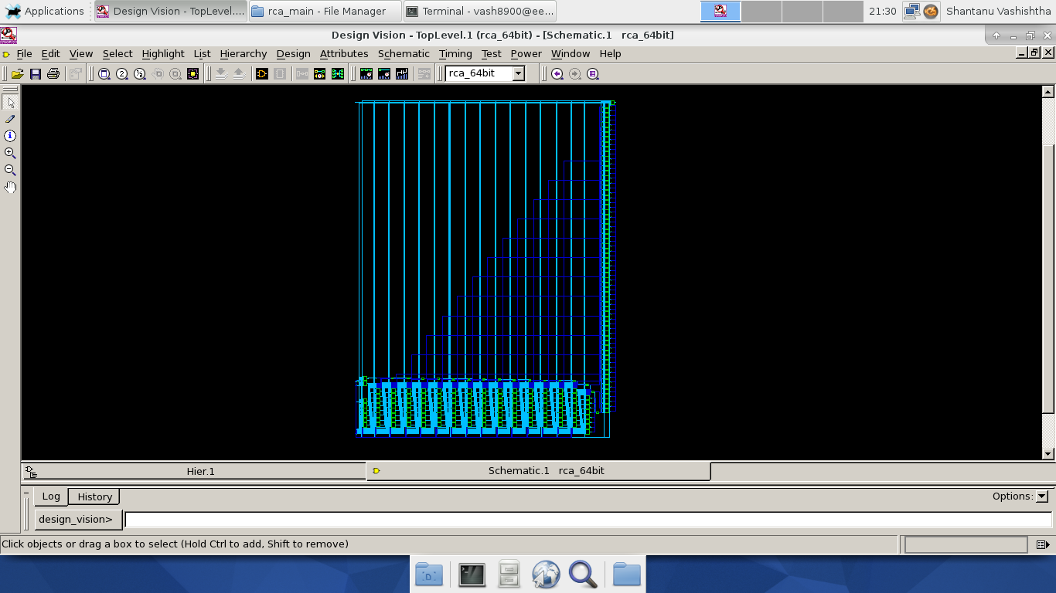

**C.4b. Screenshot Circuits from Synthesis from CLA (Design Compiler)**

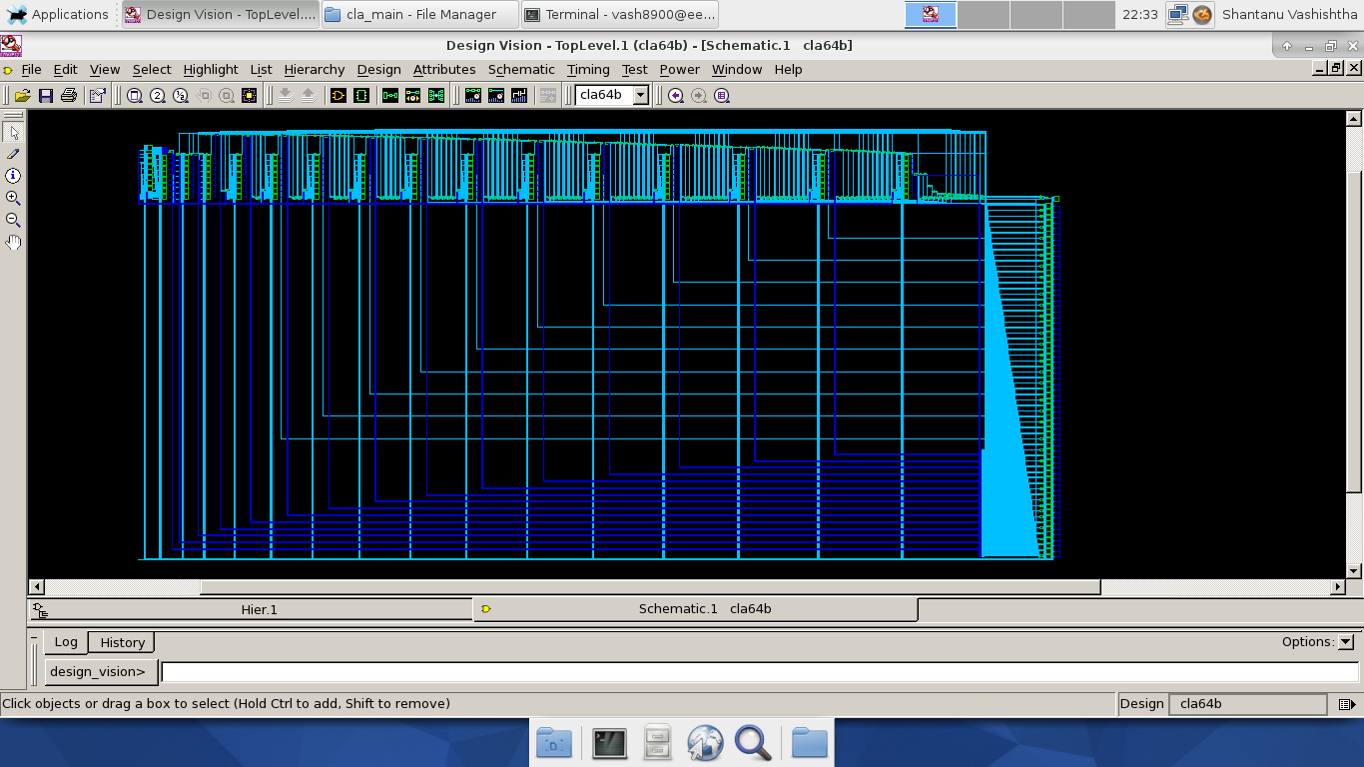

**C.4c. Screenshot Circuits from Synthesis from CSA-EQG (Design Compiler)**

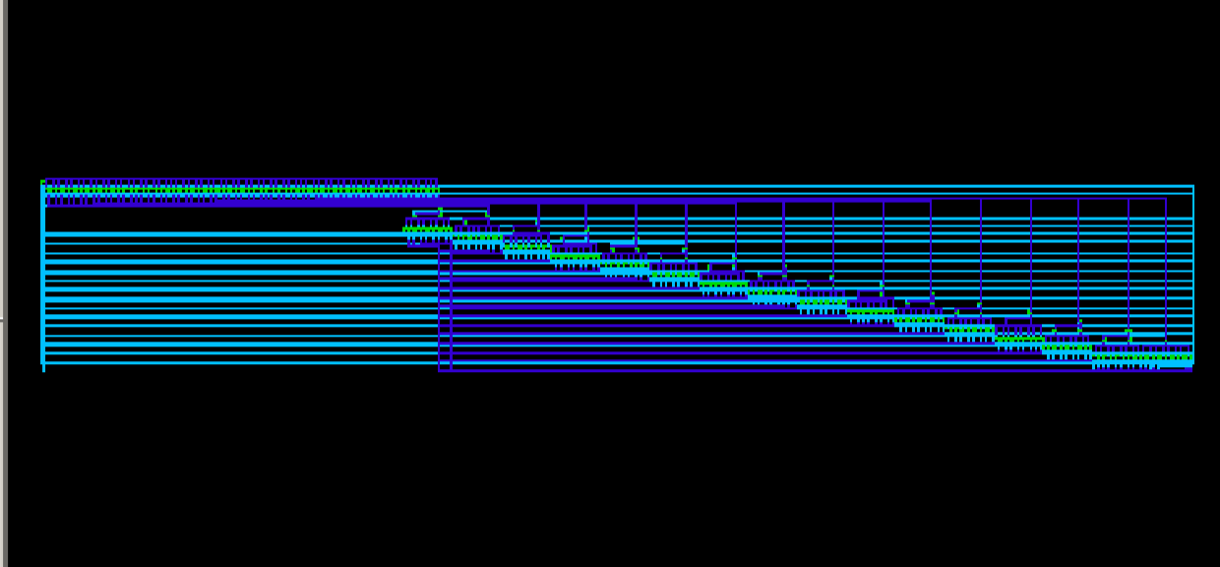

**C.4d. Screenshot Circuits from Synthesis from CSA-UEQG (Design Compiler)**

